Captain Rad Ickle’s Booty

After years of piracy on the high seas, Captain Rad Ickle has finally been captured. Alone he waits in a cold dark cell; waiting for the trial that will sentence him to life in the dungeon, or to his death. The excitement of his capture and the anticipation of his judgement day have created quite a stir among the citizens. You feel anxious to know the outcome, but feel unsure of which you hope for.

Piracy is unforgiveable, but you imagine yourself sailing port to port on an endless adventure and feel a strange sense of sympathy. You decide, against your better judgment, to sneak down to the holding cell to meet the Captain. But what would a good person like you want to learn from a thieving pirate?

You arrive at the prison shortly after sunset. A small bribe is all is takes to get past the night guard and suddenly you are standing in front of the Captain’s cell. He walks towards the bars to size you up. His mouth curls up into a sly grin, as if he recognizes you.

“Aye Peter, ye’ve come fer me spoils, have ye?” He has obviously mistaken you for someone else, but you feel that now is not the time to correct him. You nod slowly.

“Yarr,it pains me to give it up after all these years, but I fear me ship be approaching her final port. When ye find me treasure chest, don’t share the booty with anybody.” Reaching into his boot, he draws a small roll of parchment. You know at once what this is: a map.

The Captain says no more as he returns to the dark corner of his cell. You leave feeling confused. Who is Peter? Where does this map lead? And what is this treasure?

Destiny has spoken. You know what must be done. The following morning you set out with nothing but two weeks rations and your map. You find a merchant ship willing to take you to your destination. The captain of the merchant ship lets out a deep chuckle as he tells you: “Foolish lad, if death is what you seek, I’ll take you there – for a fee of course. But I warn you that no one comes back from Root Island!”

As the merchant ship nears the island, you are forced to jump ship and swim ashore. Walking up the beach, dripping wet, you wonder if this was such a good idea. “No time for doubt now,” you tell yourself, “I’ve got a treasure to find.”

- Calculate the length of EACH potential trail segment.

- Indicate clearly which path I took.

Scale: each grid square:
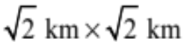

Root Island
Each grid square is $\sqrt{2} km long and \sqrt{2} km wide$
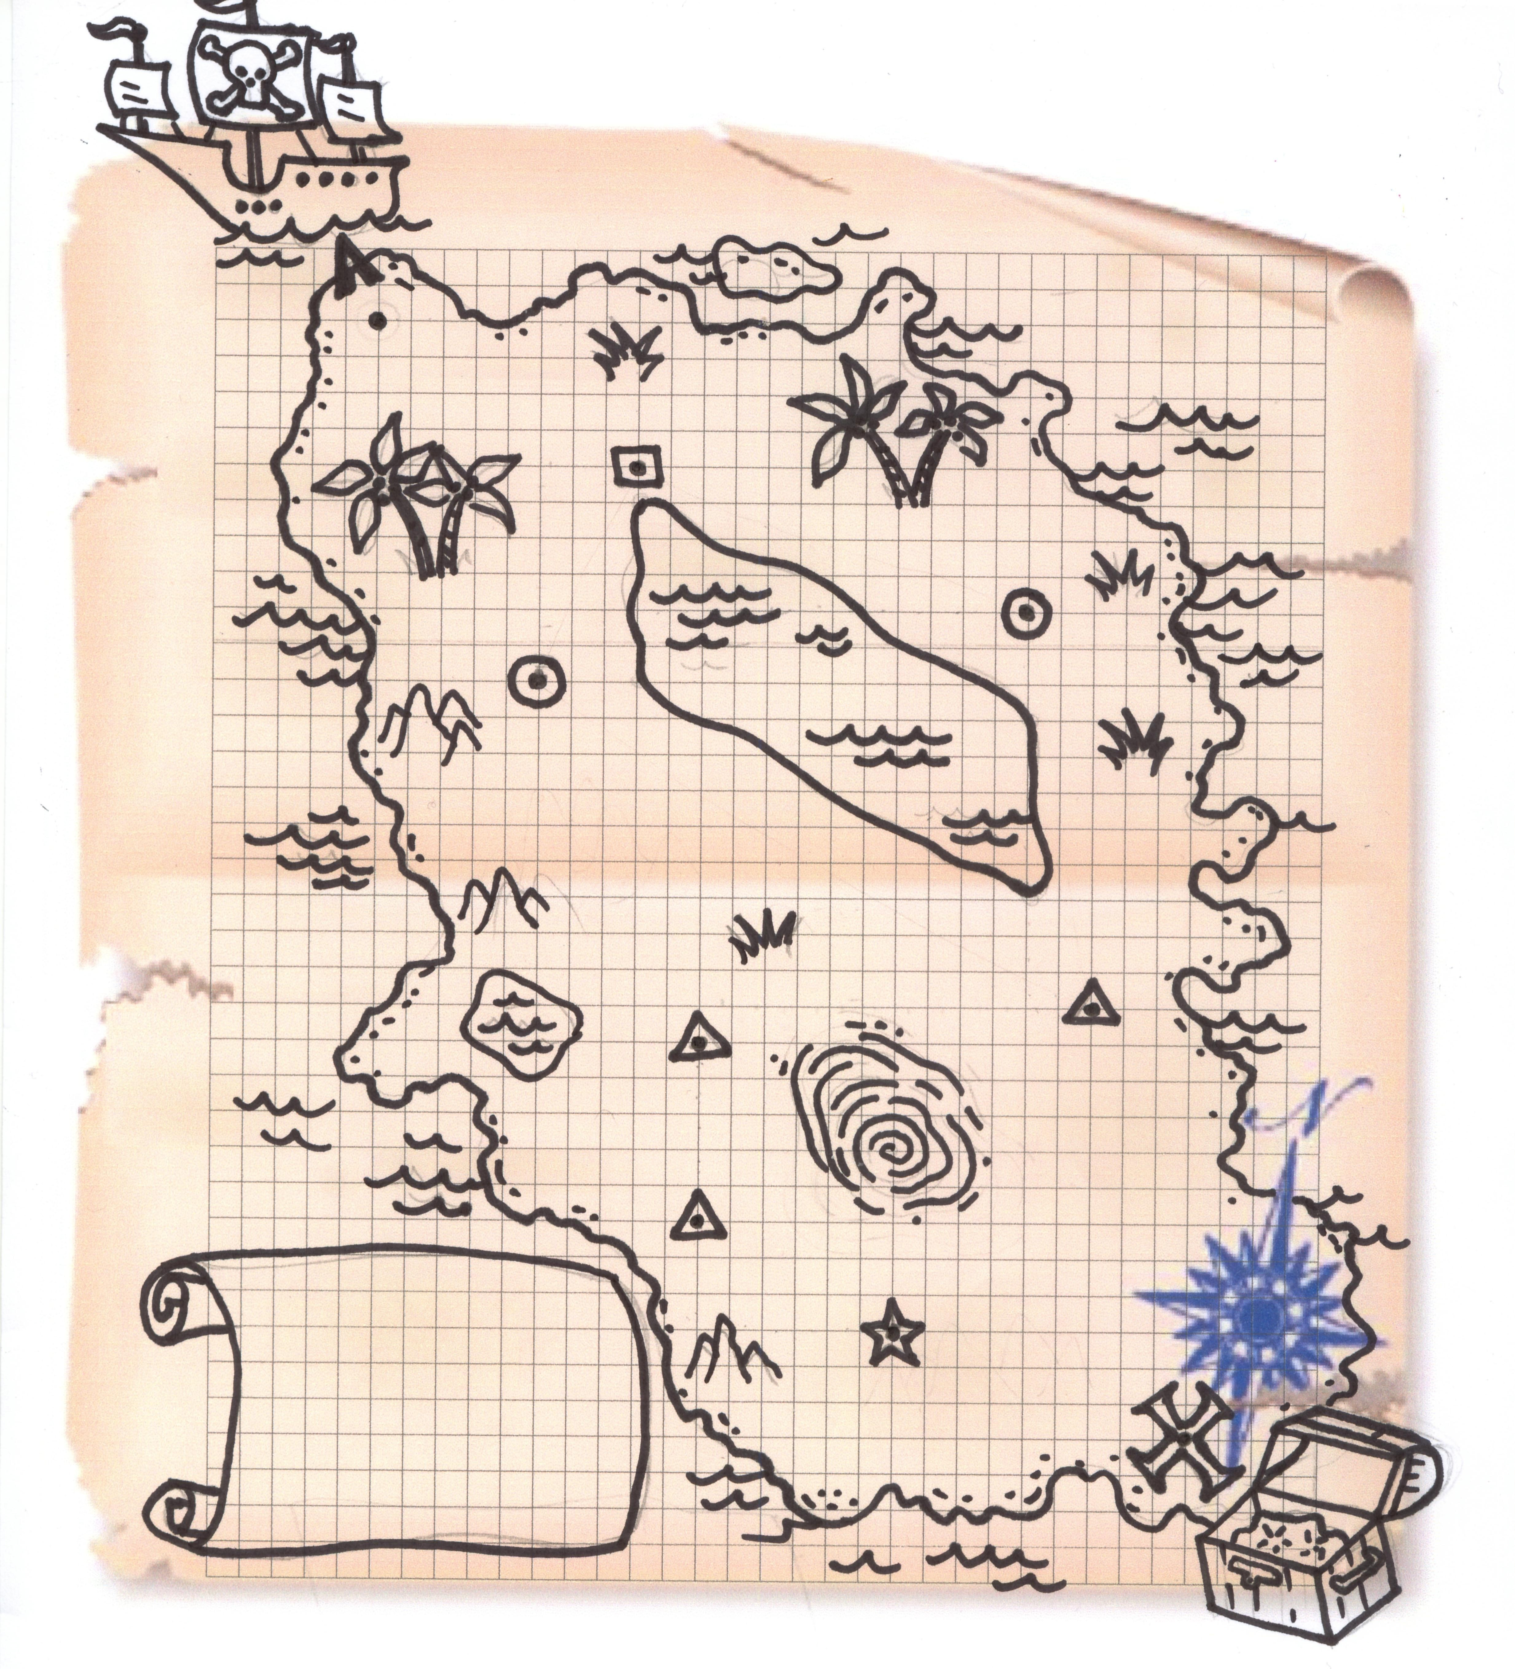

Route: Ship ■ ● ▲  Treasure

Distance of the path you took:
$$12\sqrt{10}+6\sqrt{5}+10\sqrt{2}$$

