Kinematics Review

- What is the difference between average velocity and instantaneous velocity?

- What is the difference between velocity and speed?

- What is the definition of acceleration?

- A high-powered racing car accelerates from rest at a rate of 7.0 m/s². How fast will it be moving after 10.0 s? Express your answer in m/s and km/h.

- Avery, a frustrated physics student, drops a physics textbook off the top of the CN tower. If the tower is 5.3 x 10² m high, how long will the book take to reach the ground, assuming there is negligible air resistance?

- If an electron inside a TV tube accelerates in a space of 5.0 cm from rest to 10.0% of the speed of light, what is its acceleration? (the speed of light is 3.00 x 10⁸ m/s)

- Snoopy is taking off in his World War I biplane. He coasts down the runway at a speed of 40.0 m/s, then accelerates for 5.2 s at a rate of 4.90 m/s². How fast is the plane moving after the 5.2 s?

- A car accelerates from rest at 6.00 m/s². How far does it move between 10.0 s and 15.0 s?

- A skier accelerates steadily down a hill from 3.50 m/s to 11.40 m/s in 4.20 s.
  - What distance is travelled?
  - What is the average speed for the trip?

- A child on a toboggan slides down a snowy hill, accelerating uniformly at 2.8 m/s². When the toboggan passes the first observer, it is travelling with a speed of 1.4 m/s. How fast will it be moving when it passes a second observer who is 2.5 m downhill from the first observer?

- A space vehicle is orbiting the earth at a speed of 7.58 x 10³ m/s. In preparation for a return to earth, it fires retro-rockets which provide an acceleration in the opposite direction of 78.4 m/s². Ignoring any change in altitude that might occur, how long will it take the vehicle to slow down to 1.52 x 10³ m/s?

- A truck is moving along at 80 km/h when it hits a gravel patch, which causes it to accelerate in the opposite direction at 1.4 m/s². How far will the truck travel before it slows down to 20.0 km/h?

- A woman biker is driving along the highway at 80.0 km/h, in a 60 km/h speed zone. She sees a police car ahead, so she brakes so her bike accelerates in the opposite direction at 2.22 m/s². How far along the road will she travel before she is at the legal speed limit?

- Spiderman is crawling up a building at a rate of 0.50 m/s. Seeing Spiderwoman 56 m ahead of him, he accelerates at a rate of 2.3 m/s².
- How fast will he be moving when he reaches Spiderwoman?
- How much time will it take to reach Spiderwoman?
- When he reaches Spiderwoman, Spiderman discovers that she is a Black Widow and, as you may know, Black Widows eat their mates! If he is 200.00 m from the road below, how long will it take him to fall to the safety of the road.

- A stone is dropped from the top of a tall building. How long will the stone take to pass a window that is 2.0 m high if the top of the window is 20.0 m below the point from which the stone is dropped?

- An arrow shot straight up into the air at 50.0 m/s accelerates downward at 9.8 m/s² until it reaches a speed of zero at its peak. Draw a velocity vs. time graph of this motion.

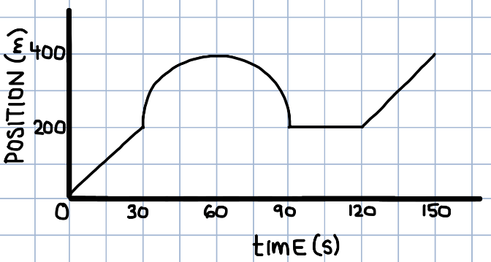
- Use the following position vs. time graph to answer the following:
  - What is the total displacement of the car between 90 and 150 s?
  - When is the car moving in the positive direction?
  - What is the velocity of the car between 0 and 30 s?
  - What is the instantaneous velocity of the car at 60 s?
  - What is the average speed of the car between 0 and 150 s?

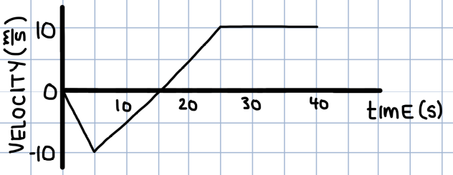
- Use the following velocity vs. time graph to answer the following:
- When is the car moving in the positive direction?
- When does the car have a positive acceleration?
- Describe the motion of the car from 25 to 40 s.
- What is the total displacement of the car over the 40 s?
- What is the total distance travelled by the car over the 40 s?
- What is the average velocity of the car over the 40 s?

- A glider on an air track is made to accelerate uniformly by tilting the track at a slight angle. The distance travelled by the glider was measured at the end of each 0.10 s interval and the following data was gathered:
distance d (cm) | 0 | 0.025 | 0.100 | 0.225 | 0.400 | 0.625
time t (s) | 0 | 0.100 | 0.200 | 0.300 | 0.400 | 0.500
- Plot a graph with distance, d, on the y-axis and time, t, on the x-axis.
- Plot a second graph with d on the y-axis and t² on the x-axis.
- Calculate the slope of your second graph to figure out the acceleration of the glider on the air track.

