BC Numeracy 10 Exam Practice – Area 3

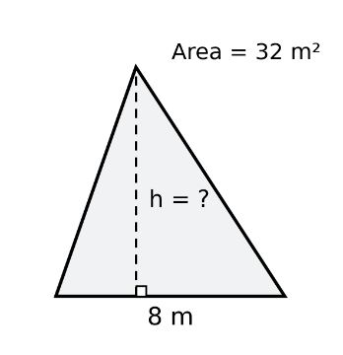
- A community centre is planning a triangular mural on a rectangular wall. The mural must cover an area of 32 m², and its horizontal base will measure 8 m. The available wall height is 7 m.
  - Calculate the perpendicular height required for the mural.
  - Determine whether the mural will fit on the wall. Explain your reasoning.
  - If the base cannot be changed, what is the greatest area the mural could cover?

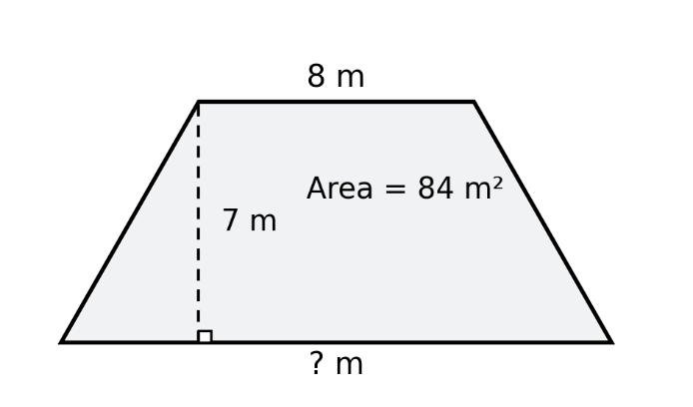
- A community garden is designed as a trapezoid with an area of 84 m². One parallel side measures 8 m, and the perpendicular distance between the parallel sides is 7 m.
  - Draw and label a diagram of the garden.
  - Determine the length of the other parallel side.
  - The available property allows the longer parallel side to be at most 15 m. Will the proposed garden fit?
  - If the longer parallel side is reduced to 15 m, what perpendicular height would maintain the original area?

- A circular drying tarp has a radius of 1.8 m. It will be replaced by a larger circular tarp that covers an additional 2 m².
  - Calculate the area of the original tarp.
  - Determine the area the new tarp must cover.
  - Calculate the required radius of the new tarp. Round to the nearest hundredth of a metre.

- A metal drum has a circular opening with a radius of 11 cm. A machinist wants to enlarge the opening so that its area increases by 40%.
  - Calculate the original area of the opening.
  - Determine the required area of the enlarged opening.
  - Calculate the new radius, rounded to the nearest tenth of a centimetre.

- A community wants to redesign a fishing net opening shaped like a circle. The current opening has a diameter of 80 cm. They want the new opening to have 1.5 times the area of the original.
  - Calculate the original area of the opening.
  - Determine the required area of the new opening.
  - Calculate the new diameter, rounded to the nearest centimetre.

- A town wants to build a circular pond with a surface area between 450 m² and 500 m².
  - Calculate the smallest possible radius.
  - Calculate the largest possible radius.
  - If construction costs $42 per square metre, estimate the total cost using the midpoint of the permitted area range.

- A rectangular garden measures 12 m by 8 m. Two redesigns are being considered:
Design A: Increase the length by 25% and decrease the width by 20%.
Design B: Increase both the length and the width by 10%.
  - Calculate the original area of the garden.
  - Determine the new dimensions and area of Design A.
  - Determine the new dimensions and area of Design B.
  - Calculate the percentage change in area for each design.
  - A gardener claims that increasing both dimensions by 10% must increase the area by 10%. Explain whether this claim is correct.

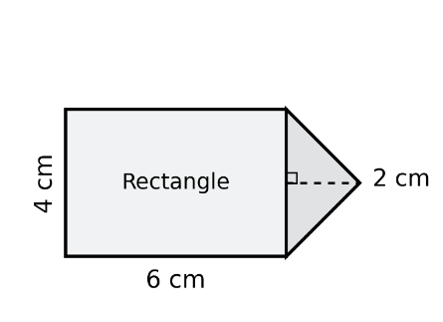
- An architect creates a scale drawing of a public plaza. The plaza consists of a rectangle with a triangle attached to one of its shorter sides. The scale is 1 cm represents 2.5 m. On the drawing, the rectangle measures 6 cm by 4 cm. The triangle has a base of 4 cm and a perpendicular height of 2 cm.
  - Determine the actual dimensions of the rectangular and triangular sections.
  - Calculate the actual area of each section.
  - Determine the total area of the plaza.
  - If paving costs $24 per square metre, calculate the total paving cost.

- A community is planning a new learning space, each learner requires at least 2.5 m² of usable floor space.

Two floor plans are being considered:
Design A – Rectangular Layout: Main building 12 m × 9 m; storage room 3 m × 4 m; hallways and circulation 12 m²; flooring cost $70 per m² of total floor area.
Design B – Composite Layout: Main rectangle 10 m × 8 m; attached triangular section with base 8 m and perpendicular height 4 m; storage room 5 m²; hallways and circulation 7 m²; flooring cost $85 per m² of total floor area.
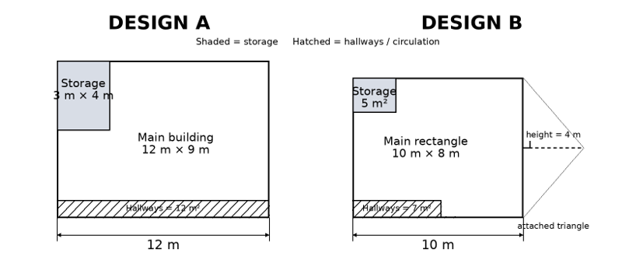

  - Calculate the total floor area of each design.
  - Determine the usable floor area after subtracting storage and circulation space.
  - Calculate the maximum number of learners each design could accommodate.
  - Calculate the total flooring cost for each design.
  - Which design would you recommend? Support your recommendation using calculations and at least two considerations.

