BC Numeracy 10 Exam Practice – Area 1

- A flooring company installs regular square tiles. Each tile has side length 22 cm.
  - What is the area of one tile?
  - If a small foyer floor is 3.5 m², estimate how many tiles are needed (rounded up).

- A school is installing a solar panel field shaped like a rectangle. base: 18 m. Height: 12 m. Each solar panel requires 1.6 m².
  - What is the area of the field?
  - Estimate how many solar panels can fit, allowing 10% of the land for walkways.

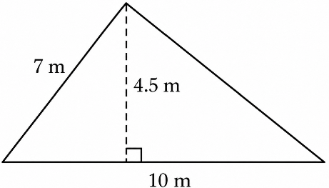
- A triangular sail has a base measuring 10 m, a sloping side measuring 7 m, and a perpendicular height of 4.5 m.
  - Which measurements are needed to calculate the area? Explain why.
  - Calculate the area of the sail.
  - The sail requires 0.35 L of waterproofing solution per square metre. How much solution is needed?

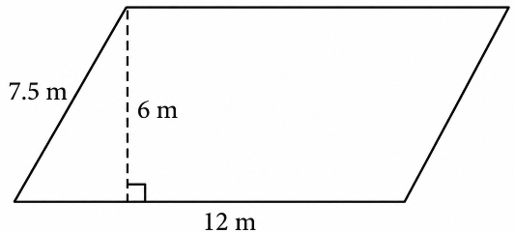
- A community garden is shaped like a parallelogram. Its base measures 12 m, its sloping side measures 7.5 m, and the perpendicular distance between its parallel bases is 6 m.
- Calculate its area.
- Explain why using 7.5 m as the height would give an incorrect result.
- If 25% of the garden is reserved for pathways, how much area remains for planting?

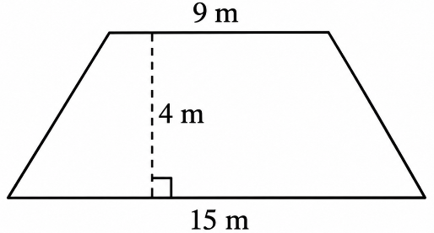
- A landscaping company is preparing a trapezoid-shaped flower bed. The two parallel sides measure 9 m and 15 m, and the perpendicular distance between them is 4 m.
  - Calculate its area.
  - Landscaping fabric is sold in rolls that cover 7 m² each. How many whole rolls must the company purchase?

- Three students share an 82 m² apartment. Two students share Bedroom A (3.4 m × 3.2 m), while the third occupies Bedroom B (2.9 m × 2.8 m). The remaining floor area is shared equally among all three students. Rent is divided proportionally, with each student responsible for their allocated share of the common area and their private bedroom space.
  - How much private area does each of the two bedrooms provide?
  - If rent is $2100/month, how much should each student pay?

- The roof of a ski lodge is shaped like a large triangle: Base: 18 m. Height: 9.5 m. A section near the apex cannot accumulate snow because of warming vents, forming a smaller triangular region with: Base: 4 m. Height: 2.5 m
  - Calculate the snow-collecting area of the roof (large triangle minus small triangle).
  - If snow load is estimated at 320 kg per m², how much snow mass could accumulate on the roof?

- A museum wants to add a floor decal shaped like an irregular polygon, made of: A 4 m × 6 m rectangle. A triangle attached to the 6 m side with height 3 m.
  - Find the total area.
  - If decals cost $35 per m² installed, estimate the total cost.

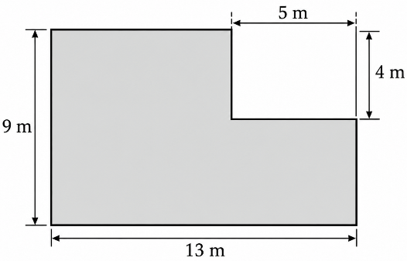
- A homeowner plans to build an L-shaped patio. The design fits inside a rectangle measuring 13 m by 9 m, but a rectangular corner measuring 5 m by 4 m will not be paved.
  - Calculate its area by subtracting the missing rectangular section.
  - Calculate the area again by dividing the L-shape into two rectangles.
  - Explain why both methods give the same result.

- A drone maps a small pond and approximates its outline as a 5-sided irregular polygon made of: A 10 m × 6 m rectangle. A triangle on one long side with base 10 m and height 4 m
  - Estimate the area of the pond’s surface.
  - If wetland plants naturally grow around 15% of the surface area, how many square metres is that?

- A community is planning a park made from three connected regions:
- A central rectangle measuring 12 m by 8 m.
- A triangle attached to one 8 m side of the rectangle, with a perpendicular height of 5 m.
- A trapezoid attached to the opposite 8 m side, with parallel sides measuring 8 m and 4 m and a perpendicular height of 6 m.
- Calculate the area of each region.
- Determine the total area of the park.
- If 25% of the park is reserved for pathways, how much area remains for recreation and landscaping?

