Word Problem Sequences (1)

DO NOT SOLVE THE PROBLEMS. Instead, for each problem:
- Build a table using the information provided.
- Identify whether $y-y_{1} =\frac{rise}{run}\left(x-x_{1}\right)$ is needed or if you can use slope, $m$, and y-intercept, b.
- Build a formula, $y=mx+b$, using your chosen method.

- A pediatric record shows that a child was 70 cm tall at age 3 and 105 cm tall at age 10.
- How tall is the child expected to be at age 14?
- At what age will the child reach 150 cm?

- Using the figures to the left,
- Find the number of marbles in figure 20.
- Which figure has 206 marbles?
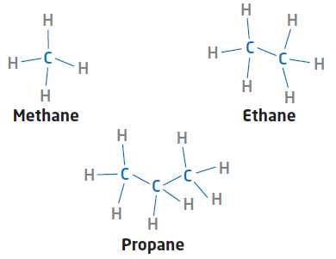
- Hydrocarbons are the building blocks of thousands of products, including fuels, plastics, and synthetic fibres. Some hydrocarbon compounds contain only carbon and hydrogen atoms.
- How many hydrogen atoms does octane have?
- How many carbon atoms are required to support 202 hydrogen atoms?

- A child’s allowance was $5 at age 4, and through yearly raises, it had grown to $44 at age 17.
- How much will the weekly allowance be at age 20?
- At what age will the allowance reach $50?

- A runner began training and logged 5 km in week 1 and 19 km in week 8.
- How many kilometres will the runner complete in week 12?
- In which week will the runner run 25 km?

- A savings bond was worth $1000 after 0 years and $1400 after 10 years.
- What will the value of the bond be after 18 years?
- After how many years will the bond reach $1600?

- A furnace technician charges $60 for a house call (0 hours) and $460 when the job takes 10 hours.
- What will the charge be for 15 hours of labour?
- How many hours were worked if the bill was $820?

- A community events leader earned $16 for 1 hour of work and $64 for 3 hours of work.
- How much will the leader earn for 6 hours of work?
- After how many hours will the total pay be $160?

- On Banks Island in northern Canada, the musk-ox population was 9250 animals in 1955 and grew to 100 000 animals in 2010.
- Estimate the population in 2030.
- In what year will the population reach 200 000?

- During a fitness program, Susan recorded 11 sit-ups on day 6 and 29 sit-ups on day 15.
- How many sit-ups will she complete on day 40?
- On what day will she complete 100 sit-ups?

