Pick a Career in Chemistry

Agricultural chemist
Analytical chemist
Astronomical chemist
Bio-chemist
Forensic chemist
Chemical Engineer
Cryogenic chemist
Electro-chemist
Environmental chemist
Pyrotechnic chemist
Food chemist
Geo-chemist
Diamond chemist
Medical chemist
Nano chemist
Nuclear chemist
Photo chemist
Solid state battery chemist

Create Slides
You Need to Include These Things

It needs to be visually appealing.

It needs to be creative.

It needs to contain lots of information.

It needs to contain pictures of what that career looks like.
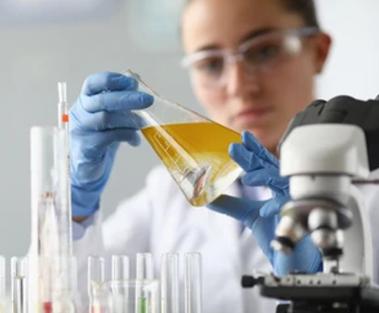
Ideas

- annual salary

- duties and responsibilities

- working conditions

- possibilities for advancement

- What it is you might LOVE about this career.

- What research would you get to do?

- What problems do chemists in this career solve?

- Typical experiments performed

- Tools and equipment used

- Workplaces and environments

- People they work with

- Important skills needed

- Education and training required

- University programs related to the career

- Certifications or licenses required

- Industries that hire this type of chemist

- A typical day in the job
- Major discoveries in this field

- Current research in this field

- Challenges of the career

- Safety considerations in the job

- Technologies used in the field

- How this career impacts society

- Environmental impact of the work

- Famous scientists in this field

- Important companies or organizations in this field

- Future developments in this area of chemistry

- Demand for this career in the future

- Related careers

- Opportunities for advancement

- Leadership roles in the field

- Research areas you could specialize in

- Reasons someone might not enjoy this career

