Graphing Horizontal Projectile Motion

- A ball leaves a cliff horizontally at 12.0 m/s and remains in the air for 3.00 s.

  - Calculate the horizontal and vertical displacements and velocities at each time shown.

Time (s) | $$d_{x}=v_{i}t+\frac{1}{2}at^{2}$$ | $$v_{x}=v_{i}+at$$ | $$d_{y}=v_{i}t+\frac{1}{2}at^{2}$$ | $$v_{y}=v_{i}+at$$
0 s | 0 m | 12.0 m/s | 0 m | 0 m/s
1 s
2 s
3 s

  - Plot all four relationships below. For each graph, choose a suitable vertical scale and plot your calculated points. Stop each graph at impact.

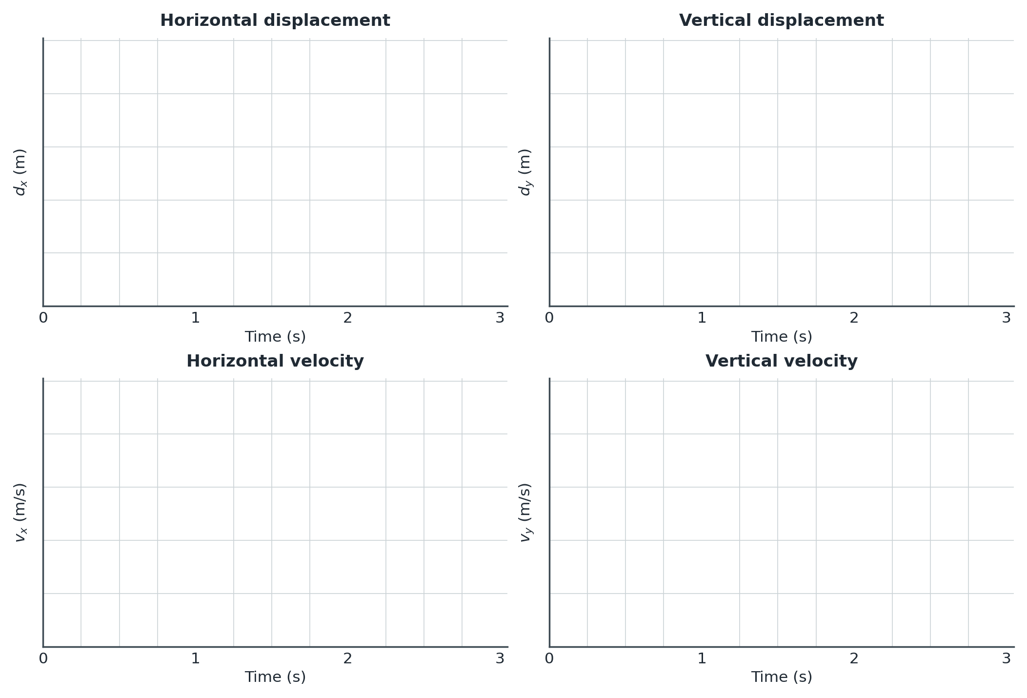
- Two balls are launched horizontally from the same height. Ball A travels at 10.0 m/s and Ball B at 20.0 m/s. Both are in the air for 3.00 s.
  - On the same axes, sketch horizontal displacement vs. time for both balls. Label each line.
  - Which ball has the steeper graph? Explain what its slope represents.
  - Would their vertical displacement–time graphs be identical or different? Explain.

- Two balls leave different heights with the same horizontal launch speed. Ball A is airborne for 2.00 s; Ball B is airborne for 4.00 s.
  - On the same axes, sketch vertical velocity vs. time for both balls. Label where each graph ends.
  - Explain why the graphs have the same slope but end at different times.

Graph-reading reminder:
The slope of a velocity–time graph gives acceleration.
The area under a velocity–time graph gives displacement.

- The graphs below show the horizontal and vertical velocities of a projectile from launch to impact.

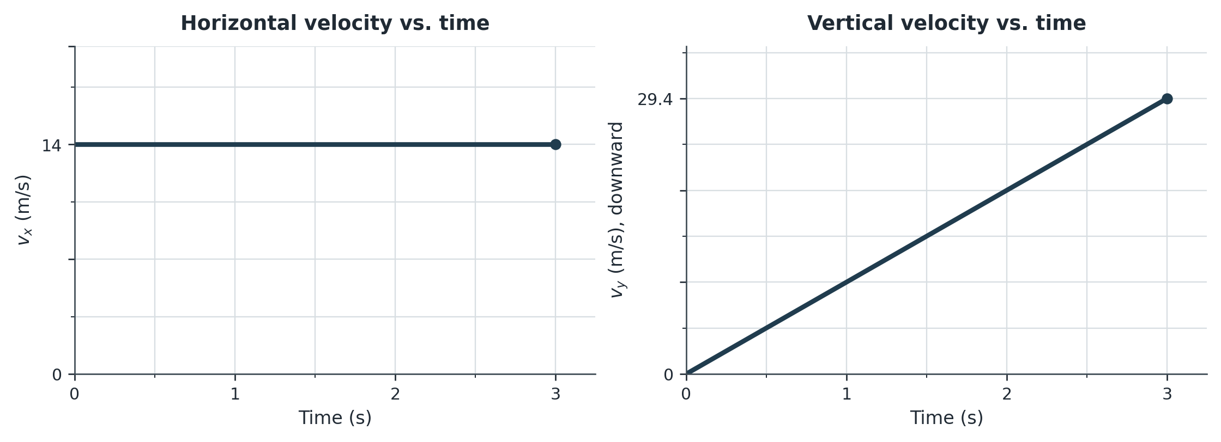

  - Determine the horizontal launch velocity.
  - Determine how long the projectile is in the air.
  - Calculate the vertical acceleration from the slope of the vertical velocity graph.
  - Determine the horizontal displacement from the area under the horizontal velocity graph.
  - Determine the vertical distance fallen from the area under the vertical velocity graph.
  - Sketch horizontal acceleration vs. time and vertical acceleration vs. time.

