NAME:____________________
Create a Map of Classroom Safety Features
Indicate on the map the position of these saftey features:

Eyeglass station

Eye wash station

Fire extinguishers

Fire Blanket

Windows

Fumehood

Exits

Emergency response bag

Front of Classroom

Back of Classroom
WHMIS Symbols (Pg. xv)
Include each of the WHMIS symbols

Drawing | Name | Meaning

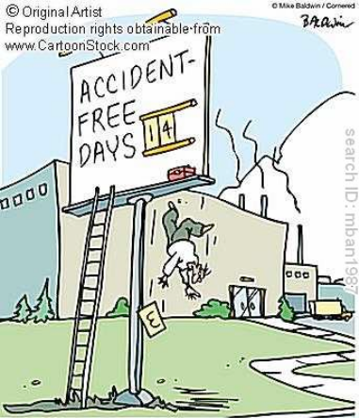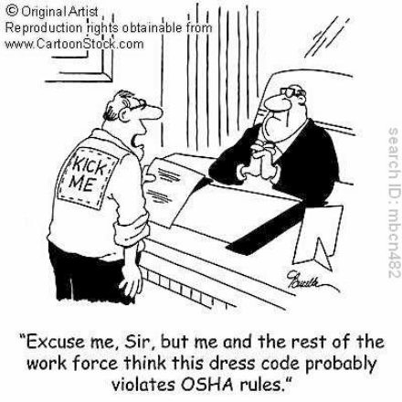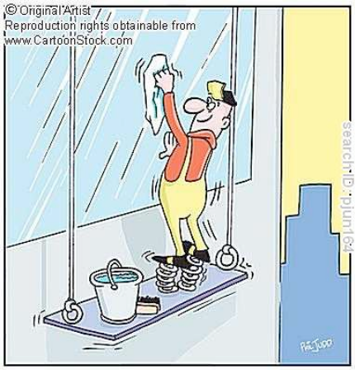

Create a comic strip
It Should:

Explains why safety in the science lab is important.

OR

Explain how you should behave in a science lab.

OR

Explain how to use lab equipment safely.

Make it easy to read, drawn and colored.

Include at least 6 panels.

Actions and dialogue should match.

Captions should be related to the scenes.

The connections to behavior and safety should be easy to understand.

