Cosine Law
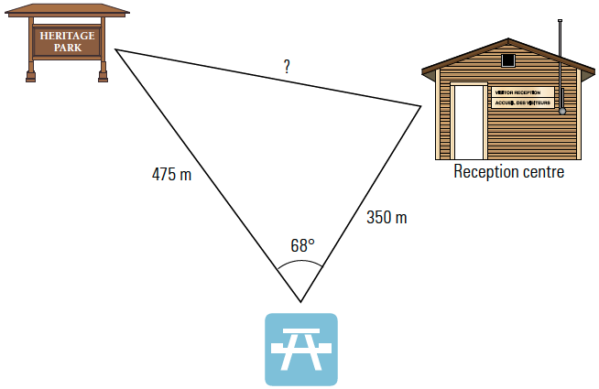
- John has measured the straight-line distance between the reception center and the picnic site as 350 meters, and the straight-line distance from the billboard to the picnic site as 475 meters. If the angle between the two lines is 68°, how far apart are the billboard and the reception center?

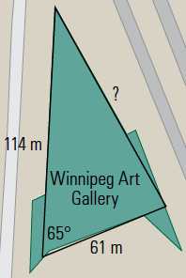

- The Winnipeg Art Gallery houses one of the world’s largest collections of contemporary Inuit art. The building is in the shape of a triangle. Two of the outer walls form an angle of about 65° are approximately 61 m and 114 m in length. What is the length of the third side?
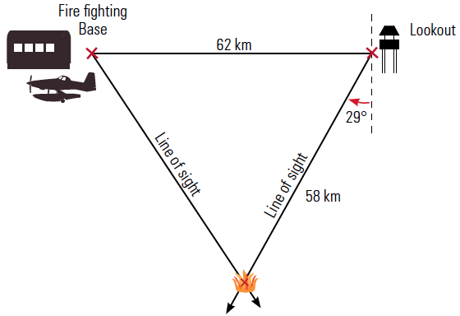

- From a forest fire lookout station, a fire is spotted 29Åã degrees west of south. The fire is 58 km from the lookout station. A fire fighting base is 62 km due west of the first station. How far is the fire from the fire fighting base?
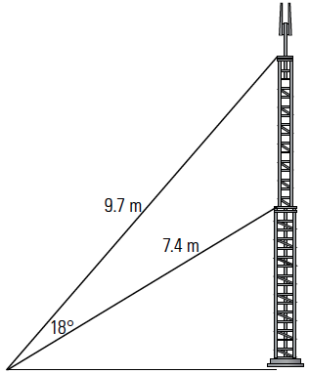

- Guy wires are used to stabilize a mast. The difference between the angles of elevation of two guy wires is 18°. If the guy wires are 9.7 m and 7.4 m long, what is the distance between the two places on the mast where the guy wires are attached?

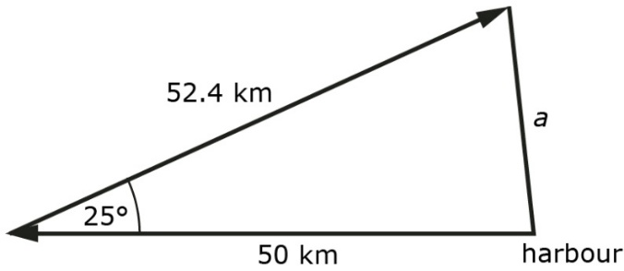
- A ship leaves a harbor and travels west 50 km. It then sails 52.4 km in a direction of 25 N of E, at which point the ship has engine trouble. A second ship is dispatched from the harbor to assist. If the second ship sails directly from the harbor to the first ship, how far must the second ship sail?

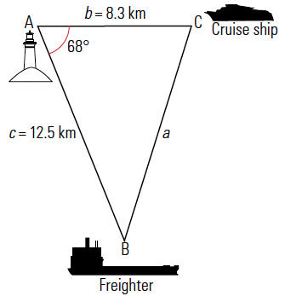
- A lighthouse keeper at Trial Island Light Station observes a cruise ship at a distance of 8.3 km. At the same time, a freighter is observed at a distance of 12.5 km. If the angle between the lines of observation is 68°, how far apart are the freighter and the cruise ship?

Cosine Law – Solving for Angles

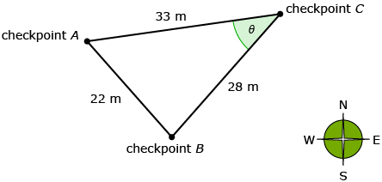
- Rahim is standing at checkpoint C and knows distances to two other checkpoints. In order to walk in the correct direction, Rahim needs to determine the angle between checkpoints A and B. Find $θ$ using the cosine law.

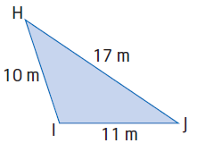
- Determine the measure of ∠I.

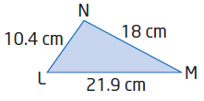
- Determine the measure of ∠L.

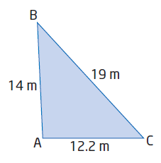
- Determine the measure of the angle opposite the 14-m side.

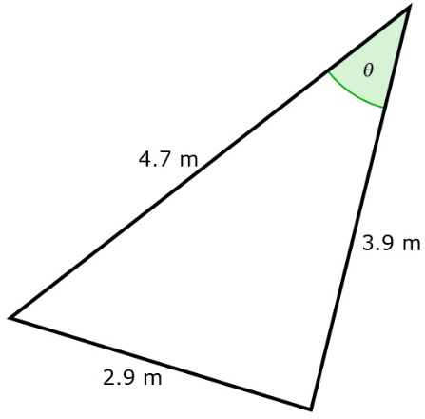
- Use the cosine law to determine the measure of .

Sine Law

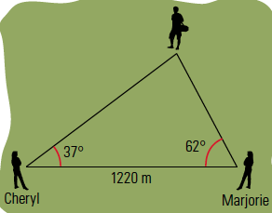
- Marjorie observes the hiker at an angle of 62°, Cheryl observes him at an angle of 37°. If Marjorie and Cheryl are 1220 meters apart on opposite sides of the hiker, how far is Cheryl from the hiker?

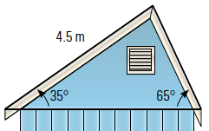
- The roof of the shack will be asymmetrical, as shown in the diagram. The longer section of the roof is 4.5 m and forms an angle of 35° above horizontal. The shorter section of the roof forms an angle of 65° above horizontal. How long is the shorter section of the roof and how wide is the shed?

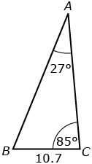
- In triangle ABC, BC = 10.7 m, angle A = 27°, and angle C = 85°. Calculate the length of AB to the nearest tenth of a metre.

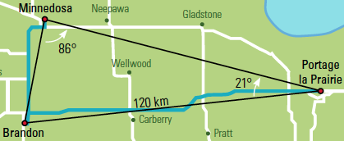
- Huong is a truck driver. He is driving from Portage la Prairie, MB, to Brandon, MB, to drop off a shipment. From there, he will drive to Minnedosa and back to Portage la Prairie. How far will Huong drive?

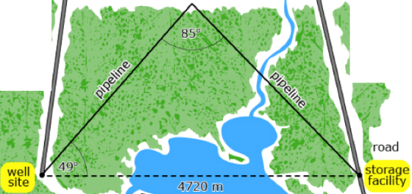
- A pipeline is being built from a well site to a road storage facility. The two sites are 4720 m apart. The pipeline forms a triangle with the sites, with an angle of 49° at the well site and an angle of 85° at the point where the two pipeline sections meet. Calculate the total length of pipeline required, to the nearest metre.

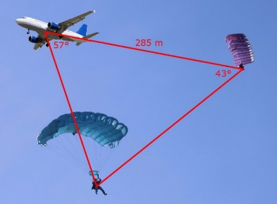
- An airplane and a weather balloon are 285 m apart. A parachutist is visible from both locations. The angle between the line from the airplane to the balloon and the line from the airplane to the parachutist is 57°. The corresponding angle at the weather balloon is 43°. Calculate the distance from the airplane to the parachutist, to the nearest meter.

Sine Law – Solving for Angles

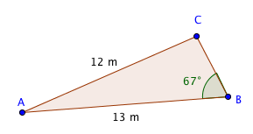
Determine the measure of angle C.

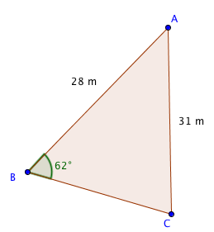
Determine the measure of angle C.

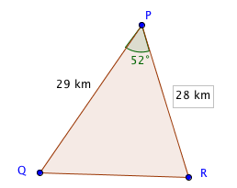
Determine the measure of angle Q.

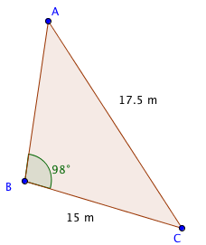

Determine the measure of angle C.

Determine the measure of angle B.

