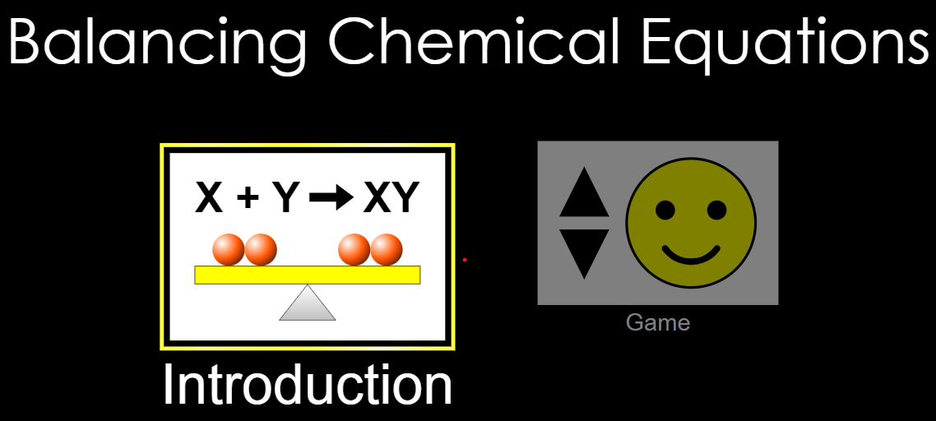

Search “PHET Balancing Chemical Equations”

https://phet.colorado.edu/sims/html/balancing-chemical-equations/latest/balancing-chemical-equations_en.html

Start with the introduction, then beat the game.

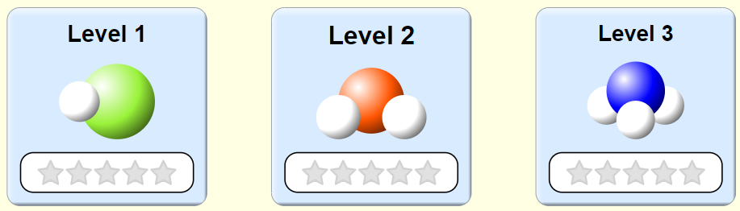

You need to earn ALL 15 STARS.

Level 1
Balance these equations by filling out the composition tables.

______ C₂H₆ ______ C₂H₄ + ______ H₂

Bohr Diagrams Bohr Diagrams Bohr Diagrams

______ SO₃ ______ SO₂ + ______ O₂

Bohr Diagrams Bohr Diagrams Bohr Diagrams

______ P₄ + ______ O₂ ______ PO₃

Bohr Diagrams Bohr Diagrams Bohr Diagrams

Level 2
Balance these equations by filling out the composition tables.

_______ C_{(g)} + ______ H₂O_{(l)} ______ CH_{4(g)} + ______ CO_{2(g)}

Bohr Diagrams Bohr Diagrams Bohr Diagrams Bohr Diagrams

_______ H₂ + ______ SO₂ ______ S₈ + ______ H₂O

Bohr Diagrams Bohr Diagrams Bohr Diagrams Bohr Diagrams

_______ S₈ + ______ CH₄ ______ CS₂ + ______ H₂S

Bohr Diagrams Bohr Diagrams Bohr Diagrams Bohr Diagrams

Level 3
Balance these equations by filling out the composition tables.

_______ NO₂ + ______ H₂O ______ NH₃ + ______ O₂

Bohr Diagrams Bohr Diagrams Bohr Diagrams Bohr Diagrams

_______ NH₃ + ______ O₂ ______ N₂ + ______ H₂O

Bohr Diagrams Bohr Diagrams Bohr Diagrams Bohr Diagrams

_______ C₂H₂ + ______ O₂ ______ CO₂ + ______ H₂O

Bohr Diagrams Bohr Diagrams Bohr Diagrams Bohr Diagrams

