Trigonometry Review

The Tangent Ratio: A triangle represented by a tangent ratio of $\tan{θ}=\frac{opposite}{adjacent}$ is shown.
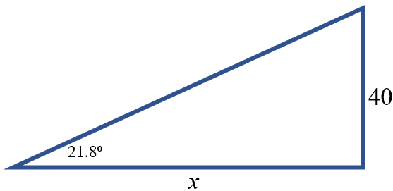
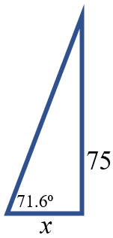
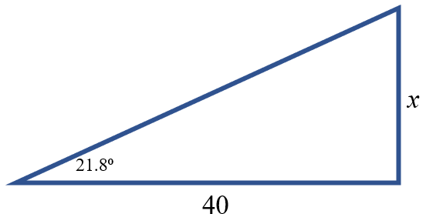
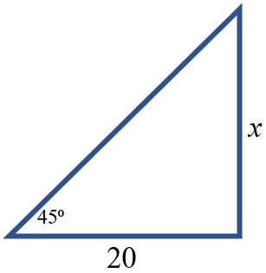

The Sine Ratio: A triangle represented by a sine ratio of $\sin{θ}=\frac{opposite}{hypotenuse}$ is shown below.
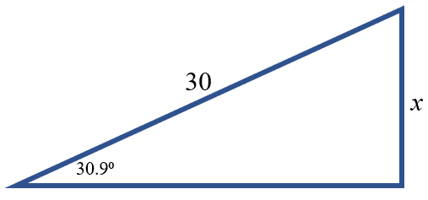
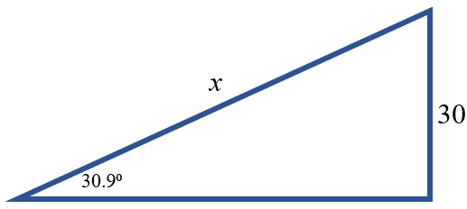
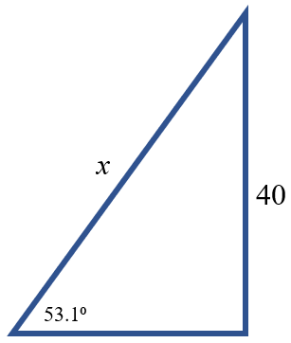

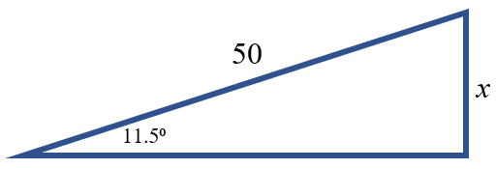

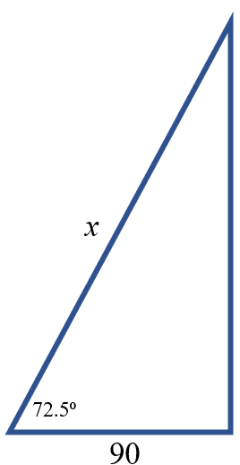
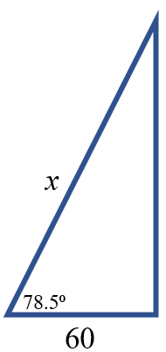
The Cosine Ratio: A triangle represented by a sine ratio of $\cos{θ}=\frac{adjacent}{hypotenuse}$ is shown below.
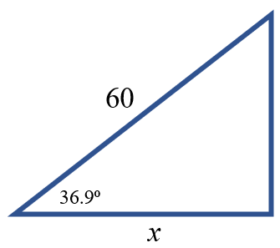
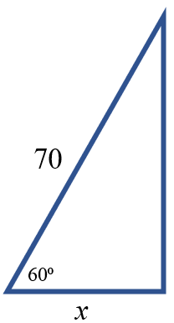

Determine the measure of the marked angle.

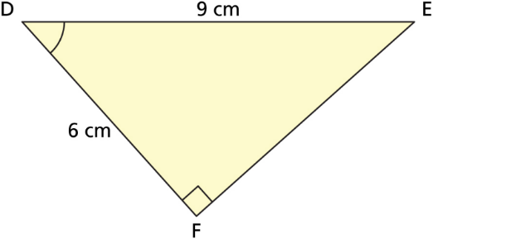
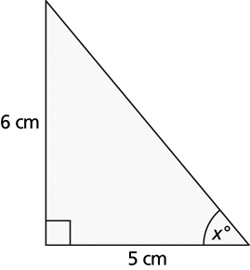

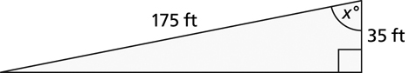

- Natalie is rock climbing and Aaron is belaying. When Aaron pulls the rope taut to the ground, the angle of depression is 73°. If Aaron is standing 8 ft from the wall, what length of rope is off the ground?

- A fire truck has an aerial ladder that extends 30.5 m measured from the ground. The angle of inclination of the ladder is 77°. How far up the wall of an apartment building can the ladder reach?

- What is the angle of depression of the person’s line of sight 150 m vertically and 285 m to the object horizontally?

- A surveyor wants to determine the width of a gorge without crossing it. From point D, the surveyor walks 25.23 m along the edge of the gorge to point E. From E, the angle between ED and the line of sight to point C on the opposite side is 58.5. The line CD is perpendicular to DE. Calculate the width of the gorge, CD, to the nearest tenth of a metre.

- A kite has a string 150-m long. If the string makes an angle of 41° with the ground, find the height of the kite above the ground.

- From the top of a 350 m tall building the angle of elevation to the top of another building is 52°. The angle of depression to the bottom of the second building is 60°. How tall is the second building?

- A surveyor is standing some distance from a flagpole. The surveyor measures an angle of elevation of 31° to the top of the pole and an angle of depression of 40° to the base of the pole. The horizontal distance from the surveyor to the flagpole is 28.0 m. Calculate the total height of the flagpole to the nearest tenth of a metre.

- A person is standing 275 feet from the base of a building. The angle of elevation to the base of the tower’s antennae is 32º. The angle of elevation to the top of the antenna is 42º. How tall is the antenna?

- Two people are at points A and B on a straight road. They are approaching a 20 m tall fire tower (T ). The angles of elevation to the top of the tower from the two people are 40º and 60º. How far apart are the people?

- A roller coaster at an amusement park heads upwards at an angle of 40 degrees for 50 meters along the slope, then drops right back to ground level over a horizontal distance of 30 meters. What is the angle of descent, indicated by x?

