SCIENCE 10

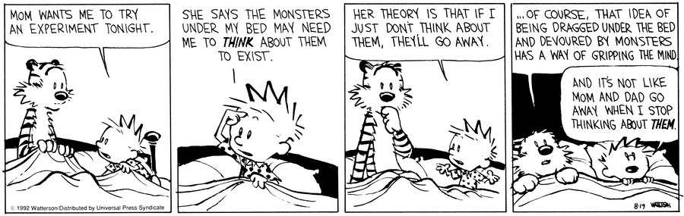

TABLE OF CONTENTS
TABLE OF CONTENTS 1
CLASSROOM EXPECTATIONS 2
INTRODUCTION 3
PROGRAM OF STUDIES 3
CONTENT 3
COURSE CALENDAR 3
ASSESSMENT 6

CLASSROOM EXPECTATIONS

Students are expected to:

- Refrain from the use of drugs or alcohol, including vaping.
- Refrain from verbal aggression and assault.
- Refrain from physical aggression and assault.

Students are expected to observe these classroom courtesies:

1. Be on time.
2. Come prepared to learn.
3. Demonstrate your learning each day.
4. Be respectful of the teacher, educational assistants, and classmates.
5. Respect the classroom environment.

Students are expected to be familiar with these classroom routines:

Cell Phones: Cell phones belong out of sight. Students will be provided with access to calculator apps such as Desmos Graphing Calculator and ClevCalc..

Hand-In: Students may hand in complete (or incomplete) activities at any time during the semester.

Hall Passes: Students are expected to fill out hall passes themselves and explain to staff where they are going, and for how long, before they leave the classroom.
Support: Students may access support rooms during class. Students are expected to fill out hall passes so that they might access the rooms that are supervised as well as the LART rooms that are available if students need extra one-on-one support.
Missed: If you are away from the classroom for a period of time, please contact me to establish expectations for at-home learning.
SHUT DOWNS

The curricular expectations of the class will be reduced in the event of a shutdown. Activities supporting learner acquisition of these will be posted on google classroom (zh4sjia). It is recommended that students learning these curricular outcomes at home do so by participating in activities that help develop each of the supporting learning outcomes listed in the program of studies.

INTRODUCTION
The Curriculum Introduces Science, ensures Flexible Teaching and Learning, and establishes the Goals and Rationale of this and any other Mathematics Programs claiming to meet the standards of the BC Ministry of Education.

There are several Important Considerations outlined within the curriculum. These considerations are intended to be infused within the design of this program and during each of the daily activities. These considerations include Inquiry in Science, First Peoples Knowledge and Perspectives, Working with the First Peoples communities, Scientific Habits of Mind, The Environment and Science Learning, and Considerations for Classroom Action.

PROGRAM OF STUDIES
The Curriculum is full of insightful suggestions for the development and implementation of learning activities in the classroom. Pay particular attention to the sections about the three Core Competencies: Communication, Thinking, and Personal and Social.

The tasks are intended to offer all students opportunities to engage in meaningful and rigorous science that allow for the development of and each of the interrelated sub-competencies: Communicating, Collaborating, Creative Thinking, Critical and Reflective Thinking, Personal Awareness and Responsibility, Positive Personal and Cultural Identity, and Social Awareness and Responsibility.

The Science 10 Curriculum is designed around four big ideas: DNA is the basis for the diversity of living things, Energy change is required as atoms rearrange in chemical processes, Energy is conserved, and its transformation can affect living things and the environment, and The formation of the universe can be explained by the big bang theory.

This program will be delivered via hand-crafted lessons and additionally supported through unique, curricular extension opportunities. Each activity will be vetted for its contribution to the development of the Curricular Competencies: Questioning and predicting, Planning and conducting, Processing and analyzing data and information, Evaluating, Applying and innovating, and Communicating.

CONTENT
As the course progresses, we will document our time together. Students and Educators will agree on reasonable, fair grades in a build-a-grade fashion while completing course material.

Reactions | 30%
Genetics | 20%
Energy | 25%
Astronomy | 15%
Final Project | 10%

COURSE CALENDAR

SCIENCE 10 SEMESTER PLAN
WEEK | MONDAY | TUESDAY | WEDNESDAY | THURSDAY | FRIDAY
Feb 2 - Feb 6 | Reactions | Reactions | Reactions | Reactions | Reactions
Feb 9 - Feb 13 | Reactions | Reactions | Reactions | Reactions | School Based PD-Day
Feb 16 - Feb 20 | Family Day | Reactions | Reactions | Reactions | Reactions
Feb 23 - Feb 27 | Reactions | Reactions | Reactions | Reactions | Reactions
Mar 2 - Mar 6 | Reactions | Reactions | Reactions | Reactions | Reactions
Mar 9 - Mar 13 | Reactions | Genetics | Genetics | Genetics | Genetics
Mar 16 - Mar 20 | SPRING BREAK
Mar 23 - Mar 27 | SPRING BREAK
Mar 30 - Apr 3 | Genetics | Genetics | Genetics | Genetics | Good Friday
Apr 6 - Apr 10 | Easter Monday | Genetics | Genetics | Genetics | Genetics

SCIENCE 10 SEMESTER PLAN
WEEK | MONDAY | TUESDAY | WEDNESDAY | THURSDAY | FRIDAY
Apr 13 - Apr 17 | Genetics | Genetics | Genetics | Genetics | Genetics
Apr 20 - Apr 24 | Genetics | Energy | Energy | Energy | Energy
Apr 27 - May 1 | Energy | Energy | Energy | Energy | Energy
May 4 - May 8 | Energy | Energy | Energy | Energy | District PD-Day
May 11 - May 15 | Energy | Energy | Energy | Energy | Energy
May 18 - May 22 | Victoria Day | Energy | Energy | Energy | Energy
May 25 - May 29 | Energy | Energy | Astronomy | Astronomy | Astronomy
Jun 1 - Jun 5 | Astronomy | Astronomy | Astronomy | Astronomy | Astronomy
Jun 8 - Jun 12 | Astronomy | Astronomy | Astronomy | Astronomy | Astronomy
Jun 15 - Jun 19 | Astronomy | Astronomy | Astronomy | Course Wrap-Up | Course Wrap-Up
Jun 22 - Jun 26 | Course Wrap-Up | Course Wrap-Up | Course Wrap-Up | Course Wrap-Up | Administrative Day

ASSESSMENT
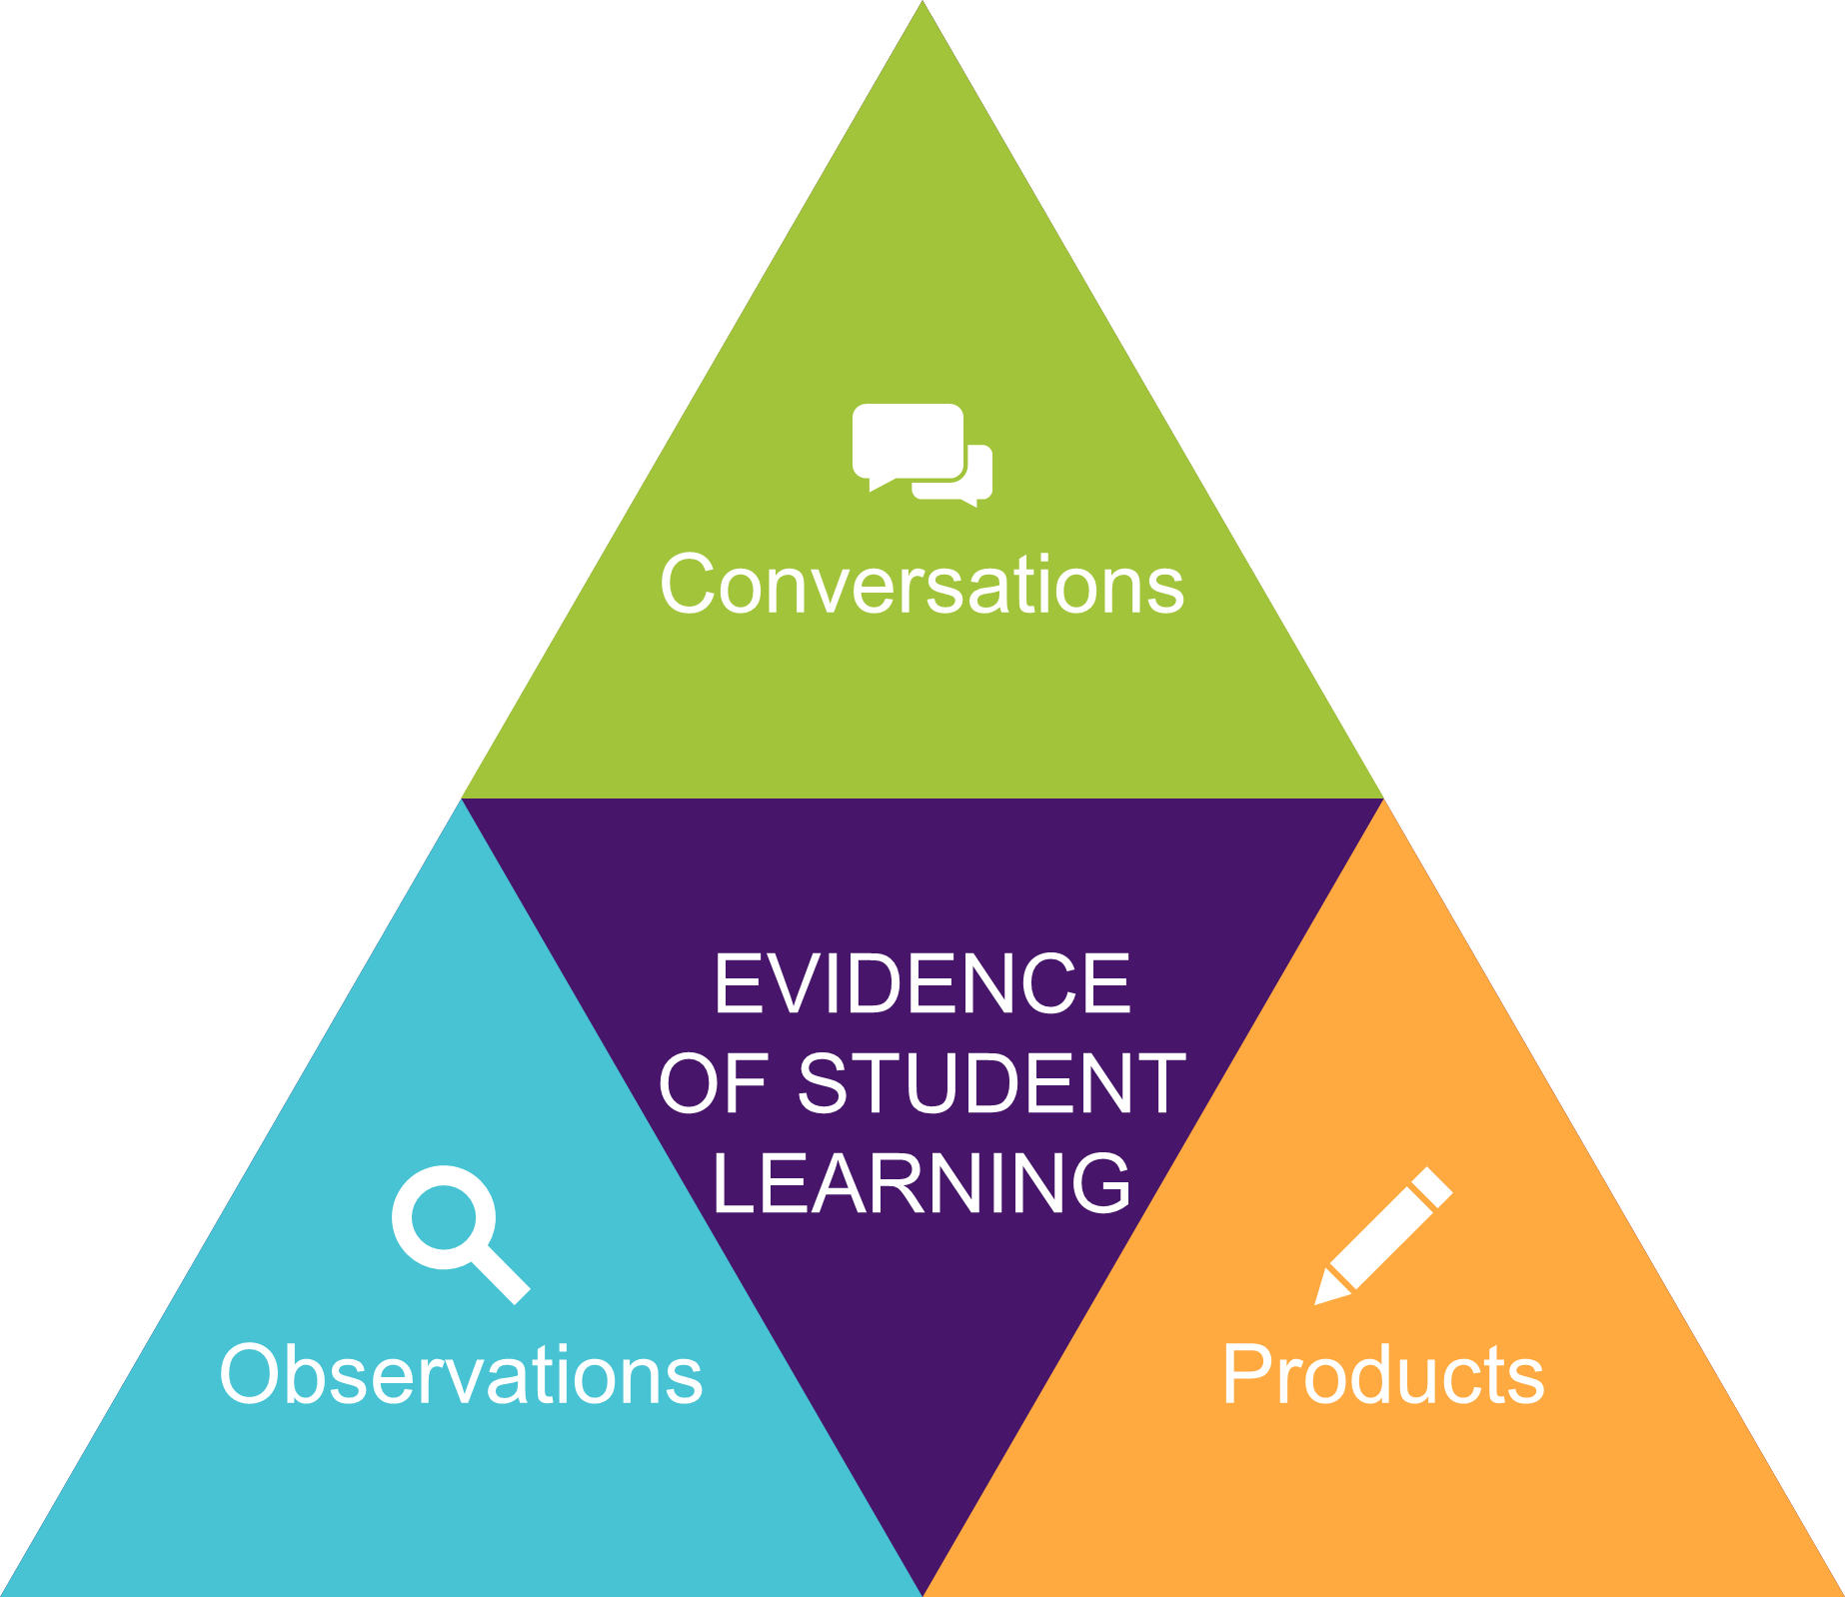
Your teacher is interested in observing the improvements and learning that take place rather than searching for errors on multiple choice exams.

As a result, you will be asked to demonstrate your learning through conversations, observations, and products. Everything counts,

This is a movement from a points-gathering system of grading to a data-gathering system. When learning is prioritized, assessment must reflect that.

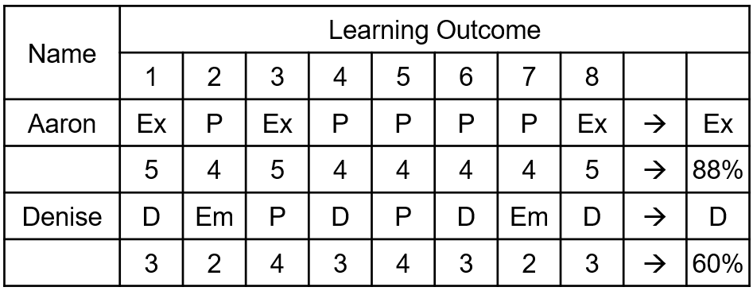
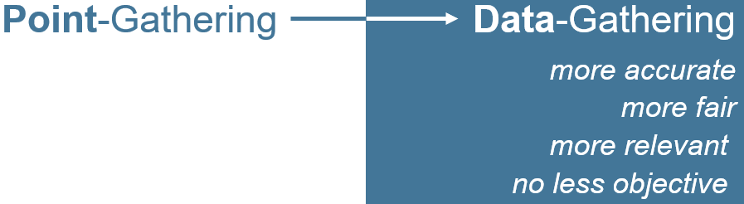

Your teacher will provide immediate, verbal feedback and will use a variety of forms of assessment throughout the course. In addition, each learning opportunity will provide information that will be used while assigning your final grade. All students should be able to meaningfully participate in tasks and make sense of their learning.

Students may not be able to meaningfully participate in activities without having previously discerned key attributes. Tasks might require students to have previously discerned one or more attributes in a given context. Previous learning and experiences will lend meaning and opportunity for students participating in inquiries as they apply what they have learned so far to new situations.

Students will need to engage in dialogue, discern key ideas, and overcome potential frustrations and impediments. Meaningful participation in tasks will alert educators to students who may wish to widen or deepen their understanding of the material and the purposes therein.

Grades will be determined by looking at a student’s overall performance in each content area, taking into account the development of skills throughout the course and the consistency with which a student demonstrates those skills. A final project will provide students with one last opportunity for learning in the last week of class.

