Indirect Measurement
Build a Clinometer
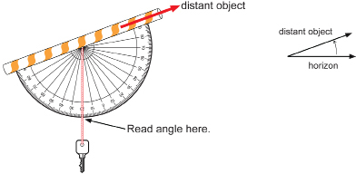

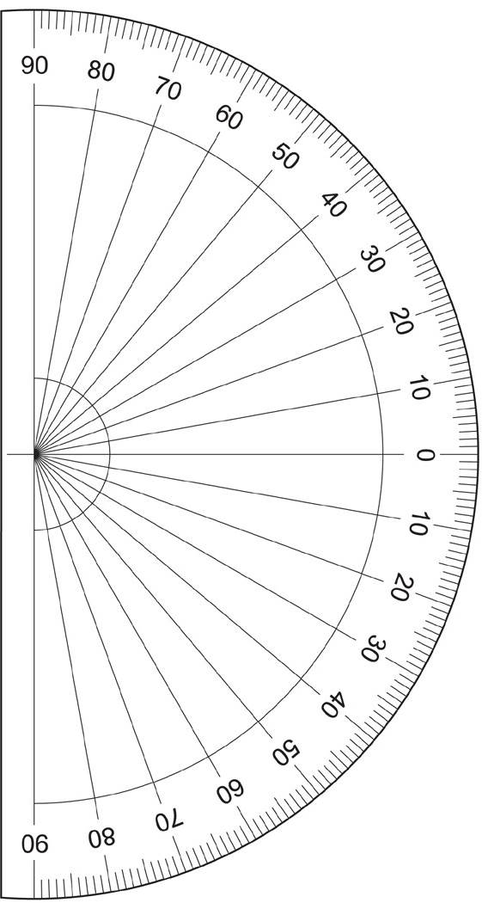

Indirect Measurement
You will need a Clinometer & a Tape Measure

- To determine the height of a basketball hoop.

  - Measure your distance from the basketball.

  - Measure the angle of elevation to the top of the basketball hoop.

  - Label the right triangle.

  - Calculate the height.

- To determine the height of a light standard.

  - Measure your distance from the base.

  - Measure the angle of elevation to the top.

  - Draw and label the right triangle.

  - Calculate the height.

- Determine the height of a tree.

  - Measure your distance from the base.

  - Measure the angle of elevation to the top.

  - Draw and label the right triangle.

  - Calculate the height.

- Determine the height of the school roof.

  - Measure your distance from the building.

  - Measure the angle of elevation to the roofline.

  - Draw and label the right triangle.

  - Calculate the height.

- Determine the height of the totem pole.

  - Measure your distance from the base.

  - Measure the angle of elevation to the top.

  - Draw and label the right triangle.

  - Calculate the height.

