Pythagorean Theorem

For each of the triangles below:

- Begin by sketching the triangle.

- Measure the length of each side.

- Draw a perfect square attached to each side of the triangle.


Draw an ACUTE triangle.

- Calculate the area of the squares.

- Add the Two Small Ones.

- Compare the Sum of the Two Small Ones to the Big One.

Draw an OBTUSE triangle.

- Calculate the area of the squares.

- Add the Two Small Ones.

- Compare the Sum of the Two Small Ones to the Big One.

Draw a RIGHT triangle.

- Calculate the area of the squares.

- Add the Two Small Ones.

- Compare the Sum of the Two Small Ones to the Big One.

Application of Pythagoras (The Small Squares)
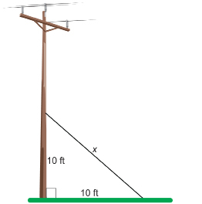
A guy wire supporting a power pole is anchored 10 ft up the pole and, at the ground, 10 ft from the pole. What is the length of the guy wire?

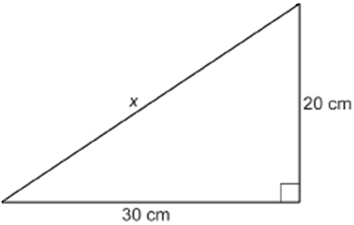What is the longest metal rod that will lie flat on the bottom of a rectangular box 20 cm wide and 30 cm long?

If the legs of a right triangle are 3 cm and 4 cm, what is the length of the hypotenuse?

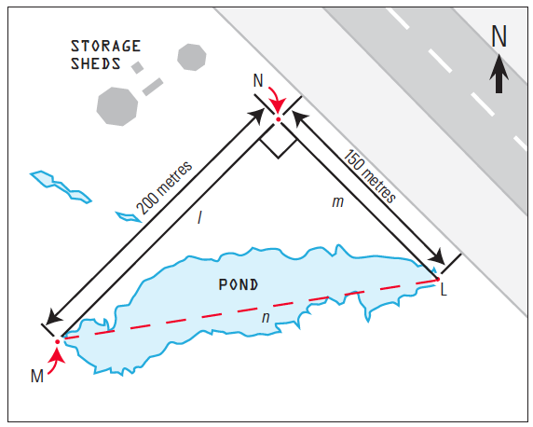

Find the length of the pond.

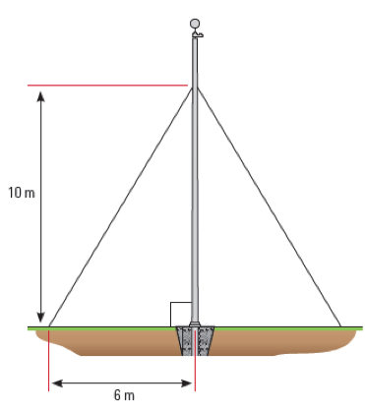
How much guy wire will you need in order to support this pole in the ground?

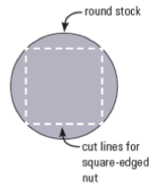
I must cut a square-edged nut from a piece of round stock in his machine technology class. What is the smallest diameter of stock needed if the nut must have a side length of 30 mm?
30 mm

Pythagoras & The Coordinate Plane

- The first dot’s coordinates are (8, 4) and the second dot’s coordinates are (−6,−6). What is the length of the line segment between the two dots?

- The first dot’s coordinates are (-7, 5) and the second dot’s coordinates are (8, -5). What is the length of the line segment between the two dots?

- The first dot’s coordinates are (−3, 7) and the second dot’s coordinates are (3, 10). What is the length of the line segment between the two dots?

- The first dot’s coordinates are (3, 12) and the second dot’s coordinates are (-9, -2). What is the length of the line segment between the two dots?

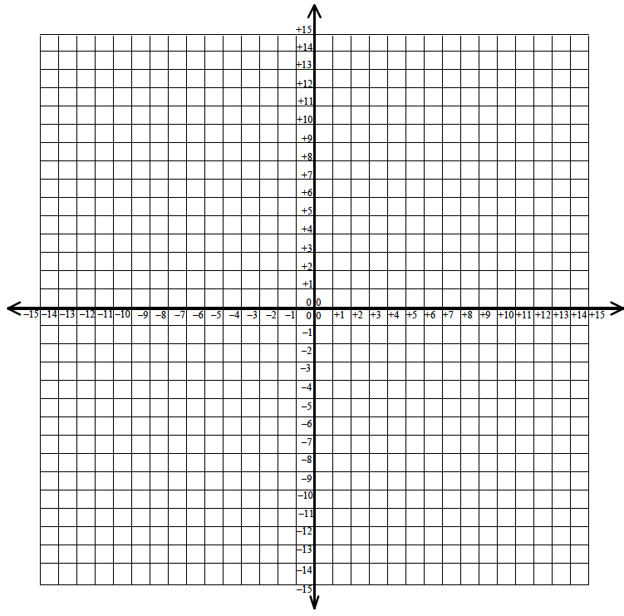

Application of Pythagoras (The Large Square)

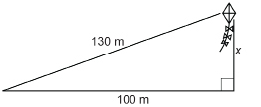
A kite is being flown over a school 100 m away. In reaching this position, 130 m of string has been let out. How high above the ground is the kite?

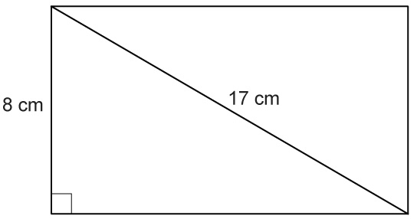
The diagonal of this rectangle is 17 cm long and one leg is 8 cm long. How long is the other side?

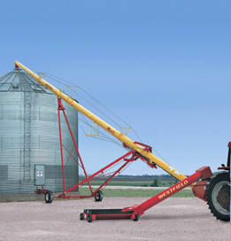
The foot of a 51-ft grain auger is positioned 40 ft from a grain bin. How high is the top of the auger above the ground?

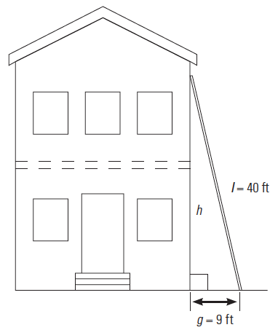

Find how high up the house the ladder reaches.

One of the ziplines at Calgary’s Canada Olympic Park is 500 m in length and has a vertical drop of 100 m. What horizontal distance do riders travel?

Pythagorean Theorem

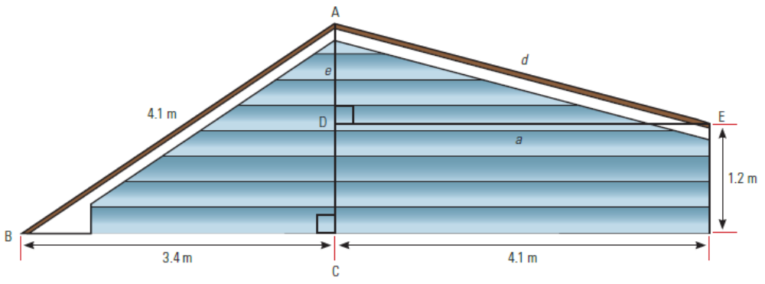
The roof of a shed is offset as in the diagram shown. Ben must determine its measurements so that he can order materials to repair it. How high is the peak (AC)? What is the length of the right-hand side (AE)?

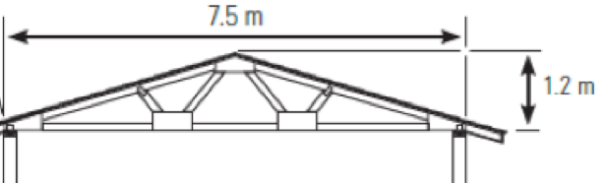
Al has been contracted to build a garage in Prince Albert, Saskatchewan. The garage will be 7.5 m wide and the roof will have a 0.6 m overhang. If the peak of the garage is 1.2 m higher than the walls, how long does the rafter on each side have to be?

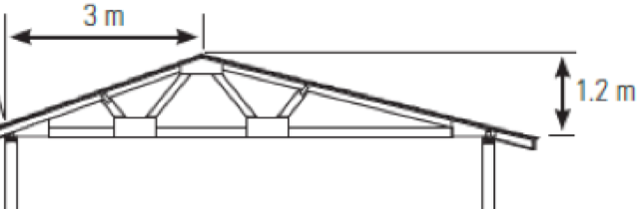
The owner changes his mind and wants the peak to be off-centre. If it is 3 m from one side, how long will Al have to make each of the rafters?

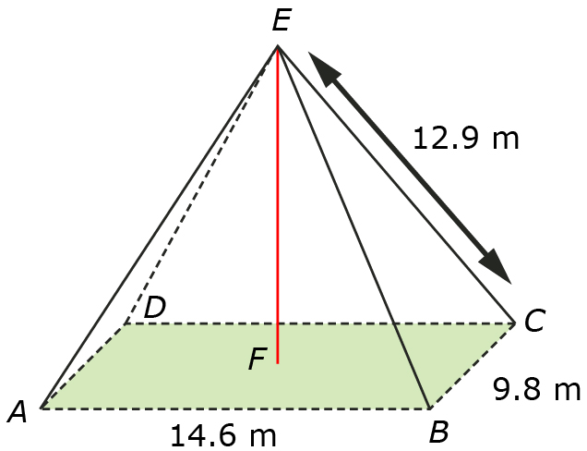
A roof in the shape of a rectangular pyramid is going to be filled with insulation so that heat does not escape through it. The dimensions of the attic are shown in the following diagram. Determine the height, EF, of the attic by answering the following questions.

- Determining the length of AC.
- Find the distance CF.
- Determine the length of EF.

