Pythagorean Puzzles
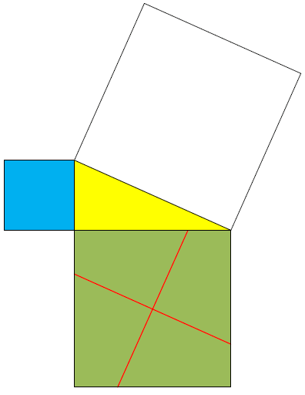
CRITICAL DISERNMENT: The two small squares fit exactly into the big square.
5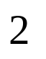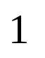
4
2
3
1
Cut out all the small squares. Glue these pieces onto the big square
© Alberta Education. Adapted from: Mathematics 20-3
Learn EveryWare, Module 4. 2011, 2013, 2016. Alberta Education
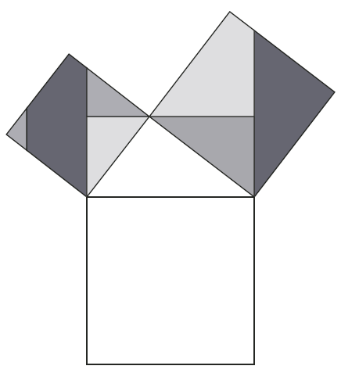
1
4
3
7
6
5
2
Cut out all the small squares. Glue these pieces onto the big square.

© Alberta Education. Adapted from: Mathematics 20-3
Learn EveryWare, Module 4. 2011, 2013, 2016. Alberta Education
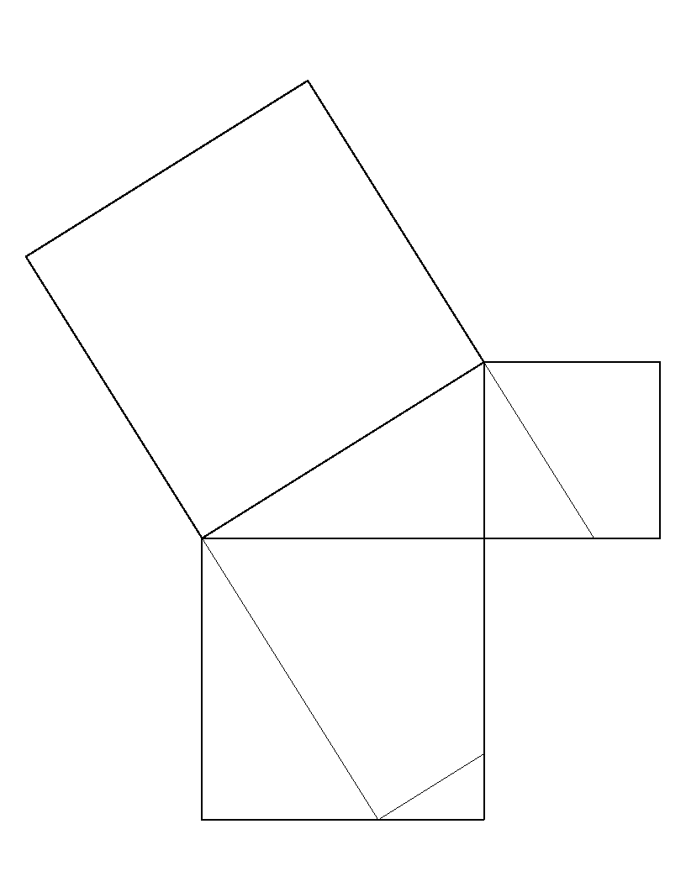
3
5
4
2
1
Cut out all the small squares. Glue these pieces onto the big square.

© Alberta Education. Adapted from: Mathematics 20-3
Learn EveryWare, Module 4. 2011, 2013, 2016. Alberta Education
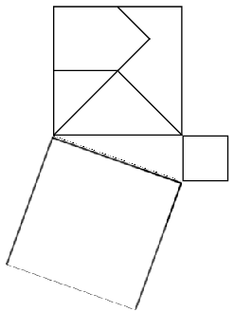

1

4

2
3

5

Cut out all the small squares. Glue these pieces onto the big square.

Cut out all the small squares. Glue these pieces onto the big square.
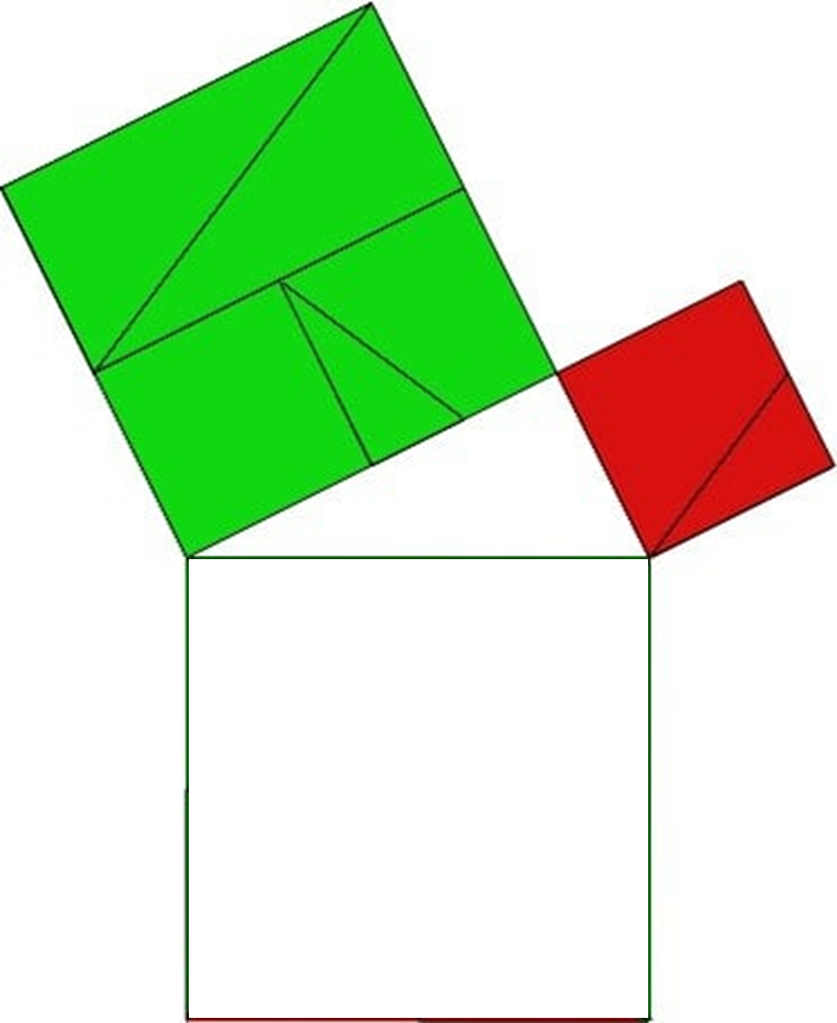
7
6
4
5
2
1
3
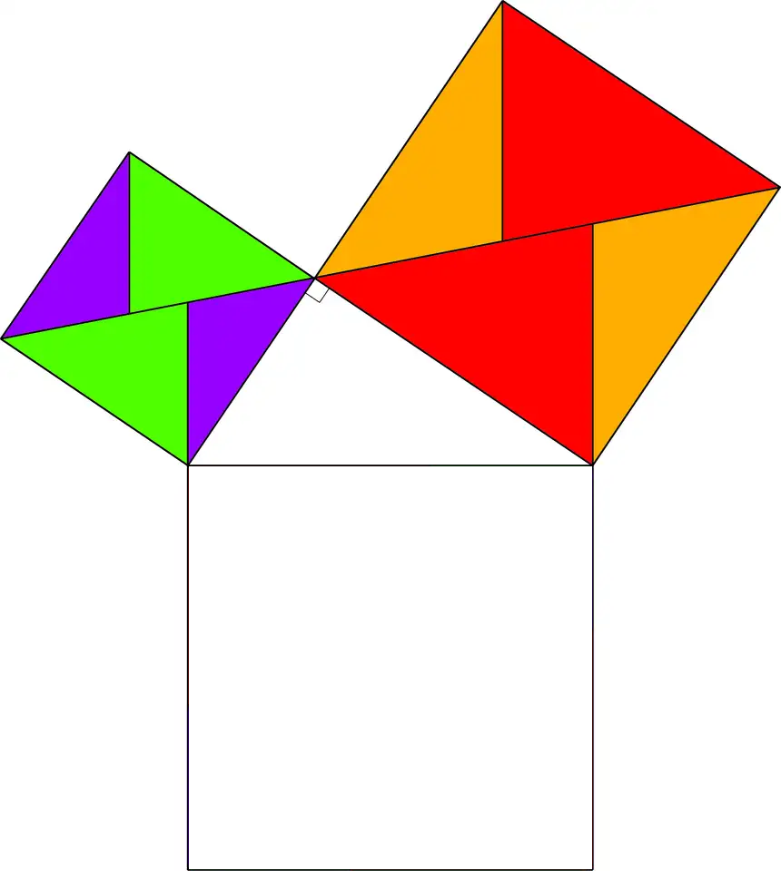

7

5

2
8
1

6
4
3

Cut out all the small squares. Glue these pieces onto the big square.

5
4
2
3
1

© Alberta Education. Adapted from: Mathematics 20-3
Learn EveryWare, Module 4. 2011, 2013, 2016. Alberta Education

1
4
3
7
6
5
2

© Alberta Education. Adapted from: Mathematics 20-3
Learn EveryWare, Module 4. 2011, 2013, 2016. Alberta Education

3
5
4
2
1

© Alberta Education. Adapted from: Mathematics 20-3
Learn EveryWare, Module 4. 2011, 2013, 2016. Alberta Education

5
4
3
2
1

7
6
4
5
2
1
3

7

5

2
8
1

6
4
3

