Trigonometry - Spicy

$\sin{θ= \frac{opposite}{hypotenuse}}$ $\cos{θ= \frac{adjacent}{hypotenuse}}$ $\tan{θ= \frac{opposite}{adjacent}}$

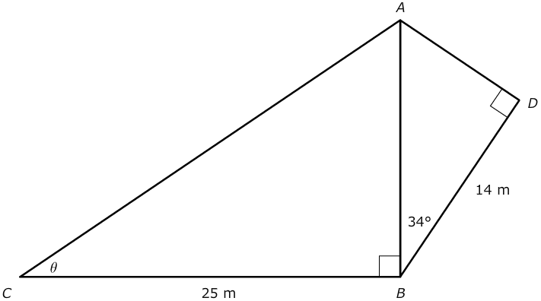
Calculate all of the unknown angles in the following diagra

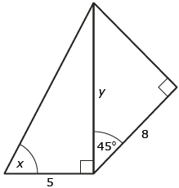
Solve for the unknowns ‘y’ and ‘x’ in the following right-triangle problem.

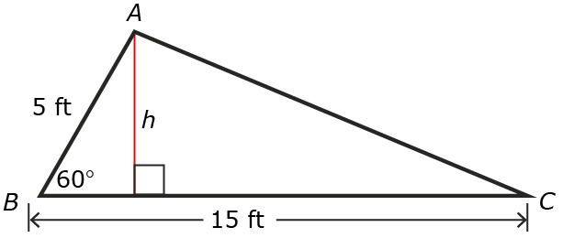
A triangular flower bed, ABC, is shown. What is the length from A to C?

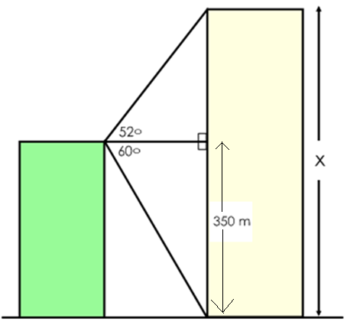
From the top of a 350 m tall building the angle of elevation to the top of another building is 52°. The angle of depression to the bottom of the second building is 60°. How tall is the second building?

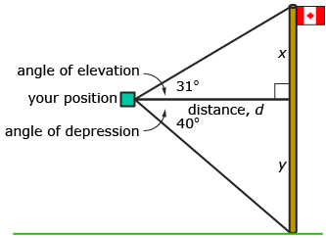
You are given the following diagram showing a flagpole outside a second-storey window. Use the information in the diagram to find the height of the flagpole. Distance d = 20 m.

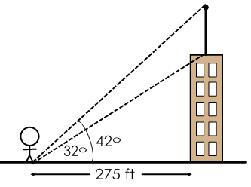
A person is standing 275 feet from the base of a building. The angle of elevation to the base of the tower’s antennae is 32º. The angle of elevation to the top of the antenna is 42º. How tall is the antenna?

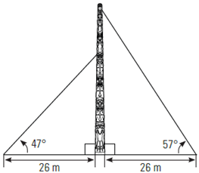
Totem poles are almost always erected by being pulled upright with ropes into a wooden scaffold support until they are stable. How much longer is the longer rope than the smaller rope?

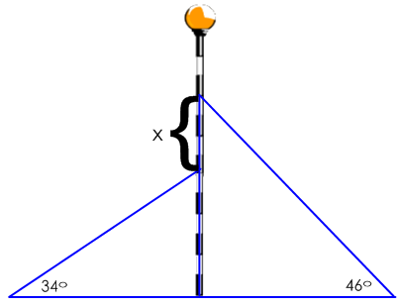
A cell phone tower is supported by two guy wires, each attached to the ground 3 m from the base of the tower. The angles of elevation for each guy wire are 46° and 34°. How much higher up the cell phone tower is the top guy wire attached?

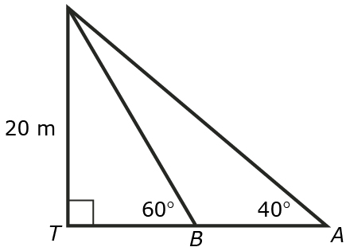
Two people are at points A and B on a straight road. They are approaching a 20 m tall fire tower (T ). The angles of elevation to the top of the tower from the two people are 40º and 60º. How far apart are the people?

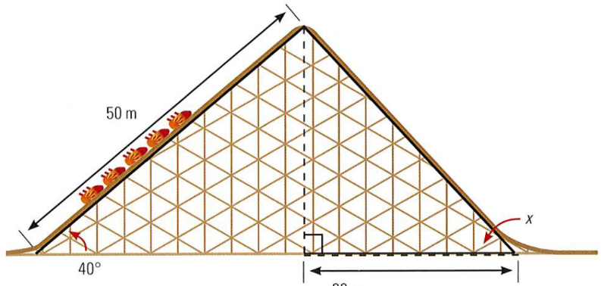
A roller coaster at an amusement park heads upwards at an angle of 40 degrees for 50 meters along the slope, then drops right back to the ground level over a horizontal distance of 30 meters. What is the angle of decent, indicated by x?

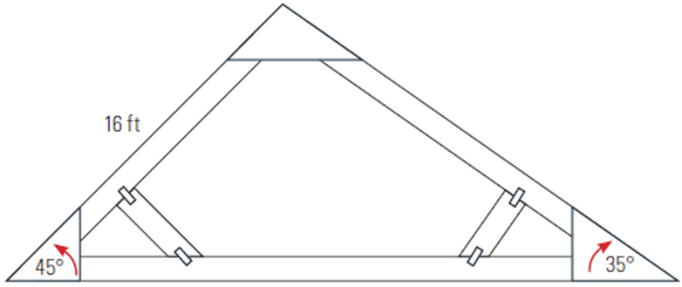
Eugene is building a triangular asymmetric roof truss as shown in the diagram. He wants to know to what length he must cut the base. What is the length of the base of the truss?

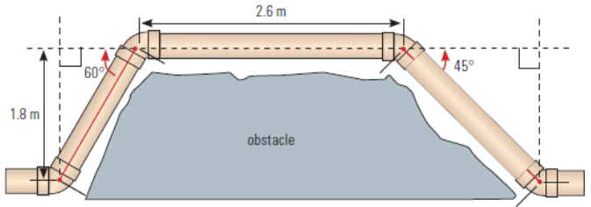How much pipe will be needed in total to get around the obstruction?

