Trigonometry - Medium

$\sin{θ= \frac{opposite}{hypotenuse}}$ $\cos{θ= \frac{adjacent}{hypotenuse}}$ $\tan{θ= \frac{opposite}{adjacent}}$

Determine the measure of the missing length.

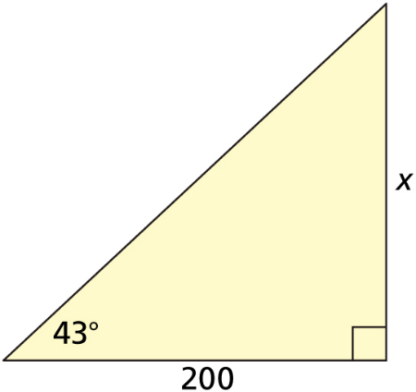
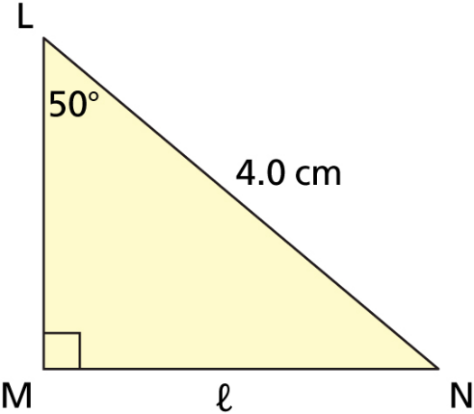
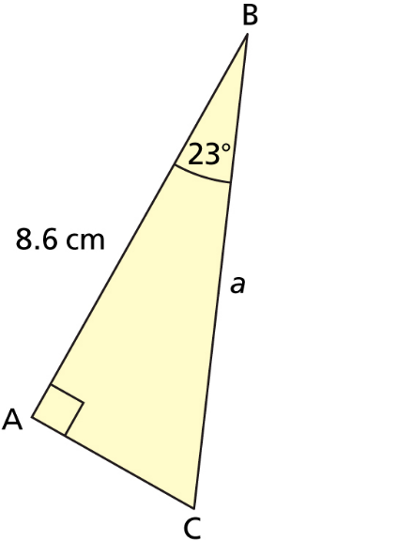

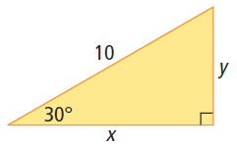
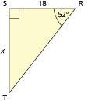
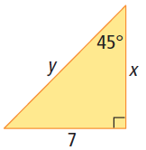

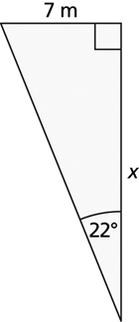

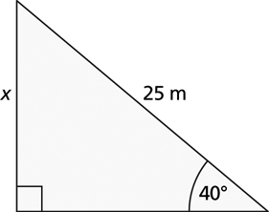
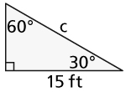

If the kite’s angle of elevation in the photograph is 40°, and the line is 30 m long, how high above the water is the kite?

A javelin point embedded in the ground with 210 cm of the javelin’s length above ground. The end of the javelin sticks 120 cm above the ground. What is the angle the javelin struck the ground at?

A helicopter ambulance is dispatched from the airport to an accident scene 20 km north and 5 km east. What course should the helicopter fly to reach the accident scene directly?

Maxine is building a set of stairs with a $7\frac{1}{2}$-in riser and a 10-in tread. What is the staircase angle? Regulations specify that the angle should not be more than 42°. Is Maxine within specifications?

A guy wire will be used to support a vertical telephone pole. What must the length of the guy wire be if one end is to be attached to the pole at a point 10 ft above the ground and the other end, which is fastened to a stake, is to make a 50° angle with the ground?

If the foot of the ladder were placed 1.5 m from the wall at an angle of 75°, what length of the ladder need to be?

Wheat will form a conical pile with an angle of 25° between the slant side and the horizontal (ground). Suppose a conical pile of wheat is 3 m in height. What is the length of the slant side of the conical pile?

A ship’s navigator sights a lighthouse on the top of a vertical cliff. The light on the top of the lighthouse is 50 m above the sea. The navigator measures the angle of elevation of the light to be 1.5°. If the navigator’s charts say to stay at least 2 km from the foot of the cliff, is the ship safe?

The Broadway Bridge in Portland, Oregon, was constructed in 1913 over the Willamette River, each 42 m half of the bridge raises up to let boats under, it is raised to an angle of 89°. Determine how far the bridge extends out over the water when it is raised.

A ramp 10 ft long is used to load items from the ground to a truck flatbed 3 ft above the ground. To the nearest degree, what angle does the ramp make with the ground?

From the jungle canopy of Costa Rica to the Yukon Territory, zip lining is becoming a very popular activity. How long must a zip line be to carry people a horizontal distance of 250 m if the angle of depression from the upper platform to the end of the line is 5°?

An airplane being flown at a vertical height of 100 m is approaching the runway of the local airport. From the cockpit, the angle of depression to the start of the runway is 5°. Calculate the horizontal distance between the plane and the start of the runway.

A 15 m ladder is placed against the side of an apartment and reaches a windowsill that is 12 m above the ground. What is the angle of elevation of the ladder?

A telephone is diagonally braced by a piece of timber 6.8 feet long. The angle between the pole and the timber is 34°. How high up the pole does the timber reach?

A flagpole casts a shadow 12 m long when the angle of elevation of the sun is 40°. How tall is the flagpole?

