Trigonometry – Mild

The Sine Ratio

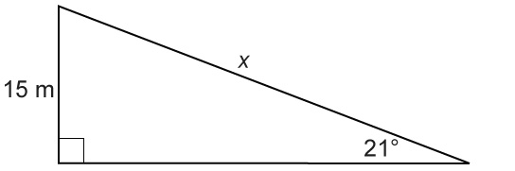
Determine the value of x.

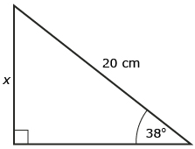

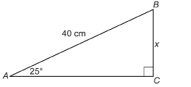

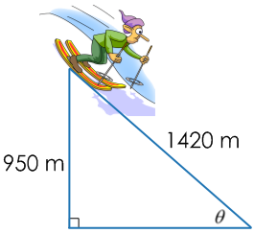

A downhill skier is traversing a steep slope. If this section of the 1420 m ski slope has a vertical drop of 950 m, what is the angle of elevation of the slope?

An electrician must bend a length of metal conduit to go around an obstacle. If the vertical offset must be 40 cm to avoid the obstacle, what will be the length of conduit between bends?
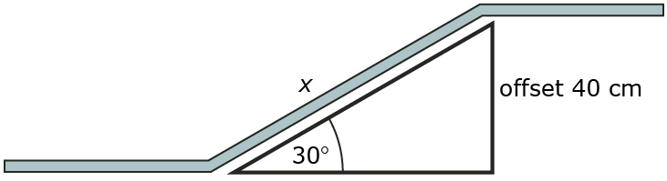

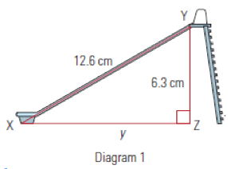
At what angle does the slide descend?

The Cosine Ratio

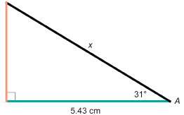
Determine the value of x.
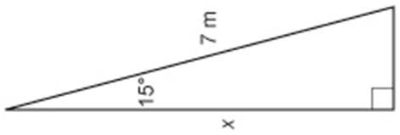

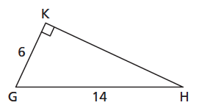
Determine the value of the angles.

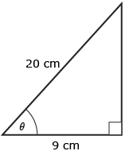

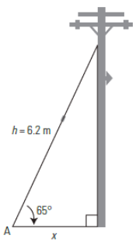
How far from the base of a pole must a 6.2 m long guy wire be attached if the angle of elevation is 65°?

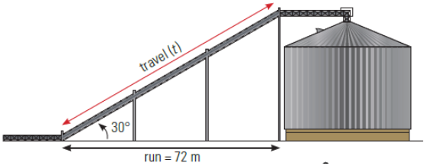
The angle of elevation between a grain auger and the granary to which it is to be connected is 30°. If the run is 72 m, how long must the travel pipe be?

The Tangent Ratio

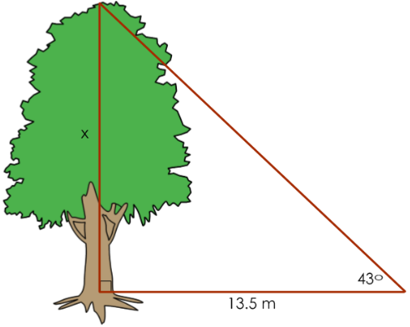
A tree casts a shadow that is 13.5 m long and the angle of elevation to the sun is 43°. How tall is the tree?

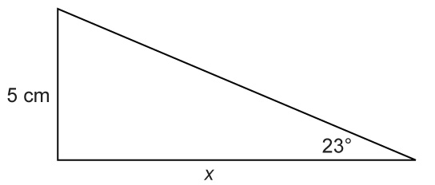
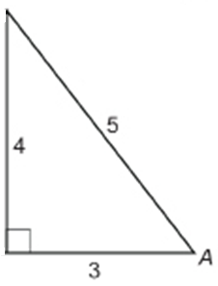Determine the value of x.

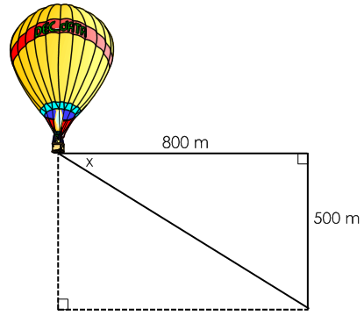

You are in a hot air balloon that is floating 500 m above Eagle Butte High School. At what angle of depression would you be looking if you were looking at a point on the ground that is 800 m horizontally from the balloon?

An airplane flying at an altitude of 1000 m is headed towards the North Battleford airport. If the angle of depression is 3°, how far is the plane from the airport?

1000 ft

Mixed Trigonometric Ratios

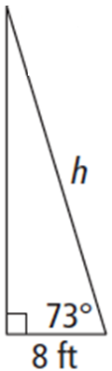
Natalie is rock climbing and Aaron is belaying. When Aaron pulls the rope taut to the ground, the angle of depression is 73°. If Aaron is standing 8 ft from the wall, what length of rope is off the ground?

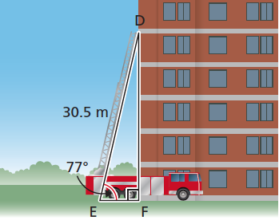
A fire truck has an aerial ladder that extends 30.5 m measured from the ground. The angle of inclination of the ladder is 77°. How far up the wall of an apartment building can the ladder reach?

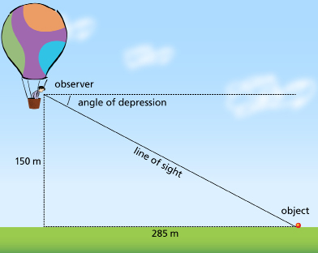

What is the angle of depression of the person’s line of sight 150 m up and 285 m to the object on the ground?

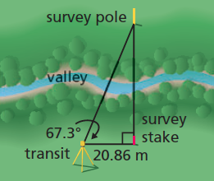
A surveyor made the measurements shown in the diagram. How could the surveyor determine the distance from the transit to the survey pole?

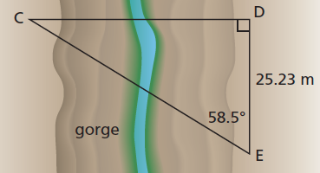
A surveyor makes the measurements shown in the diagram to determine the distance from C to E across a gorge. What is the distance from C to E?

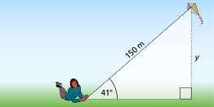

A kite has a string 150-m long. If the string makes an angle of 41° with the ground, find the height of the kite above the ground.

