Trigonometry - Introduction

The Tangent Ratio

CRITICAL DISCERNMENT: Scaling the value of the tangent ratio, $\tan{θ}=\frac{opposite}{adjacent}$, can be used to indirectly measure lengths.

A triangle represented by a tangent ratio of $\tan{θ}=\frac{opposite}{adjacent}$ is shown. Find the length of x.
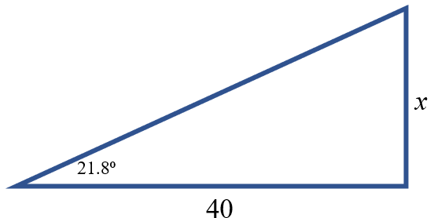

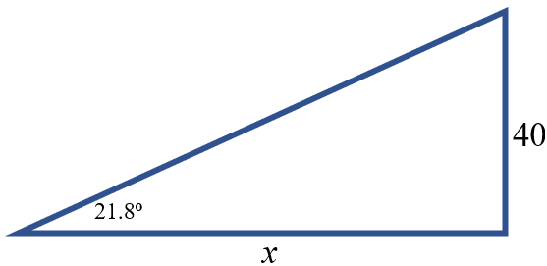

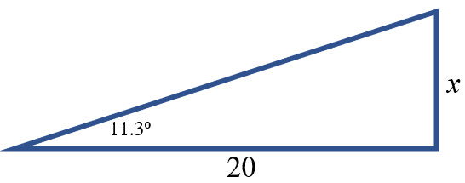
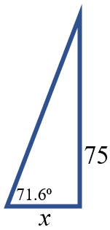

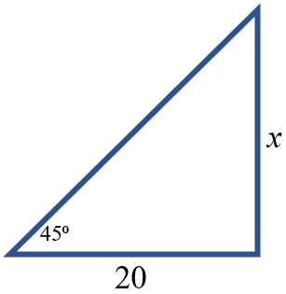

The Sine Ratio

CRITICAL DISCERNMENT: Scaling the value of the sine ratio, $\sin{θ}=\frac{opposite}{hypotenuse}$, can be used to indirectly measure lengths.

A triangle represented by a sine ratio of $\sin{θ}=\frac{opposite}{hypotenuse}$ is shown below. Find the length of x.
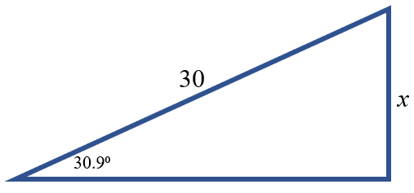

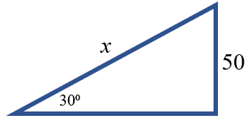

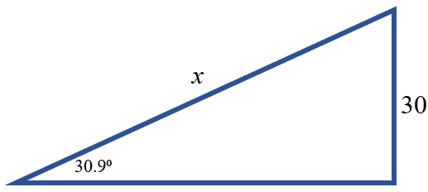
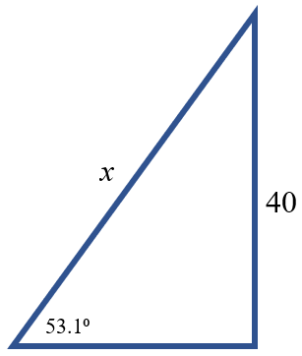
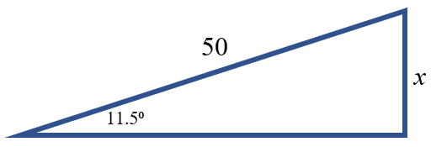
The Cosine Ratio

CRITICAL DISCERNMENT: Scaling the value of the cosine ratio, $\cos{θ}=\frac{adjacent}{hypotenuse}$, can be used to indirectly measure lengths.

A triangle represented by a cosine ratio of $\cos{θ}=\frac{adjacent}{hypotenuse}$ is shown below. Find the length of x.
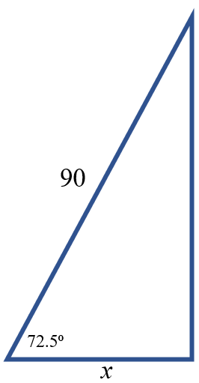
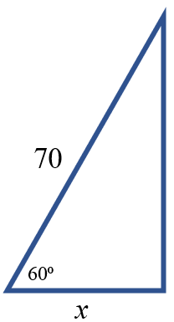
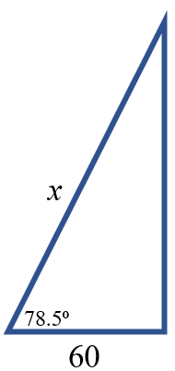
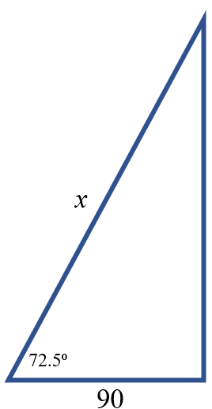
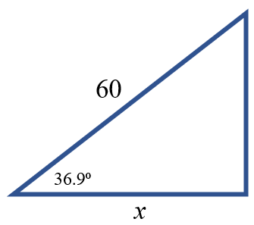
Trigonometric Ratios

$\sin^{-1}\left(\frac{opposite}{hypotenuse}\right)=θ$ $\cos^{-1}\left(\frac{adjacent}{hypotenuse}\right){=θ }$ $\tan^{-1}\left(\frac{opposite}{adjacent}\right)=θ$

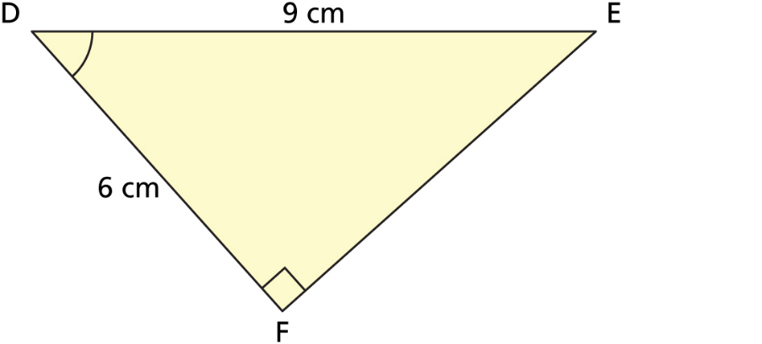
Determine the measure of the marked angle.

