Create a Pythagorean spiral.

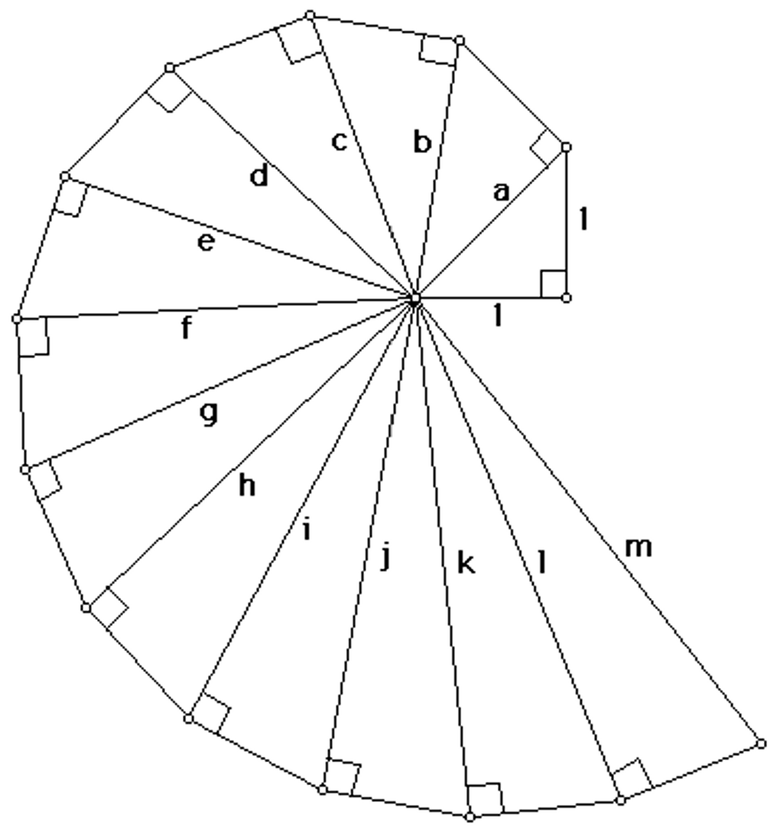
- Start by drawing a right-angle triangle with a base of$1 \text{inch }$and a height of$1 \text{inch}$.

- Use the Pythagorean theorem to calculate the exact length of the hypotenuse. Label the hypotenuse ‘a’ with your answer.

- At the end of the hypotenuse ‘a’, draw a new line segment exactly$1 \text{inch }$long and perpendicular to the hypotenuse.

- Use hypotenuse ‘a’ and the new$1 \text{inch }$side as the legs of your next right triangle. Use the Pythagorean theorem to calculate the exact length of the new hypotenuse ‘b’.

- Continue until you have constructed and labelled all of the triangles shown in the example.
For each new triangle:
  - draw a$1 \text{inch }$side perpendicular to the previous hypotenuse,
  - calculate the exact length of the new hypotenuse,
  - label the hypotenuse with your answer.

After you have completed the Pythagorean Spiral:

Use your completed Pythagorean spiral to locate each radical on a number line.

- Draw a number line using$1 \text{inch}$ as one unit. Mark the whole numbers from$0$ to$4$.

- Measure the length of the first hypotenuse,$\sqrt{2}$, on your spiral.

- Transfer that length to the number line and mark its exact location. Label it$\sqrt{2}$.

- Repeat this process using each hypotenuse from your spiral.

- Continue until every radical from your spiral has been placed on the number line.

- Check your work. Some radicals, such as$\sqrt{4}$ and$\sqrt{9}$, should land exactly on whole numbers.

Like this, but actual measurements.
$$\sqrt{3}$$
$$\sqrt{2}$$
1
2
3
4
0

The Pythagorean Theorem & Radicals

$$\sqrt{a^{2}+b^{2}}=c$$

- Draw a right angle triangle with a base of 2 cm and a height of 3 cm. Then, find the length of the hypotenuse in radical form.

- Draw and label a right triangle whose hypotenuse is exactly$\sqrt{34} \text{cm}$. Both legs must have whole-number lengths.

- Draw and label a right triangle whose hypotenuse is exactly$\sqrt{58} \text{cm}$.

- Draw and label a right triangle whose hypotenuse is exactly$\sqrt{97} \text{cm}$.

- Draw and label a right triangle whose hypotenuse is exactly$\sqrt{153} \text{cm}$.

- There are two different right triangles with whole-number legs whose hypotenuse is$\sqrt{85} \text{cm}$. Find both.

- There are two different right triangles with whole-number legs whose hypotenuse is$\sqrt{130} \text{cm}$. Find both.

- Find two different right triangles with whole-number legs whose hypotenuse is$\sqrt{250} \text{cm}$.

- A student claims they can make a right triangle with whole-number legs and a hypotenuse of$\sqrt{30} \text{cm}$. Determine whether this is possible. Explain your reasoning.

- Draw a right angle triangle with a base of$\sqrt{2}$cm and a height of 3 cm. Then, find the length of the hypotenuse in radical form.

- Draw a right angle triangle with a base of 4 cm and a height of$\sqrt{13}$cm. Then, find the length of the hypotenuse in radical form.

- Draw a right angle triangle with a base of$\sqrt{7}$cm and a height of$\sqrt{3}$cm. Then, find the length of the hypotenuse in radical form.

- Draw a right angle triangle with a base of$\sqrt{8}$cm and a height of$\sqrt{5}$cm. Then, find the length of the hypotenuse in radical form.

- Draw a right angle triangle with a base of$\sqrt{10}$cm and a height of$\sqrt{4}$cm. Then, find the length of the hypotenuse in radical form.

