Trigonometric Scale
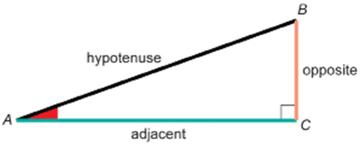

$\sin{θ= \frac{opposite}{hypotenuse}}$ $\cos{θ= \frac{adjacent}{hypotenuse}}$ $\tan{θ= \frac{opposite}{adjacent}}$

Draw 2 right triangles with a reference angle of 15$°$. Make one LARGE and one small.
LARGE TRIANGLE
small triangle
Draw 2 right triangles with a reference angle of 35$°$. Make one LARGE and one small.
LARGE TRIANGLE
small triangle
Draw 2 right triangles with a reference angle of 45$°$. Make one LARGE and one small.
LARGE TRIANGLE
small triangle
Draw 2 right triangles with a reference angle of 60$°$. Make one LARGE and one small.
LARGE TRIANGLE
small triangle
Draw 2 right triangles with a reference angle of 80$°$. Make one LARGE and one small.
LARGE TRIANGLE
small triangle

Reflection

- When you made your triangles bigger or smaller, did the sine, cosine, and tangent values change? What did you notice about the numbers when the size changed?

- What does this tell you about how the trigonometric ratios are connected to the angle? Do the ratios depend on the angle or on the size of the triangle?

- Why do both the big and small triangles for the same angle give almost the same results? What’s going on with the sides of those triangles that makes this happen?

- What do you think is the main reason the ratios stay the same even though the triangles are different sizes? Try to explain it in your own words.

- Can you think of a real-life situation where it’s helpful that these ratios don’t change with size? For example, how might builders, pilots, or surveyors use this idea?

- Which part of this activity helped you best understand what a ratio actually means? What made the idea of a ratio click for you?

The Reference Angle

Identify the opposite and adjacent sides in the following triangles if x is the reference angle.

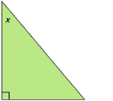

Is the adjacent side always the bottom side? Which side is it?

Why do you think x called the reference angle?

Trigonometric Ratios
- Circle the Reference Angle.
- Label all three sides of the triangle: Opposite, Hypotenuse, Adjacent
- Provide the three trigonometric ratios:

$\sin{θ= \frac{opposite}{hypotenuse}}$ $\cos{θ= \frac{adjacent}{hypotenuse}}$ $\tan{θ= \frac{opposite}{adjacent}}$

CALCULATE each trigonometric ratio.
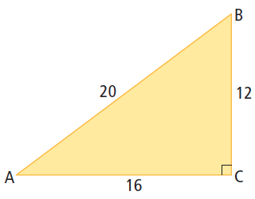
sin B

cos B

tan B

CALCULATE each trigonometric ratio.

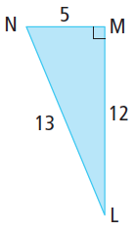
sin L

cos L

tan L

CALCULATE each trigonometric ratio.

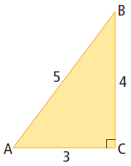
sin A

cos A

tan A

CALCULATE each trigonometric ratio.

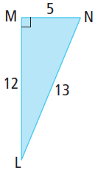
sin N

cos N

tan N

CALCULATE each trigonometric ratio.

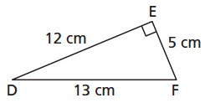
sin D

cos D

tan D

CALCULATE each trigonometric ratio.

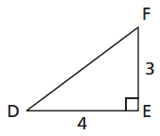
sin D

5
cos D

tan D

