Formula Sheet – Pre-Calculus 10

Trigonometry

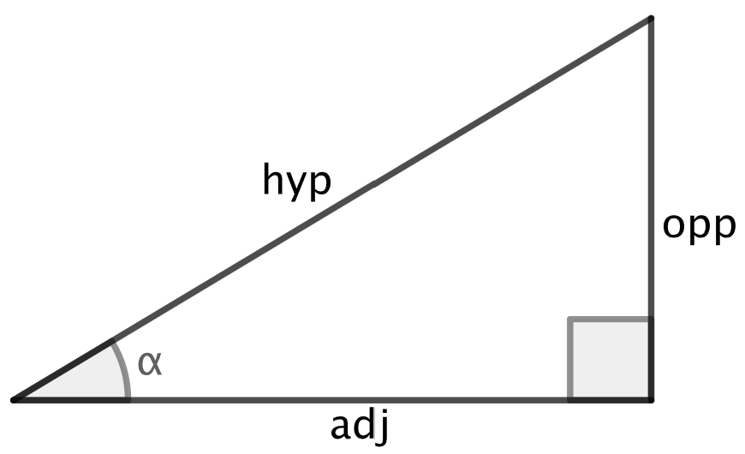
Calculator must be in DEGREE mode

Right Triangles
$$a^{2}+b^{2}=c^{2}$$

Right Triangle Ratios

$\sin{θ}=\frac{o}{h}$ $\cos{θ}=\frac{a}{h}$ $\tan{θ}=\frac{\sin{θ}}{\cos{θ}}$ $\text{area}=\frac{1}{2}bh$ SOH-CAH-TOA

Arithmetic Sequences & Linear Functions

Arithmetic Sequences

$$t_{n}=t_{1}+d(n-1)$$

$$S_{n}=\frac{n(t_{1}+t_{n})}{2}$$

$$S_{n}=\frac{n(2t_{1}+d(n-1))}{2}$$

Calculating Slope

$$m=\frac{rise}{run}=\frac{y_{2}-y_{1}}{x_{2}-x_{1}}$$

y-intercept Form
$$y=mx+b$$

Sketching Method:
- Identify the slope $m$ and the y-intercept $b$.
- Plot the y-intercept at $\left(0 , b\right)$.
- Use the slope $m=\frac{rise}{run}$ to plot a second point.
- Draw the line through the points.
Slope-Point Form
$$y-y_{1}=m(x-x_{1})$$

Sketching Method:
- Identify the point $\left(x_{1} , y_{1}\right)$ and the slope $m$.
- Plot the point on the graph.
- Use the slope $m=\frac{rise}{run}$ to plot a second point.
- Draw the line through the points.

General Form
$$Ax+By=C$$

Sketching Method:
- Find the y-intercept: set $x=0$ and calculate $y$.
- Find the x-intercept: set $y=0$ and solve for $x$.
- Plot both intercepts.
- Draw the line connecting them

Exponents

Radical Properties

$$\sqrt{ab}=\sqrt{a}\sqrt{b}$$

$$\sqrt{\frac{a}{b}}=\frac{\sqrt{a}}{\sqrt{b}}$$

$$a\sqrt{b}=\sqrt{a^{2}b}$$

Laws of Exponents

$a^{x}a^{y}=a^{x+y}$

$$\frac{a^{m}}{a^{n}}=a^{m-n}$$

$${\left(a^{m}\right)}^{n}=a^{mn}$$

$$a^{y}b^{y}={\left(ab\right)}^{y}$$

Interest

$$I=Prt$$

$$A=P{\left(1 + \frac{r}{n}\right)}^{nt}$$

Quadratic Functions

General Form

$$y=ax^{2}+bx+c$$

Sketching Method
- Find the axis of symmetry using $x=-\frac{b}{2a}$
- Find the vertex by substituting the axis of symmetry value into the equation.
- Find the y-intercept: set $x=0$ and calculate.

Factored Form

$$y=a(x-r_{1})(x-r_{2})$$

Sketching Method
- Identify the x-intercepts by solving for x in each of the binomials.
- Find the axis of symmetry by averaging the intercepts, the middle of the x-intercepts.
- Find the vertex by substituting the axis of symmetry value into the equation.

Common Angle Relationships

Triangle Angle Sum

$$∠A+∠B+∠C={180}^{∘}$$
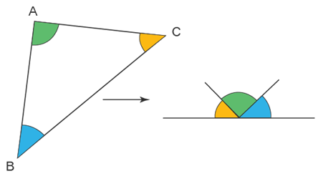

Complementary Angles

$$A+B={90}^{∘}$$
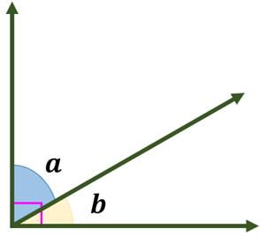

Supplementary Angles

$$A+B={180}^{∘}$$
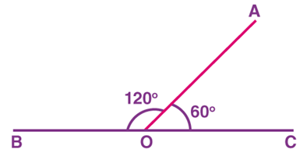

Straight Angles

$$\text{Straight angle}={180}^{∘}$$
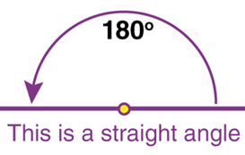

Vertically Opposite Angles

$$∠A=∠B$$
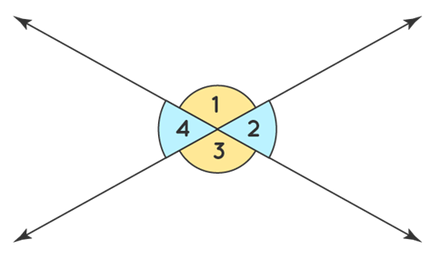

Corresponding Angles

$$∠A=∠B$$
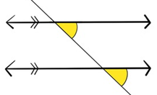

Alternate Interior Angles

$$∠A=∠B$$
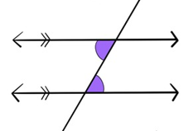

Co-Interior Angles

$$∠A+∠B={180}^{∘}$$
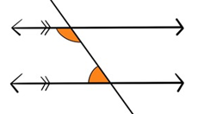

Alternate Exterior Angles

$$∠A=∠B$$
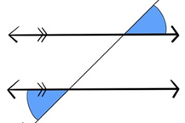

Co-Exterior Angles

$$∠A+∠B={180}^{∘}$$
