

Pre-calculus 11

Curriculum Overview

Education for the 21st Century

British Columbia has one of the best education systems in the world. Teachers are skilled, facilities are sound, and students are performing near the top of international assessments. Yet it is an education system modelled on the very different circumstances of an earlier century — when change was much more gradual than it is today. Conditions in the world are changing greatly and rapidly. Today’s students will grow into a world that is very different from and more connected than that of generations before.

To maintain high achievement, British Columbia must transform its education system to one that better engages students in their own learning and fosters the skills and competencies students will need to succeed. One focus for this transformation is a curriculum that enables and supports increasingly personalized learning, through quality teaching and learning, flexibility and choice, and high standards.

To guide the transformation, the province conducted reviews of trends in national and international jurisdictions and invited authorities on curriculum and assessment design to advise on proposed changes. In addition, as part of the work on core competencies, several commissioned researchers summarized the literature in critical thinking, creative thinking, and social and personal responsibility.

Student success through curriculum transformation

Today we live in a state of constant change. It is a technology-rich world, where communication is instant and information is immediately accessible. The way we interact with each other personally, socially, and at work has changed forever. Knowledge is growing at exponential rates in many domains, creating new information and possibilities. This is the world our students are entering.

British Columbia’s curriculum is being redesigned to respond to this demanding world our students are entering, To develop new models, we consulted with experts in the field. They suggested that to prepare students for the future, the curriculum must be learner-centred and flexible and maintain a focus on literacy and numeracy, while supporting deeper learning through concept- based and competency-driven approaches.

The redesign of curriculum maintains a focus on sound foundations of literacy and numeracy while supporting the development of citizens who are competent thinkers and communicators, and who are personally and socially competent in all areas of their lives. British Columbia’s redesigned curriculum honours the ways in which students think, learn, and grow, and prepares them for a successful lifetime of learning where ongoing change is constant.

The educated citizen

“A quality education system assists in the development of human potential and improves the well-being of each individual person in British Columbia society.” These words, along with the description of the educated citizen, became educational policy following the report of the Royal Commission on Education (known as the Sullivan Commission), in 1988. They continue to have meaning today.

Achieving British Columbia’s social and economic goals requires well-educated citizens who are able to think critically and creatively and adapt to change. Progress toward the achievement of these goals also depends on the province having citizens who accept the tolerant and multifaceted nature of Canadian society and who are motivated to participate actively in our democratic institutions.

To ensure the development of an educated society, government is responsible for providing all youth with the opportunity to obtain high-quality education. To that end, British Columbia’s schools assist in developing citizens who:

- Are thoughtful and able to learn and to think critically, and can communicate

- Information from a broad knowledge base

- Are creative, flexible, and self-motivated and have a positive self-image

- Are capable of making independent decisions

- Are skilled and able to contribute to society generally, including the world of work

- Are productive, gain satisfaction through achievement, and strive for physical well-being

- Are co-operative, principled, and respectful of others regardless of differences

- Are aware of the rights of the individual and are prepared to exercise the responsibilities of the individual within the family, the community, Canada, and the world

The redesigned curriculum captures these qualities, both implicitly and explicitly, in the core and curricular competencies. The concept of the educated citizen will continue to guide educational decisions for years to come, ensuring that students across the province are supported and that future generations of British Columbians are empowered by their school experience.

Personalized learning

Personalized learning acknowledges that not all students learn successfully at the same rate, in the same learning environment, and in the same ways. It involves the provision of high-quality and engaging learning opportunities that meet the diverse needs of all students. Schools may provide flexible timing and pacing through a range of learning environments, with learning supports and services tailored to meet student needs.

Personalized learning focuses on enhancing student engagement in learning and giving students choices — more of a say in what and how they learn — leading to lifelong, self-directed learning. Students and teachers develop learning plans to build on student’s interests, goals, and learning needs. Involving students in reflecting on their work and setting new goals based on their reflections allows them to take more control of their learning. Personalized learning also encompasses place-based learning, where learning experiences are adapted to the local environment or an individual context.

Key features of BC's Curriculum

At the heart of British Columbia’s redesigned curriculum are the Core Competencies, essential learning and literacy and numeracy foundations. All three features contribute to deeper learning.

Core competencies

Core Competencies underpin the curricular competencies in all areas of learning. They are directly related to the educated citizen and as such are what we value for all students in the system.

- Review the Core Competencies, including profiles and illustrations

Essential learning

The curriculum for each subject area includes the essential learning for students, which represent society’s aspirations for B.C’s educated citizen. The redesigned curriculum develops around key content, concepts, skills and big ideas that foster the higher-order thinking demanded in today’s world.

Literacy and numeracy foundations

Literacy is the ability to understand, critically analyze, and create a variety of forms of communication, including oral, written, visual, digital, and multimedia, in order to accomplish one’s goals.

Numeracy Is the ability to understand and apply mathematical concepts, processes, and skills to solve problems in a variety of contexts.

Literacy and numeracy are fundamental to all learning. While they are commonly associated with language learning and mathematics, literacy and numeracy are applied in all areas of learning.

Curriculum model

All areas of learning are based on a “Know-Do-Understand” model to support a concept-based competency-driven approach to learning.

Three elements, the Content (Know), Curricular Competencies (Do), and Big Ideas (Understand) all work together to support deeper learning.
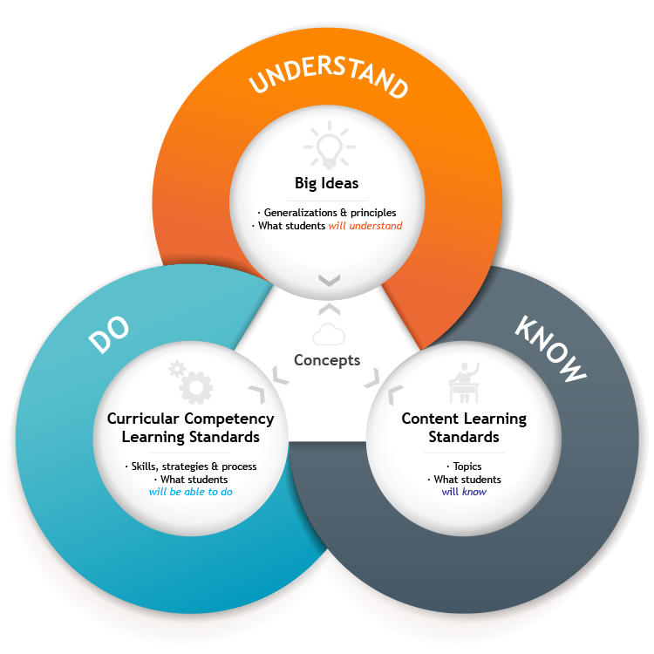

Big Ideas (Understand)

The big ideas consist of generalizations and principles and the key concepts important in an area of learning. They reflect the "understand" component of the know-do-understand model of learning.

The big ideas represent what students will understand at the completion of the curriculum for their grade. They are intended to endure beyond a single grade and contribute to future understanding.

Content (Know)

The content learning standards — the “Know” of the know-do-understand model of learning — detail the essential topics and knowledge at each grade level.

Curricular Competencies (Do)

The curricular competencies are the skills, strategies, and processes that students develop over time. They reflect the "do" in the know-do-understand model of learning. While curricular competencies are more subject-specific, they are connected to the core competencies.
Concept-based, competency-driven curriculum

British Columbia’s redesigned curriculum brings together two features that most educators agree are essential for 21st-century learning: a concept-based approach to learning and a focus on the development of competencies, to foster deeper, more transferable learning. These approaches complement each other because of their common focus on active engagement of students. Deeper learning is better achieved through “doing” than through passive listening or reading. Similarly, both concept-based learning and the development of competencies engage students in authentic tasks that connect learning to the real world.

Concept-based learning

A concept-based curriculum uses concepts to define standards of knowledge and skills associated with a given area of learning. It is focused on the key concepts, principles, and generalizations that are used to organize knowledge and solve problems within and across disciplines.

A concept-based curriculum:

- Is built around higher-order standards and key ideas, allowing a more in-depth exploration of topics to gain deeper understanding

- Balances the study of factual information with the development of conceptual understanding and disciplinary skills

- Offers opportunities for the transfer of learning

- Is not a list of topics to cover in isolation from one another

A concept-based curriculum allows for connections between big ideas — for example, through exploration of the concept of reoccurring patterns and comparison of how patterns appear in literature, geographical features, and the evolution of species.

Competency-driven learning

“Competency” and “competencies” are defined in different ways in different contexts. The terms have their own meanings when used by business and industry, where they generally refer to the skills needed to perform a given job. In the context of education, the terms refer to the ability of students to perform a task as expected within a specific discipline or area of learning. That ability represents a combination of skills, processes, behaviours, and habits of mind. Students are competent in an area of learning to the extent that they understand and can apply knowledge to new contexts.

Competencies are often narrowly equated with skills, but in a 21st-century educational context, competencies represent a much broader and more adaptable achievement than a simple set of skills. The redesigned curriculum defines competencies at two levels: Core Competencies develop across the curriculum, and Curricular Competencies are explicit statements of what is expected at each grade level in each area of learning.

Redesigned curriculum in action

When planning, it is important to begin with a broad understanding of the curriculum being used.

- The rationale and goals provide the context for the area of learning and make clear its contribution to the development of educated citizens

- The rationale and goals provide a broad instructional and assessment context for the area of learning

- The introduction to each area of learning provides specifics about features, structure, and important considerations of the curriculum

The curriculum for each area of learning is displayed in two ways—in HTML format on the website and in PDF or Word formats.

The curriculum website will continue to evolve in ways that support planning for learning. At this point, several features are available such as:

- A search engine to allow teachers to search for key words or select key elements from specific grades or areas of learning

- The results of the search can be exported into a Word document for further manipulation

- PDF or Word versions of the curriculum can be printed

- Some resources for planning are included now and will be further expanded in the future

This flexibility supports teachers to combine the learning standards in various ways. Teachers are encouraged to create courses, modules, thematic units or learning experiences that go beyond learning area borders to focus on students’ needs and interests or local contexts. The curriculum design and the website features provide the flexibility to serve the unique needs of classrooms, students, and teachers.

Flexible learning environments

Learning can take place anywhere, not just in classrooms. Many schools and teachers create learning environments that explore the use of time and space in creative ways. The integration of areas of learning and technology also have opened the door for teachers and schools to approach the use of time and space in creative ways — ways that adapt to the students’ needs and interests.

Although the learning standards are described within areas of learning, there is no requirement for teachers to organize classrooms, schools or instruction in this manner. In effect, we define the “what” to teach but not the “how to organize the time, space or methods to teach it.

The focus on personalization and the flexible structure of the curriculum support the configuration of combined grade classrooms. Classes of students of more than one grade provide opportunities for teachers to develop a mindset that sees all the students as a group of learners with a range of needs and interests. Multi-grade programs should find a comfortable fit with the curriculum.

ICT-enabled learning environments

Students need opportunities to develop the competencies required to use current and emerging technologies effectively in all aspects of their learning and life. Technology can facilitate collaboration between students, educators, parents, and classrooms while also providing schools with rich online resources. Today’s technology enables classrooms, communities, and experts around the world to share digitally in a learning experience, wherever they may be.

Inquiry and question-based approaches

Through demonstration of the core and curricular competencies, students are bound to form questions that provide teachers with insight into their thinking. Questions generated by both students and teachers are critical to encouraging a sense of wonder and curiosity among students. This dialogue can take place through many question-based approaches, including, but not limited to:

- Inquiry

- Project-based learning

- Problem-based learning

- Self-assessment

- Research skills

- Scientific methods

Collaboration with community

Indigenous perspectives and knowledge

British Columbia has long had the goal of improving school success for all Indigenous students. Achieving this goal will require that the voice of Indigenous people be heard in all aspects of the education system; the presence of Indigenous languages, cultures, and histories be increased in provincial curricula; and leadership and informed practice be provided.

At the same time, Indigenous perspectives and knowledge are a part of the historical and contemporary foundation of British Columbia and Canada. British Columbia’s education transformation therefore incorporates the Indigenous voice and perspective by having Indigenous expertise at all levels, ensuring that Indigenous content is a part of the learning journey for all students, and ensuring that the best information guides the work. An important goal in integrating Indigenous perspectives into curricula is to ensure that all learners have opportunities to understand and respect their own cultural heritage as well as that of others.

Over the past decade, British Columbia’s curriculum has integrated Indigenous content into specific courses. The redesigned curriculum builds on what has been learned and extends Indigenous perspectives into the entire learning journey, rather than into specific courses or grade levels. This means that from Kindergarten to graduation, students will experience Indigenous perspectives and knowledge as part of what they are learning. And because Indigenous perspectives and knowledge are embedded in the curriculum, they will naturally influence the ways in which students will be assessed.

The First Peoples Principles of Learning provided a crucial lens for teacher teams when drafting curricula, and all curriculum teams included Indigenous representation. The teams put great effort into embedding Indigenous knowledge and worldviews in curriculum in authentic and meaningful ways. Curriculum material was reviewed by our staff as well as by Indigenous teachers and other experts.

References to Indigenous perspectives and knowledge are both explicit and implicit in the redesigned curriculum and are evident in the rationale statements, goals, learning standards, and some of the elaborations. Rich instructional samples to inspire teaching and learning will be collected and shared online to provide examples of relevant teaching units and place-based learning. In all of the areas of learning, teachers are encouraged to teach in ways that respect the place in which the students are — to teach from within the school and its surrounding community.

Program considerations

Valuing diversity

British Columbia’s schools include young people of varied backgrounds, interests, and abilities. The Kindergarten to grade 12 school system focuses on meeting the needs of all students. When selecting specific topics, activities, and resources to support the implementation of the curriculum, teachers are encouraged to ensure that these choices support inclusion, equity, and accessibility for all students. In particular, teachers should ensure that classroom instruction, assessment, and resources reflect sensitivity to diversity and incorporate positive role portrayals, relevant issues, and themes such as inclusion, respect, and acceptance. This includes diversity in family compositions and gender orientation.

The school system strives to create and maintain conditions that foster success for all students.

These conditions include:

- Equitable access to and equitable participation in quality education for all students

- School cultures that value diversity and respond to the diverse social and academic needs of individual students School cultures that promote understanding of others and respect for all

- School environments that are safe and welcoming

- Policies and practices that promote fair and equitable treatment

- Processes that give a voice to all members of the school community

Honouring diversity within the school system is based on the principle that if our differences are acknowledged and utilized in a positive way, it is of benefit to the quality of our learning and working environments.

Supporting Diverse Learners

B.C educators strive to ensure that all learners are supported to participate in school, to develop their individual potential, and to acquire the knowledge, skills, and attitudes they need for a successful personal future and to contribute positively to society and to the economy. Curriculum used in British Columbia schools remains designed for the majority of students, with classroom teachers continually personalizing their instruction and assessment methods for students as appropriate.

Government policy supports the principles of inclusion of all students. Students with special and/or ELL needs can achieve the prescribed learning standards through the strategic use of personalized instruction and assessment methods.

Some students with special needs may require program adaptation or modification to facilitate their achievement of the learning standards in this curriculum.

Adapted programs

An adapted program addresses the learning standards of the prescribed curriculum by providing accommodations to selected students. These accommodations may include alternative formats for resources, instructional strategies, and assessment procedures.

Accommodations may also be made in areas such as skill sequence, pacing, methodology, materials, technology, equipment, services, and setting. Students on adapted programs are assessed using the learning standards and can receive full credit.

- Digital/audio texts or peer helper to assist with assigned readings

- Access to assistive tools/technology (e.g., word processor, calculator, text to speech/voice to text software, magnifier, FM system etc.)

- Alternative ways of demonstrating learning standards

- Graphic organizers/strategy lists to assist students

- Extended time to complete assignments or tests

- Support to develop and practice study skills; for example, in a learning assistance class

- Preteaching key vocabulary or concepts; multiple exposure to materials

- Working on select learning standards from different grade levels

Modified programs

A modified program has learning standards that are substantially different from the prescribed curriculum and specifically selected to meet the student’s special needs. A student on a modified program is assessed in relation to the goals and objectives established in the student’s IEP.

The following are examples of strategies that may help students on modified programs:

- Specify personal support (by peers or educational assistants, for example)

- Set individualized goals that may consider learning standards but are developed to suit the student’s special needs

- Modify activities by providing parallel ones for students with special needs

Inclusion

British Columbia promotes an inclusive education system in which students with special needs are fully participating members of a community of learners. Inclusion describes the principle that all students are entitled to equitable access to learning, achievement, and the pursuit of excellence in all aspects of their educational programs.

The practice of inclusion is not necessarily synonymous with full integration in regular classrooms, and goes beyond placement to include meaningful participation and the promotion of interaction with others.

Placement

A school board must ensure that a principal offers to consult with a parent or guardian of a child who has special needs regarding the student’s placement in an educational program. A school board must provide a student who has special needs with an educational program in a classroom where the student is integrated with other students who do not have special needs, unless the educational needs of the student with special needs or other students indicate that the educational program for the student with special needs should be provided otherwise.

The emphasis on educating students with special needs in neighbourhood school classrooms with their age and grade peers, however, does not preclude the appropriate use of learning assistance rooms, self-contained classes, community-based programs, or specialized settings. Students with special needs may be placed in settings other than a neighbourhood school classroom with age and grade peers. This should only be done when the school board has made all reasonable efforts to integrate the student, and it is clear that a combination of education in such classes and supplementary support cannot meet the student’s educational or social needs, or when there is clear evidence that partial or full placement in another setting is the only option after considering the student’s educational needs or the educational needs of others.

Integration

Integration is one of the major strategies used to achieve inclusion, Students with special needs are included in educational settings with their peers who do not have special needs, and are provided with the necessary accommodations, determined on an individual basis, to enable them to be successful there. The principle of “placement in the most enabling learning environment” applies when decisions are made about the extent to which an individual student is placed in regular classrooms or is assigned to an alternate placement.

English Language Learning (ELL)/Apprentissage de la langue anglaise (ALS)

People from all parts of the globe contribute to the social, cultural, and linguistic fabric of British Columbia. This diversity is mirrored in our school populations, in both the contributions made and the unique needs that must be addressed. ELL/ALS students come from many linguistic and cultural backgrounds and have had a wide variety of life experiences — attributes that can significantly enrich the life of the school and help enhance learning for all students.

English Language Learning (ELL)/Apprentissage de la langue anglaise (ALS) services enable students whose primary language or languages of the home is/are other than English to achieve the expected learning outcomes of the provincial curriculum and to develop their individual potential within British Columbia’s school system.

Differentiated Instruction

Differentiated Instruction (DI) is a flexible approach to teaching in which a teacher plans and carries out varied approaches to address content, learning processes, learning style, practical procedures, presentation strategies, and assessment tools. It results in a more personal, proactive learning environment, inclusive of a wide variety of learners.

When teachers differentiate instruction, they provide students with the structures to maximize strengths, work around weaknesses, and experience timely remediation. This enables students to take advantage of effective learning strategies as they begin to understand their own personal learning styles, interests, and needs and engage with their learning. As a result, student motivation increases.

Universal Design for Learning

Universal Design for Learning (UDL) is a framework of instructional approaches that recognizes and accommodates varied learning styles. It provides learning activities that expand students’ opportunities for acquiring information and demonstrating learning, as well as for enhancing social participation and inclusion.

The driver for universal design is the philosophy of proactively addressing needs. Universal Design for Learning is integrated into regular instructional planning as a mechanism to make diversity the norm. It provides support for all students and motivates through the element of choice.

Response to Intervention

Response to Intervention (RTI) is a framework for formative assessment that involves collecting data on a regular basis to make instructional decisions in a multi-tier model. RTI is based on the principle of prevention and early intervention. By using ongoing assessment to inform teaching practice and allocate instructional resources, teachers are able to provide appropriate, evidence-based interventions.

Central elements of all RTI models include early screening of all students to identify those at risk for academic difficulties, implementing research-based interventions matched to student need and increasing intensity of intervention when needed. RTI also involves continuous monitoring and recording of student progress during interventions to guide decisions for both the student (e.g., further assessment, individualized planning) and the teacher (e.g., using small-group or one-to-one learning contexts, topics for professional development).

Although RTI originates from special education, it is intended for use with all students in general education.

Personal safety

To ensure a safe learning environment, teachers may consider the following questions before, during, and after instruction:

- Are students aware of established rules and procedures for safety?

- Do students fully understand the instructions?

- Is the activity suitable to each student’s interest, confidence, and ability?

- Has the instruction been sequenced progressively to ensure safety?

- Are students being properly supervised?

- Are facilities, equipment, and technologies suitable and in good repair?

Some areas of learning make use of specific safety guides and manuals. These should be employed to ensure that students and teachers can enjoy safe learning activities at all times.

In addition to physical safety, teachers should consider the emotional safety of students when planning instruction. This includes, but is not limited to:

- Being sensitive to individual students

- Being prepared to respond to unique situations

- Employing creative strategies to deal with rivalry, stress, fear of failure, performance anxiety, and so on

As well, teachers should be mindful of activities that may cause emotional or psychological stress for individual students (e.g., blindfolding, working in closed environments, solo performance, body contact, heterogeneous groupings), and be prepared to offer alternative strategies as needed.

Alternative Delivery policy

The Alternative Delivery policy outlines how students and their parents or guardians, in consultation with their local school authority, may choose means other than instruction by a teacher within the regular classroom setting for addressing the learning standards contained in the health component of the Physical and Health Education curriculum. The Alternative Delivery policy applies only to the health-related learning standards (Note: the policy will be revised in the 2015/16 school year).

The policy recognizes the family as the primary educator in the development of children’s attitudes, standards, and values, but it still requires that all learning standards be addressed and assessed in the agreed-upon alternative manner of delivery.

It is important to note the significance of the term “alternative delivery” as it relates to the Alternative Delivery policy. The policy does not permit schools to omit any of the learning standards within the Physical and Health Education curriculum. Neither does it allow students to be excused from meeting any learning standards related to health. It is expected that students who arrange for alternative delivery will address the health-related learning standards and will be able to demonstrate their understanding of these learning standards.

BC CORE COMPETENCIES

The Core Competencies are sets of intellectual, personal, and social and emotional proficiencies that all students need in order to engage in deep, lifelong learning. Along with literacy and numeracy foundations, they are central to British Columbia’s K-12 curriculum and assessment system and directly support students in their growth as educated citizens.

Students develop Core Competencies when they are engaged in the “doing” – the Curricular Competencies – within a learning area. As such, they are an integral part of the curriculum. While they manifest themselves uniquely in each area of learning, the Core Competencies are often interconnected and are foundational to all learning.

Before students enter school, development of Core Competencies begins at home and then continues throughout their life. Students encounter opportunities to develop their competence in formal and informal settings. They move from demonstrating competence in relatively simple and highly supported situations, to demonstrating independence in more complex and varied contexts. Competency development does not end with school graduation but continues in personal, social, educational, and workplace contexts.



Communication

The Communication competency encompasses the knowledge, skills, processes and dispositions we associate with interactions with others. Through their communication, students acquire, develop and transform ideas and information, and make connections with others to share their ideas, express their individuality, further their learning, and get things done. The communication competency is fundamental to finding satisfaction, purpose and joy.

The Communication Core Competency has two interrelated sub-competencies: Communicating & Collaborating



Thinking

The Thinking competency encompasses the knowledge, skills and processes we associate with intellectual development. It is through their competency as thinkers that students take subject-specific concepts and content and transform them into a new understanding. Thinking competence includes specific thinking skills as well as habits of mind, and metacognitive awareness. These are used to process information from a variety of sources, including thoughts and feelings that arise from the subconscious and unconscious mind and from embodied cognition, to create new understandings.

The Thinking Core Competency has two interrelated sub-competencies: Creative Thinking & Critical and Reflective Thinking



Personal and Social

The Personal and Social competency is the set of abilities that relate to students' identity in the world, both as individuals and as members of their community and society. Personal and social competency encompasses what students need to thrive as individuals, to understand and care about themselves and others, and to find and achieve their purposes in the world.

The Personal and Social Core Competency has three interrelated sub-competencies: Personal Awareness and Responsibility, Positive Personal and Cultural Identity, & Social Awareness and Responsibility

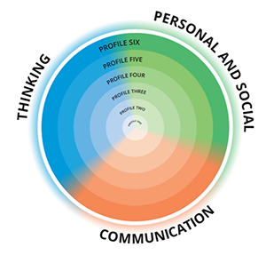

Shared Responsibility

Students, teachers, and parents/guardians share responsibility for the ongoing development of Core Competencies. Each group has its own considerations.

Student

- Discussing the Core Competencies with peers, teachers, and family can deepen students’ understanding of the Core Competencies and help them identify personal strengths and establish goals for further development as educated citizens

- Examining the illustrations helps students develop an appreciation of the different ways, forms, and contexts in which the Core Competencies can be applied

- The illustrations connect the Core Competencies with students’ own classroom experiences and bring the profiles to life for them

- Students are responsible for assessing their own growth in the Core Competencies. The profiles linked with each sub-competency can serve as a helpful guide in this self-assessment

Teachers

- Teachers can use the sub-competency profiles and illustrations to support students in their growth as educated citizens

- Providing students with meaningful tasks and activities, where they can explicitly reflect on where and how they are using the Core Competencies, will further their development in Communication, Thinking, and Personal and Social. The illustrations for each sub-competency provide examples of rich tasks, activities, and feedback

- The Core Competencies are embedded within the curriculum and are naturally supported when students engage with the Big Ideas and Curricular Competencies in each area of learning. Examples of explicit connections with Big Ideas can be found in the “Connection” section for each sub-competency

- Teachers support students in assessing their own growth in the Core Competencies. (For more information on assessment and the Core Competencies, please see Classroom Assessment and Reporting)

Parents/Guardians

- Students develop Core Competencies at home as well as at school, making parent/guardian support for students’ growing awareness, understanding, and development of the Core Competencies crucial

- Parents/guardians will likely already have some understanding of their students’ development in Communication, Thinking, and Personal and Social

- Formal school tasks and activities often look different from the more informal tasks students are involved in at home. While both contexts are valuable, parents/guardians can expect that a student’s use of the Core Competencies may look very different in these two contexts

- The illustrations offer examples from a variety of contexts and can provide parents/guardians with a new lens through which to view their students’ development as educated citizens

Unpacking the three Core Competencies

Sub-competencies

Sub-competencies are smaller competencies that fit within a Core Competency.

The Core Competencies are interrelated and interdependent and each sub-competency is naturally intertwined with all the other sub-competencies. These connections are explicitly described in the Connections among Core Competencies section included for each sub-competency. As students move through the profiles in one sub-competency, their growth will influence development in other sub-competencies.



Facets

Each sub-competency includes three or four facets. Facets are the unique and interrelated components of the sub-competencies. Students tend to demonstrate multiple facets of a sub-competency at once when completing tasks and actions.



Profiles

Each sub-competency has a set of six Profiles. Profiles are descriptors of students’ sub-competency development and reflect the interrelated facets of each sub-competency. They are progressive and additive, and they emphasize the concept of expanding and growing. As students move through the profiles, they maintain and enhance competencies from previous profiles while developing new skills. Students may also find themselves reflecting aspects of more than one profile at a time.

It is important to remember that the profiles are not tied to specific grade levels and are reflective of lifelong development.



Illustrations

Illustrations are examples of how B.C. students from diverse backgrounds and communities have demonstrated their developing competence. These examples are varied and can include student work samples, student and teacher reflections, interviews, teacher observations, learning stories, and/or photos and videos.

All illustrations include a profile analysis that highlights the parts of one or more sub-competency profiles the student is demonstrating in the illustration.

Communicating

Communicating encompasses the set of abilities that people use to impart and exchange information, experiences, and ideas; to explore the world around them; and to understand and effectively use communication forms, strategies, and technologies. Communicating provides a bridge between peoples’ learning, their personal and social identity, and the world in which they interact.

People who communicate effectively use their skills and strategies intentionally to ensure understanding their audience. They communicate in an increasing variety of contexts, for a variety of purposes, and often with multiple audiences.

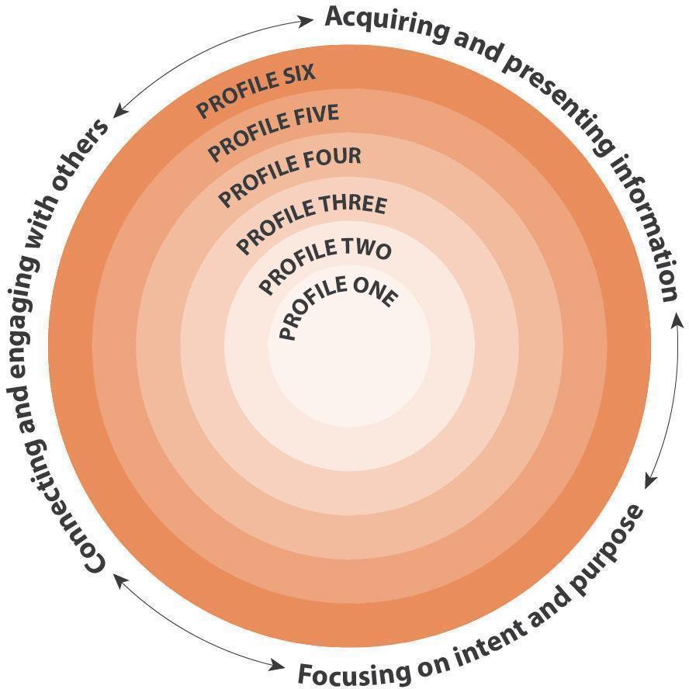

Facets

Connecting and engaging with others

Students engage in informal and structured conversations in which they listen, contribute, develop understanding and relationships, and learn to consider diverse perspectives. This facet of communication is closely linked to the building and sustaining of relationships at home, at school, in the community, and through social media.

Focusing on intent and purpose

Students communicate with intention and purpose. They understand that communication can influence, entertain, teach, inspire, and help us make sense of the world and our experiences. They recognize the role the audience plays in constructing meaning, and they make strategic choices to help convey their messages and create their intended impact. They draw from a range of forms, media, and techniques, monitoring and adjusting their approaches and assessing their effects.

Acquiring and presenting information

Students communicate by receiving and presenting information. They inquire into topics of interest and topics related to their studies. They acquire information from a variety of sources, including people, print materials, and media; this may involve listening, viewing, or reading, and requires understanding of how to interpret information. They present information for many purposes and audiences, and their presentations often feature media and technology.

Profiles

Profile 1

In a safe and supported environment, I respond meaningfully to communication from peers and adults.

Profile 2

In familiar settings, I communicate with peers and adults.

I talk and listen to people I know. I can communicate for a purpose. I can understand and share basic information about topics that are important to me, and answer simple, direct questions about my activities and experiences.

Profile 3

I communicate purposefully, using forms and strategies I have practiced.

I participate in conversations for a variety of purposes (e.g., to connect, help, be friendly, learn and share). I listen and respond to others. I can consider my purpose when I am choosing a form and content. I can communicate clearly about topics I know and understand well, using forms and strategies I have practiced. I gather the basic information I need and present it.

Profile 4

I communicate clearly and purposefully, using a variety of forms appropriately.

I share my ideas and try to connect them with others’ ideas. I am an active listener – I make connections and ask clarifying and extending questions when appropriate. I can plan ways to make my message clear and engaging for my audience and create communications that focus on a variety of purposes and audiences. I acquire the information I need for specific tasks and for my own interests and present it clearly.

Profile 5

I communicate confidently, using forms and strategies that show attention to my audience and purpose.

In discussions and conversations, I am focused and help to build and extend understanding. I am an engaged listener; I ask thought-provoking questions when appropriate and integrate new information. I can create a wide range of effective communications that feature powerful images and words, and I identify ways to change my communications to make them effective for different audiences. I use my understanding of the role and impact of story to engage my audiences in making meaning. I acquire information about complex and specialized topics from various sources, synthesize it, and present it with thoughtful analysis.

Profile 6

I communicate with intentional impact, in well-constructed forms that are effective in terms of my audience and in relation to my purpose.

I contribute purposefully to discussions and conversations. I synthesize, deepen, and transform my own and others’ thinking. I can weave multiple messages into my communications; I understand that my audience will use their own knowledge and experiences in making meaning. I show understanding and control of the forms and technologies I use; I can assess audience response and draw on a repertoire of strategies to increase my intended impact. I can acquire, critically analyze, and integrate well-chosen information from a range of sources.

Connections

The Core Competencies relate to each other and with every aspect of learning.

Connections among Core Competencies

The Core Competencies are interrelated and interdependent. Taken together, the competencies are foundational to every aspect of learning. Communicating is intertwined with the other Core Competencies.

Communication

Communicating is one of the Communication Core Competency’s two interrelated sub-competencies, Communicating and Collaborating.
Communicating and collaborating overlap. For example:

- Students communicate in order to collaborate.

- Students often collaborate in order to develop effective communications.

Thinking

Communicating is closely related to the two Thinking sub-competencies, Creative Thinking and Critical and Reflective Thinking. For example:

- Students communicate to share and build on one another’s creative ideas.

- Students apply critical and reflective thinking to acquire and interpret information, and to make choices about how to communicate their ideas.

- Thinking critically to recognize and appreciate different perspectives is key to both interpreting and creating communications.

Personal and Social

Communicating is closely related to the three Personal and Social sub-competencies, Personal Awareness and Responsibility, Social Awareness and Responsibility, and Positive Personal and Cultural Identity. For example:

- Students communicate to explain their values and how those affect the choices they make.

- Students communicate to build and sustain positive relationships with diverse people, including people from different generations.

- Students communicate to express their needs and seek help when they need it, and to advocate for themselves.

Connections with areas of learning

Communicating is embedded within the curricular competencies of the concept-based, competency-driven curriculum. Curricular competencies are focused on the “doing” within the area of learning and include skills, processes, and habits of mind required by the discipline. For example, the Communicating sub-competency can be seen in the following Big Ideas in Mathematics:

- Objects and shapes have attributes that can be described, measured, and compared. (Mathematics 1-2)

- Regular changes in patterns can be identified using tools and tables. (Mathematics 4)

- Continuous linear relationships can be identified and represented in many connected ways to identify regularities and make generalizations. (Mathematics 9)

- Statistical analysis allows us to notice, wonder about, and answer questions about variation. (Foundations of Mathematics 11)

Illustrations

Title |  | Sub-competencies
Un projet UNIS Bien-être pour lutter contre les changements climatiques | Les élèves conçoivent des projets de service communautaire liés aux changements climatiques dans le cadre d’un projet UNIS Bien-être. | La collaboration, Conscience de soi et responsabilité personnelle, Conscience et responsabilité sociales
Rédaction d’une constitution de classe | Les élèves entreprennent la rédaction d’une constitution de classe et collaborent à la fois au plan et au produit. | La collaboration
Aménagement d’habitats pour les animaux | Les élèves utilisent le matériel de classe pour concevoir des habitats qui procurent aux animaux ce dont ils ont besoin pour survivre. | La collaboration, L'interaction, Pensée critique et réflexive
Organisation d’une Journée du chandail orange | Une élève, inspirée par un roman sur l’expérience d’une jeune fille dans un pensionnat indien, rassemble de plus amples renseignements et, quatre ans plus tard, organise une Journée du chandail orange dans son école. | La collaboration, Pensée critique et réflexive, Conscience et responsabilité sociales
Fabrication de chaussures en papier journal | Les élèves travaillent en petits groupes pour fabriquer des chaussures avec du papier journal. | La collaboration
Chaînes de dominos | Quelques élèves commencent à faire des chaînes de dominos, ce qui déclenche une activité de classe. | La collaboration
Élaboration de règles de base pour des cercles de lecture | Les élèves réfléchissent sur leurs expériences antérieures de collaboration afin d’élaborer des règles de base qu’ils pourront utiliser dans le cadre de cercles de lecture pour l’étude de romans. | La collaboration
Apprendre à de jeunes élèves à utiliser une application | Des élèves apprennent à des camarades plus jeunes comment utiliser une application pour représenter leurs apprentissages. | La collaboration
Porter bien haut le flambeau | Après avoir rencontré d’anciens combattants lors d’un événement du jour du Souvenir, un élève forme un groupe consacré aux liens intergénérationnels entre élèves et anciens combattants. | La collaboration, Pensée critique et réflexive, Conscience et responsabilité sociales
Écriture collaborative | Les élèves travaillent en petits groupes pour écrire une histoire à propos d’un animal. | La collaboration
Handprint Turkeys | A student teaches her classmates now to make handprint turkeys. | Communicating, Collaborating
Save Fred: Collaborative Problem-solving | Students work in groups on a problem-solving challenge called “Save Fred”. | Collaborating, Critical and Reflective Thinking
Making a Hockey Rink | Students make a hockey rink with whiteboards. | Collaborating, Critical and Reflective Thinking
Reflecting on a Musical Performance | A student reflects on her performance singing a duet. | Collaborating, Communicating, Critical and Reflective Thinking
Addressing Climate Change Through a WE Wellbeing project | Students design community service projects related to climate change as part of a WE Wellbeing project. | Collaborating, Personal Awareness and Responsibility, Social Awareness and Responsibility
You Mud? | Two children sit together and observe each other as they spread mud on an outdoor table. | Collaborating, Social Awareness and Responsibility
Exploring Factors that Effect Motion | Students collaboratively create ramps to explore the forces that effect motion. | Collaborating, Communicating, Critical and Reflective Thinking
Designing Animal Habitats | Students use classroom materials to design models of animal habitats that provide animals with what they need to survive. | Collaborating, Communicating, Critical and Reflective Thinking
Making Newspaper Shoes | Students work in small groups to make newspaper shoes. | Collaborating
Domino chains | A few students start making domino chains and spark a class activity. | Collaborating
Teaching Younger Students How to Use an App | Older students teach younger students how to use an app to represent their learning. | Collaborating
What We Want in a Playground | Students work in pairs to discuss and build their ideal playground using classroom materials. | Collaborating
Developing Ground Rules for Literature Circles | Students reflect on their previous experiences with collaboration in order to develop ground rules to use in novel study Literature Circles. | Collaborating
Developing a Classroom Constitution | Students initiate the development of a Classroom Constitution and collaborate on both the plan and the product. | Collaborating
A Compromise | When two children’s ideas about an imaginative story diverge, one of the children finds a compromise. | Collaborating, Social Awareness and Responsibility
Junior Fire Crew | First Nations students reflect on the collaborative aspects of working on a fire crew. | Collaborating
Collaborative Writing | Students work in small groups to write a story about an animal. | Collaborating
Organizing an Orange Shirt Day | A student, inspired by a novel about a girl’s residential school experience, gathers further information and, four years later, organizes an Orange Shirt Day at her school. | Collaborating, Critical and Reflective Thinking, Social Awareness and Responsibility
Hold High the Torch | After meeting veterans at a Remembrance Day event, a student forms a group dedicated to intergenerational connections between students and veterans. | Collaborating, Critical and Reflective Thinking, Social Awareness and Responsibility

Collaborating

Collaborating involves the skills, strategies, and dispositions that people use to work together to pursue common purposes and accomplish common goals.

People who collaborate effectively recognize how combining others’ perspectives, strategies, and efforts with their own enhances collective understanding, use, and impact. They value the contributions of group members, interact supportively and effectively using inclusive practices, and strive for shared commitment and mutual benefit.

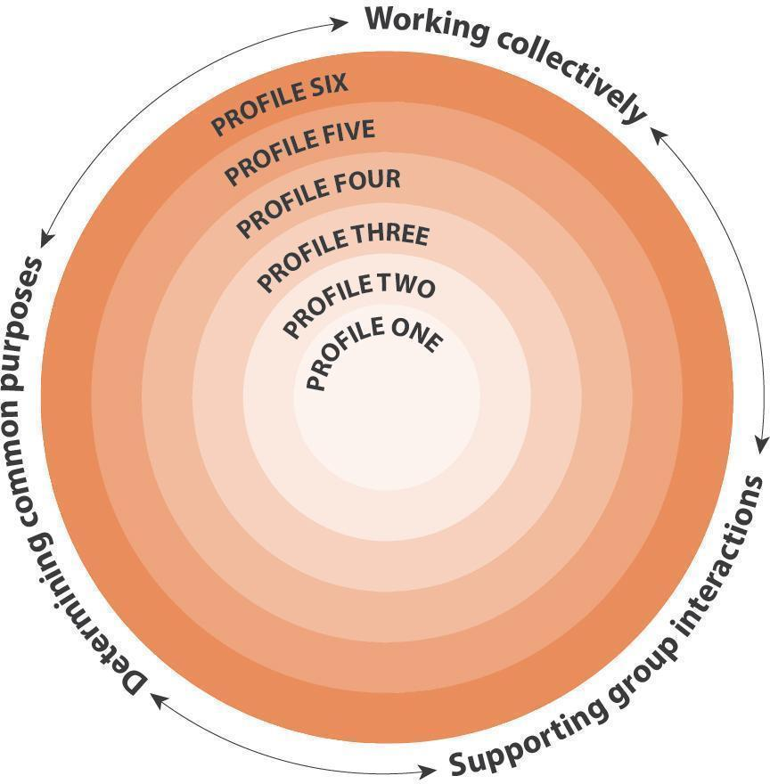

Facets

Working collectively

Students combine their efforts with those of others to effectively accomplish learning and tasks. As members of a group, they appreciate interdependence and cooperation, commit to needed roles and responsibilities, and are conscientious about contributing. They also negotiate respectfully and follow through on plans, strategies, and actions as they share resources, time, and spaces for collaborative projects.

Supporting group interactions

Students engage with others in ways that build and sustain trusting relationships and contribute to collective approaches. They value diverse perspectives and integrate the ideas of others with their own to tackle tasks, issues, and problems. Students seek to distribute leadership, listen actively, take turns in discussions, acknowledge contributions, and identify missing voices. They regulate the group’s interactions together, mutually encouraging one another, creating space for marginalized voices, and applying constructive strategies to navigate through misunderstandings, struggles, and conflict.

Determining common purposes

Students develop shared understandings of information, issues, situations, and problems in pursuit of common purposes and goals. They honour various group processes and proactively support movement forward, including refocusing on intended goals as needed. They revise plans according to mutual deliberations and strive for consensus. As co-members of a group, students see one another as valuable resources, commit to impact and collective success, assess group results and processes, and share in the recognition of achievements.

Profiles

Profile 1

In familiar situations, I can participate with others.

Profile 2

In familiar situations, I cooperate with others for specific purposes.

I contribute during group activities, cooperate with others, and listen respectfully to their ideas. I can work with others for a specific purpose.

Profile 3

I contribute during group activities with peers and share roles and responsibilities to achieve goals.

I take on different roles and tasks in the group and work respectfully and safely in our shared space. I express my ideas and help others feel comfortable to share theirs so that all voices are included. I work with others to achieve a common goal and can evaluate our group processes and results.

Profile 4

I can confidently interact and build relationships with other group members to further shared goals.

I can identify and apply roles and strategies to facilitate groupwork. I draw on past experiences to negotiate and develop group processes. I am an active listener and speaker. I share my ideas and try to connect them with others’ ideas, I ask clarifying questions and check for understanding when appropriate, and I test my ideas with others and consider their input. I help resolve conflicts and challenges as they arise. I recognize how my contributions and those of others complement each other. I can plan with others and adjust our plan according to the group’s purpose.

Profile 5

I can facilitate group processes and encourage collective responsibility for our progress.

I play a role in collectively monitoring the progress of the group and adjust my contributions as needed. I recognize the interdependence of our roles and draw on these to move us forward. I ask thought-provoking questions, integrate new information and various perspectives from others, and think critically about whose voices are missing. I can disagree respectfully, and I anticipate potential conflicts and help manage them when they arise. I give, receive, and act on constructive feedback in support of our goals, and I can evaluate and revise plans with other group members.

Profile 6

I can connect my group with other groups and broader networks for various purposes.

I can step outside of my comfort zone to develop working relationships with unfamiliar groups. I develop and coordinate networking partnerships beyond and in service of the group. I demonstrate my commitment to the group’s purpose by taking on different roles as needed. I acknowledge different perspectives and seek out and create space for missing or marginalized voices. I summarize key themes to identify commonalities and focus on deepening or transforming our collective thinking and actions. I recognize when wisdom and strategies from others are needed and access these to address complex goals. I help create connections with other groups or networks to further our common goals and our impact.

Connections

The Core Competencies relate to each other and with every aspect of learning.

Connections among Core Competencies

The Core Competencies are interrelated and interdependent. Taken together, the competencies are foundational to every aspect of learning. Communicating is intertwined with the other Core Competencies.

Communication

Collaborating is one of the Communication Core Competency’s two interrelated sub-competencies, Communicating and Collaborating.
Collaborating and Communicating overlap. For example:

- Collaborating requires active speaking and listening for effective interactions

Thinking

Collaborating is closely related to the two Thinking sub-competencies, Creative Thinking and Critical and Reflective Thinking. For example:

- When students think creatively, they build on group members’ ideas and integrate one another’s contributions to develop novel approaches

- As students think critically, they consider alternative perspectives and seek out missing or marginalized voices

Personal and Social

Collaborating is closely related to the three Personal and Social sub-competencies: Personal Awareness and Responsibility, Social Awareness and Responsibility, and Positive Personal and Cultural Identity. For example:

- Participating in the supportive interactions and collective efforts of collaboration enhances students’ positive identity development including their relationship to others and their membership in various groups

- As students take on diverse roles and responsibilities during collaborative activities, they learn to appreciate how their own ideas and strategies can be helpful to others

- Collaboration involves building relationships, contributing to community, valuing diversity, and solving problems in peaceful ways

Connections with areas of learning

Collaborating is embedded within the curricular competencies of the concept-based, competency-driven curriculum. Curricular competencies are focused on the “doing” within the area of learning and include skills, processes, and habits of mind required by the discipline. For example, the Collaborating sub-competency can be seen in the following Big Ideas in Career Education:

- Effective collaboration relies on clear, respectful communication. (Career Education K-3)

- Leadership represents good planning, goal-setting, and collaboration. (Career Education 6-7)

- Engaging in networks and reciprocal relationships can guide and broaden career-life awareness and options. (Career Life Connections)

Illustrations

Title |  | Sub-competencies
Un projet UNIS Bien-être pour lutter contre les changements climatiques | Les élèves conçoivent des projets de service communautaire liés aux changements climatiques dans le cadre d’un projet UNIS Bien-être. | La collaboration, Conscience de soi et responsabilité personnelle, Conscience et responsabilité sociales
Rédaction d’une constitution de classe | Les élèves entreprennent la rédaction d’une constitution de classe et collaborent à la fois au plan et au produit. | La collaboration
Aménagement d’habitats pour les animaux | Les élèves utilisent le matériel de classe pour concevoir des habitats qui procurent aux animaux ce dont ils ont besoin pour survivre. | La collaboration, L'interaction, Pensée critique et réflexive
Organisation d’une Journée du chandail orange | Une élève, inspirée par un roman sur l’expérience d’une jeune fille dans un pensionnat indien, rassemble de plus amples renseignements et, quatre ans plus tard, organise une Journée du chandail orange dans son école. | La collaboration, Pensée critique et réflexive, Conscience et responsabilité sociales
Fabrication de chaussures en papier journal | Les élèves travaillent en petits groupes pour fabriquer des chaussures avec du papier journal. | La collaboration
Chaînes de dominos | Quelques élèves commencent à faire des chaînes de dominos, ce qui déclenche une activité de classe. | La collaboration
Élaboration de règles de base pour des cercles de lecture | Les élèves réfléchissent sur leurs expériences antérieures de collaboration afin d’élaborer des règles de base qu’ils pourront utiliser dans le cadre de cercles de lecture pour l’étude de romans. | La collaboration
Apprendre à de jeunes élèves à utiliser une application | Des élèves apprennent à des camarades plus jeunes comment utiliser une application pour représenter leurs apprentissages. | La collaboration
Porter bien haut le flambeau | Après avoir rencontré d’anciens combattants lors d’un événement du jour du Souvenir, un élève forme un groupe consacré aux liens intergénérationnels entre élèves et anciens combattants. | La collaboration, Pensée critique et réflexive, Conscience et responsabilité sociales
Écriture collaborative | Les élèves travaillent en petits groupes pour écrire une histoire à propos d’un animal. | La collaboration
Handprint Turkeys | A student teaches her classmates now to make handprint turkeys. | Communicating, Collaborating
Save Fred: Collaborative Problem-solving | Students work in groups on a problem-solving challenge called “Save Fred”. | Collaborating, Critical and Reflective Thinking
Making a Hockey Rink | Students make a hockey rink with whiteboards. | Collaborating, Critical and Reflective Thinking
Reflecting on a Musical Performance | A student reflects on her performance singing a duet. | Collaborating, Communicating, Critical and Reflective Thinking
Addressing Climate Change Through a WE Wellbeing project | Students design community service projects related to climate change as part of a WE Wellbeing project. | Collaborating, Personal Awareness and Responsibility, Social Awareness and Responsibility
You Mud? | Two children sit together and observe each other as they spread mud on an outdoor table. | Collaborating, Social Awareness and Responsibility
Exploring Factors that Effect Motion | Students collaboratively create ramps to explore the forces that effect motion. | Collaborating, Communicating, Critical and Reflective Thinking
Designing Animal Habitats | Students use classroom materials to design models of animal habitats that provide animals with what they need to survive. | Collaborating, Communicating, Critical and Reflective Thinking
Making Newspaper Shoes | Students work in small groups to make newspaper shoes. | Collaborating
Domino chains | A few students start making domino chains and spark a class activity. | Collaborating
Teaching Younger Students How to Use an App | Older students teach younger students how to use an app to represent their learning. | Collaborating
What We Want in a Playground | Students work in pairs to discuss and build their ideal playground using classroom materials. | Collaborating
Developing Ground Rules for Literature Circles | Students reflect on their previous experiences with collaboration in order to develop ground rules to use in novel study Literature Circles. | Collaborating
Developing a Classroom Constitution | Students initiate the development of a Classroom Constitution and collaborate on both the plan and the product. | Collaborating
A Compromise | When two children’s ideas about an imaginative story diverge, one of the children finds a compromise. | Collaborating, Social Awareness and Responsibility
Junior Fire Crew | First Nations students reflect on the collaborative aspects of working on a fire crew. | Collaborating
Collaborative Writing | Students work in small groups to write a story about an animal. | Collaborating
Organizing an Orange Shirt Day | A student, inspired by a novel about a girl’s residential school experience, gathers further information and, four years later, organizes an Orange Shirt Day at her school. | Collaborating, Critical and Reflective Thinking, Social Awareness and Responsibility
Hold High the Torch | After meeting veterans at a Remembrance Day event, a student forms a group dedicated to intergenerational connections between students and veterans. | Collaborating, Critical and Reflective Thinking, Social Awareness and Responsibility

Creative Thinking

Creative Thinking involves the generation of ideas and concepts that are novel and innovative in the context in which they are generated, reflection on their value to the individual or others, and the development of chosen ideas and concepts from thought to reality.

People who think creatively are curious and open-minded, have a sense of wonder and joy in learning, demonstrate a willingness to think divergently, and are comfortable with complexity. A creative thinker reflects on existing ideas and concepts; uses imagination, inventiveness, resourcefulness, and flexibility; and is willing to take risks to go beyond existing knowledge.

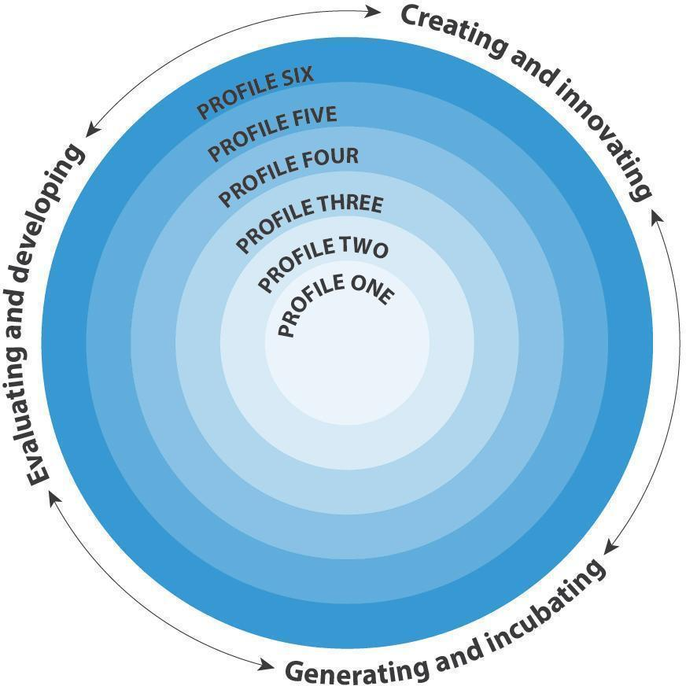

Facets

Creating and innovating

Students get creative ideas that are novel and have value. An idea may be new to the student or their peers, and it may be novel for their age group or the larger community. It may be new to a particular context or absolutely new. The idea or product may have value in a variety of ways and contexts – it may be fun, provide a sense of accomplishment, solve a problem, be a form of self-expression, provoke reflection, or provide a new perspective that influences the way people think or act. It can have a positive impact on the individual, classmates, the community, or the world.

Generating and incubating

Students may generate creative ideas through free play, engagement with other’s ideas, or consideration of a problem or constraint, and/or because of their interests and passions. New ideas and inspirations can spontaneously arise from the unconscious mind, but students can also develop strategies to facilitate the generation of ideas – learning a lot about something, engaging in a period of reflection, providing time for incubation, and doing relaxing or automatic activities to quiet their conscious mind. The capacity for creative thinking expands as individuals increase their range of ideas and concepts to recombine them into new ideas. The ideas available as raw material for creative thinking depend on previous experiences and learning, as well as students’ cultural legacies.

Evaluating and developing

Students reflect on their creative ideas in order to decide which ones to develop. They consider whether their idea would ultimately support the well-being of self, community, and the land. They do this with a sense of place and taking into consideration unintended consequences for other living things and our planet. If they decide to develop an idea, they work individually and/or collaboratively to refine it and work to realize it. This may require accessing the knowledge of those who have gone before, building the necessary skills, sustaining perseverance, using failure productively over time, and reflecting on process and results. It may also require the generation of additional creative ideas to come up with solutions to problems along the way.

Profiles

Profile 1

I get ideas when I play.

I get ideas when I use my senses to explore. My play ideas are fun for me and make me happy. I make my ideas work or I change what I am doing.

Profile 2

I can get new ideas or build on or combine other people’s ideas to create new things within the constraints of a form, a problem, or materials.
I can get new ideas to create new things or solve straightforward problems. My ideas are fun, entertaining, or useful to me and my peers, and I have a sense of accomplishment. I can use my imagination to get new ideas of my own, or build on other’s ideas, or combine other people’s ideas in new ways. I can usually make my ideas work within the constraints of a given form, problem, or materials if I keep playing with them.

Profile 3

I can get new ideas in areas in which I have an interest and build my skills to make them work.

I generate new ideas as I pursue my interests. I deliberately learn a lot about something by doing research, talking to others, or practicing, so that I can generate new ideas about it; the ideas often seem to just pop into my head. I build the skills I need to make my ideas work, and I usually succeed, even if it takes a few tries.

Profile 4

I can get new ideas or reinterpret others’ ideas in novel ways.

I get ideas that are new to my peers. My creative ideas are often a form of self-expression for me. I have deliberate strategies for quieting my conscious mind (e.g., walking away for a while, doing something relaxing, being deliberately playful), so that I can be more creative. I use my experiences with various steps and attempts to direct my future work.

Profile 5

I can think “outside the box” to get innovative ideas and persevere to develop them.

I can get new ideas that are innovative, may not have been seen before, and have an impact on my peers or in my community. I have interests and passions that I pursue over time. I look for new perspectives, new problems, or new approaches. I am willing to take significant risks in my thinking in order to generate lots of ideas. I am willing to accept ambiguity, setbacks, and failure, and I use them to advance the development of my ideas.

Profile 6

I can develop a body of creative work over time in an area of interest or passion.

I can get ideas that are groundbreaking or disruptive and can develop them to form a body of work over time that has an impact in my community or beyond. I challenge assumptions as a matter of course and have deliberate strategies (e.g., free writing or sketching, meditation, thinking in metaphors and analogies) for getting new ideas intuitively. I have a strong commitment to a personal aesthetic and values, and the inner motivation to persevere over years if necessary to develop my ideas.

Connections

The Core Competencies relate to each other and with every aspect of learning.

Connections among Core Competencies

The Core Competencies are interrelated and interdependent. Taken together, the competencies are foundational to every aspect of learning. Communicating is intertwined with the other Core Competencies.

Thinking

Creative Thinking is one of the Thinking Core Competency’s two interrelated sub-competencies, Creative Thinking and Critical and Reflective Thinking.

Creative Thinking and Critical and Reflective Thinking overlap. For example:

- Students use critical thinking to analyze and reflect on creative ideas in order to determine whether they have value and should be developed

- Students engage in ongoing reflection as they develop their creative ideas

- Students use creative thinking to generate new ideas to solve problems and constraints that arise as they design and develop

Communication

Creative Thinking is closely related to the two Communication sub-competencies, Communicating and Collaborating. For example:

- Students communicate to share and build on one another’s creative ideas and collaborate to develop their creative ideas

- Students use creative thinking to get new ideas about how to communicate effectively

- Students can use creative thinking to come up with new ideas about how to distribute leadership and co-regulate group interactions as they collaborate

Personal and Social

Creative Thinking is closely related to the three Personal and Social sub-competencies: Personal Awareness and Responsibility, Social Awareness and Responsibility, and Positive Personal and Cultural Identity. For example:

- Students use their personal and social awareness and responsibility to decide which creative ideas have value for themselves, others, and the community

- Students use creative thinking to generate new ideas for ways to exercise personal and social responsibility

- Students often see their chosen forms of creative expression as an important part of their identity

Connections with areas of learning

Creative Thinking is embedded within the curricular competencies of the concept-based, competency-driven curriculum. Curricular competencies are focused on the “doing” within the area of learning and include skills, processes, and habits of mind required by the discipline. For example, the Creative Thinking sub-competency can be seen in the following Big Ideas in Arts Education:

- Creative expression develops our unique identity and voice. (Arts Education 2)

- Artists experiment in a variety of ways to discover new possibilities. (Arts Education 4)

- Creative growth requires patience, readiness to take risks, and willingness to try new approaches. (Arts Education 8)

Illustrations

Title |  | Sub-competencies
Salon de manucure | Pendant plusieurs semaines, une enfant et son amie créent une série complexe d’activités liées à un salon de manucure imaginaire. | Pensée créatrice, L'interaction, Conscience et responsabilité sociales
Comment les artistes expriment-ils le mieux leurs pensées ou leurs sentiments? | Une élève a enquêté sur la façon dont les artistes s’expriment et a créé une œuvre authentique. | Pensée critique et réflexive, Pensée créatrice, L'interaction
Conception d’un logo pour des toilettes d’accès universel | Des élèves conçoivent un logo pour des toilettes d’accès universel. | Pensée critique et réflexive, Pensée créatrice, Conscience et responsabilité sociales, L'interaction
Des poissons heureux et en bonne santé | Un élève construit une maquette d’aquarium qui garderait les poissons heureux et en santé. | Pensée critique et réflexive, Pensée créatrice
Fabrication d’ailes | Pendant le temps d’exploration libre, une élève décide de fabriquer des ailes qu’elle pourra porter. | Pensée créatrice
Explorations artistiques de l’identité | Au fil du temps, l’élève réalise un ensemble d’œuvres créatives sur le thème de l’identité. | Pensée créatrice, Pensée critique et réflexive, L'interaction, Identité personnelle et culturelle positive
I Am from the Leeson and Faithful Family | Students write their own “I Am From” poems and then created a mixed media self-portrait that reflected the imagery and information in their poems. | Positive Personal and Cultural Identity, Creative Thinking
Using Poetry as a Medium for Personal Awareness | A student creates a poem to show her growth in personal awareness. | Personal Awareness and Responsibility, Communicating, Creative Thinking
LEGO Creations | Students create different objects with the same Lego pieces. | Creative Thinking
Artistic Representation of Hotels | During an architecture project, a student uses found materials to represent that hotels simultaneously act as public space and private refuge. | Creative Thinking, Critical and Reflective Thinking
Genius Hour | A student paints the Leaning Tower of Pisa during class time dedicated to pursuing interests and passions. | Creative Thinking
Running Water for a Model House | A student has an “Aha!” moment about adding plumbing to a model house when he reflects on his juice box. | Creative Thinking
"Not a Stick" Sticks | A student extends a classroom assignment by designing a fire starter for campers. | Creative Thinking, Critical and Reflective Thinking
Plant Tag Bookmarks | A student encourages classmates to repurpose plant tags as bookmarks. | Creative Thinking
Response to "Chalk" | A student imagines storybook heroes coming to life when drawn with magic chalk. | Creative Thinking
The Kitchen Pantry Parkade | A student uses the kitchen centre pantry to make a parkade. | Creative Thinking
"Not a Box" Class Book | A student makes a kite from a paper square for a class book modelled on “Not a Box.” | Creative Thinking
Making Food with Stacking Blocks | A student uses her imagination to make “food” with stacking blocks. | Creative Thinking
Writing a Story for Kindergarten Buddies | Students write a story to read to their Kindergarten buddies. | Creative Thinking, Communicating
"Steal" a Story | A student retells the story of Humpty Dumpty as a news item. | Creative Thinking, Communicating
Spoken Word Poetry | A student writes and performs a spoken word poem and then reflects on their creative process. | Creative Thinking, Communicating
Speaker's Corner Rant | A student creates a Speaker’s Corner rant that has an emotional impact on her peers. | Creative Thinking, Communicating
Santa Vending Machine | A student works with classmates to build a cardboard vending machine to deliver secret Santa presents. | Creative Thinking, Critical and Reflective Thinking
Political Cartoon | A student creates a political cartoon to encourage community members to support a ban of shark fin products. | Creative Thinking, Communicating, Critical and Reflective Thinking
Plasticine Story Puppets and Props | A student uses Plasticine to create puppets and props for their stories. | Creative Thinking
Designing Your Own Robot | After doing a report on robots and assembling a robot from a kit, a student designs his own robot. | Creative Thinking, Critical and Reflective Thinking
Investigation Workbook in Visual Arts | A student creates an Investigation Workbook of artistic research, reflection, and original work. | Creative Thinking, Communicating
Hundreds Chart | A student builds on a classmate’s idea for how to use a hundreds chart using only his fingers. | Creative Thinking
Essay about a Poem | Students reflect on how they generated creative ideas for a group essay about a poem. | Creative Thinking, Communicating
Duct Tape Wallets | A student makes duct tape wallets as a hobby. | Creative Thinking, Critical and Reflective Thinking
Constructing a Working Crane | A group of students engage in a multi-stage design process to make a working model of a construction crane. | Creative Thinking, Critical and Reflective Thinking
Retelling the Three Billy Goats Gruff | A student retells the story of the “Three Billy Goats Gruff” from the perspective of the troll while adding in a few twists. | Creative Thinking, Critical and Reflective Thinking
Underground Mine | A student knows he has lots of creative ideas when he draws underground mines, but he is not sure how he comes up with his ideas. | Creative Thinking
Building a Structure for Toy Animals | Two students incorporate scarves into their building block structure. | Creative Thinking
Building a Block Tower | A student explains how she is building her tower of blocks. | Creative Thinking
Artistic Explorations of Identity | Over time, a student develops a body of creative work exploring the theme of identity. | Creative Thinking, Critical and Reflective Thinking, Communicating, Positive Personal and Cultural Identity
Inquiry: How Do Artists Best Express How They Think or Feel? | A student inquired into how artists express themselves, and produced an authentic piece of her own. | Critical and Reflective Thinking, Creative Thinking, Communicating
Designing a Logo for Universal Washrooms | Students design a logo for a universal washroom. | Critical and Reflective Thinking, Creative Thinking, Social Awareness and Responsibility, Communicating
Happy, Healthy Fish | A student builds a model of an aquarium that would keep fish happy and healthy. | Critical and Reflective Thinking, Creative Thinking
Making Wings | During free exploration time, a student decides to make wings she can wear. | Creative Thinking
The Nail Salon | A child and her friend create an elaborate series of activities, over several weeks, connected to an imaginary nail salon. | Creative Thinking, Communicating, Social Awareness and Responsibility

Critical and Reflective Thinking

Critical and Reflective Thinking encompasses a set of abilities that students use to examine their own thinking and that of others. This involves making judgments based on reasoning, where students consider options, analyze options using specific criteria, and draw conclusions.

People who think critically and reflectively are analytical and investigative, willing to question and challenge their own thoughts, ideas, and assumptions and challenge those of others. They reflect on the information they receive through observation, experience, and other forms of communication to solve problems, design products, understand events, and address issues. A critical thinker uses their ideas, experiences, and reflections to set goals, make judgments, and refine their thinking.

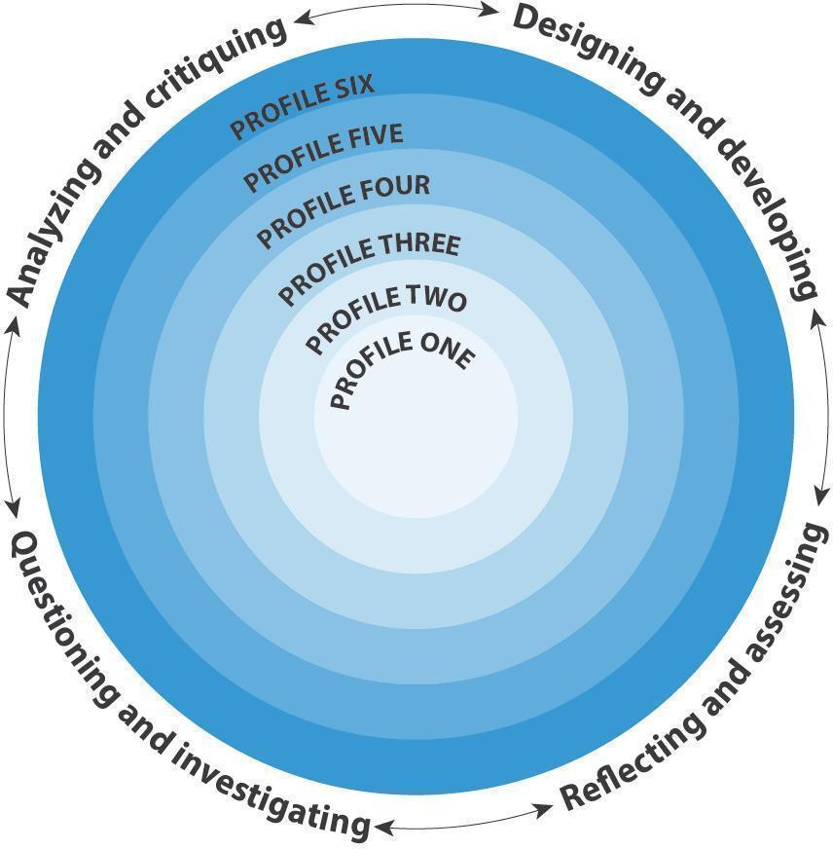

Facets

Analyzing and critiquing

Students learn to analyze and make judgments about a work, a position, a process, a performance, or another product or act. They reflect to consider purpose and perspectives, pinpoint evidence, use explicit or implicit criteria, make defensible judgments or assessments, and draw conclusions. Students have opportunities for analysis and critique through engagement in formal tasks, informal tasks, and ongoing activities.

Questioning and investigating

Students learn to engage in inquiry when they identify and investigate questions, challenges, key issues, or problematic situations in their studies, lives, and communities and in the media. They develop and refine questions; create and carry out plans; gather, interpret, and synthesize information and evidence; and reflect to draw reasoned conclusions. Critical thinking activities may focus on one part of the process, such as questioning, and reach a simple conclusion, while others may involve more complex inquiry requiring extensive thought and reflection.

Designing and developing

Students think critically to develop ideas. Their ideas may lead to the designing of products or methods or the development of performances and representations in response to problems, events, issues, and needs. They work with clear purpose and consider the potential uses or audiences of their work. They explore possibilities, develop and reflect on processes, monitor progress, and adjust procedures in light of criteria and feedback.

Reflecting and assessing

Students apply critical, metacognitive, and reflective thinking in given situations, and relate this thinking to other experiences, using this process to identify ways to improve or adapt their approach to learning. They reflect on and assess their experiences, thinking, learning processes, work, and progress in relation to their purposes. Students give, receive, and act on feedback and set goals individually and collaboratively. They determine the extent to which they have met their goals and can set new ones.

Profiles

Profile 1

I can explore.

I can explore materials and actions. I can show whether I like something or not.

Profile 2

I can use evidence to make simple judgments.

I can ask questions, make predictions, and use my senses to gather information. I can explore with a purpose in mind and use what I learn. I can tell or show others something about my thinking. I can contribute to and use simple criteria. I can find some evidence and make judgments. I can reflect on my work and experiences and tell others about something I learned.

Profile 3

I can ask questions and consider options. I can use my observations, experience, and imagination to draw conclusions and make judgments.

I can ask open-ended questions, explore, and gather information. I experiment purposefully to develop options. I can contribute to and use criteria. I use observation, experience, and imagination to draw conclusions, make judgments, and ask new questions. I can describe my thinking and how it is changing. I can establish goals individually and with others. I can connect my learning with my experiences, efforts, and goals. I give and receive constructive feedback.

Profile 4

I can gather and combine new evidence with what I already know to develop reasoned conclusions, judgments, or plans.

I can use what I know and observe to identify problems and ask questions. I explore and engage with materials and sources. I can develop or adapt criteria, check information, assess my thinking, and develop reasoned conclusions, judgments, or plans. I consider more than one way to proceed and make choices based on my reasoning and what I am trying to do. I can assess my own efforts and experiences and identify new goals. I give, receive, and act on constructive feedback.

Profile 5

I can evaluate and use well-chosen evidence to develop interpretations; identify alternatives, perspectives, and implications; and make judgments.

I can examine and adjust my thinking.

I can ask questions and offer judgments, conclusions, and interpretations supported by evidence I or others have gathered. I am flexible and open-minded; I can explain more than one perspective and consider implications. I can gather, select, evaluate, and synthesize information. I consider alternative approaches and make strategic choices. I take risks and recognize that I may not be immediately successful. I examine my thinking, seek feedback, reassess my work, and adjust. I represent my learning and my goals and connect these with my previous experiences. I accept constructive feedback and use it to move forward.

Profile 6

I can examine evidence from various perspectives to analyze and make well-supported judgments about and interpretations of complex issues.

I can determine my own framework and criteria for tasks that involve critical thinking. I can compile evidence and draw reasoned conclusions. I consider perspectives that do not fit with my understandings. I am open-minded and patient, taking the time to explore, discover, and understand. I make choices that will help me create my intended impact on an audience or situation. I can place my work and that of others in a broader context. I can connect the results of my inquiries and analyses with action. I can articulate a keen awareness of my strengths, my aspirations and how my experiences and contexts affect my frameworks and criteria. I can offer detailed analysis, using specific terminology, of my progress, work, and goals.

Connections

The Core Competencies relate to each other and with every aspect of learning.

Connections among Core Competencies

The Core Competencies are interrelated and interdependent. Taken together, the competencies are foundational to every aspect of learning. Communicating is intertwined with the other Core Competencies.

Thinking

Critical and Reflective Thinking is one of the Thinking Core Competency’s two interrelated sub-competencies, Creative Thinking and Critical and Reflective Thinking.

Critical and Reflective Thinking and Creative Thinking overlap. For example:

- Students use creative thinking to generate new ideas when solving problems and addressing constraints that arise as they question and investigate, and design and develop

- Students use critical thinking to analyze and reflect on creative ideas to determine whether they have value and should be developed, engaging in ongoing reflection as they develop their creative ideas

Communication

Critical and Reflective Thinking is closely related to the two Communication sub-competencies: Communicating and Collaborating. For example:

- Students apply critical thinking to acquire and interpret information, and to make choices about how to communicate their ideas

- Students often collaborate as they work in groups to analyze and critique, and design and develop

Personal and Social

Critical and Reflective Thinking is closely related to the three Personal and Social sub-competencies, Personal Awareness and Responsibility, Social Awareness and Responsibility, and Positive Personal and Cultural Identity. For example:

- Students think critically to determine their personal and social responsibilities

- Students apply their personal awareness as they reflect on their efforts and goals

Connections with areas of learning

Critical and Reflective Thinking is embedded within the curricular competencies of the concept-based, competency-driven curriculum. Curricular competencies are focused on the “doing” within the area of learning and include skills, processes, and habits of mind required by the discipline. For example, the Critical and Reflective Thinking sub-competency can be seen in the sample inquiry questions that elaborate on the following Big Ideas in Science:

- Light and sound can be produced and their properties can be changed: How can you explore the properties of light and sound? What discoveries did you make? (Science 1)

- Matter has mass, takes up space, and can change phase: How can you explore the phases of matter? How does matter change phases? How does heating and cooling affect phase changes? (Science 4)

- Elements consist of one type of atom, and compounds consist of atoms of different elements chemically combined: What are the similarities and differences elements and compounds? How can you investigate the properties of elements and compounds? (Science 7)

- The formation of the universe can be explained by the big bang theory: How could you model the formation of the universe? (Science 10)

Illustrations

Title |  | Sub-competencies
Débat sur le contrôle des armes à feu aux États Unis | Les élèves participent à une simulation de débat de l’ONU sur le contrôle des armes à feu aux États Unis en tenant compte du point de vue de divers États. | Pensée critique et réflexive, L'interaction
Aménagement d’habitats pour les animaux | Les élèves utilisent le matériel de classe pour concevoir des habitats qui procurent aux animaux ce dont ils ont besoin pour survivre. | La collaboration, L'interaction, Pensée critique et réflexive
Organisation d’une Journée du chandail orange | Une élève, inspirée par un roman sur l’expérience d’une jeune fille dans un pensionnat indien, rassemble de plus amples renseignements et, quatre ans plus tard, organise une Journée du chandail orange dans son école. | La collaboration, Pensée critique et réflexive, Conscience et responsabilité sociales
Exploration de futures carrières | Un élève explore des possibilités de carrières. | Pensée critique et réflexive, L'interaction
Comment les artistes expriment-ils le mieux leurs pensées ou leurs sentiments? | Une élève a enquêté sur la façon dont les artistes s’expriment et a créé une œuvre authentique. | Pensée critique et réflexive, Pensée créatrice, L'interaction
Examen final sous forme de réflexion sur vidéo | Un élève fait une réflexion approfondie sur ses expériences d’apprentissage comme examen final d’un programme STIM (sciences, technologie, ingénierie, mathématiques). | Pensée critique et réflexive, Communication, Conscience de soi et responsabilité personnelle
Bénévolat à une mission urbaine | Un élève est amené à réfléchir spontanément à son point de vue sur l’itinérance et la pauvreté après avoir fait du bénévolat à une mission urbaine. | Pensée critique et réflexive
Entrevues avec des personnes d’âge mûr | On a demandé aux élèves d’interviewer des « personnes d’âge mûr de la collectivité », et l’élève a choisi d’interviewer un voisin de longue date. | Pensée critique et réflexive, Conscience de soi et responsabilité personnelle, Conscience et responsabilité sociales
Phobie ou peur? | Les élèves font des recherches sur les phobies pour les distinguer de la peur, puis réfléchissent et discutent des réactions aux questions d’orientation sexuelle et d’identité de genre. | Pensée critique et réflexive, Conscience et responsabilité sociales, L'interaction
Qu’est-ce qu’une famille? | Les élèves ont étudié la question de ce qu’est une famille et ont réfléchi à leur propre famille. | L'interaction, Pensée critique et réflexive, Identité personnelle et culturelle positive
Conception d’un logo pour des toilettes d’accès universel | Des élèves conçoivent un logo pour des toilettes d’accès universel. | Pensée critique et réflexive, Pensée créatrice, Conscience et responsabilité sociales, L'interaction
Discussions mathématiques | Une élève participe à une discussion mathématique et réfléchit ensuite sur sa capacité à communiquer sa pensée pendant cette discussion. | Pensée critique et réflexive, L'interaction
Des poissons heureux et en bonne santé | Un élève construit une maquette d’aquarium qui garderait les poissons heureux et en santé. | Pensée critique et réflexive, Pensée créatrice
Porter bien haut le flambeau | Après avoir rencontré d’anciens combattants lors d’un événement du jour du Souvenir, un élève forme un groupe consacré aux liens intergénérationnels entre élèves et anciens combattants. | La collaboration, Pensée critique et réflexive, Conscience et responsabilité sociales
Explorations artistiques de l’identité | Au fil du temps, l’élève réalise un ensemble d’œuvres créatives sur le thème de l’identité. | Pensée créatrice, Pensée critique et réflexive, L'interaction, Identité personnelle et culturelle positive
Enregistrer des observations à l’aide de « pièces détachées » (du matériel de toute sorte) | A student uses “loose parts” to record his observations of seasonal changes in the local environment. | Pensée critique et réflexive, L'interaction
Magnetic Wand | A student explores magnetic properties using a magnetic wand. | Critical and Reflective Thinking
Reflection on School Experience and Goals for the Future | A student creates a presentation reflecting on their school experience and goals for the future. | Positive Personal and Cultural Identity, Communicating, Critical and Reflective Thinking, Personal Awareness and Responsibility
Persistence | A student explains how he learned to be persistent and why that trait is important to him. | Positive Personal and Cultural Identity, Communicating, Critical and Reflective Thinking
Narrative Essay | A student writes an essay in response to the prompt “How We Know Who We Are”. | Positive Personal and Cultural Identity, Communicating, Critical and Reflective Thinking, Personal Awareness and Responsibility
Mars Mission | Students present their application for the Mars One project, explaining how they would be suited to the project and how they would deal with issues they would likely face. | Positive Personal and Cultural Identity, Communicating, Critical and Reflective Thinking
Interview | A student reflects on the personal experiences that have changed his goals and aspirations. | Positive Personal and Cultural Identity, Communicating, Critical and Reflective Thinking, Personal Awareness and Responsibility
Portfolio Review and Reflection | During a portfolio review, students reflect on their writing, set goals, and create a plan for moving forward. | Personal Awareness and Responsibility, Critical and Reflective Thinking
Asking for Math Help | A student approaches a teacher with her concerns about her progress in math. | Personal Awareness and Responsibility, Critical and Reflective Thinking
"Just" Jeans | Students explore issues related to the manufacturing of jeans in sweatshops. | Critical and Reflective Thinking
Making Submersibles | After creating submersibles, students reflected on their creation process and the challenges they encountered. | Critical and Reflective Thinking, Communicating
Mind Map | Students create a mind map to assess and reflect on their learning. | Critical and Reflective Thinking, Communicating
Dinosaur Battle | A student shares his reasoning about which group of dinosaurs would win a battle. | Critical and Reflective Thinking
The Lost Thing | A student creates a one-page representation of the story “The Lost Thing”. | Critical and Reflective Thinking, Communicating
Stacking and Building | Students generate and develop a variety of ideas when challenged to see how high they can stack provided materials. | Critical and Reflective Thinking
Sharing Cookies | Students work together to solve an open-ended problem about sharing cookies. | Critical and Reflective Thinking
Roller Coaster | As part of an engineering study, students work collaboratively to build, test, and adapt roller coasters. | Critical and Reflective Thinking
Osmosis Experiment with Gummy Bears | Students work in small groups to design an experiment that explores the effects of different salt solutions on gummy bears. | Critical and Reflective Thinking
Martin Luther on Trial |  | Critical and Reflective Thinking, Communicating
Essay on the Movie "Gattaca" | A student applies what he knows about genetics to critique the movie "Gattaca". | Critical and Reflective Thinking, Communicating
Finding the Area Under a Curve | A student develops, evaluates, and revises a process for calculating the area under a curve. | Critical and Reflective Thinking
Exploring Objects | A student uses her senses to explore a toy bear and rocks. | Critical and Reflective Thinking
Clean Energy - Site C | Students create documentaries that explore the pros and cons of the Site C dam while considering the various stakeholders. | Critical and Reflective Thinking, Communicating
Pinhole Camera Critique | Students reflect on the process they used to make pinhole cameras and the variables that affected its effectiveness. | Critical and Reflective Thinking, Communicating
Artistic Representation of Hotels | During an architecture project, a student uses found materials to represent that hotels simultaneously act as public space and private refuge. | Creative Thinking, Critical and Reflective Thinking
Pull-Tab Snake | A student designs a snake made of pull-tabs in response to a class challenge. | Critical and Reflective Thinking
"Not a Stick" Sticks | A student extends a classroom assignment by designing a fire starter for campers. | Creative Thinking, Critical and Reflective Thinking
Santa Vending Machine | A student works with classmates to build a cardboard vending machine to deliver secret Santa presents. | Creative Thinking, Critical and Reflective Thinking
Political Cartoon | A student creates a political cartoon to encourage community members to support a ban of shark fin products. | Creative Thinking, Communicating, Critical and Reflective Thinking
Designing Your Own Robot | After doing a report on robots and assembling a robot from a kit, a student designs his own robot. | Creative Thinking, Critical and Reflective Thinking
Duct Tape Wallets | A student makes duct tape wallets as a hobby. | Creative Thinking, Critical and Reflective Thinking
Constructing a Working Crane | A group of students engage in a multi-stage design process to make a working model of a construction crane. | Creative Thinking, Critical and Reflective Thinking
Mousetrap Car | Students build mousetrap cars made from household materials and participated in a Mousetrap Car Competition. | Critical and Reflective Thinking
Retelling the Three Billy Goats Gruff | A student retells the story of the “Three Billy Goats Gruff” from the perspective of the troll while adding in a few twists. | Creative Thinking, Critical and Reflective Thinking
Save Fred: Collaborative Problem-solving | Students work in groups on a problem-solving challenge called “Save Fred”. | Collaborating, Critical and Reflective Thinking
Making a Hockey Rink | Students make a hockey rink with whiteboards. | Collaborating, Critical and Reflective Thinking
Reflecting on a Musical Performance | A student reflects on her performance singing a duet. | Collaborating, Communicating, Critical and Reflective Thinking
Artistic Explorations of Identity | Over time, a student develops a body of creative work exploring the theme of identity. | Creative Thinking, Critical and Reflective Thinking, Communicating, Positive Personal and Cultural Identity
Inquiry: How Do Artists Best Express How They Think or Feel? | A student inquired into how artists express themselves, and produced an authentic piece of her own. | Critical and Reflective Thinking, Creative Thinking, Communicating
What is a Family? | Students investigated the question, “What is a family”, and reflected on their own families. | Communicating, Critical and Reflective Thinking, Positive Personal and Cultural Identity
Interviewing an Older Adult | Students were asked to interview an “older adult from the community” and this student chose to interview a long-time neighbour. | Critical and Reflective Thinking, Personal Awareness and Responsibility, Social Awareness and Responsibility
Phobia versus Fear | Students research phobias to distinguish between phobias as fear and then discuss and reflect on reactions to SOGI. | Critical and Reflective Thinking, Social Awareness and Responsibility, Communicating
Designing a Logo for Universal Washrooms | Students design a logo for a universal washroom. | Critical and Reflective Thinking, Creative Thinking, Social Awareness and Responsibility, Communicating
Debate on Gun Control in United States | Students participate in a Model UN debate on gun control in the United States by taking the perspectives of various states. | Critical and Reflective Thinking, Communicating
Exploration of Future Careers | A student explores possible future careers. | Critical and Reflective Thinking, Communicating
Exploring Factors that Effect Motion | Students collaboratively create ramps to explore the forces that effect motion. | Collaborating, Communicating, Critical and Reflective Thinking
Designing Animal Habitats | Students use classroom materials to design models of animal habitats that provide animals with what they need to survive. | Collaborating, Communicating, Critical and Reflective Thinking
Final Exam Video Reflection | A student completes a comprehensive reflection of their learning experiences as a final exam in a STEM program. | Critical and Reflective Thinking, Communication, Personal Awareness and Responsibility
Volunteering at an Urban Mission | A student is moved to spontaneously reflect on his views on homelessness and poverty after volunteering at an urban mission. | Critical and Reflective Thinking
Number Talk | A student participates in a number talk and then reflects on her ability to communicate her thinking during these talks. | Critical and Reflective Thinking, Communicating
Recording Observations with Loose Parts | A student uses “loose parts” to record his observations of seasonal changes in the local environment. | Critical and Reflective Thinking, Communicating
Happy, Healthy Fish | A student builds a model of an aquarium that would keep fish happy and healthy. | Critical and Reflective Thinking, Creative Thinking
Organizing an Orange Shirt Day | A student, inspired by a novel about a girl’s residential school experience, gathers further information and, four years later, organizes an Orange Shirt Day at her school. | Collaborating, Critical and Reflective Thinking, Social Awareness and Responsibility
Hold High the Torch | After meeting veterans at a Remembrance Day event, a student forms a group dedicated to intergenerational connections between students and veterans. | Collaborating, Critical and Reflective Thinking, Social Awareness and Responsibility

Personal Awareness and Responsibility

Personal Awareness and Responsibility involves understanding the connections between personal and social behaviour and well-being; it encourages people to make constructive and ethical decisions and act on them.

People who are personally aware and responsible demonstrate self-respect, persevere in difficult situations, and exercise responsibility. They understand that there are consequences for their decisions and actions. A personally aware and responsible individual takes steps to ensure their well-being, sets goals and monitors progress, regulates emotions and manages stress, and recognizes and advocates for their own rights.

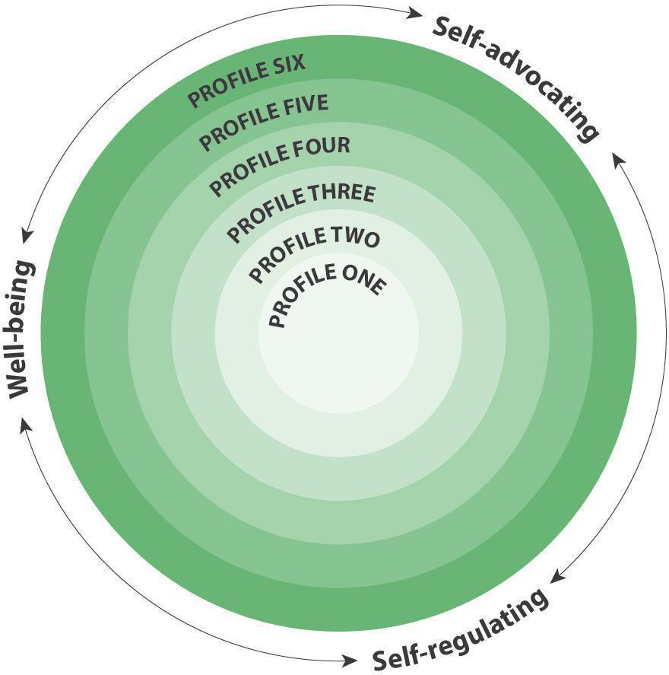

Facets

Self-advocating

Students who are personally aware and responsible have a sense of self-worth and a growing confidence in a variety of situations. They value themselves, their ideas, and their accomplishments. They are able to express their needs and seek help when needed, find purpose and motivation, act on decisions, and advocate for themselves.

Self-regulating

Students who are personally aware and responsible take ownership of their choices and actions. They set goals, monitor progress, and understand their emotions, using that understanding to regulate actions and reactions. They are aware that learning involves patience and time. They can persevere in difficult situations, and to understand how their actions affect themselves and others.

Well-being

Students who are personally aware and responsible recognize the factors that affect their holistic wellness and take increasing responsibility for caring for themselves. They keep themselves healthy and stay active, manage stress, and express a sense of personal well-being. They make choices that contribute to their safety in their communities, including their online communities and use of social media. They recognize their personal responsibility for their happiness and have strategies that help them find peace in challenging situations.

Profiles

Profile 1

I can show a sense of accomplishment and joy, and express some wants, needs, and preferences. I can sometimes recognize my emotions.

Profile 2

I can initiate actions that bring me joy and satisfaction and recognize that I play a role in my well-being.

I can seek out experiences that make me feel happy and proud. I can express my wants and needs and celebrate my efforts and accomplishments. I have some strategies that help me recognize and manage my feelings and emotions. I recognize and can explain my role in learning activities and explorations, and I can give some evidence of my learning. I can describe how some specific choices can affect my well-being and participate in activities that support my well-being.

Profile 3

I can make choices that help me meet my wants and needs and increase my feelings of well-being. I take responsibility for my actions.

I can take action toward meeting my own wants and needs and finding joy and satisfaction, and work toward a goal or solving a problem. I can use strategies that increase my feeling of well-being and help me manage my feelings and emotions. I can connect my actions with both positive and negative consequences and try to make adjustments; I accept feedback. I make decisions about my activities and take some responsibility for my physical and emotional well-being.

Profile 4

I can recognize my strengths and take responsibility for using strategies to focus, manage stress, and accomplish my goals.

I advocate for myself and my ideas; I accept myself. I am willing to engage with ideas or information that is challenging for me. I can be focused and determined. I can set realistic goals, use strategies to accomplish them, and persevere with challenging tasks. I can tell when I am becoming angry, upset, or frustrated, and I have strategies to calm myself. I can make choices that benefit my well-being and keep me safe in the communities I belong to.

Profile 5

I recognize my value and advocate for my rights. I take responsibility for my choices, my actions, and my achievements.

I have valuable ideas to share. I am willing to explore controversial issues, and I can imagine and work toward change in myself and in the world. I can set priorities; implement, monitor, and adjust a plan; and assess the results. I take responsibility for my learning, seeking help as I need it. I use strategies for working toward a healthy and balanced lifestyle, for dealing with emotional challenges, and for finding peace in stressful times. I know how to find the social support I need.

Profile 6

I can identify my strengths and limits, find internal motivation, and act on opportunities for self-growth. I take responsibility for making
ethical decisions.

I am aware of my personal journey and reflect on my experiences as a way of enhancing my well-being and dealing with challenges. I can advocate for myself in stressful situations. I can take the initiative to inform myself about controversial issues and take ethical positions. I take ownership of my goals, learning, and behaviour. I act on what is best, over time, in terms of my goals and aspirations. I recognize the implications of my choices and consult with others who may be affected by my decisions. I can identify my potential as a leader in the communities I belong to. I sustain a healthy and balanced lifestyle.

Connections

The Core Competencies relate to each other and with every aspect of learning.

Connections among Core Competencies

The Core Competencies are interrelated and interdependent. Taken together, the competencies are foundational to every aspect of learning. Communicating is intertwined with the other Core Competencies.

Thinking

Personal Awareness and Responsibility is closely related to the two Thinking sub-competencies, Creative Thinking and Critical and Reflective Thinking. For example:

- Students demonstrate their competence as creative thinkers when they generate ideas about ways to increase their wellbeing, personal agency, or progress toward their goals

- Reflection is a key part of all aspects of developing goals and monitoring and assessing progress toward them

Communication

Personal Awareness and Responsibility is closely related to the two Communication sub-competencies, Communicating and Collaborating. For example:

- As students develop and refine their communication competence, they become increasingly confident and able to participate effectively and advocate for themselves in a variety of situations
- As students collaborate, they commit to needed roles and responsibilities, and are conscientious about contributing and creating space for marginalized voices

Personal and Social

Personal Awareness and Responsibility is one of the Personal and Social Core Competency’s three interrelated sub-competencies, Personal Awareness and Responsibility, Positive Personal and Cultural Identity, and Social Awareness and Responsibility.

Personal Awareness and Responsibility overlaps with the other two Personal and Social sub-competencies. For example:

- Students identify their personal strengths and abilities to self-advocate effectively

- Students increase their well-being by recognizing their personal values and choices

Connections with areas of learning

Personal Awareness and Responsibility is embedded within the curricular competencies of the concept-based, competency-driven curriculum. Curricular competencies are focused on the “doing” within the area of learning and include skills, processes, and habits of mind required by the discipline. For example, the Personal Awareness and Responsibility sub-competency can be seen in the following Big Ideas in Physical and Health Education:

- Good health comprises physical, mental, and emotional well-being. (PHE K-1)

- Understanding ourselves and the various aspects of health helps us to develop a balanced lifestyle. (PHE 4-5)

- Healthy choices influence, and are influenced by, our physical, emotional, and mental well-being. (PHE 10)

- Physical activity is an important part of overall health and well-being. (Active Living 11)

Illustrations

Title |  | Sub-competencies
Un projet UNIS Bien-être pour lutter contre les changements climatiques | Les élèves conçoivent des projets de service communautaire liés aux changements climatiques dans le cadre d’un projet UNIS Bien-être. | La collaboration, Conscience de soi et responsabilité personnelle, Conscience et responsabilité sociales
Réécrire nos histoires négatives (troisième partie de trois) | Les élèves réagissent à une présentation d’Alvin Law et réfléchissent à la façon dont ils peuvent réécrire leurs propres histoires négatives. Trois illustrations à ce sujet ont été choisies; chacune d’elles présente un échantillon différent de travail d’élève et comporte sa propre analyse de profil. | Conscience de soi et responsabilité personnelle, Conscience et responsabilité sociales
Réécrire nos histoires négatives (deuxième partie de trois) | Les élèves réagissent à une présentation d’Alvin Law et réfléchissent à la façon dont ils peuvent réécrire leurs propres histoires négatives. Trois illustrations à ce sujet ont été choisies; chacune d’elles présente un exemple différent d’échantillon de travail d’élève et comporte sa propre analyse de profil. | Conscience de soi et responsabilité personnelle, Conscience et responsabilité sociales
Réécrire nos histoires négatives (première partie de trois) | Les élèves réagissent à une présentation d’Alvin Law et réfléchissent à la façon dont ils peuvent réécrire leurs propres histoires négatives. Trois illustrations à ce sujet ont été choisies; chacune d’elles présente un échantillon différent de travail d’élève et comporte sa propre analyse de profil. | Conscience de soi et responsabilité personnelle, Conscience et responsabilité sociales
Examen final sous forme de réflexion sur vidéo | Un élève fait une réflexion approfondie sur ses expériences d’apprentissage comme examen final d’un programme STIM (sciences, technologie, ingénierie, mathématiques). | Pensée critique et réflexive, Communication, Conscience de soi et responsabilité personnelle
Proposer son aide à ses pairs | Une élève explique la façon dont elle favorise le bien-être socioaffectif de ses pairs. | Conscience et responsabilité sociales, Conscience de soi et responsabilité personnelle
Conception d’un livre pour les tout-petits | Un enfant crée un nouveau livre adapté aux « bébés ». | Conscience de soi et responsabilité personnelle, Conscience et responsabilité sociales
Les dangers qu’il y a à ne connaître qu’une facette des choses : Conférence TED | Un élève réagit à une conférence de Chimamanda Ngozi Adichie sur les dangers qu’il y a à ne connaître qu’une facette des choses. | L'interaction, Identité personnelle et culturelle positive, Conscience de soi et responsabilité personnelle
Entrevues avec des personnes d’âge mûr | On a demandé aux élèves d’interviewer des « personnes d’âge mûr de la collectivité », et l’élève a choisi d’interviewer un voisin de longue date. | Pensée critique et réflexive, Conscience de soi et responsabilité personnelle, Conscience et responsabilité sociales
Poèmes sur la persévérance | Les élèves examinent des poèmes célèbres sur la persévérance, puis créent des poèmes originaux en vers libres qui parlent de leurs propres difficultés et de leur persévérance. | L'interaction, Conscience de soi et responsabilité personnelle
Promenades dans la nature | Un enfant amorce des conversations et des activités lors de promenades dans la nature dans son quartier. | Conscience de soi et responsabilité personnelle, Conscience et responsabilité sociales
Une danse joyeuse | Un enfant présente sa danse spéciale à d’autres enfants et à des adultes le jour de son anniversaire. | Conscience de soi et responsabilité personnelle
Entretenir des amitiés positives | Après avoir réfléchi à certains aspects de leur amitié, quatre élèves changent leur comportement pour entretenir des amitiés plus saines et positives. | Conscience et responsabilité sociales, Conscience de soi et responsabilité personnelle
Des paroles et des actes bienveillants | Une élève apprend qu’en étant gentil et en faisant du bien aux autres, on se sent bien aussi. | Conscience et responsabilité sociales, Conscience de soi et responsabilité personnelle
Reflection on School Experience and Goals for the Future | A student creates a presentation reflecting on their school experience and goals for the future. | Positive Personal and Cultural Identity, Communicating, Critical and Reflective Thinking, Personal Awareness and Responsibility
Narrative Essay | A student writes an essay in response to the prompt “How We Know Who We Are”. | Positive Personal and Cultural Identity, Communicating, Critical and Reflective Thinking, Personal Awareness and Responsibility
Interview | A student reflects on the personal experiences that have changed his goals and aspirations. | Positive Personal and Cultural Identity, Communicating, Critical and Reflective Thinking, Personal Awareness and Responsibility
Waiting Is Not Easy | Students reflect on times when they had to wait and the strategies they used to keep calm and patient. | Personal Awareness and Responsibility
Student Responds to Being Denied a Job | A student responds to not being hired because she is from an alternate school. | Personal Awareness and Responsibility
Checking Blood Glucose Level | A student takes responsibility for monitoring her health. | Personal Awareness and Responsibility
Balancing Homework, Hobbies, and Family Responsibilities | A student speaks with his teacher about making choices related to their responsibilities and personal preferences. | Personal Awareness and Responsibility
Creating a Whirligig | A student creates a whirligig to demonstrate his personal journey. | Personal Awareness and Responsibility, Communicating
Using Poetry as a Medium for Personal Awareness | A student creates a poem to show her growth in personal awareness. | Personal Awareness and Responsibility, Communicating, Creative Thinking
Portfolio Review and Reflection | During a portfolio review, students reflect on their writing, set goals, and create a plan for moving forward. | Personal Awareness and Responsibility, Critical and Reflective Thinking
Asking for Math Help | A student approaches a teacher with her concerns about her progress in math. | Personal Awareness and Responsibility, Critical and Reflective Thinking
Showing Love | A student shows pride in her artwork after creating a heart to show love. | Personal Awareness and Responsibility
The Importance of Running | A young student explains how running gives him energy. | Personal Awareness and Responsibility
Rewriting Our Negative Stories (Part One of Three) | Students respond to a presentation by Alvin Law and reflect on how they can rewrite their own negative stories. There are three related illustrations; each one has a different student work sample and profile analysis. | Personal Awareness and Responsibility, Social Awareness and Responsibility
Rewriting Our Negative Stories (Part Three of Three) | Students respond to a presentation by Alvin Law and reflect on how they can rewrite their own negative stories. There are three related illustrations; each one has a different student work sample and profile analysis. | Personal Awareness and Responsibility, Social Awareness and Responsibility
Rewriting Our Negative Stories (Part Two of Three) | Students respond to a presentation by Alvin Law and reflect on how they can rewrite their own negative stories. There are three related illustrations; each one has a different student work sample and profile analysis. | Personal Awareness and Responsibility, Social Awareness and Responsibility
Developing Positive Friendships | After reflecting on aspects of their friendship, four students change their behavior to develop healthier, more positive friendships. | Social Awareness and Responsibility, Personal Awareness and Responsibility
Kind Words and Acts | A student learns how it feels to be kind and understands that making others feel good makes her feel good too. | Social Awareness and Responsibility, Personal Awareness and Responsibility
The Danger of a Single Story: Ted Talk | A student responds to a Ted Talk by Chimamanda Ngozi Adichie about the danger of a single story. | Communicating, Positive Personal and Cultural Identity, Personal Awareness and Responsibility
Addressing Climate Change Through a WE Wellbeing project | Students design community service projects related to climate change as part of a WE Wellbeing project. | Collaborating, Personal Awareness and Responsibility, Social Awareness and Responsibility
Making a Book for Younger Children | A child creates a new book that will be suitable for “babies.” | Personal Awareness and Responsibility, Social Awareness and Responsibility
Offering Peer Assistance | A student discusses how she supports her peers’ social emotional well-being. | Social Awareness and Responsibility, Personal Awareness and Responsibility
Interviewing an Older Adult | Students were asked to interview an “older adult from the community” and this student chose to interview a long-time neighbour. | Critical and Reflective Thinking, Personal Awareness and Responsibility, Social Awareness and Responsibility
Nature Walks | A child initiates conversations and activities while on nature walks in his community. | Personal Awareness and Responsibility, Social Awareness and Responsibility
Final Exam Video Reflection | A student completes a comprehensive reflection of their learning experiences as a final exam in a STEM program. | Critical and Reflective Thinking, Communication, Personal Awareness and Responsibility
Learning to Be Brave on the Playground | With the support of a friend, a student develops pride and confidence in her ability to deal with new experiences. | Social Awareness and Responsibility, Personal Awareness and Responsibility, Communicating
Cleaning Up the School Grounds | A student chooses to clean up the leaves at the classroom entrance during free time. | Social Awareness and Responsibility, Personal Awareness and Responsibility
Poems about Perseverance | Students explore famous poems about perseverance and then create original free verse poems reflecting on their own struggles and perseverance. | Communicating, Personal Awareness and Responsibility
A Joyful Dance | A child shares his special dance with other children and adults on his birthday. | Personal Awareness and Responsibility

Positive Personal and Cultural Identity

Positive Personal and Cultural Identity involves the awareness, understanding, and appreciation of the factors that contribute to a healthy sense of oneself; it includes knowledge of one’s family background, heritage(s), language(s), beliefs, and perspectives in a pluralistic society.

People who have a positive personal and cultural identity value their personal and cultural narratives and understand how these shape their identity. They exhibit a sense of self-worth, self-awareness, and positive identity to become confident individuals who take satisfaction in who they are and what they can do. They contribute to their own well-being and to the well-being of their family, community, and society.

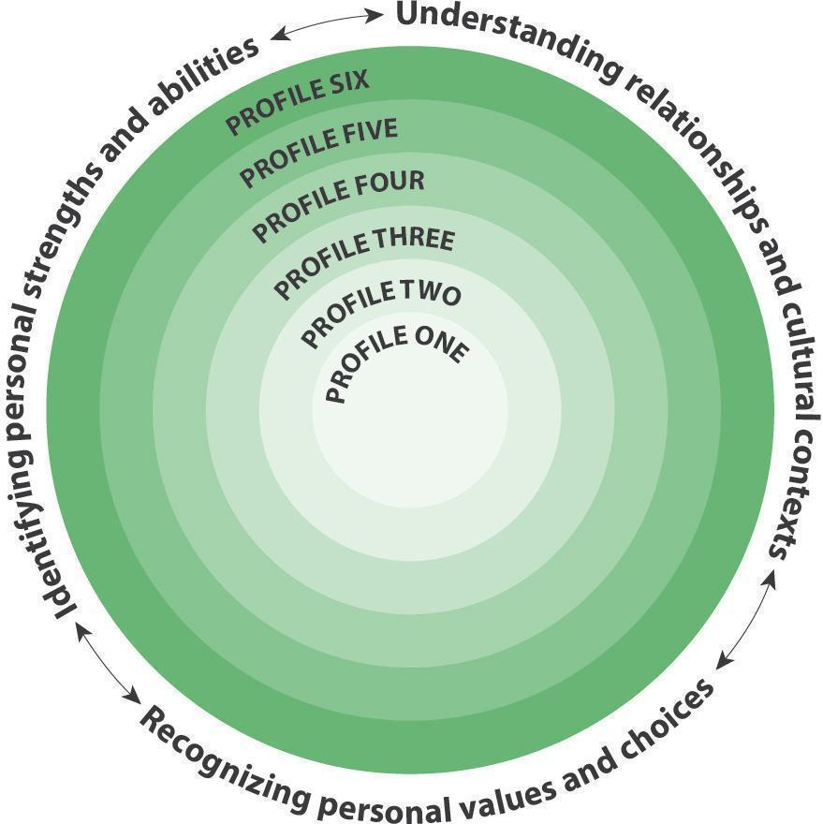

Facets

Understanding relationships and cultural contexts

Students understand that their relationships and cultural contexts help to shape who they are. This includes culture in its broadest sense, including how one identifies in terms of ethnicity, nationality, language(s), abilities, sexual orientation, gender identity, age, geographic region, and religious or spiritual beliefs. Students explore who they are in terms of their relationship to others and their relationship to the world (people and place) around them.

Recognizing personal values and choices

Students define who they are by what they value. They understand how what they value has been influenced by their life experiences. They identify how their values help to shape their choices, in all contexts of their lives.

Identifying personal strengths and abilities

Students acknowledge their strengths and abilities, and they intentionally consider these as assets, helping them in all aspects of their lives. Students understand that they are unique and are a part of larger, and often multiple, communities. They explain how they are using their strengths and abilities in their families, their relationships, and their communities.

Profiles

Profile 1

I am aware of myself as different from others.

I know my name. I am aware of some of my family and/or caregiver relationships.

Profile 2

I am aware of different aspects of myself. I can identity people, places, and things that are important to me.

With some help, I can identify some of my attributes. I can identify objects or images that represent things that are important to me and explain what I like and dislike. I can describe my family, home, and/or community (people and/or place).

Profile 3

I can describe different aspects of my identity.

I can identify my individual characteristics and explain what interests me. I can describe different groups that I belong to.

Profile 4

I have pride in who I am. I understand that I am a part of larger communities.

I can describe and demonstrate pride in my positive qualities, characteristics, and/or skills. I can explain why I make specific choices. I am able to represent aspects of my cultural contexts (such as family, communities, school, peer groups) through words and/or images, and describe some ways that I participate in, or am connected to, a community.

Profile 5

I understand that my identity is influenced by many aspects of my life. I am aware that my values shape my choices and contribute to making me a unique individual.

I understand that my characteristics, qualities, strengths, and challenges make me unique and are an important part of the communities I belong to (including people and places). I understand that what I value influences the choices I make and how I present myself in various contexts (including online). I can explain how I am able to use my strengths to contribute in my home and/or communities.

Profile 6

I can identify how my life experiences have contributed to who I am; I recognize the continuous and evolving nature of my identity.

I can identify ways in which my strengths can help me meet challenges, and how my challenges can be opportunities for growth. I understand that I will continue to develop new skills, abilities, and strengths. I can describe how aspects of my life experiences, family history, background, and where I live (or have lived) have influenced my values and choices. I understand that my learning is continuous, my concept of self and identity will continue to evolve, and my life experiences may lead me to identify with new communities of people and/or place.

Connections

The Core Competencies relate to each other and with every aspect of learning.

Connections among Core Competencies

The Core Competencies are interrelated and interdependent. Taken together, the competencies are foundational to every aspect of learning. Communicating is intertwined with the other Core Competencies.

Thinking

Positive Personal and Cultural Identity is closely related to the two Thinking sub-competencies, Creative Thinking and Critical and Reflective Thinking. For example:

- As students generate creative ideas, they strengthen their appreciation of their strengths and abilities and intentionally use them during this process

- Students use critical thinking and reflection to explore their personal and cultural narratives and to understand how these narratives help shape their identity

Communication

Positive Personal and Cultural Identity is closely related to the two Communication sub-competencies, Communicating and Collaborating. For example:

- As students develop and refine their communication competence, they can increasingly demonstrate pride in who they are

- As students collaborate, they become increasingly able to identify how to use their unique strengths and abilities to contribute to a variety of situations

Personal and Social

Positive Personal and Cultural Identity is one of the Personal and Social Core Competency’s three interrelated sub-competencies, Personal Awareness and Responsibility, Positive Personal and Cultural Identity, and Social Awareness and Responsibility.

Positive Personal and Cultural Identity overlaps with the other two sub-competencies. For example:

- Students use their personal awareness to identify their strengths and abilities

- Students use their social awareness to understand how their relationships and cultural contexts shape who they are

Connections with areas of learning

Positive Personal and Cultural Identity is embedded within the curricular competencies of the concept-based, competency-driven curriculum. Curricular competencies are focused on the “doing” within the area of learning and include skills, processes, and habits of mind required by the discipline. For example, the Positive Personal and Cultural Identity sub-competency can be seen in the following Big Ideas in English Language Arts:

- Stories and other texts help us learn about ourselves and our families. (English Language Arts K-1)

- Stories and other texts connect us to ourselves, our families, and our communities. (English Language Arts 2-3)

- Exploring stories and other texts helps us understand ourselves and make connections to others and to the world. (English Language Arts 4-9)

- The exploration of text and story deepens understanding of one’s identity, others, and the world. (English First Peoples Literacy Studies 10; English Studies 12)

Illustrations

Title |  | Sub-competencies
Arbres de personnalité | Les élèves créent un « arbre de personnalité » qui représente les aspects de leur identité. | Identité personnelle et culturelle positive
Les dangers qu’il y a à ne connaître qu’une facette des choses : Conférence TED | Un élève réagit à une conférence de Chimamanda Ngozi Adichie sur les dangers qu’il y a à ne connaître qu’une facette des choses. | L'interaction, Identité personnelle et culturelle positive, Conscience de soi et responsabilité personnelle
Qu’est-ce qu’une famille? | Les élèves ont étudié la question de ce qu’est une famille et ont réfléchi à leur propre famille. | L'interaction, Pensée critique et réflexive, Identité personnelle et culturelle positive
Explorations artistiques de l’identité | Au fil du temps, l’élève réalise un ensemble d’œuvres créatives sur le thème de l’identité. | Pensée créatrice, Pensée critique et réflexive, L'interaction, Identité personnelle et culturelle positive
I Am from the Leeson and Faithful Family | Students write their own “I Am From” poems and then created a mixed media self-portrait that reflected the imagery and information in their poems. | Positive Personal and Cultural Identity, Creative Thinking
We Can Be Different | Students identified differences between them and their classmates and created self-portraits. | Positive Personal and Cultural Identity
Welcome Centre ELL | An English Language Learner creates a video about transitions that have affected his identity. | Positive Personal and Cultural Identity, Communicating
We Are All Related | Students represent their personal interests, abilities, and family relationships on a poster and then discuss what they included and why it was included. | Positive Personal and Cultural Identity
Reflection on School Experience and Goals for the Future | A student creates a presentation reflecting on their school experience and goals for the future. | Positive Personal and Cultural Identity, Communicating, Critical and Reflective Thinking, Personal Awareness and Responsibility
Persistence | A student explains how he learned to be persistent and why that trait is important to him. | Positive Personal and Cultural Identity, Communicating, Critical and Reflective Thinking
Personal Narrative | A student writes an essay on belonging. | Positive Personal and Cultural Identity, Communicating
Narrative Essay | A student writes an essay in response to the prompt “How We Know Who We Are”. | Positive Personal and Cultural Identity, Communicating, Critical and Reflective Thinking, Personal Awareness and Responsibility
Mars Mission | Students present their application for the Mars One project, explaining how they would be suited to the project and how they would deal with issues they would likely face. | Positive Personal and Cultural Identity, Communicating, Critical and Reflective Thinking
Life Is What You Make It | After reading the story “A Boy in the Ditch”, students respond to the prompt, “Life is What You Make It.” | Positive Personal and Cultural Identity
Identity Recipes | Students create “Identity Recipes” to represent who they are. | Positive Personal and Cultural Identity
How Names Were Given | Students compiled the stories behind their names into a class book. | Positive Personal and Cultural Identity
Fulfilling Needs | Students identify their needs and how those needs are met. | Positive Personal and Cultural Identity
Interview | A student reflects on the personal experiences that have changed his goals and aspirations. | Positive Personal and Cultural Identity, Communicating, Critical and Reflective Thinking, Personal Awareness and Responsibility
Artifacts of Who We Are | Students choose artifacts to represent key aspects of their identities. | Positive Personal and Cultural Identity
The Danger of a Single Story: Ted Talk | A student responds to a Ted Talk by Chimamanda Ngozi Adichie about the danger of a single story. | Communicating, Positive Personal and Cultural Identity, Personal Awareness and Responsibility
Artistic Explorations of Identity | Over time, a student develops a body of creative work exploring the theme of identity. | Creative Thinking, Critical and Reflective Thinking, Communicating, Positive Personal and Cultural Identity
Personality Trees | Students create “personality trees” that represent aspects of their identity. | Positive Personal and Cultural Identity
What is a Family? | Students investigated the question, “What is a family”, and reflected on their own families. | Communicating, Critical and Reflective Thinking, Positive Personal and Cultural Identity

Social Awareness and Responsibility

Social Awareness and Responsibility involves the awareness, understanding, and appreciation of connections among people, including between people and the natural environment. Social Awareness and Responsibility focuses on interacting with others and the natural world in respectful and caring ways.

People who are socially aware and responsible contribute to the well-being of their social and physical environments. They support the development of welcoming and inclusive communities, where people feel safe and have a sense of belonging.

A socially aware and responsible individual contributes positively to their family, community, and environment; empathizes with others and appreciates their perspectives; resolves problems peacefully; and develops and sustains healthy relationships.

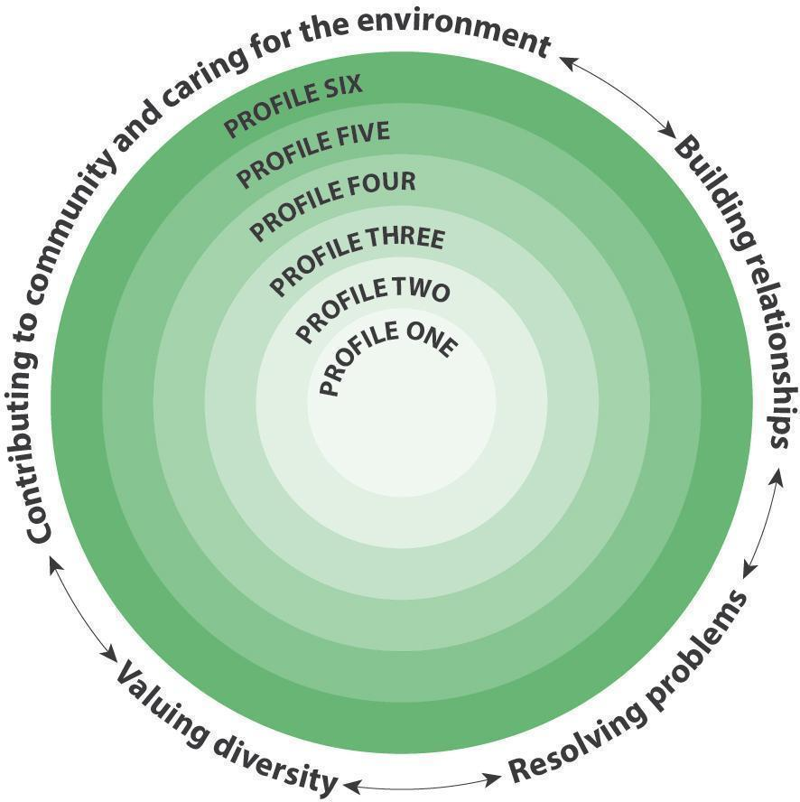

Facets

Building relationships

Students build and maintain diverse, positive peer and intergenerational relationships. They are aware and respectful of others’ needs and feelings and share their own in appropriate ways. They adjust their words and actions to care for their relationships.

Contributing to community and caring for the environment

Students develop awareness of and take responsibility for their social, physical, and natural environments by working independently and collaboratively for the benefit of others, communities, and the environment. They are aware of the impact of their decisions, actions, and footprint. They advocate for and act to bring about positive change.

Resolving problems

Students identify and develop an appreciation for different perspectives on issues. They show empathy, disagree respectfully, and create space for others to use their voices. They generate, use, and evaluate strategies to resolve problems.

Valuing diversity

Students value diversity, defend human rights, advocate for issues, and interact ethically with others. They are inclusive in their language and behaviour and recognize that everyone has something to contribute. Their approach to inclusive relationships exemplifies commitment to developing positive communities.

Profiles

Profile 1

I can be aware of others and my surroundings.

I like to be with my family and friends. I can help and be kind. I can tell when someone is sad or angry and try to make them feel better. I am aware that other people can be different from me.

Profile 2

In familiar settings, I can interact with others and my surroundings respectfully.

I can build relationships and work and play cooperatively. I can participate in activities to care for and improve my social and physical surroundings. I use materials respectfully. I can solve some problems myself and ask for help when I need it. I listen to others’ ideas and concerns. I can be part of a group and invite others to join. I can identify when something is unfair to me or to others.

Profile 3

I can interact with others and the environment respectfully and thoughtfully.

I can build and sustain relationships and share my feelings. I contribute to group activities that make my classroom, school, community, or natural world a better place. I can identify different perspectives on an issue, clarify problems, consider alternatives, and evaluate strategies. I can demonstrate respectful and inclusive behaviour with people I know. I can explain why something is fair or unfair.

Profile 4

I can take purposeful action to support others and the environment.

I can build relationships and be a thoughtful and supportive friend. I can identify ways my actions and the actions of others affect my community and the natural environment. I look for ways to make my classroom, school, community, or natural world a better place and identify small things I can do that could make a difference. I demonstrate respectful and inclusive behaviour in a variety of settings, and I recognize that everyone has something to offer.

Profile 5

I can advocate and take action for my communities and the natural world. I expect to make a difference.

I am aware of how others may feel and take steps to help them feel included. I maintain relationships with people from different generations. I work to make positive change in the communities I belong to and the natural environment. I can clarify problems or issues, generate multiple strategies, weigh consequences, compromise to meet the needs of others, and evaluate actions. I value differences; I appreciate that each person has unique gifts. I use respectful and inclusive language and behaviour, including in social media. I can advocate for others.

Profile 6

I can initiate positive, sustainable change for others and the environment.

I build and sustain positive relationships with diverse people, including people from different generations. I show empathy for others and adjust my behaviour to accommodate their needs. I advocate and take thoughtful actions to influence positive, sustainable change in my communities and in the natural world. I can analyze complex social or environmental issues from multiple perspectives and understand how I am situated in types of privilege. I act to support diversity and defend human rights and can identify how diversity is beneficial for the communities I belong to.

Connections

The Core Competencies relate to each other and with every aspect of learning.

Connections among Core Competencies

The Core Competencies are interrelated and interdependent. Taken together, the competencies are foundational to every aspect of learning. Communicating is intertwined with the other Core Competencies.

Personal and Social

Social Awareness and Responsibility is one of the Personal and Social Core Competency’s three interrelated sub-competencies, Personal Awareness and Responsibility, Positive Personal and Cultural Identity, Social Awareness and Responsibility. Social Awareness and Responsibility overlaps with the other two sub-competencies. For example:

- Students identify their personal values and strengths and abilities to determine ways they can contribute to their communities and care for the environment

- Students self-regulate to resolve problems

- Students bring their understanding of how relationships and cultural contexts shape who they are to building relationships with others

Communication

Social Awareness and Responsibility is closely related to the two Communication sub-competencies, Communicating and Collaborating. For example:

- Recognizing and appreciating different perspectives is key to both interpreting and creating communications

- Collaboration involves building and sustaining relationships, interacting, and solving problems ethically

Thinking

Social Awareness and Responsibility is closely related to the two Thinking sub-competencies, Creative Thinking and Critical and Reflective Thinking. For example:

- Creative thinking often requires students to consider and extend the value and impact of their work in influencing how people think and act

- Critical thinking requires students to consider a variety of perspectives as they analyze the audiences or users of their work

Connections with areas of learning

Social Awareness and Responsibility is embedded within the curricular competencies of the concept-based, competency-driven curriculum. Curricular competencies are focused on the “doing” within the area of learning and include skills, processes, and habits of mind required by the discipline. For example, the Social Awareness and Responsibility sub-competency can be seen in the following Big Ideas in Applied Design, Skills, and Technologies:

- Social, ethical, and sustainability considerations impact design. (ADST 9)

- Design for the life cycle includes consideration of social and environmental impacts. (Several of the 11/12 ADST curricula; see Woodwork, for example)

- Tools and technologies can influence communications and relationships. (Several of the 11/12 ADST curricula; see Woodwork, for example)

Illustrations

Title |  | Sub-competencies
Un projet UNIS Bien-être pour lutter contre les changements climatiques | Les élèves conçoivent des projets de service communautaire liés aux changements climatiques dans le cadre d’un projet UNIS Bien-être. | La collaboration, Conscience de soi et responsabilité personnelle, Conscience et responsabilité sociales
Gentillesse et empathie | Un enfant fait preuve de gentillesse et d’empathie durant ses interactions en classe avec les enseignants et ses pairs. | Conscience et responsabilité sociales
Salon de manucure | Pendant plusieurs semaines, une enfant et son amie créent une série complexe d’activités liées à un salon de manucure imaginaire. | Pensée créatrice, L'interaction, Conscience et responsabilité sociales
Organisation d’une Journée du chandail orange | Une élève, inspirée par un roman sur l’expérience d’une jeune fille dans un pensionnat indien, rassemble de plus amples renseignements et, quatre ans plus tard, organise une Journée du chandail orange dans son école. | La collaboration, Pensée critique et réflexive, Conscience et responsabilité sociales
Réécrire nos histoires négatives (troisième partie de trois) | Les élèves réagissent à une présentation d’Alvin Law et réfléchissent à la façon dont ils peuvent réécrire leurs propres histoires négatives. Trois illustrations à ce sujet ont été choisies; chacune d’elles présente un échantillon différent de travail d’élève et comporte sa propre analyse de profil. | Conscience de soi et responsabilité personnelle, Conscience et responsabilité sociales
Réécrire nos histoires négatives (deuxième partie de trois) | Les élèves réagissent à une présentation d’Alvin Law et réfléchissent à la façon dont ils peuvent réécrire leurs propres histoires négatives. Trois illustrations à ce sujet ont été choisies; chacune d’elles présente un exemple différent d’échantillon de travail d’élève et comporte sa propre analyse de profil. | Conscience de soi et responsabilité personnelle, Conscience et responsabilité sociales
Réécrire nos histoires négatives (première partie de trois) | Les élèves réagissent à une présentation d’Alvin Law et réfléchissent à la façon dont ils peuvent réécrire leurs propres histoires négatives. Trois illustrations à ce sujet ont été choisies; chacune d’elles présente un échantillon différent de travail d’élève et comporte sa propre analyse de profil. | Conscience de soi et responsabilité personnelle, Conscience et responsabilité sociales
Démarche communautaire | Des élèves visitent des organismes communautaires, puis recueillent des contributions qu’ils reversent aux organismes qui en ont besoin. | Conscience et responsabilité sociales
Consoler un ami | A child consoles his friend, who is crying because he misses his dad. | Conscience et responsabilité sociales
Proposer son aide à ses pairs | Une élève explique la façon dont elle favorise le bien-être socioaffectif de ses pairs. | Conscience et responsabilité sociales, Conscience de soi et responsabilité personnelle
Conception d’un livre pour les tout-petits | Un enfant crée un nouveau livre adapté aux « bébés ». | Conscience de soi et responsabilité personnelle, Conscience et responsabilité sociales
Entrevues avec des personnes d’âge mûr | On a demandé aux élèves d’interviewer des « personnes d’âge mûr de la collectivité », et l’élève a choisi d’interviewer un voisin de longue date. | Pensée critique et réflexive, Conscience de soi et responsabilité personnelle, Conscience et responsabilité sociales
Phobie ou peur? | Les élèves font des recherches sur les phobies pour les distinguer de la peur, puis réfléchissent et discutent des réactions aux questions d’orientation sexuelle et d’identité de genre. | Pensée critique et réflexive, Conscience et responsabilité sociales, L'interaction
Conception d’un logo pour des toilettes d’accès universel | Des élèves conçoivent un logo pour des toilettes d’accès universel. | Pensée critique et réflexive, Pensée créatrice, Conscience et responsabilité sociales, L'interaction
Fabrication d’une pâte à modeler unique en son genre | Les élèves ont travaillé en groupes pour lire des recettes et créer de la pâte à modeler originale (avec de la boue, du sable, du revitalisant pour les cheveux, de la farine d’avoine et du café). | Conscience et responsabilité sociales, L'interaction
Promenades dans la nature | Un enfant amorce des conversations et des activités lors de promenades dans la nature dans son quartier. | Conscience de soi et responsabilité personnelle, Conscience et responsabilité sociales
Rôles, droits et responsabilités | Les élèves réfléchissent à leurs rôles, à leurs droits et à leurs responsabilités au sein de leur famille et de leur communauté. | Conscience et responsabilité sociales, L'interaction
Tu me soutiens | Inspirés par le livre You Hold Me Up, les élèves prennent des photos les uns des autres, puis superposent des mots qui représentent les nombreux traits positifs que chaque élève apporte dans la salle de classe. | Conscience et responsabilité sociales
Ce qui compte | Inspirés par l’histoire What Matters, les élèves font de petits gestes qui peuvent changer les choses et créent des histoires sur leur geste dans un style semblable à celui utilisé dans le livre. | Conscience et responsabilité sociales, L'interaction
Entretenir des amitiés positives | Après avoir réfléchi à certains aspects de leur amitié, quatre élèves changent leur comportement pour entretenir des amitiés plus saines et positives. | Conscience et responsabilité sociales, Conscience de soi et responsabilité personnelle
Des paroles et des actes bienveillants | Une élève apprend qu’en étant gentil et en faisant du bien aux autres, on se sent bien aussi. | Conscience et responsabilité sociales, Conscience de soi et responsabilité personnelle
Porter bien haut le flambeau | Après avoir rencontré d’anciens combattants lors d’un événement du jour du Souvenir, un élève forme un groupe consacré aux liens intergénérationnels entre élèves et anciens combattants. | La collaboration, Pensée critique et réflexive, Conscience et responsabilité sociales
Écrire sur la gentillesse | Une élève écrit dans son journal sur la gentillesse envers les autres. | Conscience et responsabilité sociales
Burlap Sac Dress | A student takes an opportunity to change a graduation tradition and help raise funds for people in need. | Social Awareness and Responsibility
Downtown Eastside Service | Students visited a community organization where they volunteered, interacted with clients, and learned about the services provided. | Social Awareness and Responsibility
Comforting an Adult | A young child comforts an adult who cut her finger preparing classroom snacks. | Social Awareness and Responsibility
Partner Play Plans | Students worked in pairs to make, implement, and reflect on partner play plans for lunch recess. | Social Awareness and Responsibility
Inquiry and Action | A student investigates the issue of poverty and then initiates a fundraising effort by creating homemade crafts and selling them at school. | Social Awareness and Responsibility
Trees and Me | A student decides to begin adopting and caring for trees. | Social Awareness and Responsibility
Cleaning Up the Beach | A student picks up garbage on the beach as part of a class beach clean-up activity. | Social Awareness and Responsibility
Apology Letter | A student writes an apology letter to his friend. | Communicating, Social Awareness and Responsibility
Rewriting Our Negative Stories (Part One of Three) | Students respond to a presentation by Alvin Law and reflect on how they can rewrite their own negative stories. There are three related illustrations; each one has a different student work sample and profile analysis. | Personal Awareness and Responsibility, Social Awareness and Responsibility
Rewriting Our Negative Stories (Part Three of Three) | Students respond to a presentation by Alvin Law and reflect on how they can rewrite their own negative stories. There are three related illustrations; each one has a different student work sample and profile analysis. | Personal Awareness and Responsibility, Social Awareness and Responsibility
Rewriting Our Negative Stories (Part Two of Three) | Students respond to a presentation by Alvin Law and reflect on how they can rewrite their own negative stories. There are three related illustrations; each one has a different student work sample and profile analysis. | Personal Awareness and Responsibility, Social Awareness and Responsibility
Developing Positive Friendships | After reflecting on aspects of their friendship, four students change their behavior to develop healthier, more positive friendships. | Social Awareness and Responsibility, Personal Awareness and Responsibility
Kind Words and Acts | A student learns how it feels to be kind and understands that making others feel good makes her feel good too. | Social Awareness and Responsibility, Personal Awareness and Responsibility
Consoling a friend | A child consoles his friend, who is crying because he misses his dad. | Social Awareness and Responsibility
Addressing Climate Change Through a WE Wellbeing project | Students design community service projects related to climate change as part of a WE Wellbeing project. | Collaborating, Personal Awareness and Responsibility, Social Awareness and Responsibility
Kindness and Empathy | A child demonstrates kindness and empathy in her classroom interactions with teachers and peers. | Social Awareness and Responsibility
Community Outreach | Students visit community organizations and then collect and deliver contributions to the organizations that support the organization’s needs. | Social Awareness and Responsibility
You Mud? | Two children sit together and observe each other as they spread mud on an outdoor table. | Collaborating, Social Awareness and Responsibility
Making a Book for Younger Children | A child creates a new book that will be suitable for “babies.” | Personal Awareness and Responsibility, Social Awareness and Responsibility
Offering Peer Assistance | A student discusses how she supports her peers’ social emotional well-being. | Social Awareness and Responsibility, Personal Awareness and Responsibility
Interviewing an Older Adult | Students were asked to interview an “older adult from the community” and this student chose to interview a long-time neighbour. | Critical and Reflective Thinking, Personal Awareness and Responsibility, Social Awareness and Responsibility
Phobia versus Fear | Students research phobias to distinguish between phobias as fear and then discuss and reflect on reactions to SOGI. | Critical and Reflective Thinking, Social Awareness and Responsibility, Communicating
Designing a Logo for Universal Washrooms | Students design a logo for a universal washroom. | Critical and Reflective Thinking, Creative Thinking, Social Awareness and Responsibility, Communicating
Nature Walks | A child initiates conversations and activities while on nature walks in his community. | Personal Awareness and Responsibility, Social Awareness and Responsibility
You Hold Me Up | Inspired by the book, You Hold Me Up, students take photos of each other and then superimpose words that represent the many positive traits each student brings with them into the classroom community. | Social Awareness and Responsibility
A Compromise | When two children’s ideas about an imaginative story diverge, one of the children finds a compromise. | Collaborating, Social Awareness and Responsibility
What Matters | Inspired by the story What Matters, students complete small acts that can make a big difference and create stories about their act in a style like the one used in What Matters. | Social Awareness and Responsibility, Communicating
Learning to Be Brave on the Playground | With the support of a friend, a student develops pride and confidence in her ability to deal with new experiences. | Social Awareness and Responsibility, Personal Awareness and Responsibility, Communicating
Cleaning Up the School Grounds | A student chooses to clean up the leaves at the classroom entrance during free time. | Social Awareness and Responsibility, Personal Awareness and Responsibility
Journal Entries about Being Kind | A student creates journal entries about making being kind to others. | Social Awareness and Responsibility
Making Unique Dough | Students worked in groups to read recipes and create unique dough (mud dough, sand dough, hair conditioner dough, oatmeal dough, and coffee dough.) | Social Awareness and Responsibility, Communicating
Organizing an Orange Shirt Day | A student, inspired by a novel about a girl’s residential school experience, gathers further information and, four years later, organizes an Orange Shirt Day at her school. | Collaborating, Critical and Reflective Thinking, Social Awareness and Responsibility
Hold High the Torch | After meeting veterans at a Remembrance Day event, a student forms a group dedicated to intergenerational connections between students and veterans. | Collaborating, Critical and Reflective Thinking, Social Awareness and Responsibility
Roles, Rights and Responsibilities | The students explored and reflected on their roles in their friendships, and the rights and responsibilities they have to themsleves and others. | Social Awareness and Responsibility, Communicating
The Nail Salon | A child and her friend create an elaborate series of activities, over several weeks, connected to an imaginary nail salon. | Creative Thinking, Communicating, Social Awareness and Responsibility

INTRODUCTION TO MATHEMATICS

Mathematics is integral to every aspect of daily life. Mathematical skills are essential for solving problems in most areas of life and are part of human history. All peoples have used and continue to use mathematical knowledge and competencies to make sense of the world around them.

Mathematical values and habits of mind go beyond numbers and symbols; they help us connect, create, communicate, visualize, and reason, as part of the complex process of problem solving. These habits of mind are valuable when analyzing both novel and complex problems from a variety of perspectives, considering possible solutions, and evaluating the effectiveness of the solutions. When developed early in life, mathematical habits of mind help us see the math in the world around us and help to generate confidence in our ability to solve everyday problems without doubt or fear of math.

Observing, learning, and engaging in mathematical thinking empowers us to make sense of our world. For example, exploring the logic of mathematics through puzzles and games can foster a constructive mathematical disposition and result in a self-motivated and confident student with unique and individualized mathematical perspectives. Whether students choose to pursue a deeper or broader study in mathematics, the design of the Mathematics curriculum ensures that they are able to pursue their individual interests and passions while establishing a strong mathematical foundation.

Flexible teaching and learning

The Mathematics curriculum allows for instructional flexibility. For example, the curriculum components may be combined to provide a diverse range of learning opportunities. Within and across grades, there are multiple ways to combine learning standards to create lessons, units, and learning experiences, encouraging any and all approaches that support the growth and development of students’ mathematical understandings and skills.

The focus on flexible teaching and learning enables teachers to confidently choose the strategies, resources, and applications best suited to the needs of students in their local setting (e.g., embedding mathematics in issues, projects, and passions relevant to the local community). It enables teachers to focus on “hands-on” experiential learning, by incorporating the learning of foundational skills through opportunities to encounter math in a wide variety of situational contexts.

Explicit financial literacy components are included throughout the K-12 curriculum, as part of building a strong foundation of mathematical understanding and skills for every student. Regardless of the pathway students choose in Grades 11 and 12, they will share a common experience in the Mathematics curriculum that includes mathematical reasoning and probability/statistics, along with financial literacy components that have been customized to fit each area of specialty:

- Grade 11 courses (with the exception of History of Mathematics) share similar financial literacy concepts, with the structure and emphasis differing, based on the course.

- In Grade 12, both Apprenticeship Mathematics 12 and Foundations of Mathematics 12 continue financial literacy education. Apprenticeship Mathematics 12 emphasizes financial learning relevant to those pursuing the post-secondary apprenticeship path, and Foundations of Mathematics 12 continues to broaden student understanding in personal financial decision making.

Features of the Mathematics curriculum

The Mathematics curriculum is designed to build on students’ mathematics knowledge and enables them to apply this knowledge to a broad range of situations encountered in everyday life. This is facilitated by condensing the learning standards, focusing on flexible teaching and learning within relevant situational contexts, and continuing to develop a strong foundation of mathematical understandings and skills, as just one part of an interdisciplinary set of problem-solving, exploratory, and investigative skills and knowledge.

Design of the Mathematics curriculum

The Mathematics curriculum has the same format as all other areas of learning. Three curricular elements – the Big Ideas, Curricular Competencies, and Content – link the knowing, doing, and understanding of mathematics learning. Elaborations support each curricular area by providing suggestions, definitions, and clarifications to better support teaching and learning. More information on the curriculum model is available at https://www.curriculum.gov.bc.ca/curriculum/overview.

In all courses, the focus is on real-life, relevant contexts for learning, and all courses take a problem-solving approach. The Curricular Competencies for all Mathematics courses are organized around a problem-solving process adapted from the National Council of Teachers of Mathematics (NCTM), which supports inquiry, the development of thinking strategies, and the explanation and justification of mathematical ideas.

Elaborations

There are elaborations (included as hyperlinks) for many of the learning standards in the Mathematics curriculum. The elaborations take the form of explanations, definitions, and clarifications. They provide additional information and support for both teachers and students and can serve as potential places to begin teaching and learning. Examples of elaborations are shown below.

K equality as a balance and inequality as an imbalance

equality as a balance:

- modelling equality as balanced and inequality as imbalanced using concrete and visual models (e.g., using a pan balance with cubes on each side to show equal and not equal) fish drying and sharing

3 addition and subtraction to 1000

addition and subtraction:

- using flexible computation strategies, involving taking apart (e.g., decomposing using friendly numbers and compensating) and combining numbers in a variety of ways, regrouping
- estimating sums and differences of all operations to 1000
- using addition and subtraction in real-life contexts and problem-based situations
- whole-class number talks

6 multiplication and division facts to 100 (developing computational fluency)

facts to 100:

- mental math strategies (e.g., the double-double strategy to multiply 23 x 4)

9 operations with rational numbers (addition, subtraction, multiplication, division, and order of operations)

operations:

- includes brackets and exponents
- simplifying $\left(–\frac{3}{4}\right)÷\frac{1}{5}+\left(\left(–\frac{1}{3}\right)×\left(–\frac{5}{2}\right)\right)$
- simplifying $1–2×{\left(\frac{4}{5}\right)}^{2}$
- paddle making

12 polynomial functions and equations

polynomial:

- factoring, including the factor theorem and the remainder theorem
- graphing and the characteristics of a graph (e.g., degree, extrema, zeros, end-behaviour)
- solving equations algebraically and graphically

CONTINUOUS VIEWS

Continuous Views are available for Mathematics. These documents capture the progression of Big Ideas, Curricular Competencies, and Content for K-9.

Big Ideas (PDF)

Curricular Competencies (PDF)

Content (PDF)

Big Ideas

The Big Ideas are generalizations and principles discovered through experiencing the Content and Curricular Competencies of the curriculum – the “Understand” component of the Know-Do-Understand model of learning. Big Ideas represent the “aha!” and the “so what?” of the curriculum – the deeper learning.

The Big Ideas of the Mathematics curriculum highlight the progression of related skills and concepts. For each area of mathematics in Kindergarten through Grade 9 (K-9) – computational fluency, number, patterns and relations, spatial sense, and statistics and probability – important concepts are introduced in Kindergarten, growing with students and expanding in scope and depth of learning as they progress through the grades. For Grades 10 through 12, students have the opportunity to further explore their passions and interests through diverse Mathematics courses. In each of these, specialized learning builds on the K-9 progression of skills and concepts.

The chart below shows an example of the progression of number from Kindergarten through Grade 9.

Number: Number represents and describes quantity

K Numbers represent quantities that can be decomposed into smaller parts.
1 Numbers to 20 represent quantities that can be decomposed into 10s and 1s.
2 Numbers to 100 represent quantities that can be decomposed into 10s and 1s.
3 Fractions are a type of number that can represent quantities.
4 Fractions and decimals are types of numbers that can represent quantities.
5 Numbers describe quantities that can be represented by equivalent fractions.
6 Mixed numbers and decimal numbers represent quantities that can be decomposed into parts and wholes.
7 Decimals, fractions, and percents are used to represent and describe parts and wholes of numbers.
8 Number represents, describes, and compares the quantities of ratios, rates, and percents.
9 The principles and processes underlying operations with numbers apply equally to algebraic situations and can be described and analyzed.

Curricular Competencies

The Core Competencies – Thinking, Communication, and Personal and Social – are embedded in the Curricular Competencies. The Curricular Competencies introduced in Kindergarten have been expanded based on a developmental continuum throughout the grades that is focused on what students can do with their Content knowledge in mathematics. Students also build on their Curricular Competencies from year to year. The example below shows how the Curricular Competencies grow with students and expand the scope and depth of learning.

K Use reasoning to explore and make connections
3 Use reasoning to explore and make connections
6 Use reasoning and logic to explore, analyze, and apply mathematical ideas
9 Use reasoning and logic to explore, analyze, and apply mathematical ideas
12 Explore, analyze, and apply mathematical ideas using reason, technology, and other tools

Content

The Content is concept-based and reflects what students should know. It identifies the concepts or topics that students will learn about at each grade level. The Content acts as both a supporting structure intended to assist students in demonstrating the Curricular Competencies and a foundational element leading students to the Big Ideas. Examples of Content learning standards are shown below.

K number concepts to 10
3 number concepts to 1000
6 small to large numbers (thousandths to billions)
9 operations with rational numbers (addition, subtraction, multiplication, division, and order of operations)
12 polynomial functions and equations

IMPORTANT CONSIDERATIONS

Inquiry in mathematics

The Mathematics curriculum continues to support the application of foundational math skills in problem solving. It is important for students to be able to approach problem solving with confidence. A problem-solving model provides students with the necessary skills to read a problem, choose from a variety of appropriate strategies, apply a strategy to solve the problem, and then reflect on the efficiency and accuracy of the strategy to explain the answer.

Mathematical habits of mind

Extensive research indicates that for students to develop mathematical habits of mind they must encounter and interact in intentional learning settings. Classroom design combined with active participation strategies will enhance student learning, increase achievement, and contribute to the development of well-educated citizens.

Students who have developed mathematical habits of mind exhibit expertise in:

- persevering and using mathematics to solve problems in everyday life

- recognizing that there are multiple ways to solve a problem

- demonstrating respect for diversity in approaches to solving problems

- choosing and using appropriate strategies and tools

- pursuing accuracy in problem solving

First Peoples knowledge and perspectives

The Ministry of Education is dedicated to ensuring that the cultures and contributions of First Peoples in British Columbia are reflected in all provincial curricula.

The First Peoples Principles of Learning have been affirmed within First Peoples societies to guide the teaching and learning of provincial curricula. Because these principles of learning represent an attempt to identify common elements in the varied teaching and learning approaches that prevail within particular First Peoples societies, it must be recognized that they do not capture the full reality of the approach used in any single First Peoples society.

The First Peoples Principles of Learning greatly influence the B.C. curriculum and are woven throughout. They lend themselves well to mathematical learning, as they promote experiential and reflexive learning, as well as self-advocacy and personal responsibility in students. They help create classroom experiences based on the concepts of community, shared learning, and trust, all of which are vital to learning.

To address First Peoples content and perspectives in the classroom in a way that is accurate and that respectfully reflects First Peoples concepts of teaching and learning, teachers are strongly encouraged to seek the advice and support of members of local First Peoples communities. As First Peoples communities are diverse in terms of language, culture, and available resources, each community will have its own unique protocol to gain support for integration of local knowledge and expertise. Permission for the use or translation of cultural materials or practices should be obtained through consultation with individuals, families, and other community members. This authorization should be obtained prior to the use of any educational plans or materials.

FIRST PEOPLES PRINCIPLES OF LEARNING

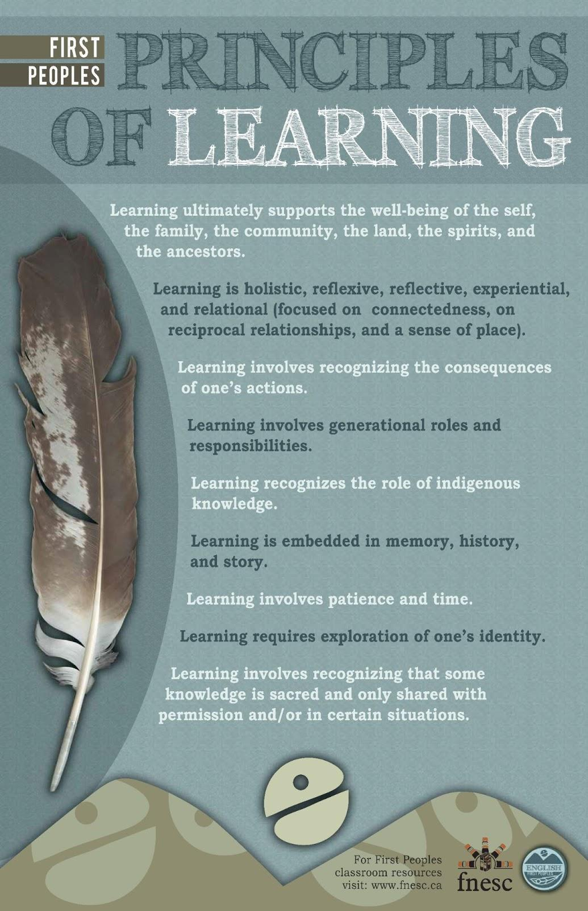

GOALS AND RATIONALE

Rationale

The British Columbia Mathematics curriculum aims to ensure that citizens are numerate and have mathematical habits of mind. The curriculum develops skills and processes that citizens can use to critically analyze information and provides the fundamentals on which mathematical specialties and professional applications of mathematics are built.

The Mathematics curriculum has been designed to develop deep mathematical understanding and fluency, logical reasoning, analytical thought, and creative thinking. There is a focus on concepts related to number sense, patterns and relations, spatial sense, and statistics and probability. Students actively investigate problems and find solutions. Throughout the K-12 Mathematics curriculum, students will develop a willingness to take risks, experiment, and make logical guesses. They will learn through both their successes and their failures, developing perseverance, competence, and confidence in mathematics.

Through the study of mathematics, students learn how to make accurate, informed, and ethical choices relating to the collection, analysis, and presentation of data. They learn how to make sound inferences and decisions through their experiences with problem solving in situational contexts. Throughout the Mathematics curriculum, students foster a strong numeracy foundation that is applicable in all areas of their lives.

Goals

The B.C. Mathematics curriculum contributes to students’ development as educated citizens through the achievement of the following goals. Students are expected to:

- develop a deep understanding of both factual (Content) and processed-based (Curricular Competencies) information, needed to solve complex problems

- reason mathematically, using their understanding of number, pattern, and spatial relationships and analyzing data in order to solve problems

- become financially literate, which supports and underpins sound financial decision making

- use flexible, effective, and personalized strategies to analyze and solve increasingly complex problems in situational contexts

- explore the connections between mathematics and other ways of knowing, such as First Peoples knowledge and other worldviews

- develop the perseverance and confidence to apply mathematical thinking in various abstract and concrete contexts

- view and navigate their world with a mathematical perspective

- develop a capacity for abstract thinking, which includes the critical thinking skills necessary for understanding global issues in society

BIG IDEAS

Algebra

Algebra allows us to generalize relationships through abstract thinking.

- Sample questions to support inquiry with students:

  - After solving a problem, can we extend it? Can we generalize it?

  - How can we take a contextualized problem and turn it into a mathematical problem that can be solved?

  - How do we tell if a mathematical solution is reasonable?

  - Where can errors occur when solving a contextualized problem?

  - What are the similarities and differences between quadratic functions and linear functions? How are they connected?

  - What do we notice about the rate of change in a quadratic function?

  - How do the strategies for solving linear equations extend to solving quadratic, radical, or rational equations?

  - What is the connection between domain and extraneous roots?

Operations

The meanings of, and connections between, operations extend to powers, radicals, and polynomials.

- Sample questions to support inquiry with students:

  - How are the different operations (+, -, x, ÷, exponents, roots) connected?

  - What are the similarities and differences between multiplication of numbers, powers, radicals, polynomials, and rational expressions?

  - How can we verify that we have factored a trinomial correctly?

  - How can visualization support algebraic thinking?

  - How can patterns in numbers lead to algebraic generalizations?

  - When would we choose to represent a number with a radical rather than a rational exponent?

  - How do strategies for factoring x²+bx+c extend to ax² + bx + c, a≠1

  - How do operations on rational numbers extend to operations with rational expressions?

Relationships

Quadratic relationships are prevalent in the world around us.

- Sample questions to support inquiry with students:

  - What are some examples of quadratic relationships in the world around us, and what are the similarities and differences between these?

  - Why are quadratic relationships so prevalent in the world around us?

  - How does the predictable pattern of linear functions extend to quadratic functions?

  - Why is the shape of a quadratic function called a parabola?

  - How can we decide which form of a quadratic function to use for a given problem?

  - What effect does each term of a quadratic function have on its graph?

Measurement

Trigonometry involves using proportional reasoning

- comparisons of relative size or scale instead of numerical difference

to solve indirect measurement problems.

- using measurable values to calculate immeasurable values (e.g., calculating the width of a river using the distance between two points on one shore and an angle to a point on the other shore)

- Sample questions to support inquiry with students:

  - How is the cosine law related to the Pythagorean theorem?

  - How can we use right triangles to find a rule for solving non-right triangles?

  - How do we decide when to use the sine law or cosine law?

  - What would it mean for an angle to have a negative measure? Identify a context for making sense of a negative angle.

CURRICULAR COMPETENCIES

Students are expected to be able to do the following:

Reasoning and modelling

Develop thinking strategies to solve puzzles and play games

- using reason to determine winning strategies

- generalizing and extending

Explore, analyze,

- examine the structure of and connections between mathematical ideas (e.g., trinomial factoring, roots of quadratic equations)

and apply mathematical ideas using reason,

- inductive and deductive reasoning

- predictions, generalizations, conclusions drawn from experiences (e.g., with puzzles, games, and coding)

technology,

- graphing technology, dynamic geometry, calculators, virtual manipulatives, concept-based apps

- can be used for a wide variety of purposes, including:

  - exploring and demonstrating mathematical relationships

  - organizing and displaying data

  - generating and testing inductive conjectures

  - mathematical modelling

and other tools

- manipulatives such as algebra tiles and other concrete materials

Estimate reasonably

- be able to defend the reasonableness of an estimated value or a solution to a problem or equation (e.g., the zeros of a graphed polynomial function)

and demonstrate fluent, flexible, and strategic thinking about number

- includes:

  - using known facts and benchmarks, partitioning, applying whole number strategies to rational numbers and algebraic expressions

  - choosing from different ways to think of a number or operation (e.g., Which will be the most strategic or efficient?)

Model

- use mathematical concepts and tools to solve problems and make decisions (e.g., in real-life and/or abstract scenarios)

- take a complex, essentially non-mathematical scenario and figure out what mathematical concepts and tools are needed to make sense of it

with mathematics in situational contexts

- including real-life scenarios and open-ended challenges that connect mathematics with everyday life

Think creatively

- by being open to trying different strategies

- refers to creative and innovative mathematical thinking rather than to representing math in a creative way, such as through art or music

and with curiosity and wonder when exploring problems

- asking questions to further understanding or to open other avenues of investigation

Understanding and solving

Develop, demonstrate, and apply conceptual understanding of mathematical ideas through play, story, inquiry, and problem solving

- includes structured, guided, and open inquiry

- noticing and wondering

- determining what is needed to make sense of and solve problems

Visualize to explore and illustrate mathematical concepts and relationships

- create and use mental images to support understanding

- Visualization can be supported using dynamic materials (e.g., graphical relationships and simulations), concrete materials, drawings, and diagrams.

Apply flexible and strategic approaches

- deciding which mathematical tools to use to solve a problem

- choosing an effective strategy to solve a problem (e.g., guess and check, model, solve a simpler problem, use a chart, use diagrams, role-play)

to solve problems

- interpret a situation to identify a problem

- apply mathematics to solve the problem

- analyze and evaluate the solution in terms of the initial context

- repeat this cycle until a solution makes sense

Solve problems with persistence and a positive disposition

- not giving up when facing a challenge

- problem solving with vigour and determination

Engage in problem-solving experiences connected with place, story, cultural practices, and perspectives relevant to local First Peoples communities, the local community, and other cultures

- through daily activities, local and traditional practices, popular media and news events, cross-curricular integration

- by posing and solving problems or asking questions about place, stories, and cultural practices

Communicating and representing

Explain and justify

- use mathematical arguments to convince

- includes anticipating consequences

mathematical ideas and decisions

- Have students explore which of two scenarios they would choose and then defend their choice.

in many ways

- including oral, written, visual, use of technology

- communicating effectively according to what is being communicated and to whom

Represent mathematical ideas in concrete, pictorial, and symbolic forms

- using models, tables, graphs, words, numbers, symbols

- connecting meanings among various representations

Use mathematical vocabulary and language to contribute to discussions in the classroom

- partner talks, small-group discussions, teacher-student conferences

Take risks when offering ideas in classroom discourse

- is valuable for deepening understanding of concepts

- can help clarify students’ thinking, even if they are not sure about an idea or have misconceptions

Connecting and reflecting

Reflect on mathematical thinking

- share the mathematical thinking of self and others, including evaluating strategies and solutions, extending, posing new problems and questions

Connect mathematical concepts with each other, with other areas, and with personal interests

- to develop a sense of how mathematics helps us understand ourselves and the world around us (e.g., daily activities, local and traditional practices, popular media and news events, social justice, cross-curricular integration)

Use mistakes

- range from calculation errors to misconceptions

as opportunities to advance learning

- by:

  - analyzing errors to discover misunderstandings

  - making adjustments in further attempts

  - identifying not only mistakes but also parts of a solution that are correct

Incorporate

- by:

  - collaborating with Elders and knowledge keepers among local First Peoples

  - exploring the First Peoples Principles of Learning (http://www.fnesc.ca/wp/wp-content/uploads/2015/09/PUB-LFP-POSTER-Princi…; e.g., Learning is holistic, reflexive, reflective, experiential, and relational [focused on connectedness, on reciprocal relationships, and a sense of place]; Learning involves patience and time)

  - making explicit connections with learning mathematics

  - exploring cultural practices and knowledge of local First Peoples and identifying mathematical connections

First Peoples worldviews, perspectives, knowledge,

- local knowledge and cultural practices that are appropriate to share and that are non-appropriated

and practices to make connections with mathematical concepts

- Bishop’s cultural practices: counting, measuring, locating, designing, playing, explaining (http://www.csus.edu/indiv/o/oreyd/ACP.htm_files/abishop.htm)

- Aboriginal Education Resources (www.aboriginaleducation.ca)

- Teaching Mathematics in a First Nations Context, FNESC (http://www.fnesc.ca/resources/math-first-peoples/)

CONTENT

Students are expected to know the following:

Real Numbers

real number system

- classification

Power Expressions

powers with rational exponents

- positive and negative rational exponents

- exponent laws

- evaluation using order of operations

- numerical and variable bases

Radical Expressions & Equations

radical operations and equations

- simplifying radicals

- ordering a set of irrational numbers

- performing operations with radicals

- solving simple (one radical only) equations algebraically and graphically

- identifying domain restrictions and extraneous roots of radical equations

Polynomial Factoring

polynomial factoring

- greatest common factor of a polynomial

- trinomials of the form ax² + bx + c

- difference of squares of the form a²x² - b²y²

- may extend to a(f(x))² + b(f(x)) + c, a²(f(x))² - b²(f(x))²

Rational Expressions & Equations

rational expressions and equations

- simplifying and applying operations to rational expressions

- identifying non-permissible values

- solving equations and identifying any extraneous roots

Quadratic Functions & Equations

quadratic functions and equations

- identifying characteristics of graphs (including domain and range, intercepts, vertex, symmetry), multiple forms, function notation, extrema

- exploring transformations

- solving equations (e.g., factoring, quadratic formula, completing the square, graphing, square root method)

- connecting equation-solving strategies

- connecting equations with functions

- solving problems in context

Linear & Quadratic Inequalities

linear and quadratic inequalities

- single variable (e.g., 3x - 7 ≤ -4, x2 - 5x + 6 > 0)

- domain and range restrictions from problems in situational contexts

- sign analysis: identifying intervals where a function is positive, negative, or zero

- symbolic notation for inequality statements, including interval notation

Trigonometric Expressions & Equations

trigonometry: non-right triangles and angles in standard position

- use of sine and cosine laws to solve non-right triangles, including ambiguous cases

- contextual and non-contextual problems

- angles in standard position:
  - degrees
  - special angles, as connected with the 30-60-90 and 45-45-90 triangles

- unit circle

- reference and coterminal angles

- terminal arm

- trigonometric ratios

- simple trigonometric equations

Financial Literacy

financial literacy: compound interest, investments, loans

- compound interest

- introduction to investments/loans with regular payments, using technology

- buy/lease

