PHYSICS 11

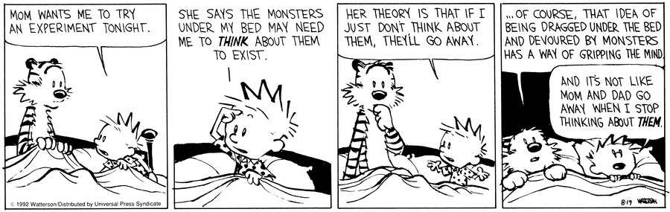
CONTENT 1
CLASSROOM EXPECTATIONS 2
INTRODUCTION TO PHYSICS 11 3
PROGRAM OF STUDIES 3
COURSE CALENDAR 4
ASSESSMENT 6

CLASSROOM EXPECTATIONS

Students are expected to:

- Refrain from the use of drugs or alcohol, including vaping.
- Refrain from verbal aggression and assault.
- Refrain from physical aggression and assault.

Students are expected to observe these classroom courtesies:

1. Be on time.
2. Come prepared to learn.
3. Demonstrate your learning each day.
4. Be respectful of the teacher, educational assistants, and classmates.
5. Respect the classroom environment.

Students are expected to be familiar with these classroom routines:

Cell Phones: Cell phones belong out of sight. Students will be provided with access to calculator apps such as Desmos Graphing Calculator and ClevCalc..

Hand-In: Students may hand in complete (or incomplete) activities at any time during the semester.

Hall Passes: Students are expected to fill out hall passes themselves and explain to staff where they are going, and for how long, before they leave the classroom.
Support: Students may access support rooms during class. Students are expected to fill out hall passes so that they might access the rooms that are supervised as well as the LART rooms that are available if students need extra one-on-one support.
Missed: If you are away from the classroom for a period of time, please contact me to establish expectations for at-home learning.
SHUT DOWNS

The curricular expectations of the class will be reduced in the event of a shutdown. Activities supporting learner acquisition of these will be posted on google classroom. It is recommended that students learning these curricular outcomes at home do so by participating in activities that help develop each of the supporting learning outcomes listed in the program of studies.

INTRODUCTION TO PHYSICS 11

The Curriculum Introduces Science, ensures Flexible Teaching and Learning, and establishes the Goals and Rationale of this and any other Mathematics Programs claiming to meet the standards of the BC Ministry of Education.

There are several Important Considerations outlined within the curriculum. These considerations are intended to be infused within the design of this program and during each of the daily activities. These considerations include Inquiry in Science, First Peoples Knowledge and Perspectives, Working with the First Peoples communities, Scientific Habits of Mind, The Environment and Science Learning, and Considerations for Classroom Action.

PROGRAM OF STUDIES

The Curriculum is full of insightful suggestions for the development and implementation of learning activities in the classroom. Pay particular attention to the sections about the three Core Competencies: Communication, Thinking, and Personal and Social.

The tasks are intended to offer all students opportunities to engage in meaningful and rigorous science that allow for the development of and each of the interrelated sub-competencies: Communicating, Collaborating, Creative Thinking, Critical and Reflective Thinking, Personal Awareness and Responsibility, Positive Personal and Cultural Identity, and Social Awareness and Responsibility.

The curriculum is designed around four big ideas: An object’s motion can be predicted, analyzed, and described, Forces influence the motion of an object, Energy is found in different forms, is conserved, and has the ability to do work, and Mechanical waves transfer energy but not matter.

This program will be delivered via hand-crafted lessons and additionally supported through unique, curricular extension opportunities. Each activity will be vetted for its contribution to the development of the Curricular Competencies: Questioning and predicting, Planning and conducting, Processing and analyzing data and information, Evaluating, Applying and innovating, and Communicating.

CONTENT
Your teacher will be approximately following this weighted grading schema:

Introduction & Skill Building | 7.9%
Motion | 28.9%
Forces | 28.9%
Energy | 23.7%
Waves | 10.5%

COURSE CALENDAR

PHYSICS 11 SEMESTER PLAN
WEEK | MONDAY | TUESDAY | WEDNESDAY | THURSDAY | FRIDAY
Sept 7 - Sept 11 | Labour Day | School Based In-Service | Introduction | Introduction | Introduction
Sept 14 - Sept 18 | Introduction | Introduction | Introduction | Motion | Motion
Sept 21 - Sept 25 | Motion | Motion | Motion | Motion | Motion
Sept 28 - Oct 2 | Motion | Motion | National Day of Truth & Reconciliation | Motion | Motion
Oct 5 - Oct 9 | Catch-Up | Motion | Motion | Motion | Motion
Oct 12 - Oct 16 | Thanksgiving Day | Motion | Motion | Motion | Motion
Oct 19 - Oct 23 | Motion | Motion | Motion | Motion | Provincial Pro-D Day
Oct 26 - Oct 30 | Motion | Motion | Motion  Exam | Forces | Forces
Nov 2 - Nov 6 | Forces | Forces | Forces | Forces | Forces
Nov 9 - Nov 13 | Forces | Forces | Remembrance Day | Forces | Forces
Nov 16 - Nov 20 | Catch-Up | Forces | Forces | Forces | Forces

PHYSICS 11 SEMESTER PLAN
WEEK | MONDAY | TUESDAY | WEDNESDAY | THURSDAY | FRIDAY
Nov 23 - Nov 27 | Forces | Forces | Forces | Forces | District PD-Day
Nov 30 - Dec 4 | Forces | Forces | Forces | Forces | Forces
Dec 7 - Dec 11 | Forces  Exam | Energy | Energy | Energy | Energy
Dec 14 - Dec 18 | Energy | Energy | Energy | Energy | Energy  Quiz
Dec 21 - Dec 25 | Christmas Break
Dec 28 - Jan 1 | Christmas Break
Jan 4 - Jan 8 | In-Service | Circuits | Circuits | Circuits | Circuits
Jan 11 - Jan 15 | Circuits | Circuits | Circuits | Circuits | Circuits  Quiz
Jan 18 - Jan 22 | Waves | Waves | Waves | Waves | Waves
Jan 25 - Jan 29 | Waves | Waves | Waves | Waves  Quiz | Course Wrap-Up

ASSESSMENT
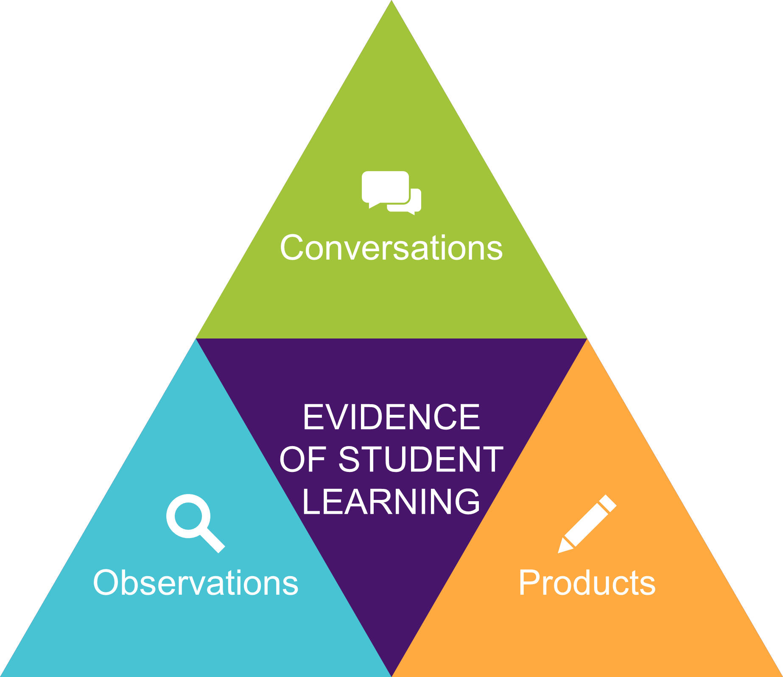
Your teacher is interested in observing the improvements and learning that take place rather than searching for errors on multiple choice exams.

As a result, you will be asked to demonstrate your learning through conversations, observations, and products. Everything counts,

This is a movement from a points-gathering system of grading to a data-gathering system. When learning is prioritised, assessment must reflect that.

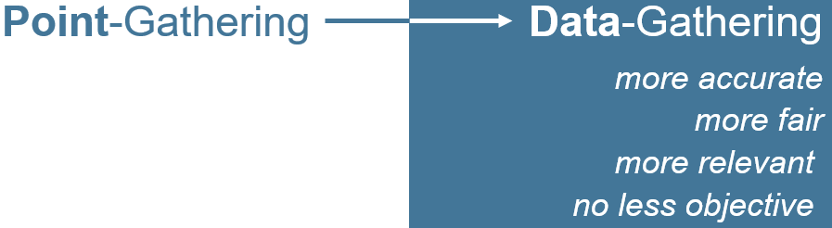

Your teacher will provide immediate, verbal feedback and will use a variety of forms of assessment throughout the course. In addition, each learning opportunity will provide information that will be used while assigning your final grade.

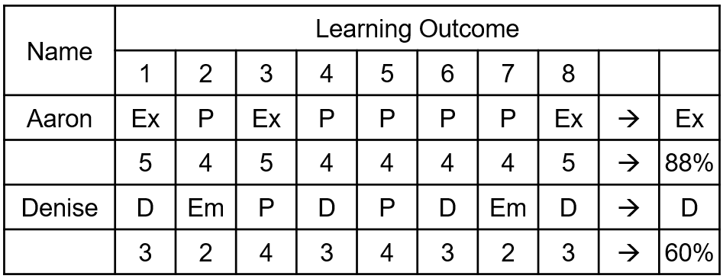

ASSESSMENT

Tasks will be designed to build trust, meaning, and capacity. All students should be able to meaningfully participate in a well-designed sequence of tasks and make sense of their learning.

As the course progresses, we will document our time together.

Students may not be able to meaningfully participate in activities without having previously discerned key mathematical attributes. Tasks might require students to have previously discerned one or more attributes in a given mathematical context.

Previous learning and experiences will lend meaning and opportunity for students participating in inquiries as they apply what they have learned so far to new situations.

Students will need to engage in dialogue, discern key mathematical ideas, and overcome potential frustrations and impediments.

Meaningful participation in tasks will alert educators to students who may wish to widen or deepen their understanding of the material and the purposes therein.

Summative Assessment will provide your teacher an opportunity to triangulate the data they have already gathered regarding your learning.

Grades will be determined by looking at a student’s overall performance in each content area, taking into account the development of skills throughout the course and the consistency with which a student demonstrates those skills.

Unit exams will provide students with one last opportunity to demonstrate their learning before each report card. A final project will provide students with one last opportunity for learning in the last week of class.

