MATHEMATICS 10

Foundations of Mathematics and Pre-calculus

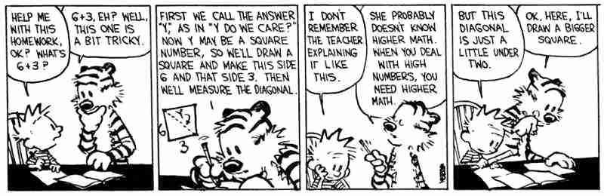

CLASSROOM EXPECTATIONS 2
INTRODUCTION 3
PROGRAM OF STUDIES 3
CONTENT 4
COURSE CALENDAR 4
ASSESSMENT 7

CLASSROOM EXPECTATIONS

Students are expected to:

- Refrain from the use of drugs or alcohol, including vaping.
- Refrain from verbal aggression and assault.
- Refrain from physical aggression and assault.

Students are expected to observe these classroom courtesies:

1. Be on time.
2. Come prepared to learn.
3. Demonstrate your learning each day.
4. Be respectful of the teacher, educational assistants, and classmates.
5. Respect the classroom environment.
6. If you know you will be away, please make me aware of it beforehand.

Students are expected to be familiar with these classroom routines:

Cell Phones: Cell phones belong in pockets or in my desk. There is one exception. Students who are using their phones responsibly to access calculator apps such as Desmos Graphing Calculator or ClevCalc are allowed to continue to do so.

Hand-In: Students may hand in complete (or incomplete) activities at any time during the semester.

Hall Passes: Students are expected to fill out hall passes themselves and explain to staff where they are going, and for how long, before they leave the classroom.
Support: Students may access support rooms during class. Students are expected to fill out hall passes so that they might access the rooms that are supervised as well as the LART rooms that are available if students need extra one-on-one support.
Missed: In our Google Classroom under Classwork, you will find the coursework, textbook, and additional information. If you are away from the classroom for a period of time, please contact me to establish expectations for at-home learning.

INTRODUCTION

The Curriculum Introduces Mathematics, ensures Flexible Teaching and Learning, and establishes the Goals and Rationale of this and any other Mathematics Programs claiming to meet the standards of the BC Ministry of Education.

There are several Important Considerations outlined within the curriculum. These considerations are intended to be infused within the design of this program and during each of the daily activities. These considerations include Inquiry in Mathematics, Mathematical Habits of Mind, and First Peoples Knowledge and Perspectives.

PROGRAM OF STUDIES

The Curriculum is full of insightful suggestions for the development and implementation of learning activities in the classroom. Pay particular attention to the sections about the three Core Competencies: Communication, Thinking, and Personal and Social.

The tasks are intended to offer all students opportunities to engage in meaningful and rigorous mathematics that allow for the development of and each of the interrelated sub-competencies: Communicating, Collaborating, Creative Thinking, Critical and Reflective Thinking, Personal Awareness and Responsibility, Positive Personal and Cultural Identity, and Social Awareness and Responsibility.

The curriculum is designed around five Big Ideas: Algebra, Powers & Polynomials, Rate of Change, Trigonometry, and Representing and Analyzing.

This program will be delivered via hand-crafted lessons and additionally supported through unique, curricular extension opportunities. Each activity will be vetted for its contribution to the development of the Curricular Competencies: Reasoning and Analyzing, Understanding and Solving, Communicating and Representing, and Connecting and Reflecting.

CONTENT

As the course progresses, we will document our time together. Students and Educators will agree on reasonable, fair grades in a build-a-grade fashion while completing course material.

Trigonometric Functions | 10.8%
Arithmetic Sequences | 30%
Linear Functions | 30%
Systems of Equations | 30%
Prime Factorization | 28.8%
Powers | 28.8%
Finance & Exponents | 28.8%
Polynomial Multiplication | 20.4%
Polynomial Factoring | 20.4%
Functions and Relations Project | 10%

COURSE CALENDAR

MATHEMATICS 10 SEMESTER PLAN
WEEK | MONDAY | TUESDAY | WEDNESDAY | THURSDAY | FRIDAY
Sept 7 - Sept 11 | Labour Day | School Based In-Service | Trigonometric Functions | Trigonometric Functions | Trigonometric Functions
Sept 14 - Sept 18 | Trigonometric Functions | Trigonometric Functions | Trigonometric Functions | Trigonometric Functions | Trigonometric Functions
Sept 21 - Sept 25 | Trigonometric Functions | Trigonometric Functions | Trigonometric Functions | Arithmetic Sequences | Arithmetic Sequences
Sept 28 - Oct 2 | Arithmetic Sequences | Arithmetic Sequences | National Day of Truth & Reconciliation | Arithmetic Sequences | Arithmetic Sequences
Oct 5 - Oct 9 | Arithmetic Sequences | Arithmetic Sequences | Arithmetic Sequences | Arithmetic Sequences | Arithmetic Sequences
Oct 12 - Oct 16 | Thanksgiving Day | Linear Functions | Linear Functions | Linear Functions | Linear Functions
Oct 19 - Oct 23 | Linear Functions | Linear Functions | Linear Functions | Linear Functions | Provincial Pro-D Day
Oct 26 - Oct 30 | Linear Functions | Linear Functions | Systems of Equations | Systems of Equations | Systems of Equations
Nov 2 - Nov 6 | Systems of Equations | Systems of Equations | Systems of Equations | Systems of Equations | Systems of Equations
Nov 9 - Nov 13 | Systems of Equations | Systems of Equations | Remembrance Day | Prime Factorization | Prime Factorization
Nov 16 - Nov 20 | Prime Factorization | Prime Factorization | Prime Factorization | Prime Factorization | Prime Factorization

MATHEMATICS 10 SEMESTER PLAN
WEEK | MONDAY | TUESDAY | WEDNESDAY | THURSDAY | FRIDAY
Nov 23 - Nov 27 | Powers | Powers | Powers | Powers | District PD-Day
Nov 30 - Dec 4 | Powers | Powers | Powers | Powers | Powers
Dec 7 - Dec 11 | Finance & Exponents | Finance & Exponents | Finance & Exponents | Finance & Exponents | Finance & Exponents
Dec 14 - Dec 18 | Finance & Exponents | Polynomial Multiplication | Polynomial Multiplication | Polynomial Multiplication | Polynomial Multiplication
Dec 21 - Dec 25 | Christmas Break
Dec 28 - Jan 1 | Christmas Break
Jan 4 - Jan 8 | In-Service | Polynomial Multiplication | Polynomial Multiplication | Polynomial Multiplication | Polynomial Factoring
Jan 11 - Jan 15 | Polynomial Factoring | Polynomial Factoring | Polynomial Factoring | Polynomial Factoring | Polynomial Factoring
Jan 18 - Jan 22 | Polynomial Factoring | Polynomial Factoring | Polynomial Factoring | Functions and Relations Project | Functions and Relations Project
Jan 25 - Jan 29 | Functions and Relations Project | Functions and Relations Project | Functions and Relations Project | Functions and Relations Project | Course Wrap-Up

ASSESSMENT
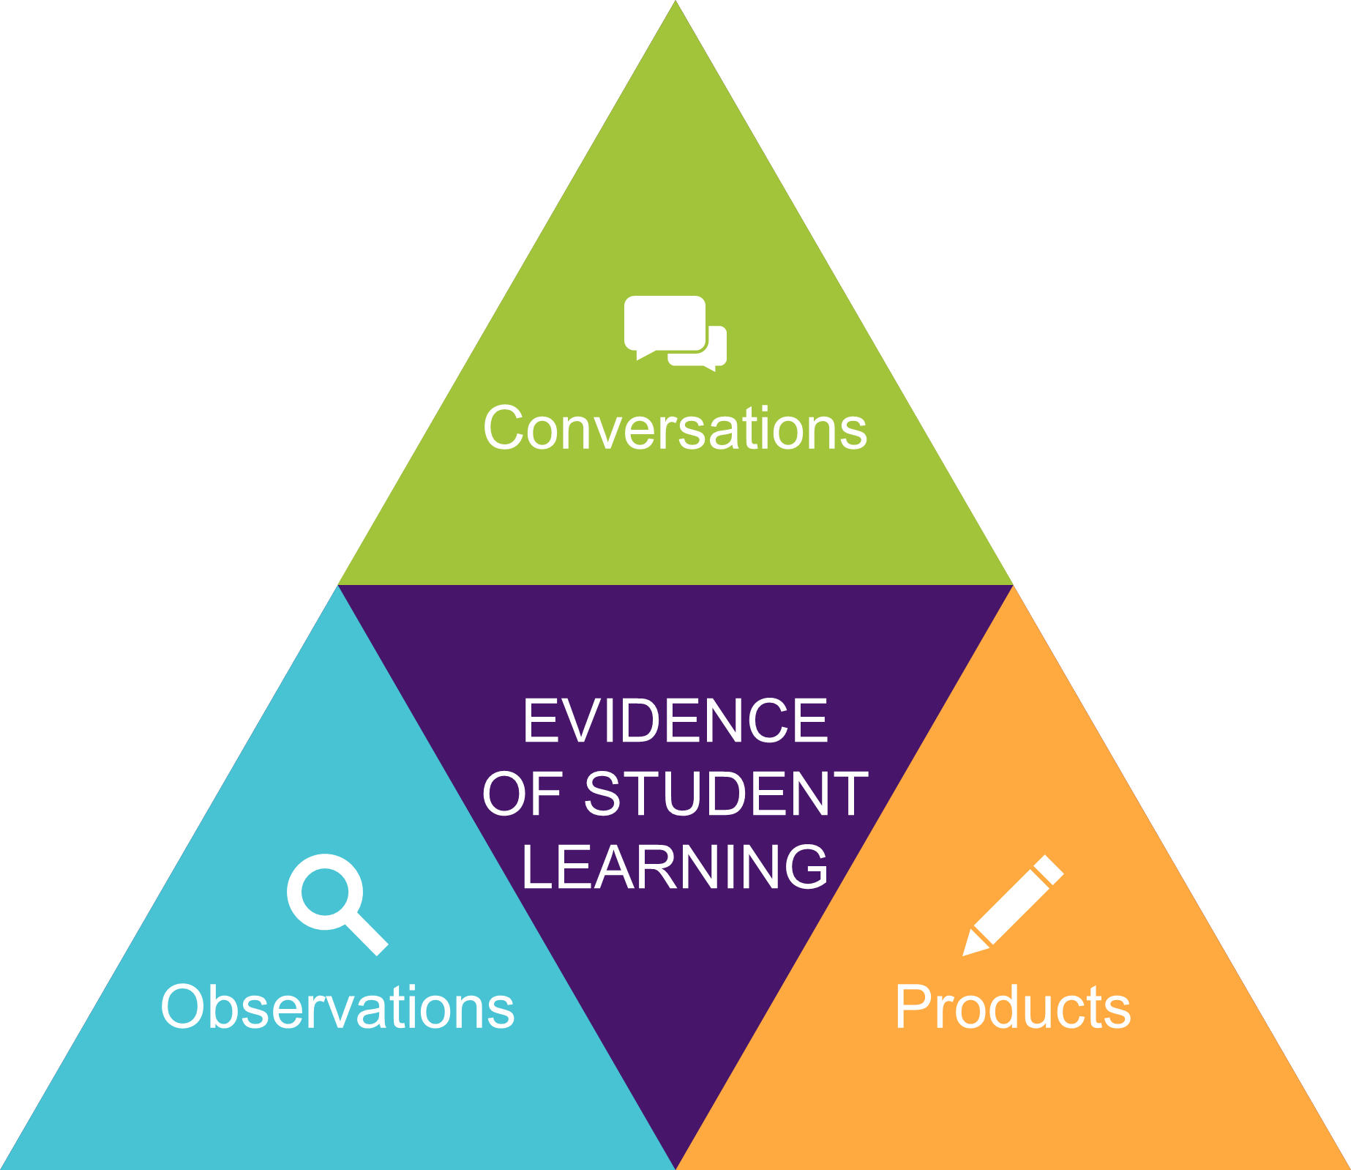
Your teacher is interested in observing the improvements and learning that take place rather than searching for errors on multiple choice exams.

As a result, you will be asked to demonstrate your learning through conversations, observations, and products. Everything counts,

This is a movement from a points-gathering system of grading to a data-gathering system. When learning is prioritised, assessment must reflect that.

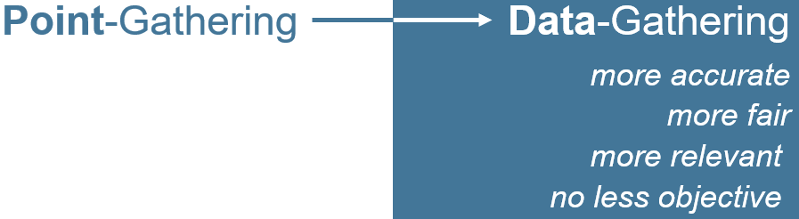

Your teacher will provide immediate, verbal feedback and will use a variety of forms of assessment throughout the course. In addition, each learning opportunity will provide information that will be used while assigning your final grade.

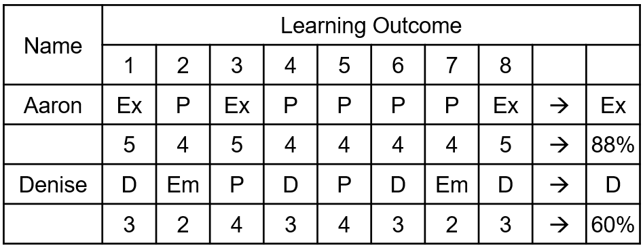

ASSESSMENT

Tasks will be designed to build trust, meaning, and capacity. All students should be able to meaningfully participate in a well-designed sequence of tasks and make sense of their learning.

As the course progresses, we will document our time together.

Students may not be able to meaningfully participate in activities without having previously discerned key mathematical attributes. Tasks might require students to have previously discerned one or more attributes in a given mathematical context.

Previous learning and experiences will lend meaning and opportunity for students participating in inquiries as they apply what they have learned so far to new situations.

Students will need to engage in dialogue, discern key mathematical ideas, and overcome potential frustrations and impediments.

Meaningful participation in tasks will alert educators to students who may wish to widen or deepen their understanding of the material and the purposes therein.

Grades will be determined by looking at a student’s overall performance in each content area, taking into account the development of skills throughout the course and the consistency with which a student demonstrates those skills.

A final project will provide students with one last opportunity for learning in the last week of class.

