Infinite Series

Part A — Understanding Infinite Series

- When does a geometric series have a finite sum? State the condition on $r$.

Part B — Determining Convergence

- Determine whether each series is convergent or divergent. Justify your answer:
$$50+45+\frac{81}{2}+\frac{729}{20}+…$$

- For what values of $x$will the series have a finite sum?
$$1+\frac{x-2}{3}+{\left(\frac{x-2}{3}\right)}^{2}+{\left(\frac{x-2}{3}\right)}^{3}+…$$

Part C — Fraction-Based Series

- Find the sum:
$$12+\frac{3}{4}+\frac{9}{16}+\frac{27}{64}+…$$

Part D — Direct Infinite Sums (Core Skills)

- Find the sum of each infinite geometric series. Show all work:

- $27+9+3+1+…$

- $\frac{14}{3}+\frac{7}{3}+\frac{7}{6}+…$

- $1-0.5+0.25-\frac{1}{8}+…$

- $\frac{125}{64}-\frac{25}{16}+\frac{5}{4}-…$

Part E — Reverse Problems

- The sum of an infinite geometric series is 1 and the common ratio is $-\frac{2}{5}$.
Find the first three terms.

- An infinite geometric series has $S_{∞}=24$ and $r=\frac{3}{4}$.
Find the 8th term.

Part F — Algebra with Infinite Series

- Given $a=12$ and $S_{∞}=350$, find $r$.

- If $1+x+x^{2}+x^{3}+⋯=20$, find $x$.

- Given $S_{3}=19$and $S_{∞}=27$, find $r$.

Part G — Visual / Pattern Models

- A trapezoid is repeatedly divided into four equal parts, and one part is shaded each time. Identify the first term and common ratio, then write an equation for $S_{∞}$and determine the total shaded area.
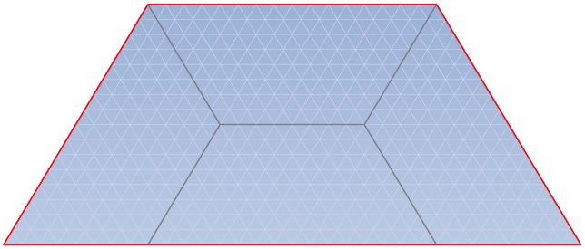

Part H — Repeating Decimals (Geometric Series)

- Convert each repeating decimal into a fraction using a geometric series and Newton’s Method:
Newton’s Method:
  - Write the number as an expanded number with lots of decimal places.
  - Write this number as the sum of infinite decimals.
  - Write this number as the sum of infinite fractions.
  - Identify the $a$ and r for the series.
  - Use the infinite geometric series formula and simplify it to find the fraction.

- $0.0\overset{‾}{3}$

- $5.\overset{‾}{36}$

- $0.\overset{‾}{87}$

Part I — Applications

- A ball is dropped from a height of 2.0m. After each bounce, it rises to 63% of its previous height.
a) Total distance after 5 bounces
b) Total distance until it comes to rest

- An oil well produces 30,000 barrels in its first month and decreases by 5% each month. What is the total production before it runs completely dry?

- A worker can be paid either:
- $5000 per day for 100 days
- or $0.01, $0.02, $0.04, … for 100 days
a) Which is better?

