Pulleys & Multi-Body Systems

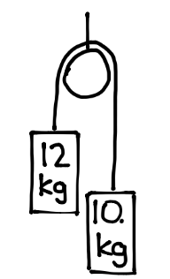
- Determine the acceleration of the system and the tension of each rope.

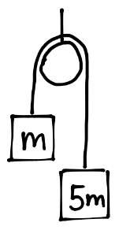
- Determine the acceleration of the system and the tension of the rope. One mass is five times heavier than the other mass.

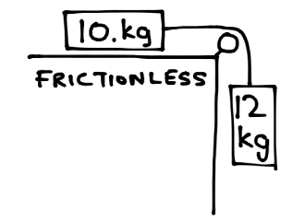
- Determine the acceleration of the system and the tension of the rope.

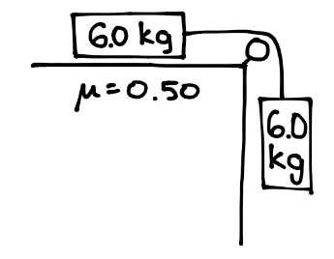
- Determine the acceleration of the system and the tension of the rope.

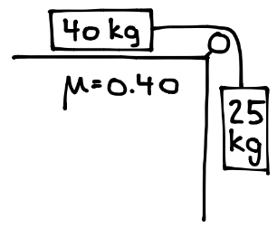
- Determine the acceleration of the system and the tension of the rope.

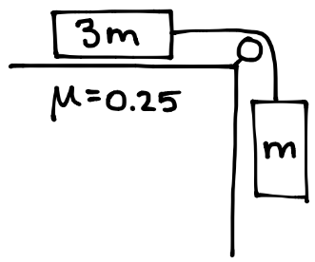
- Determine the acceleration of the system and the tension of the rope. One mass is three times heavier than the other mass.

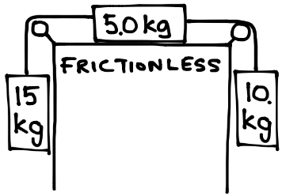
- Determine the acceleration of the system and the tension of the rope.

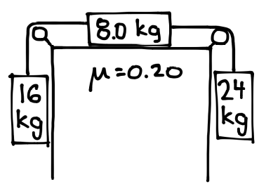
- Determine the acceleration of the system and the tension of the rope.

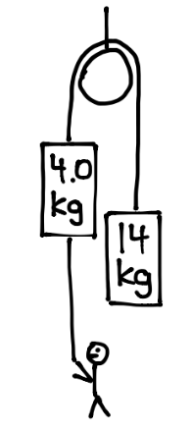
- The man pulls on a rope attached the 4.0 mass. What minimum force must he exert so the 14 kg mass does not hit his head? What would be the tension in the rope connecting the two masses?

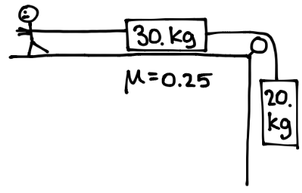
- The man pulls on a rope attached to 30 kg mass. If he exerts a force of 500. N, determine the acceleration of the system and the tension in the rope connecting the two masses.

