Circuits Challenge Questions

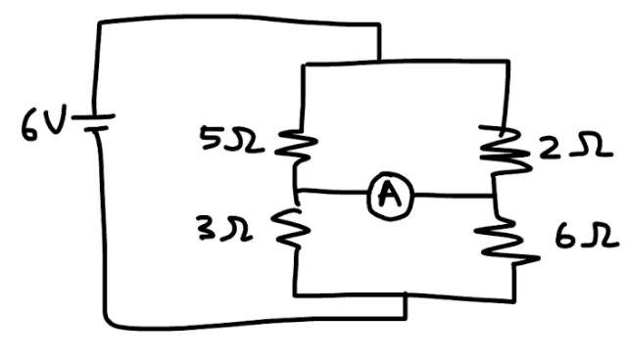
- Determine the reading of the ammeter.

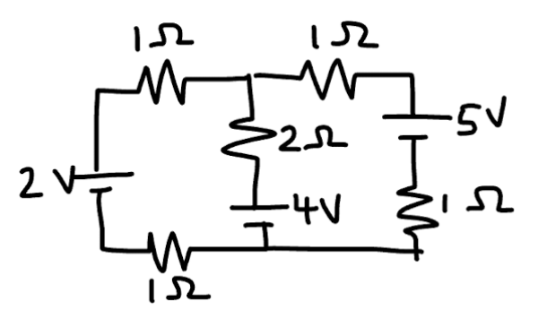
- Determine the current in each branch of the circuit.

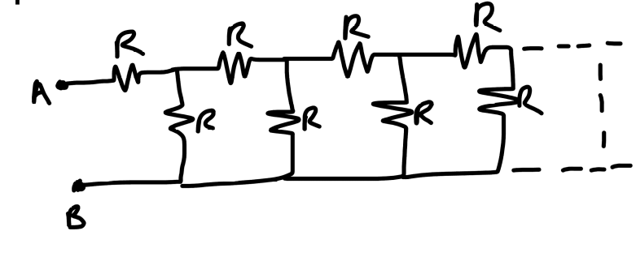
- Determine the equivalent resistance between points A and B in terms of R.

