More Terminal Voltage & Power

Notes for Students
- The power dissipated by a resistor can be calculated using:
$$P=IV \text{or} P=I^{2}R \text{or} P=\frac{V^{2}}{R}$$
- In series circuits, the current is the same through each component.
- In parallel circuits, the voltage across each branch is the same.
- The brightness of a bulb depends on the power it dissipates.

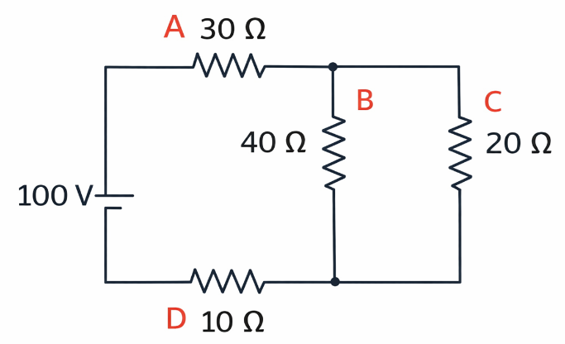
- Four identical light bulbs are connected to a 100 V power source, as shown in the diagram. The bulbs have the following resistances: Bulb A: $30 Ω,$Bulb B: $40 Ω,$Bulb C: $20 Ω,$Bulb D: $10 Ω$
The circuit has the following structure:
- Bulbs B and C are connected in parallel with each other.
- This parallel combination is connected in series with bulbs A and D.

(a) Determine the current through each bulb.

(b) Determine the power dissipated by each bulb (A, B, C, and D).

- The circuit from Question 1 is modified by adding a fifth bulb that is identical to bulb B.
- The new bulb is connected in parallel with bulbs B and C.
- All other aspects of the circuit remain unchanged.

(a) Determine the new equivalent resistance of the parallel section.

(b) Determine the total current supplied by the power source in the modified circuit.

- Using the modified circuit from Question 2:
For each bulb, indicate how its brightness changes compared to the original circuit in Question 1.
☐ brighter ☐ dimmer ☐ the same
- Bulb A: ☐ brighter ☐ dimmer ☐ the same
- Bulb D: ☐ brighter ☐ dimmer ☐ the same
- Bulb B: ☐ brighter ☐ dimmer ☐ the same
- Bulb C: ☐ brighter ☐ dimmer ☐ the same
(Explain your reasoning clearly, referring to:)
- how the total resistance of the circuit changes
- how current and voltage behave in series and parallel sections
- the relationship between power and brightness

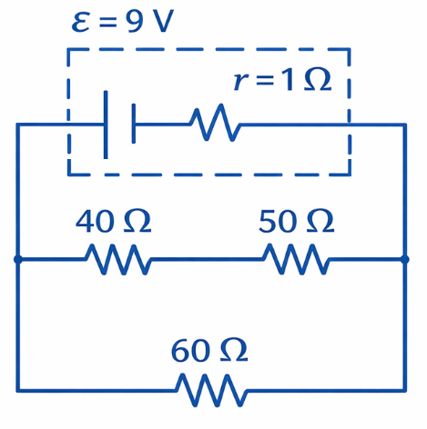
- A real battery with an emf of $ε=9.0\text{ V}$and an internal resistance of $r=1.0$is connected to an external circuit, as shown in the diagram. The external circuit consists of two branches connected in parallel:
- Upper branch: two resistors in series, $40 Ω$ and $50 Ω$
- Lower branch: a single resistor $60 Ω$
Determine the terminal voltage of the battery.

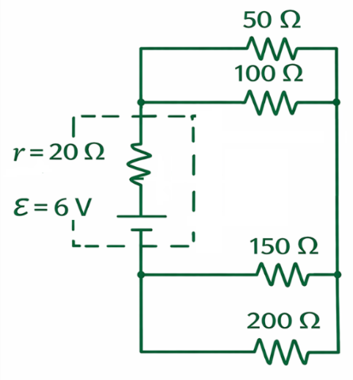
- A real battery with an emf of $ε=6.0\text{ V}$and an internal resistance of $r=20 Ω$is connected to an external circuit, as shown in the diagram. The external circuit consists of two parallel sections connected in series:
- Upper parallel section, $50 Ω$ and $100 Ω$
- Lower parallel section $150 Ω$ and $200 Ω$
Determine the terminal voltage of the battery.

- A real battery with an emf of 𝜀 = 18.0 V is connected to an external circuit, as shown in the diagram. The external circuit consists of two resistors connected in parallel:
- Upper branch resistor: 𝑅₁ = 12 Ω
- Lower branch resistor: 𝑅₂ = 6.0 Ω
The terminal voltage of the battery is measured to be 12.0 V while the circuit is operating.
Assume:
- All connecting wires have negligible resistance
- The battery’s internal resistance r is in series with the external circuit
(a) Determine the equivalent resistance of the external circuit.
(b) Determine the total current supplied by the battery.
(c) Determine the internal resistance r of the battery.

- A heating coil with a resistance of $10 Ω$is connected to a 120 V power supply. The coil is immersed in a container holding 2.0 L of water. The water initially has a temperature of 20 °C.
Additional information:
- The specific heat capacity of water is $c=4.18\text{ J/(}\text{g°C}\text{)}$
- Assume:
  - All electrical energy from the coil goes into heating the water
  - No heat is lost to the surroundings
  - The density of water is $1.0\text{ g/mL}$
(a) Determine the time required for the heating coil to raise the temperature of the water to 100 °C.
(b) Electricity costs $0.11 per kWh. Determine the cost to heat the water from 20 °C to 100 °C.
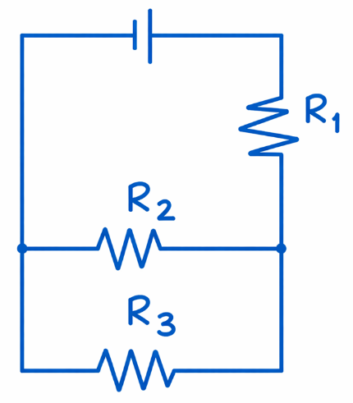
- The circuit shown consists of three identical resistors, labeled $R_{1}$, $R_{2}$, and $R_{3}$, connected to an ideal battery, as shown in the diagram.
- Resistor $R_{1}$is connected on the right-hand vertical branch.
- Resistors $R_{2}$and $R_{3}$are connected next in parallel on separate horizontal branches.
- The battery is connected across the top of the circuit.
Assume:
- All resistors have the same resistance $R$
- The battery and connecting wires are ideal
- No energy is lost outside the resistors
(a) Determine the power dissipated by each resistor: $P_{1}$, $P_{2}$, and $P_{3}$.
(b) Compare the power outputs of the three resistors by writing your answer as ratios (for example, $P_{1}=2P_{2}$or $P_{1}=P_{2}=P_{3}$).
(c) Briefly explain your reasoning, referring to:
- which resistors share the same current
- which resistors share the same voltage
- the relationship between power, current, and voltage

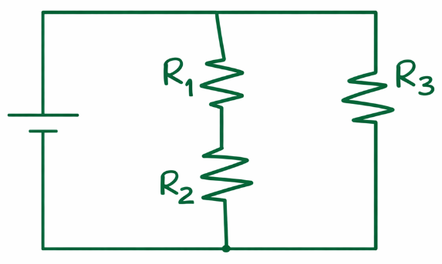
- The circuit shown consists of three identical resistors, labeled $R_{1}$, $R_{2}$, and $R_{3}$, connected to an ideal battery, as shown in the diagram.
• Resistors $R_{1}$and $R_{2}$are connected in series on the middle vertical branch of the circuit.
• Resistor $R_{3}$is connected on the right-hand vertical branch.
• The series combination $R_{1}+R_{2}$is connected in parallel with resistor $R_{3}$.
• The battery is connected across the top and bottom nodes of the circuit.
Assume:
- All resistors have the same resistance $R$
- The battery and connecting wires are ideal
- No energy is lost outside the resistors
(a) Determine the power dissipated by each resistor: $P_{1}$, $P_{2}$, and $P_{3}$.
(b) Compare the power outputs of the three resistors by writing your answer as ratios (for example, $P_{1}=2P_{2}$or $P_{1}=P_{2}=P_{3}$).
(c) Briefly explain your reasoning, referring to:
- which resistors share the same current
- which resistors share the same voltage
- the relationship between power, current, and voltage

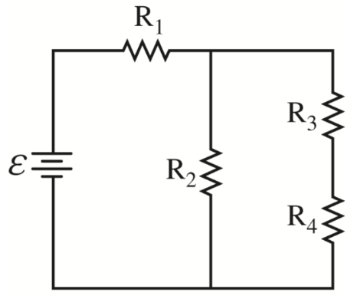
- A circuit consists of an ideal battery with emf $ε$connected to four identical resistors, each with resistance $R$, arranged as shown in the diagram.
- $R_{1}$is connected in series with the rest of the circuit.
- After $R_{1}$, the circuit splits into two parallel branches:
  - One branch contains a single resistor $R_{2}$.
  - The other branch contains two resistors $R_{3}$and $R_{4}$connected in series.
- The two branches then rejoin and return to the battery.
Assume:
- All resistors have resistance $R$
- The battery and connecting wires are ideal
- All results should be expressed symbolically in terms of $ε$and $R$
(a) Derive an expression for the current $I_{1}$through resistor $R_{1}$.
(b) Derive an expression for the current $I_{3}$through resistor $R_{3}$.
(c) Derive an expression for the total power dissipated in the circuit.

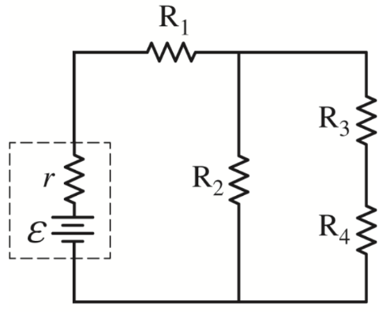
- A circuit consists of four identical resistors, labeled $R_{1}$, $R_{2}$, $R_{3}$, and $R_{4}$, arranged as shown in the diagram.
- $R_{1}$is connected in series with the rest of the circuit.
- After $R_{1}$, the circuit splits into two parallel branches:
  - One branch contains a single resistor $R_{2}$.
  - The other branch contains two resistors, $R_{3}$and $R_{4}$, connected in series.
- The branches rejoin and return to the battery.
Original Circuit
- The circuit is first connected to an ideal battery (no internal resistance).
- The total power dissipated in the resistors is $P_{\text{original}}$
Modified Circuit
- The ideal battery is then replaced with a non-ideal battery having:
- an emf $ε$
- an internal resistance $r$, as shown in the dashed box in the diagram
- The total power dissipated in the circuit is now $P_{\text{new}}$
Is $P_{\text{new}}$greater than, less than, or equal to $P_{\text{original}}$?
☐ greater than ☐ less than ☐ equal to
Explain your reasoning clearly, referring to:
- how the internal resistance affects the total current
- how power depends on current and resistance
- where energy is dissipated in each case

