Terminal Voltage and Power

Notes for students
- The terminal voltage is the voltage across the external circuit.
- The internal resistance of the battery must be included when determining the current.
- You may use the relationship $V_{\text{terminal}}=ε-Ir$

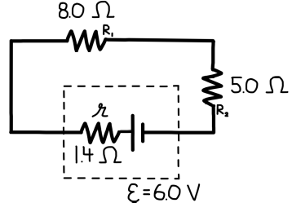
- A real battery with an emf of $6.0\text{ V}$and an internal resistance of $1.4$is connected to an external circuit, as shown in the diagram.
The external circuit consists of two resistors connected in series:
- $R_{1}=8.0$
- $R_{2}=5.0$
Assume all connecting wires have negligible resistance.
Determine the terminal voltage of the battery while the circuit is operating.

Notes for students
- The internal resistance is in series with the external resistors.
- Power dissipated in a resistor can be found using $P=I^{2}R$
- The emf of the battery is related to the current and total resistance by $V_{\text{terminal}}=ε-Ir$

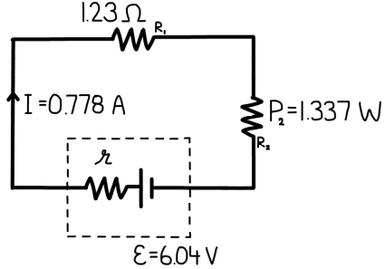
- A real battery with an emf of $ε=6.04\text{ V}$and an unknown internal resistance $r$is connected to an external circuit, as shown in the diagram.
The external circuit consists of two resistors connected in series:
- $R_{1}=1.23 Ω$
- $R_{2}$, which dissipates power at a rate of $P_{2}=1.337\text{ W}$
The current in the circuit is measured to be $I=0.778\text{ A}$
Assume all connecting wires have negligible resistance.
Determine the internal resistance $r$of the battery.

Notes for students
- The internal resistance affects the current supplied by the cell, but not the measured voltage across $R_{1}$.

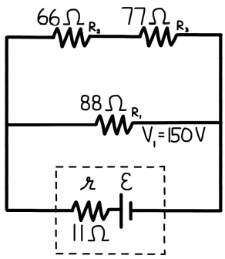
- A real cell with an internal resistance of $r=11 Ω$is connected to an external circuit, as shown in the diagram. The external circuit consists of two parallel branches:
- Upper branch: two resistors connected in series
  - $R_{2}=66 Ω$
  - $R_{3}=77 Ω$
- Middle branch: a single resistor $R_{1}=88 Ω$
The voltage across $R_{1}$is measured to be $V_{1}=150\text{ V}$
Assume all connecting wires have negligible resistance.
Determine the electromotive force (emf), $ε$, of the cell.

Notes for students
- Power dissipated in the internal resistance can be found using $P=I^{2}r$

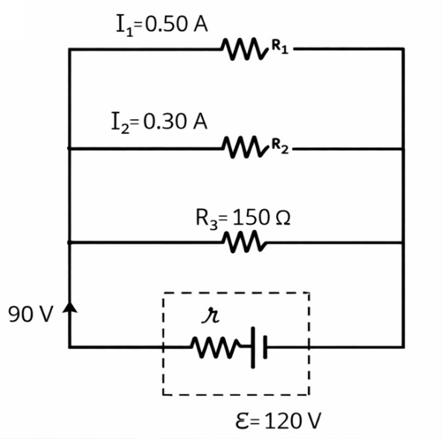
- A real battery with an emf of 𝜀 = 120 V and an internal resistance r is connected to an external circuit, as shown in the diagram. The external circuit consists of three resistors connected in parallel:
- Top resistor: current 𝐼₁ = 0.50 A
- Middle resistor: current 𝐼₂ = 0.30 A
- Bottom resistor: resistance 𝑅₃ = 150 Ω
The terminal voltage of the battery is measured to be 90 V.
Assume all connecting wires have negligible resistance.
(a) Determine the total current supplied by the battery.
(b) Determine the internal resistance r of the battery.

Notes for students
- Power dissipated in the internal resistance can be found using $P=I^{2}r$

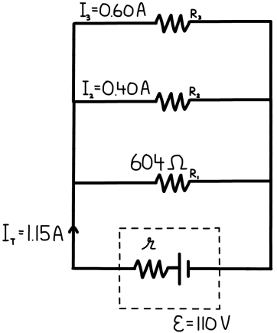
- A real battery with an emf of $ε=110\text{ V}$and an unknown internal resistance $r$is connected to three external resistors, arranged as shown in the diagram. The three external resistors are connected in parallel and have the following information:
- The current through the top resistor is $I_{1}=0.60\text{ A}$
- The current through the middle resistor is $I_{2}=0.40\text{ A}$
- The resistance of the bottom resistor is $R_{3}=604$
The total current supplied by the battery is: $I_{T}=1.15\text{ A}$
Assume all connecting wires have negligible resistance.
(a) Determine the internal resistance $r$of the battery.
(b) Determine the power dissipated in the battery’s internal resistance.

Notes for students
- The internal resistance is in series with the external circuit.
- You may use the relationship $V_{\text{terminal}}=ε-Ir$

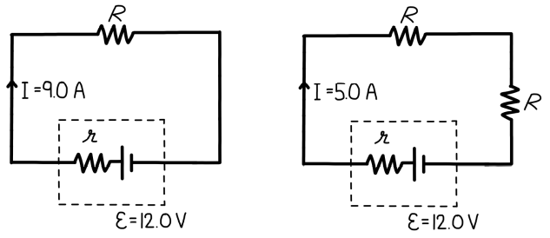
- A power supply has an emf of $ε=12.0\text{ V}$and an internal resistance $r$. Two experiments are performed using the same power supply, as shown in the diagrams.
Experiment 1
The power supply is connected to one resistor of resistance $R$.
- The current delivered by the supply is $I_{1}=9.0\text{ A}$
Experiment 2
The same power supply is connected to two identical resistors, each of resistance $R$, connected in series.
- The current delivered by the supply is $I_{2}=5.0\text{ A}$
Assume all connecting wires have negligible resistance.
Determine the internal resistance $r$of the power supply.

Notes for students
- Useful relationships: $Q=It, P=IV, P=I^{2}R, E=Pt$

- A resistor of resistance 𝑅 = 40 Ω is connected to a power supply. The current through the resistor is measured to be 𝐼 = 0.50 A. Assume the circuit operates continuously for 30 minutes.
(a) Determine the power dissipated by the resistor.
(b) Determine the total energy dissipated by the resistor during this time.

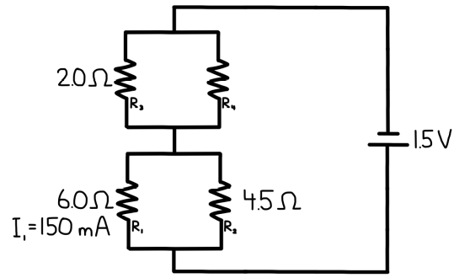
- The circuit consists of two parallel sections connected in series:
Upper parallel section
- $R_{1}=6.0 Ω$
- $R_{2}=45 Ω$
Lower parallel section
- $R_{3}=20 Ω$
- $R_{4}(resistance not specified)$
The current through resistor $R_{3}$is measured to be: $I_{1}=150\text{ mA}$
Assume all connecting wires have negligible resistance.
(a) Determine the amount of electric charge that flows through resistor $R_{4}$ in 1.0 hour.
(b) Determine the power dissipated by resistor $R_{4}$.
(c) Determine the total energy dissipated by resistor $R_{4}$during 1.0 hour of operation.

