Energy Review

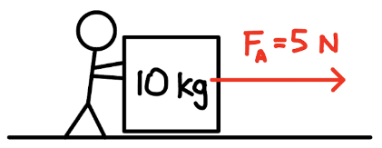
- A 10 kg box is pushed with an applied force of 5 N. There is no friction between the box and the floor. If the initial speed of the box is 2 m/s, determine the speed of the box after it has moved 10 m.
  - Solve using work and energy.
  - Solve using kinematics and dynamics.

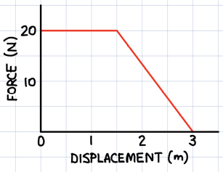
- A 10 kg box is initially at rest and is pushed with a force with a magnitude as shown on the graph. If the box slides without friction, determine its final speed.

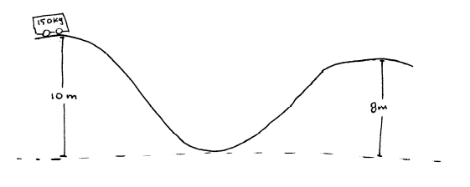
- A 150kg roller coaster is going down a 10m hill as shown. At the top of the first hill, the velocity of the roller coaster is zero. Assuming there is no friction.
  - Determine the speed at the bottom of the hill.
  - Determine the speed at the top of the second hill.
  - How would the speed change if the hills were steeper (but still the same height)?

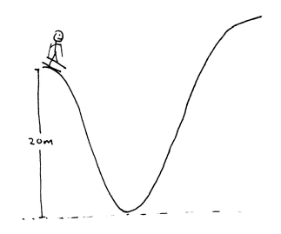
- A 70kg skier, from rest, skis down a 20m hill and up a second hill as shown.
  - How high up the second hill does the skier get if there is no friction?
  - If the skier reaches a maximum height of 18m on the second hill, how much mechanical energy was lost due to friction?

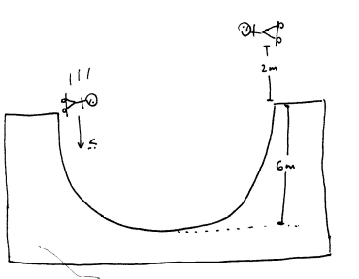
- A skateboarder pushes himself downward along a half pipe. After travelling across the half pipe, he goes up a distance of 2m into the air (as shown in the diagram). What was the initial velocity of the skateboarder?

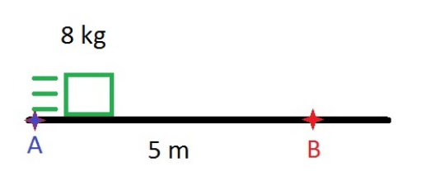
- An 8.0 kg block is launched from point A to point B over a rough surface. As the block passes point B, it has slowed down to a velocity of 4.0 m/s and it has generated 36 J of heat energy. What is the speed when it was launched from point A?

- A 60kg circus performer falls 10m from rest onto a trampoline and bounces back up to a height of 8m.
  - How much mechanical energy has been lost in this process?
  - List two forms of energy which the mechanical energy may have been transformed in to.

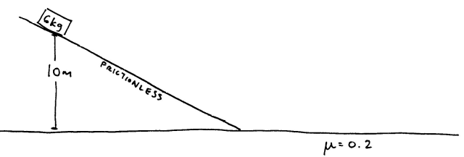
- A 6kg block slides down a frictionless ramp with a height 10m. The block then slides along a horizontal surface with a coefficient of friction, μ=0.2.
  - What is speed of the block when it reaches the base of the ramp?
  - After sliding for 3m, what is the speed of the block?
  - How far does the block slide from the base of the ramp before it stops?

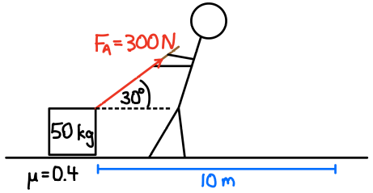
- A 50 kg box starts from rest and is pulled 10 m across the floor as shown.
  - How much work does the person do on the box?
  - How much work does friction do on the box?
  - What is the total amount of work done on the box?
  - What is the final speed of the box? Solve using energy.

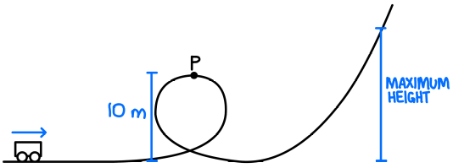
- In an amusement park ride, a 400 kg car is given an initial speed of 90 km/h.
  - If 20 kJ of mechanical energy is lost due to friction by the time the car reaches point P, what is its speed at that point?
  - What maximum height does the car reach if a total of 40 kJ of mechanical energy is lost due to friction (from the beginning to the maximum height)?

- A object starts from rest 3.0 m above the ground and slides down a frictionless incline and then along a rough horizontal surface.
  - What is the speed of the object when it reaches the bottom of the incline?
  - How far does the block slide on the horizontal surface before coming to rest?

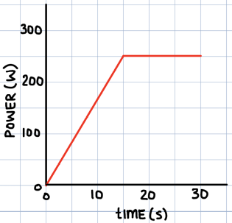
- The graph shows the power output of a device used to accelerate a 150 kg object.
  - What is the final speed of the object if it starts from rest?
  - If the device consumes 9600 J of energy over the 30 seconds, what is the efficiency of the device?

