The Doppler Effect

For a stationary observer and a moving source of sound, the frequency (f_{obs}) of sound perceived by the observer is
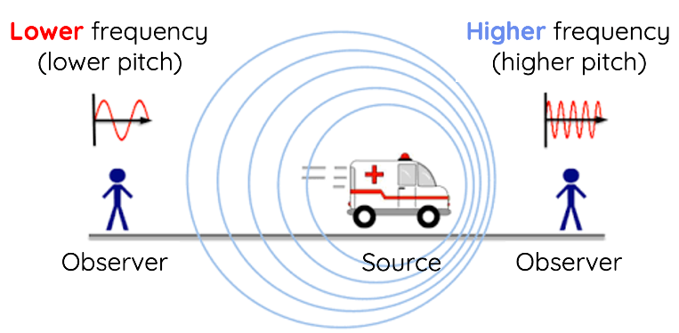

The Doppler Formula:

$$f_{obs}=f_{s}\left(\frac{v_{w}}{v_{w}±v_{s}}\right)$$

f_{s} is the frequency of sound from a source,
v_{s} is the speed of the source,
v_{w} is the speed of sound.

- A car is honking its horn at a frequency of f_{s} = 500 Hz. It moves toward a stationary observer at v_{s} = 20 m/s. Assume the speed of sound is v_{w} = 340 m/s.
- What frequency does the observer hear?
- If instead the car were moving away at 20 m/s, what would be the observed frequency?

- A fireworks truck siren emits a tone of f_{s} = 800 Hz. When the truck is moving away from a stationary observer at v_{s} = 25 m/s, what is the observed frequency? Take v_{w} = 340 m/s.

- A factory whistle has a known frequency of f_{s} = 450 Hz. An observer on a sidewalk hears a frequency of f_{obs} = 480 Hz as the source approaches. If v_{w} = 340 m/s, find the speed of the whistle by rearranging the Doppler formula to solve for v_{s}.

- A train horn is known to be f_{s} = 300 Hz. A stationary observer records f_{obs} = 280 Hz as the train moves away. If v_{w} = 340 m/s, how fast is the train traveling?

- An ambulance siren’s frequency is f_{s} = 700 Hz.
- If the ambulance travels toward a stationary observer at v_{s} = 30 m/s, find f_{obs}.
- Once it passes and travels away at the same speed, what does the observer measure then? (Assume v_{w} = 340 m/s.)

- A race car’s engine produces a tone of f_{s} = 1000 Hz. The car moves at v_{s} = 60 m/s (about 216 km/h).
- Calculate the observed frequency as the car approaches.
- Calculate the observed frequency as the car recedes. (Assume v_{w} = 340 m/s.)

- A distant alarm is known to sound at f_{s} = 600 Hz. A stationary observer measures an observed frequency of f_{obs} = 630 Hz. If the speed of sound is v_{w} = 343 m/s, how fast is the source moving toward the observer?

- The speed of sound v_{w} can be approximated as: $v_{w}≈331+0.6T$ (in m/s), where T is the temperature in °C. A music speaker on a cart emits a frequency f_{s} = 440 Hz. On a cool morning (T = 10°C), the observed frequency for an approaching cart is f_{obs} = 452 Hz. Determine v_{s}, the speed of the cart.
- First calculate v_{w} for T = 10°C.
- Use the Doppler formula to find v_{s}.

- Suppose a truck’s back-up beeper has a frequency f_{s} = 300 Hz. You measure two different observed frequencies in two different scenarios (both with you staying still):
f_{obs1} = 310 Hz at a certain truck speed v_{s1}.
f_{obs2} = 320 Hz at a faster truck speed v_{s2}.
Both times, the truck is moving toward you. Assuming v_{w} = 340 m/s, find:
- The two speeds v_{s1} and v_{s2}.
- By what ratio did the truck’s speed increase?

- A sports car wants its engine note (source frequency f_{s} = 600 Hz) to be heard at f_{obs} = 650 Hz by track-side microphones.
- How fast must the car travel (assume v_{w} = 340 m/s) so that the microphones pick up 650 Hz when it approaches?
- Is this speed practical if the car can only reach a maximum of 90 m/s (about 324 km/h)? Explain.

- Imagine an aircraft moving toward you at a speed just below the speed of sound.
- How does the pitch (frequency) of the sound change as the aircraft gets faster but stays below the speed of sound?
- What happens to the sound waves in front of the aircraft as its speed gets closer to the speed of sound?

- As the aircraft’s speed reaches the speed of sound, the sound waves in front of it begin to pile up.
- Why do the sound waves pile up in front of the aircraft?
- What physical challenges might this cause for the aircraft?

- When an aircraft travels faster than the speed of sound, it creates a shock wave instead of the usual Doppler effect.
- Why does the Doppler formula, $f_{obs}=f_{s}\left(\frac{v_{w}}{v_{w}±v_{s}}\right)$, no longer work when the aircraft moves faster than sound?
- What happens to the sound waves once the aircraft goes supersonic?

- A supersonic aircraft creates a cone-shaped shock wave that reaches the ground as a sonic boom. Why does an observer only hear the sonic boom once as the aircraft has already passed overhead?

- The Mach number tells us how fast an object is moving compared to the speed of sound.
- If an aircraft is traveling at Mach 1.2, why do you hear a sonic boom?
- How does the angle of the shock wave change if the aircraft goes even faster, like Mach 2.0?

