More Circuits

- A DC power source is connected to a circuit consisting of four resistors, arranged as shown in the diagram.
- Resistors $R_{1}$and $R_{2}$are connected in series, forming one branch of the circuit.
- Resistors $R_{3}$and $R_{4}$are connected in series, forming a second branch of the circuit.
- The two series branches are connected in parallel with each other.
The following information is known:
- The current through resistor $R_{1}$is $I_{R_{1}}=5.0\text{ A}$
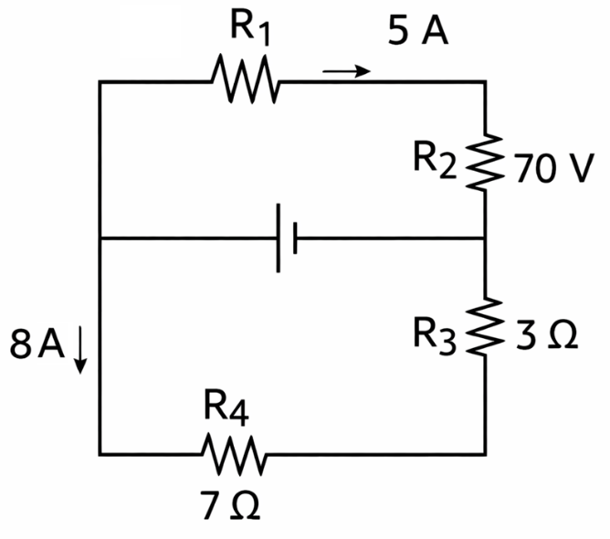
- The current in the left vertical wire below the junction is $I=8.0\text{ A}$
- The voltage drop across resistor $R_{2}$is $V_{R_{2}}=70\text{ V}$
- $R_{3}=3.0 Ω$

(a) Determine the current in each branch of the circuit.
(b) Determine the current through $R_{2}$.
(c) Determine the resistance of $R_{2}$.
(d) Determine the current through $R_{3}$and $R_{4}$.
(e) Determine the voltage across each series branch.
(f) Determine the resistance of $R_{1}$.
(g) Determine the voltage of the power source.

- A 6.0 V DC battery is connected to a circuit consisting of four resistors, arranged as shown in the diagram.
- $R_{1}=100 Ω$is connected in series with the rest of the circuit.
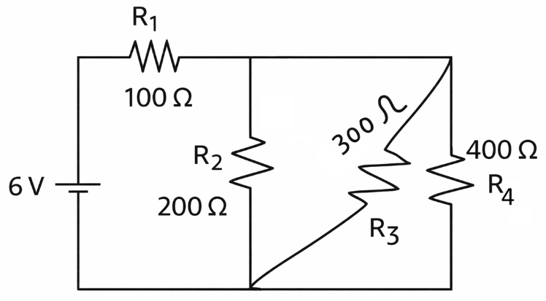
- After $R_{1}$, the circuit splits into three parallel branches:
  - $R_{2}=200 Ω$
  - $R_{3}=300 Ω$
  - $R_{4}=400 Ω$
All three of these resistors are connected between the same two junctions, and therefore form a parallel combination.

(a) Determine the equivalent resistance of the parallel combination of $R_{2}$, $R_{3}$, and $R_{4}$.
(b) Determine the total resistance of the circuit.
(c) Determine the total current supplied by the battery.
(d) Determine the current through each resistor: $R_{1}$, $R_{2}$, $R_{3}$, and $R_{4}$.
(e) Determine the voltage drop across each resistor.
(f) Verify that your results are consistent with Ohm’s Law and the rules for series and parallel circuits.
- An 8.0 V DC battery is connected to a circuit consisting of four resistors, arranged as shown in the diagram.
- $R_{1}=40 Ω$is connected in series with the rest of the circuit.
- $R_{2}=60 Ω$and $R_{3}=120 Ω$are connected in parallel with each other.
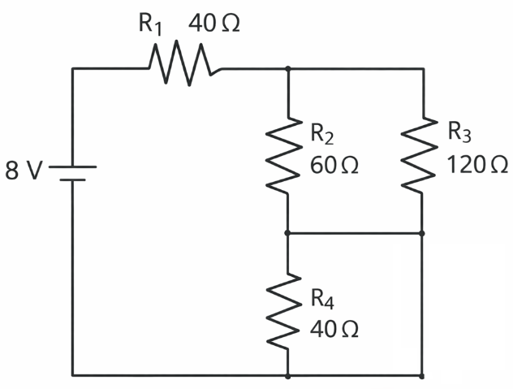
- Resistor $R_{4}=40 Ω$is bypassed by a conducting wire, creating a short circuit across it.

(a) Explain why $R_{4}$has no effect on the behaviour of the circuit.
(b) Determine the equivalent resistance of the parallel combination of $R_{2}$and $R_{3}$.
(c) Determine the total resistance of the circuit.
(d) Determine the total current supplied by the battery.
(e) Determine the current through $R_{2}$and $R_{3}$.
(f) Determine the voltage drop across $R_{1}$, $R_{2}$, and $R_{3}$.

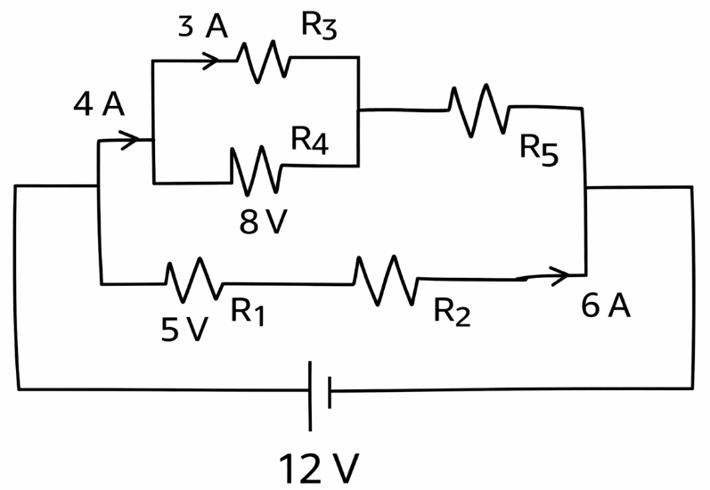
- A 12.0 V DC power source is connected to a circuit consisting of five resistors, arranged as shown in the diagram.
- Lower branch:
  - $R_{1}$is connected in series with $R_{2}$.
  - The voltage drop across $R_{1}$is 5.0 V.
  - The current through $R_{2}$is 6.0 A.
- Upper branch:
  - A total current of 4.0 A enters a parallel combination of:
    - $R_{3}$, which carries 3.0 A
    - $R_{4}$, which has a voltage drop of 8.0 V
  - The parallel combination then reconnects and passes through $R_{5}$in series.
- The upper and lower branches are connected in parallel between the same two junctions.

(a) Determine the current through $R_{4}$.
(b) Determine the current through $R_{5}$.
(c) Determine the resistance of $R_{4}$.
(d) Determine the resistance of $R_{3}$.
(e) Determine the resistance of $R_{1}$.
(f) Determine the resistance of $R_{2}$.
(g) Determine the voltage across the upper branch.
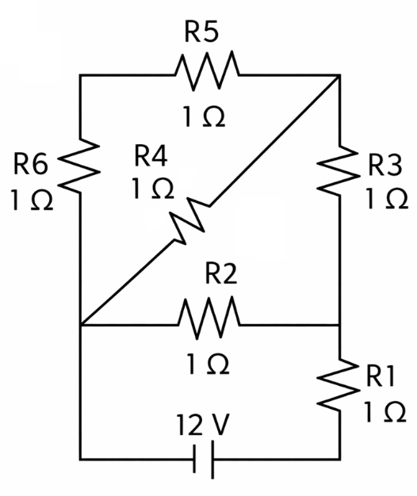
- A 12.0 V DC battery is connected to a circuit consisting of six resistors, arranged as shown in the diagram. All resistors have the same resistance:
$$R_{1}=R_{2}=R_{3}=R_{4}=R_{5}=R_{6}=1.0 Ω$$
- The circuit contains multiple junctions and cannot be reduced using simple series–parallel rules alone.
- Some resistors connect the same pairs of nodes, and symmetry may be used to simplify the analysis.
- Kirchhoff’s Laws are required.

(a) Identify all unique nodes in the circuit and label them clearly.
(b) Determine which resistors (if any) carry equal currents, and explain why.
(c) Determine the current through each resistor.
(d) Determine the voltage drop across each resistor.
(e) Determine the total current supplied by the battery.
(f) Determine the equivalent resistance of the circuit.

- A 100 V DC power source is connected to a circuit consisting of nine resistors, arranged as shown in the diagram. The circuit contains multiple junctions and loops and cannot be simplified using basic series–parallel reductions alone.
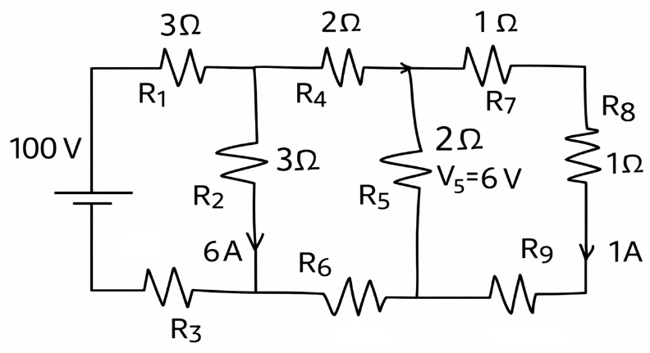
Given information
- $R_{1}=3 Ω$
- $R_{2}=3 Ω$
- $R_{4}=2 Ω$
- $R_{5}=2 Ω$
- $R_{7}=1 Ω$
- $R_{8}=1 Ω$
Additional measurements:
- The current through $R_{2}$is $I_{R_{2}}=6.0\text{ A}$
- The voltage drop across $R_{5}$is $V_{R_{5}}=6.0\text{ V}$
- The current through $R_{9}$is $I_{R_{9}}=1.0\text{ A}$
The resistances of $R_{3}$, $R_{6}$, and $R_{9}$are unknown.

(a) Identify and clearly label all junctions (nodes) in the circuit.
(b) Determine:
- the current through $R_{1}$
- the current through $R_{4}$
- the current through $R_{7}$
(c) Determine the voltage drop across $R_{2}$.
(d) Determine the resistance of $R_{3}$.
(e) Determine the resistance of $R_{6}$.
(f) Determine the resistance of $R_{9}$.
(g) Determine the total current supplied by the battery.
Solutions

