Power and Efficiency

- What unit is equivalent to a J/s?

- How much work is done when a 200 N force is used to slide a 30 kg box 6.0 m across a room?

- A person on a bicycle produces a forward force of 200 N and is travelling 3.0 m/s. What power is being produced?

- 1What is the power output of a 60. kg person who climbs a 5.0 m high staircase in 15 s?

- What power is needed to lift a 1000 kg load 10 m to the top of a construction site in 1.0 minute?

- What is the potential energy stored in a cubic meter of water (1000 kg) that is in a reservoir behind a dam at a height of 60 m above the elevation of the turbines the water will be used to turn?

- What is the kinetic energy of a 1200 kg car travelling 90 km/h?

- A 150 W motor is used to raise a garage door. If the average force needed to lift the door is 600 N, how much time will it take to raise the door 2.5 m?

- A machine rated at 2500 W lifts a 150 kg object 40.0 m vertically in 1.0 minute. What is the efficiency of this machine?

- A girl pulls a 5.0 kg wagon with a force of 20. N for 7.0 m. If the final speed of the wagon is 3.5 m/s, determine the efficiency of this process.

- A 200 g mass rests on a table 2.0 m above the floor. If the mass slips off the table, what is its speed just as it reaches the floor?

- A pendulum bob is raised in an arc to a position 20 cm higher than its lowest point. The bob is released. What is the speed of the bob as it passes through its lowest point?

- A 1500 kg car accelerates from rest at 2.0 m/s² for a distance of 250 m.
  - Neglecting friction, how much work was done in accelerating the car?
  - When the acceleration is over, what is the kinetic energy of the car?
  - What is the speed of the car?

- In an experiment, a small 20 W motor is used to lift a 100 g mass through a vertical distance.
  - If the motor runs for 40 s, how much potential energy does the mass gain?
  - How high can the mass be lifted in 40 s?

- A 65 kg cyclist on a 15 kg bicycle starts from rest and increases his speed to 12 m/s in 20. s.
  - What is the power output?
  - If the cyclist provided an average power of 400 W, what is the efficiency of the bicycle?

- A 200 W motor runs a pump to move water from a stream into a storage tank 10 m above the elevation of the stream. How many litres of water can the pump move in 1.0 hour? (recall that 1.0 L of water = 1.0 kg)

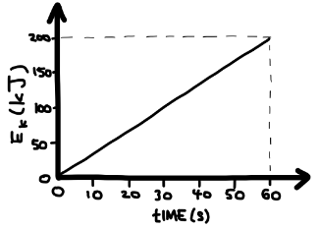
- The graph shows the kinetic energy of a car as the driver steps on the gas pedal.
  - What is the power output of the car?
  - If the process is 30% efficient, determine the power delivered to the car.

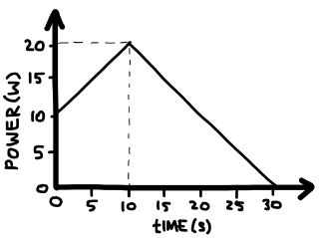
- The graph shows the power input for a 2.0 kg remote-controlled car starting from rest.
  - Determine the energy input.
  - What is the final speed of the car if the remote-controlled car is 20% efficient?

- A 3000 kg car travelling at 10 m/s rolls down a steep driveway that has a vertical drop of 5.0 m.
  - If we ignore friction, what is the car’s speed at the bottom of the incline?
  - If we include friction, and find that the heat generated along the driveway is 50 000 J, what is the speed of the car at the bottom of the incline?

- A 73 kg skier starts at rest at the top of a 100 m high hill. He skies down this hill and back up a 60 m high hill. If the speed of the skier at the top of the second hill is 11 m/s, how much energy was generated due to friction?
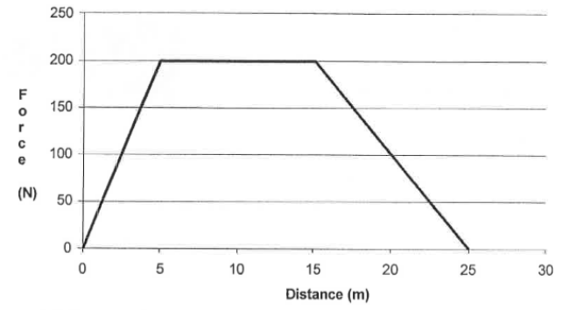
- The graph below shows the net force on a 1050. kg car.
  - What is the work done on the car after 25 m?
  - If the car was initially at rest, what is its speed after a distance of 25 m?
  - After 25 m, the force is released and the brakes are applied. The car stops after a distance of 3m. Determine the force of friction.

