Conservation of Energy with Heat Lab

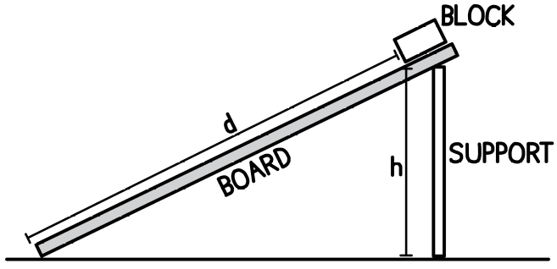
Determine the amount of energy converted into heat in a real system

Equipment
ramp with support
wooden block
stopwatch
meter stick
balance scale

Experimental Method
- Mark a starting point at the top of the ramp at which you will place the bottom corner of your block. the height at which the block is released, and the distance travelled.

Record the mass of the block, m: ________________
Measure the height, h: ________________
Distance up to the starting point, d: ________________

- Calculate the initial gravitational potential energy the block has at the top of the ramp.

- What percentage of gravitational potential energy do you think will be lost due to friction:

$$Energy Lost= __________ \%$$

Use this percentage to estimate the energy converted into heat due to friction:

$$Q = __________ J$$

- Use the gravitational potential energy, $E_{p}=mgh$, along with your predicted heat energy, $Q$, to estimate the speed of the block, $E_{k}=\frac{1}{2}mv^{2}$, when it reaches the bottom of the ramp.

$$E_{before}=E_{after}+Q$$

- Release the block from the top of the ramp and record the time it takes to reach the bottom. Repeat this at least five times. Record these times below.

Time (s)
Trial 1 | Trial 2 | Trial 3 | Trial 4 | Trial 5

- Calculate the average time for the trials.
Analysis and Discussion

- Use the average time, the initial velocity and the displacement, to determine the speed of the block at the bottom of the ramp using kinematics.

- Use this to evaluate your prediction for the percentage of energy lost.

The actual speed of the block is _______________ than the predicted speed.
greater/less

My prediction for energy loss was too _______________.
high/low

- Use the gravitational potential energy, $E_{p}=mgh$, along with the speed of the block, $E_{k}=\frac{1}{2}mv^{2}$, to determine actual amount of energy transformed to heat energy, $Q$.

$$E_{before}=E_{after}+Q$$

- What percentage of the initial mechanical energy was lost due to friction?

$$\% E_{lost}=\frac{Q}{E_{before}}∙100\%$$

- Determine the force of friction. $Q=F∙d$

Conservation of Energy with Heat Problems

- A 22.0 kg child slides down a ramp. At the bottom of the 5.00 m high ramp, the child has speed 2.50 m/s. Find the energy lost due to friction.

- A 30.0 kg child slides down a ramp that is 6.0 m high. At the bottom of the ramp, the child’s speed is 3.0 m/s. Determine the amount of energy lost due to friction.

- A 1000. kg car moving at 108. km/h slams on its brakes and comes to a stop.
  - How much work was done by friction?
  - If the car comes to stop in a distance of 64 m, what is the force of friction?

- A 1200 kg car is travelling at 90 km/h when it comes to a stop due to braking. Determine the work done by friction on the car.

- A 5.0 kg block sliding freely up a ramp. At the bottom of the ramp, the block has a velocity of 11 m/s. How high up the ramp does the block reach if 75 J is transformed to heat?

- A 450 kg roller coaster car starts from rest at the top of a 25.0 m high hill. During the ride, 60.0 kJ of energy is lost to heat. What is the speed of the coaster at the bottom of the hill?

- A 500. kg roller coaster is moving at 1.20 m/s at the top of a 30.0 m high hill. If 80. kJ is lost to heat, what will be the speed of the coaster at the bottom of the hill?

- A 4.0 kg block slides up a ramp with an initial speed of 10 m/s. During the motion, 120 J of energy is transformed into heat. Determine the maximum vertical height reached by the block.

- A child, starting from rest, slides down a 2.5 m high ramp. At the bottom of the ramp, the child has a speed of 4.0 m/s. If 580 J is lost to heat, determine the mass of the child.

- A person slides down a ramp that is 3.0 m high from rest. At the bottom of the ramp, their speed is 5.0 m/s. During the slide, 720 J of energy is lost to heat. Determine the mass of the person.

- A skydiver with a mass of 75.0 kg falls from a height of 200 m. Due to air resistance, the skydiver reaches the ground with a speed of 40.0 m/s. Determine the work done by air resistance during the fall.

- A toy car of mass 4.0 kg is pushed so that it has an initial speed of 5.0 m/s. The friction force acting on the car is 3.0 N. Determine how far the car travels before stopping using energy methods.

- A toy car of mass 5.0 kg is pushed and given an initial speed of 6.0 m/s. If the friction force is 4.0 N, find how far the car goes before stopping.
  - Solve using dynamics and kinematics
  - Solve using energy

- A 2.5 kg block slides up a ramp that makes an angle of 30° with the ground. The block starts with a speed of 6.0 m/s and travels 1.8 m along the ramp before stopping. Determine the force of friction acting on the block.

- Some years ago, a 80.0 kg paratrooper fell out of a plane at an altitude of 270. m and fell without a parachute to the ground below. When they landed, they made a 1.10 m deep crater in the snow but they survived! Assume that due to air resistance, they were moving at 50.0 m/s when they hit the ground.
  - Find the work done by air friction during the fall
  - Find the work done by the snow during the impact
  - Find the average force from the snow

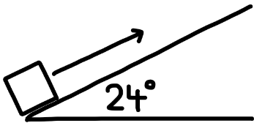
- A 3.0 kg block has a speed of 5.0 m/s at the bottom of a ramp. The angle the ramp makes with the ground is 24°. If the block reaches a height of 0.60 m, determine the force of friction acting on the block using energy.

