Circuits Simulation

- Build a table to organize your data.
- Calculate Resistance (Ω) of each resistor and through the total circuit.
- Calculate Voltage Drain (V) for each resistor and for the total circuit.
- Calculate Current (I) into each resistor and through the total circuit.

Do an Internet search for “pHET DC circuit” or go to
https://phet.colorado.edu/en/simulation/circuit-construction-kit-dc-virtual-lab
Select “Circuit Construction Kit: DC”.

- Build a matching digital circuit using the Circuit Construction Kit.

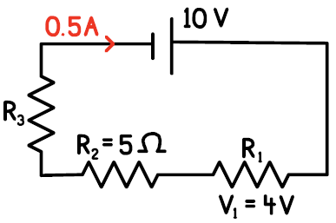
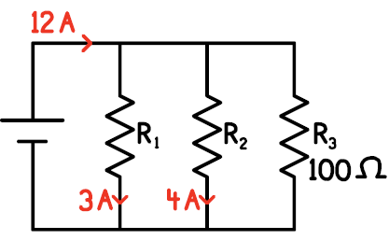

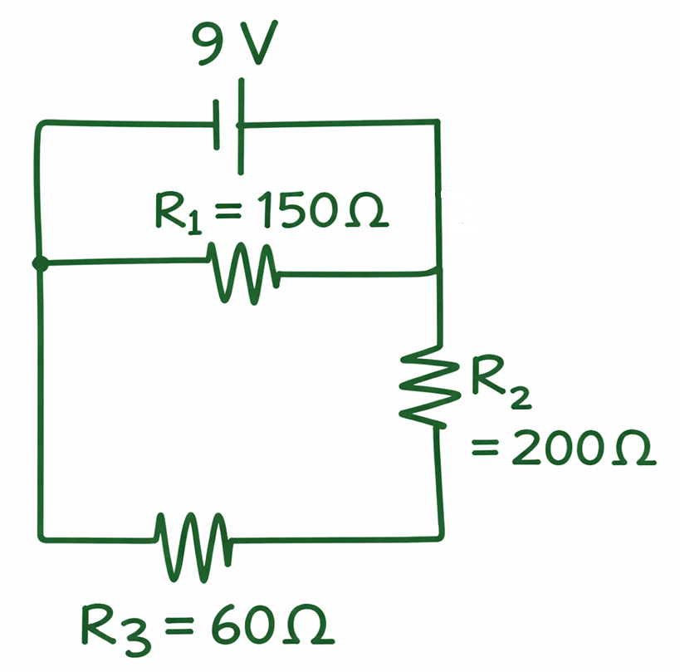
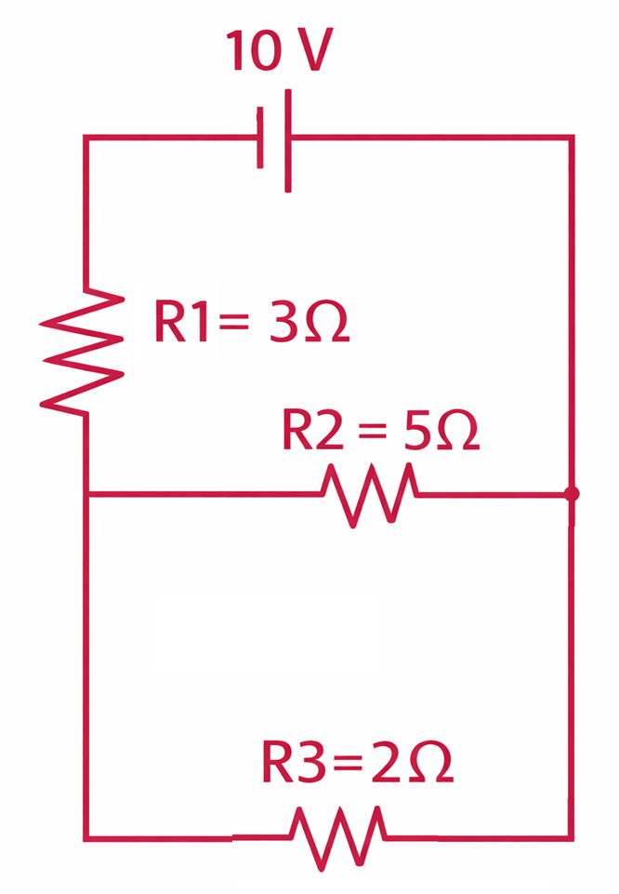
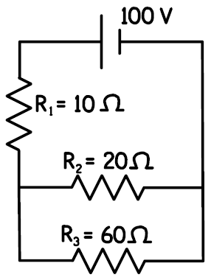

- Build a table to organize your data.
- Calculate Resistance (Ω) of each resistor and through the total circuit.
- Calculate Voltage Drain (V) for each resistor and for the total circuit.
- Calculate Current (I) into each resistor and through the total circuit.

Do an Internet search for “pHET DC circuit” or go to
https://phet.colorado.edu/en/simulation/circuit-construction-kit-dc-virtual-lab
Select “Circuit Construction Kit: DC”.

- Build a matching digital circuit using the Circuit Construction Kit.
