Formula Sheet – Pre-Calculus 12

Linear Functions
Calculating Slope
$$m=\frac{rise}{run}=\frac{y_{2}-y_{1}}{x_{2}-x_{1}}$$

y-intercept Form
$$y=mx+b$$

Sketching Method:
- Identify the slope $m$ and the y-intercept $b$.
- Plot the y-intercept at $\left(0 , b\right)$.
- Use the slope $m=\frac{rise}{run}$ to plot a second point.
- Draw the line through the points.

Slope-Point Form
$$y-y_{1}=m(x-x_{1})$$

Sketching Method:
- Identify the point $\left(x_{1} , y_{1}\right)$ and the slope $m$.
- Plot the point $\left(x_{1} , y_{1}\right)$ on the graph.
- Use the slope $m=\frac{rise}{run}$ to plot a second point.
- Draw the line through the points.

General Form
$$Ax+By=C$$

Sketching Method:
- Find the y-intercept: set $x=0$ and calculate $y$.
- Find the x-intercept: set $y=0$ and solve for $x$.
- Plot both intercepts.
- Draw the line connecting them.

Quadratic Functions
Quadratic Formula
$$x=\frac{-b±\sqrt{b^{2}-4ac}}{2a}$$

Discriminant: $b^{2}-4ac$
General Form
$$y=ax^{2}+bx+c$$

Sketching Method
- Find the axis of symmetry using $x=-\frac{b}{2a}$
- Find the vertex with $f\left(axis of symmetry\right)$.
- Find the y-intercept with $f\left(0\right)$.
OR
Sketching Method 2
- Identify $a$, $b$, and $c$.
- Identify the x-intercepts: $x=\frac{-b±\sqrt{b^{2}-4ac}}{2a}$
- Find the axis of symmetry by averaging the x-intercepts.
- Find the vertex with $f\left(axis of symmetry\right)$.
Standard (Vertex) Form
$$y=a(x-p)^{2}+q$$

Sketching Method 1
- Read the vertex $(h,k)$.
- Draw the axis of symmetry, vertically through the vertex.
- Find the y-intercept with $f\left(0\right)$.

Factored Form
$$y=a(x-r_{1})(x-r_{2})$$

Sketching Method
- Identify the x-intercepts by solving for x in each of the binomials.
- Find the axis of symmetry by averaging the x-intercepts.
- Find the vertex with $f\left(axis of symmetry\right)$.

Common Angle Relationships

Triangle Angle Sum

$$∠A+∠B+∠C={180}^{∘}$$
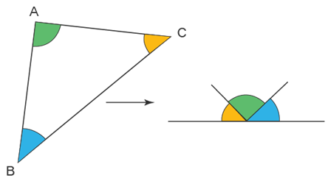

Complementary Angles

$$A+B={90}^{∘}$$
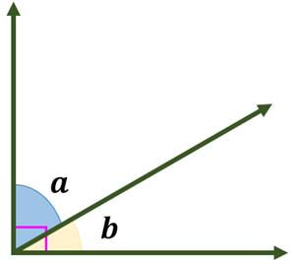

Supplementary Angles

$$A+B={180}^{∘}$$
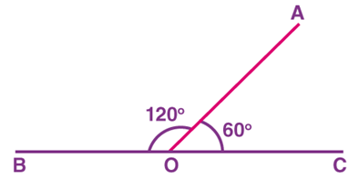

Straight Angles

$$\text{Straight angle}={180}^{∘}$$
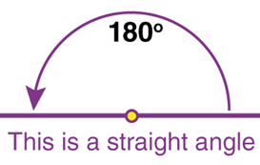

Vertically Opposite Angles

$$∠A=∠B$$
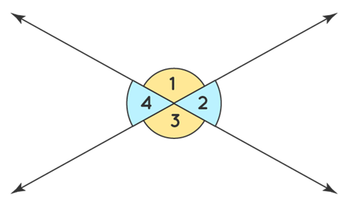

Corresponding Angles

$$∠A=∠B$$
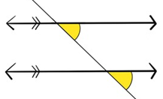

Alternate Interior Angles

$$∠A=∠B$$
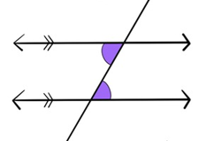

Co-Interior Angles

$$∠A+∠B={180}^{∘}$$
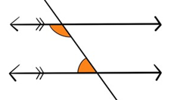

Alternate Exterior Angles

$$∠A=∠B$$
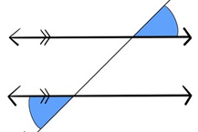

Co-Exterior Angles

$$∠A+∠B={180}^{∘}$$
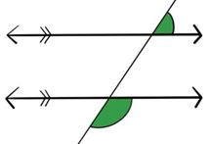

Polynomial Functions
Shapes
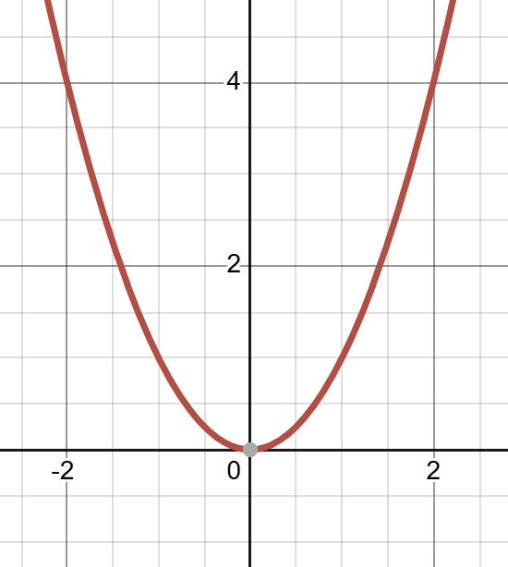
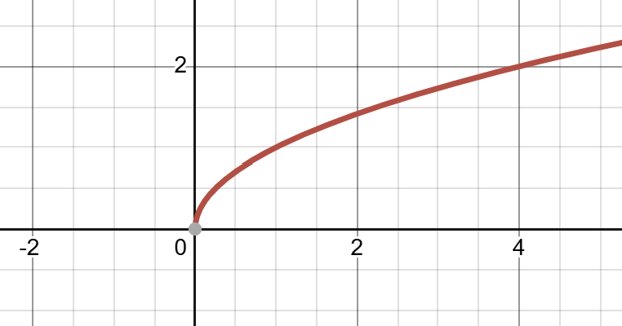
$f(x)=x^{2}$ $f(x)=\sqrt{x}$

Remainder Theorem
If a polynomial $P(x)$is divided by $\left(x − a\right)$, the remainder is $P(a)$.

Factor Theorem
If $P(a)=0$, then $\left(x − a\right)$is a factor of $P(x)$.

Drawing Polynomial Functions: $P(x)=a{(x-r_{1})}^{m_{1}}{(x+r_{2})}^{m_{2}}{(x+r_{3})}^{m_{3}}$

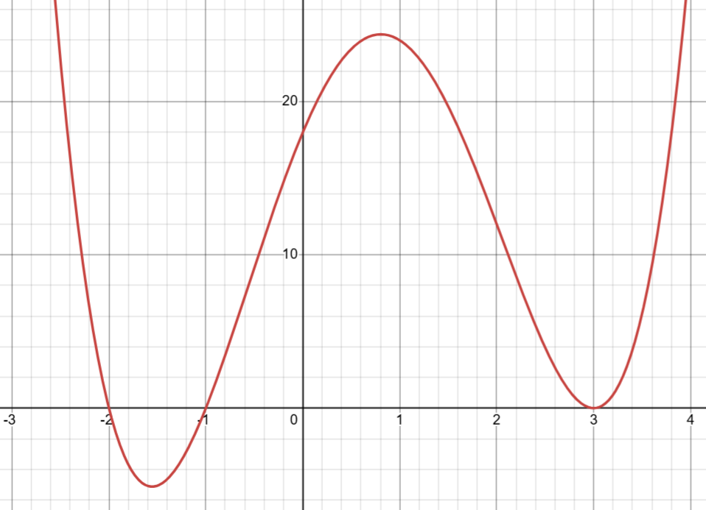
y-intercept: Occurs where $x=0$

$x$-intercepts (roots): Occur where $y=0$

Finding roots from factors:
$$(x-r)=0 ⇒ x=r$$

Leading coefficient $a$: Controls vertical stretch/compression and reflection

Multiplicity: Repeated factors
even multiplicity → touch,
odd multiplicity → cross)

End Behavior
- Even degree, positive leading coefficient: both ends ↑
- Even degree, negative leading coefficient: both ends ↓
- Odd degree, positive leading coefficient: left ↓, right ↑
- Odd degree, negative leading coefficient: left ↑, right ↓

Function Transformations

$$y=±af(±\frac{1}{b}(x-h))+q$$
Vertical Translation
Horizontal Translation

Horizontal Stretch (away from/towards the y-axis)
Vertical reflection (over the x-axis)

Horizontal reflection (over the y-axis)
Vertical Stretch (away from/towards the x-axis)

Inverses
$$x=f(y)$$
Steps to find:
- Swap $x$and $y$
- Solve for $y$

Absolute Functions
$$g\left(x\right)=\left|f(x)\right|$$
A conditional reflection over the x-axis.

Root Functions
$$g\left(x\right)=\sqrt{f(x)}$$
A transformation from a quadratic function to a linear function to a root function.

Reciprocal Functions
$$g\left(x\right)=\frac{1}{f(x)}$$
A transformation from a large values to small values and from small values to large values.

Exponents & Logarithms

Laws of Exponents

$a^{x}a^{y}=a^{x+y}$

$$\frac{a^{m}}{a^{n}}=a^{m-n}$$

$${\left(a^{m}\right)}^{n}=a^{mn}$$

$$a^{y}b^{y}={\left(ab\right)}^{y}$$

$$a^{0}=1,$$

$$a^{-n}=\frac{1}{a^{n}}$$

Radical Properties

$$\sqrt{ab}=\sqrt{a}\sqrt{b}$$

$$\sqrt{\frac{a}{b}}=\frac{\sqrt{a}}{\sqrt{b}}$$

$$a\sqrt{b}=\sqrt{a^{2}b}$$

Laws of Logarithms

$$\log_{a}\left(x\right)=y ⟺ a^{y}=x$$

$$\log_{a}\left(1\right)=0,$$

$${log⁡}_{a}(a)=1$$

$$\log_{a}{b}=\frac{\log{b}}{\log{a}}$$

$$\log{a^{m}}=m\log{a}$$

$$\log\left(ab\right)=\log{a}+\log{b}$$

$$\log\left(\frac{a}{b}\right)=\log{a}-\log{b}$$

Natural Logarithm

$$e^{\ln{x}}=x$$

$$\ln{e^{x}}=x$$

$$\ln{x}=\log_{e}x,$$

$$\ln{1}=0,$$

$$ln⁡e=1$$

Arithmetic Sequences

$$t_{n}=t_{1}+(n-1)d$$

$$S_{n}=\frac{n(t_{1}+t_{n})}{2}$$

Geometric Sequences

$$t_{n}=ar^{n-1}$$
$$r=\frac{t_{2}}{t_{1}}$$

Applications of Geometric Sequences

Compound Interest $A=P{\left(1 + \frac{r}{n}\right)}^{nt}$

Half Lives $m_{f}=m_{i}{\left(\frac{1}{2}\right)}^{\frac{t}{half-life}}$

Earthquake Intensity $I={10}^{R_{F}-R_{o}}$

Sound Intensity $I={10}^{\frac{D_{f}-D_{o}}{10}}$

Population $P_{f}=P_{i}r^{periods}$

Investment $A=P{(r)}^{periods}$

pH $\left[H^{+}\right]={(10)}^{-pH}$

Arithmetic Sequences
$$a_{n}=a+d(n-1)$$

$$S_{n}=\frac{n(a+t_{n})}{2}$$

Geometric Series
$$S_{n}=a\frac{(1-r^{n})}{1-r}$$

$$S_{n+1}-S_{n}=t_{n+1}$$
Infinite Geometric Series
$$S_{∞}=a\left(\frac{1}{1-r}\right)$$

Ordinary Annuity
$$Sn=A\frac{{(1+r)}^{n}-1}{r}$$

Annuity Due
$$Sn=A(1+r)\frac{{(1+r)}^{n}-1}{r}$$

Continuous Growth Rate
$$e^{r}={\left(1+\frac{r}{n}\right)}^{n}$$

$$A=P{(e^{r})}^{t}$$

$$S_{n}=Ae^{r}\left(\frac{e^{rn}-1}{e^{r}-1}\right)$$

Trigonometry Formula Sheet

Angles in Standard Position
Vertex at origin & Initial arm on positive $x$-axis

Reference Angle
Acute angle between terminal arm and $x$-axis

Coterminal Angles
$$θ=θ+{360}^{∘}k$$

Angle Conversion
$$\frac{Radians}{Degrees}=\frac{2π}{360}$$
Function Transformations

$y=A\sin\left(B\left(x-C\right)\right)+D$ and $y=A\cos\left(B\left(x-C\right)\right)+D$ where $B=\frac{2π}{p}$
Parameters

Amplitude: $\left|a\right|$
Period: $\frac{2π}{∣b∣}$

Phase shift: $c$
Vertical shift: $d$
Right Triangle Ratios (SOH-CAH-TOA)
$\sin{θ}=\frac{o}{h}$ $\cos{θ}=\frac{a}{h}$ $\tan{θ}=\frac{\sin{θ}}{\cos{θ}}$

$\csc{θ}=\frac{1}{\sin{θ}}$ $\sec{θ}=\frac{1}{\cos{θ}}$ $\cot{θ}=\frac{1}{\tan{θ}}$
Cosine Law
$$c^{2}=a^{2}+b^{2}-2ab\cos{C}$$
Sine Law
$a\sin{B}=b\sin{A}$ $\frac{a}{\sin{A}}=\frac{b}{\sin{B}}$ $\frac{\sin{A}}{a}=\frac{\sin{B}}{b}$

Special Triangles & Bowties

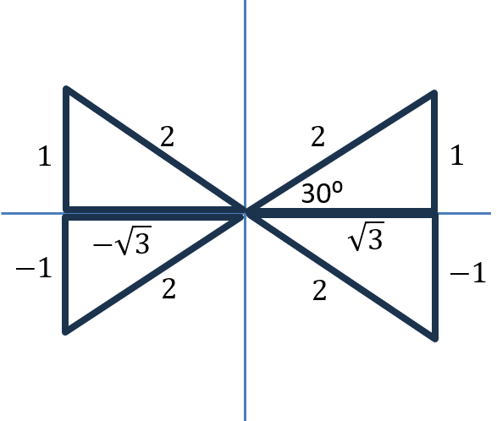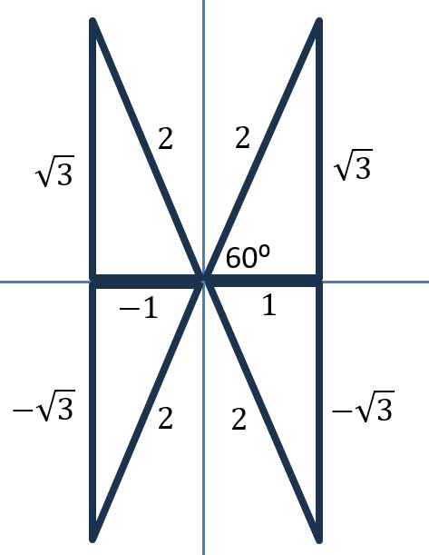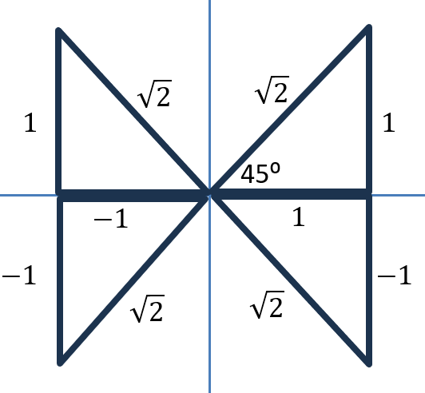
Trigonometric Identities

$$\sin^{2}{θ}+\cos^{2}{θ}=1$$

$$\tan^{2}{θ}+1=\sec^{2}{θ}$$

$$1+\cot^{2}{θ}=\csc^{2}{θ}$$

$$1+\cos{θ} OR 1-\cos{θ} Multiply by Conjugate$$

$$1+\sin{θ} OR 1-\sin{θ} Multiply by Conjugate$$

Sum & Difference Angle Identities
Sine:
$$sin(A+B)=sin(A)cos(B)+cos(A)sin(B)$$

$$sin(A-B)=sin(A)cos(B)-cos(A)sin(B)$$

Cosine:

$$cos(A+B)=cos(A)cos(B)-sin(A)sin(B)$$

$$cos(A-B)=cos(A)cos(B)+sin(A)sin(B)$$

Tangent:
$$\tan\left(a+b\right)=\frac{\tan{a}+\tan{b}}{1-\tan{a}\tan{b}}$$

$$\tan\left(a-b\right)=\frac{\tan{a}-\tan{b}}{1+\tan{a}\tan{b}}$$

Double Angle Identities

Sine:
$$sin(2A)=2sin(A)cos(A)$$

Cosine:
$$cos(2A)=cos²(A)-sin²(A)$$

$$cos(2A)=2cos²(A)-1$$

$$cos(2A)=1-2sin²(A)$$

Tangent:
$$tan(2A)=\frac{2tan(A)}{1-tan²(A)}$$

