Circuits Simulation

Objective

Investigate current, voltage, and resistance of lightbulbs in different circuits

Procedure For Each Circuit.
- Construct a matching circuit with batteries and lightbulbs.
- Measure Voltage Drain (V) for each light bulb and for the total circuit.
- Measure Current (I) into each lightbulb and through the total circuit.
- Build a table to organize your data and calculate the remaining unknown values.
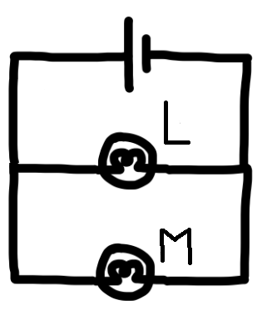

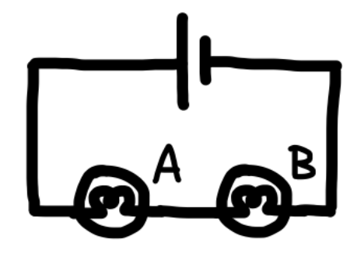
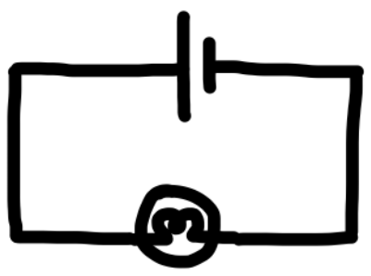

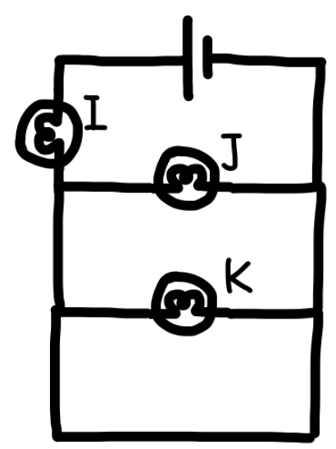
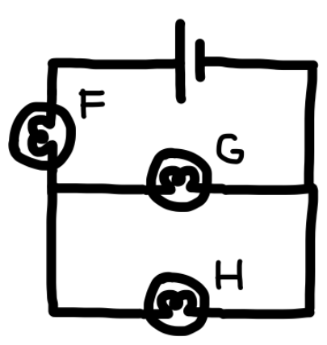
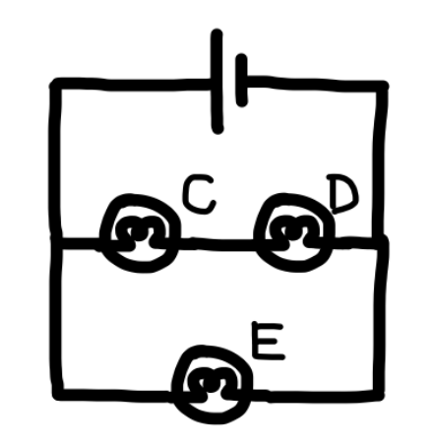

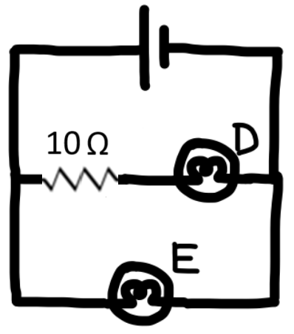
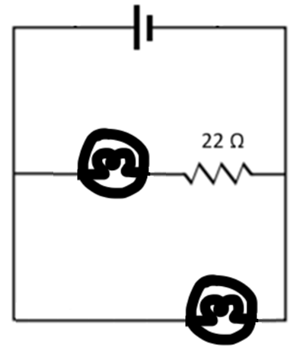

What impact does a resistor have on the brightness of a bulb?

How many ways can you connect one battery and three resistors? Draw a circuit diagram for each.

Battery: Resistor:
