Function Transformations

Given the graph of $y=f\left(x\right)$, draw the resulting image after each transformation:

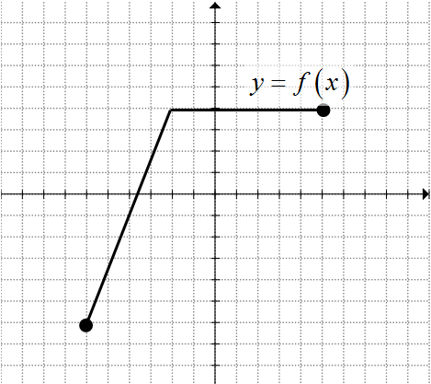$y=f\left(-x\right)$

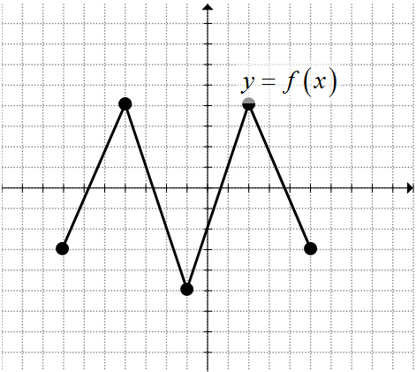
$$y=-f\left(x\right)$$

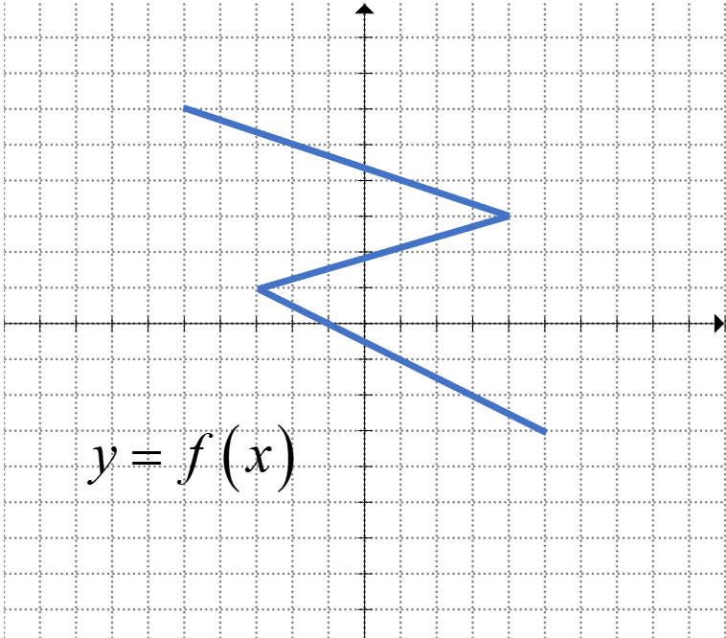$x=f\left(y\right)$

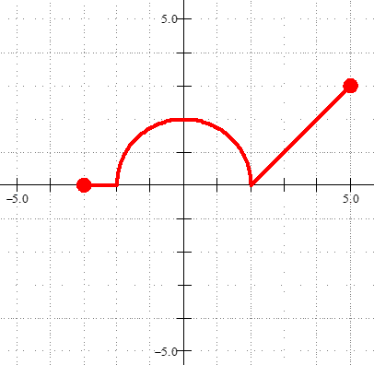
The function $f(x)$ is shown. Sketch the new function, defined by.

$$g(x)=f(x)-3$$

$$g(x)=f(x-2)+3$$

$$g(x)=2f(x)$$

$$g(x)=-2f(x)+1$$

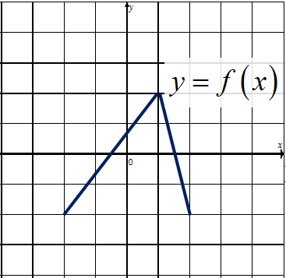The function $=f(x)$ is shown. Sketch the new function, defined by.

$$y=f(x-1)$$

$$y=0.5f(x)+1$$

$$y=2f(3x)$$

$$y=2f(2x-1)-1$$

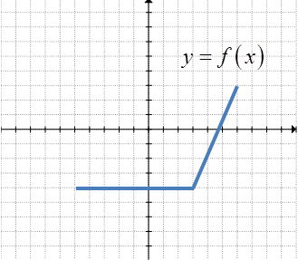Given the graph of $y=f\left(x\right)$, draw the graph of the following functions:

$$y=2f\left(x\right)$$

$$x=-0.5f\left(2y\right)$$

$$y=5-3f\left(1-2x\right)$$

$$y=f\left(0.25x-1\right)+1$$

The graph of the function $y=f(x)$ is transformed to produce the graph of the function $y=g(x)$. An equation for $g\left(x\right)=±af\left(b\left(x-h\right)\right)+k$ in terms of $f(x)$ is

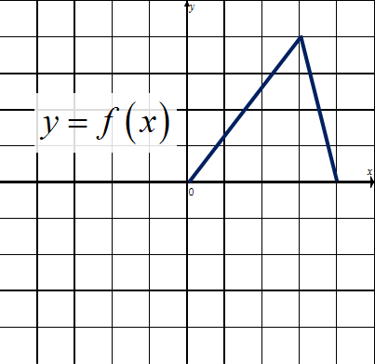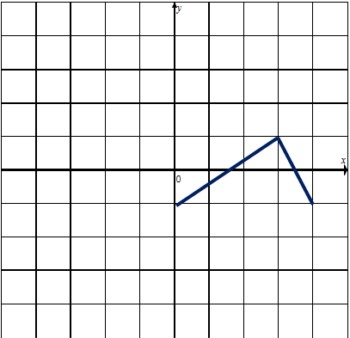

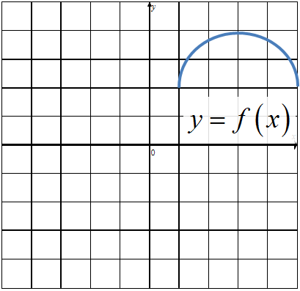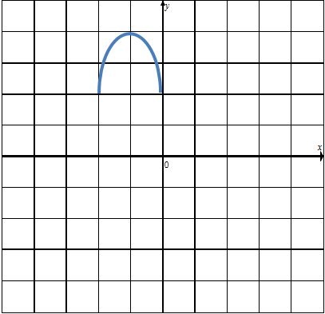

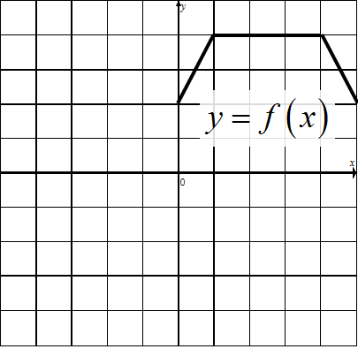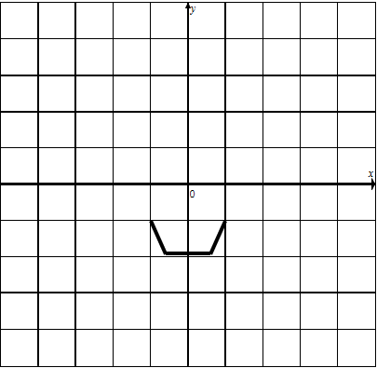

Given the graph of $y=f\left(x\right)$ and the graph after transformation, what is the equation of the function transformation?

