Function Roots

For each function:
- Sketch $y=f(x)$.
- Determine where $f(x)≥0$.
- Sketch $y=\sqrt{f(x)}$.
- Determine the following:
- x-intercepts
- y-intercept
- domain
- range
- maximum or minimum

$$y=\sqrt{4x^{2}}$$

$$y=\sqrt{x^{2}-3}$$

$$y=\sqrt{-x^{2}+7}$$

$$y=\sqrt{5-3x}$$

$$y=\sqrt{{\left(x-2\right)}^{2}-4}$$

$$y=\sqrt{2{\left(x+3\right)}^{2}+2}$$

$$y=-\sqrt{-2{\left(x+3\right)}^{2}+7}$$

$$y=-\sqrt{3x^{2}+12x-15}$$

- When we take the square root of a function $y=\sqrt{f\left(x\right)}$, which values change and which stay the same: $x$or $y$? Explain.

- Suppose the point $\left(a , b\right)$is on $y=f(x)$and $b<0$. What happens to this point on $y=\sqrt{f(x)}$?

- Suppose the point $\left(a , 1\right)$is on $y=f(x)$. What happens to this point on $y=\sqrt{f(x)}$?

- If $f(x)=0$ at some value of $x$, what happens to that point on the graph of $y=\sqrt{f(x)}$?

- If $f(x)$is negative on an interval, what happens to the graph of $y=\sqrt{f(x)}$on that interval?

Reflection: Answer in complete sentences.
- What must be true about $f(x)$for $y=\sqrt{f(x)}$ to exist?

- What happens to the x-intercepts when we take the square root of a function?

- How does the graph of $y=\sqrt{f(x)}$ compare to the graph of $y=f(x)$?
Match each equation $y=\sqrt{f(x)}$ with the corresponding graph.
then sketch in $y=f(x)$ and
determine the domain, range, x-intercepts, y-intercepts, and max/min.

$$y=\sqrt{x^{2}-9}$$

$$y=\sqrt{-x^{2}+9}$$

$$y=-\sqrt{-x^{2}+9}$$

$$y=\sqrt{x^{2}+9}$$

$$y=\sqrt{2x^{2}-4}$$

$$y=-\sqrt{2x^{2}-4}$$

$$y=-2\sqrt{-x^{2}-9}$$

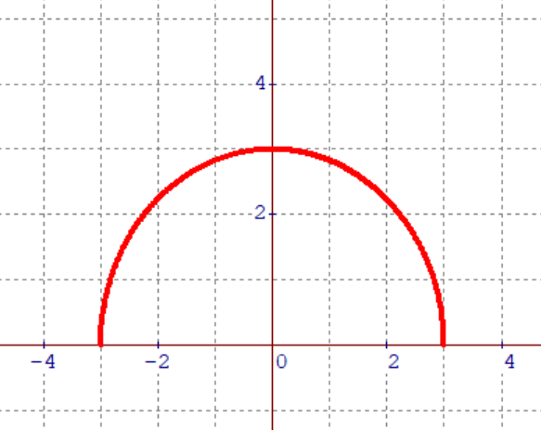 | 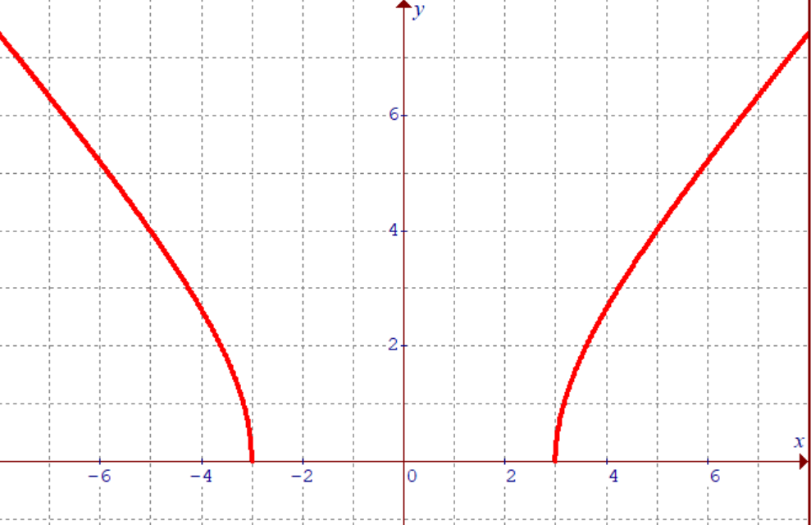 | 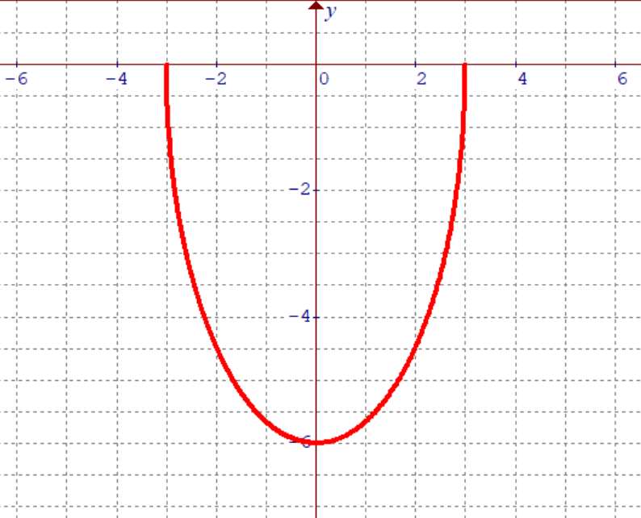
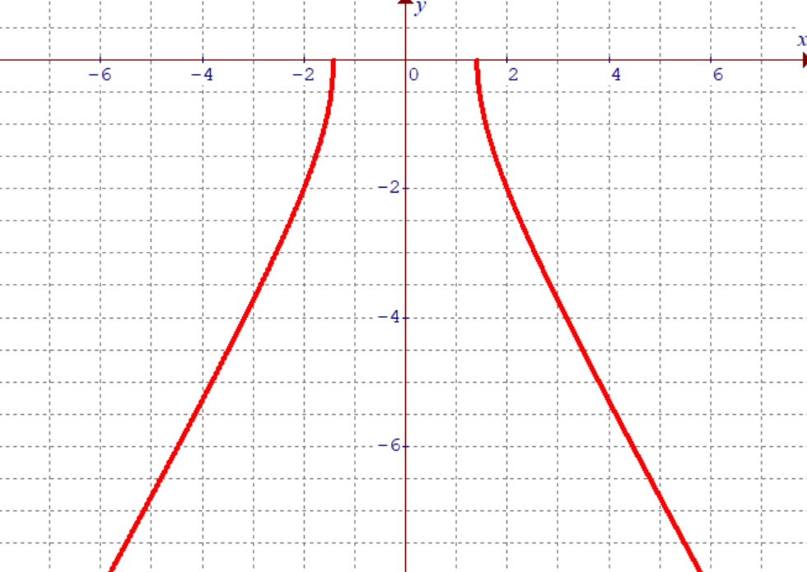 | 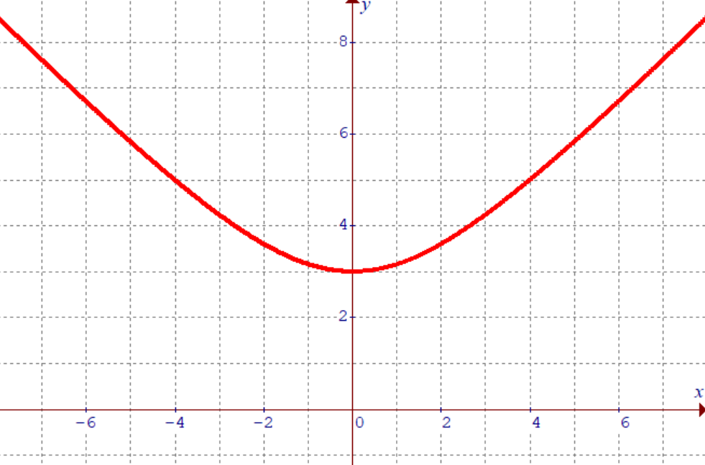 | 