Dynamics Practice

- A 45 kg toboggan and rider decelerate on level snow at 0.52 m/s². What is the coefficient of friction between the toboggan and the snow?

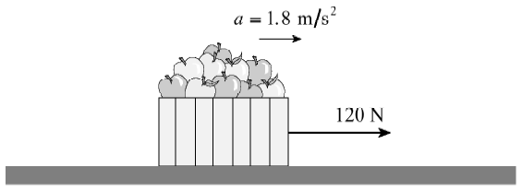
- A student exerts a 120 N horizontal force on a 25 kg carton of apples, causing it to accelerate over level ground at 1.8 m/s². Find the coefficient of friction between the carton and the ground.

- A net force, F_{net}, acts on an object of mass, m, causing it to accelerate at 4.0 m/s². If the same net force, F_{net}, acts on an object of twice the mass, 2m, what will its acceleration be?

- A 72 kg skydiver drops from a helicopter and is accelerating downwards at 8.6 m/s². Find the air friction force acting on him.

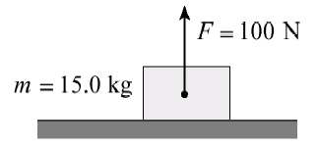
- A 15 kg block on a horizontal surface has a 100 N force acting on it as shown. What is the normal force?

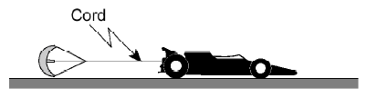
- An 810 kg dragster is being decelerated by a parachute at 2.5 m/s² as shown in the diagram. What is the tension in the cord at this moment?

- A 75 kg man stands on a scale while accelerating upwards in an elevator. If the scale reads 850 N, what is the magnitude of the acceleration of the elevator?

- A 45 kg woman is standing in an elevator that is accelerating downwards at 2.0 m/s². What force (normal force) does the elevator floor exert on the woman’s feet during this acceleration?

- A 32.0 kg box is placed on a scale in an elevator. The total mass of the elevator plus contents is 725 kg. Suddenly, the supporting cable breaks and the elevator accelerates downwards, restricted only by emergency brakes which drag along the walls of the shaft. While the elevator is falling, the scale reads 210 N.
  - Draw a free body diagram in the space below showing the forces acting on the box while the elevator is accelerating downwards.
  - What is the acceleration of the elevator?
  - What is the magnitude of the frictional force of the brakes against the walls of the shaft?

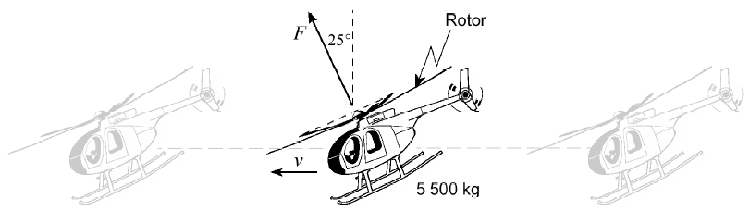
- A 5500 kg helicopter is flying at a constant speed in level flight. The rotor blades produce a single net force $F_{A}$that is tilted 25° from the vertical, as shown in the diagram. Determine the magnitude of the rotor force $F_{A}$.
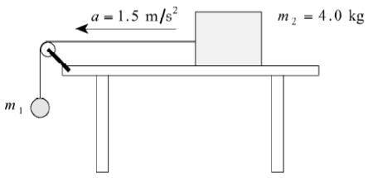
- A 4.0 kg block (m₂) rests on a horizontal table. It is connected by a light string that passes over a small pulley to a hanging mass (m₁), as shown in the diagram. When the system is released, the block accelerates to the left along the table with an acceleration of $a=1.5 {\text{m/s}}^{2}.$ Find the mass of the object m₁.
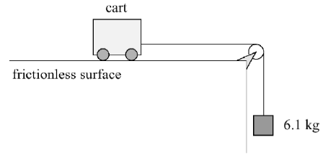
- A 6.1 kg mass hangs vertically from a light cord that passes over a small pulley and is attached to a cart on a frictionless horizontal surface, as shown in the diagram. The tension in the cord is measured to be 43 N while the system is accelerating. Determine the mass of the cart.

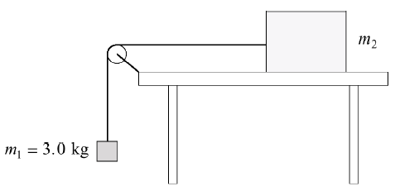
- Two objects are connected by a light string that passes over a frictionless pulley, as shown in the diagram. Object $m_{1}=3.0\text{ kg}$ hangs vertically, while object $m_{2}$rests on a frictionless horizontal table. The tension in the string is measured to be 24 N while the system accelerates. Determine the acceleration of the system. Determine the mass of object $m_{2}$.

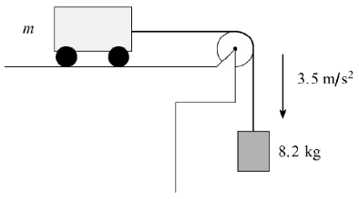
- A cart of unknown mass $m$rests on a frictionless horizontal surface. It is connected by a light string over a frictionless pulley to a hanging mass of 8.2 kg, as shown in the diagram. When the system is released, it accelerates at $a=3.5 {\text{m/s}}^{2}.$Determine the mass $m$of the cart.

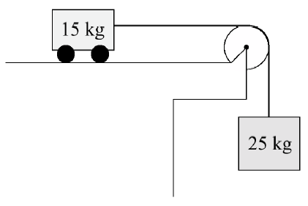
- A 15 kg cart sits on a frictionless horizontal surface. It is connected by a light string passing over a frictionless pulley to a 25 kg hanging mass, as shown in the diagram. When the system is released, the hanging mass falls and pulls the cart horizontally. Determine the acceleration of the 15 kg cart.

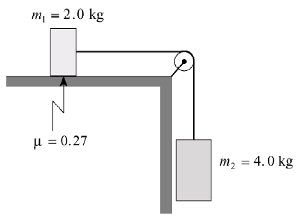
- Two masses are connected by a light string that passes over a frictionless, massless pulley, as shown in the diagram. Mass $m_{1}=2.0\text{ kg}$ rests on a horizontal surface, where the coefficient of kinetic friction is $μ_{k}=0.27.$ Mass $m_{2}=4.0\text{ kg}$ hangs vertically. When the system is released, mass $m_{2}$accelerates downward. Determine the acceleration of mass $m_{2}$.

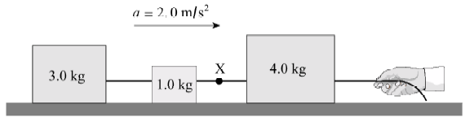
- Three blocks of masses 3.0 kg, 1.0 kg, and 4.0 kg are in contact on a frictionless horizontal surface. A force applied by a hand pulls the system to the right, causing all three blocks to accelerate together at $a=2.0 {\text{m/s}}^{2}.$ A light cord between the 1.0 kg and 4.0 kg blocks contains a point labeled X. Determine the tension in the cord at point X.

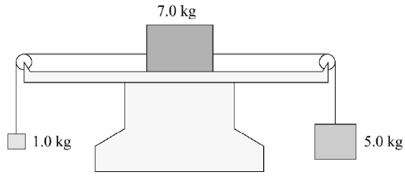
- Three blocks with masses 1.0 kg, 7.0 kg, and 5.0 kg are connected by light strings passing over frictionless pulleys. The 7.0 kg block rests on a frictionless horizontal surface, while the 1.0 kg and 5.0 kg masses hang on opposite sides. When the system is released, the masses begin to move. Determine the magnitude of the acceleration of the entire system.
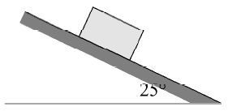
- A 5.0 kg block rests stationary on a surface inclined at 25° above the horizontal, as shown in the diagram. The block does not slide. Determine the magnitude of the friction force acting on the block.

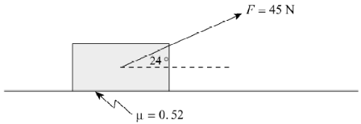
- A student pulls a 7.0 kg carton of apples across a horizontal floor by applying a 45 N force directed 24° above the horizontal, as shown in the diagram. The coefficient of kinetic friction between the carton and the floor is $μ_{k}=0.52.$Determine the acceleration of the carton.

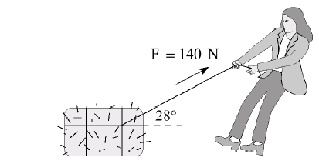
- A girl pulls a 35 kg bale of hay using a rope that makes an angle of 28° above the horizontal, as shown. She applies a force of 140 N. The bale experiences a 55 N friction force opposing the motion. Determine the horizontal acceleration of the bale.

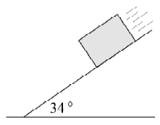
- A 5.0 kg concrete block accelerates down a 34⁰ slope at 4.2 m/s². Find the coefficient of friction between the block and the slope.

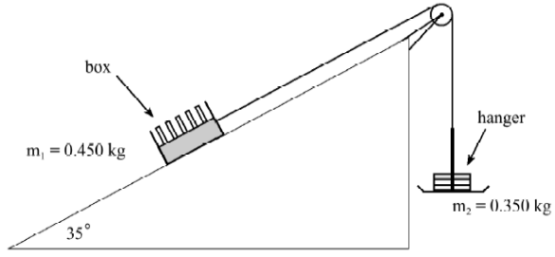
- A 0.450 kg box rests on a 35° incline and is connected by a light string over a frictionless pulley to a 0.350 kg hanger, as shown in the diagram. The box is observed to move up the incline at a constant speed, meaning the system is in dynamic equilibrium.
  - Determine the coefficient of kinetic friction between the box and the incline.
  - If 0.150 kg of mass is transferred from the box to the hanger, the masses are no longer balanced. Determine the acceleration of the system once the masses are redistributed.

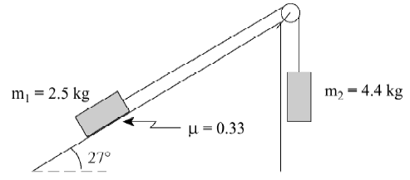
- Two masses are connected by a light string that passes over a frictionless pulley, as shown in the diagram. Mass $m_{1}=2.5\text{ kg}$rests on a 27° incline, where the coefficient of kinetic friction is $μ_{k}=0.33.$ Mass $m_{2}=4.4\text{ kg}$hangs vertically on the other side of the pulley.
  - Determine the acceleration of the system.
  - Determine the tension in the string.

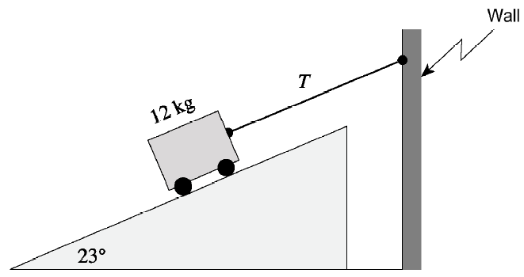
- A 12 kg cart rests on a 23° frictionless incline. It is held motionless by a light cord attached to a wall, as shown in the diagram. The cord runs parallel to the incline. Determine the tension $T$in the cord required to keep the cart at rest.

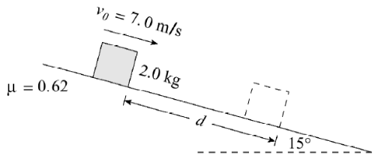
- A 2.0 kg block is sliding down a 15⁰ incline. The coefficient of friction is 0.62. At some position the block has a speed of 7.0 m/s. What distance, d, will this block move before coming to rest?

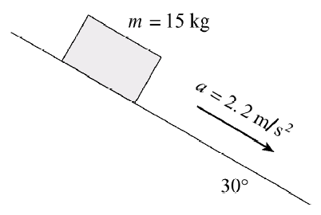
- A 15 kg block has a constant acceleration of 2.2 m/s² down a 30⁰ incline. What is the magnitude of the friction force on the block?

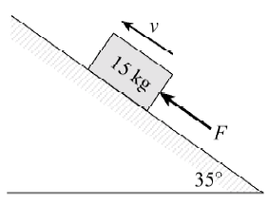
- A 15 kg block is pushed up a 35⁰ incline. A friction force of 110 N exists between the block and the incline. What minimum force, F_{A}, would be necessary to move the block up the incline at a constant speed?

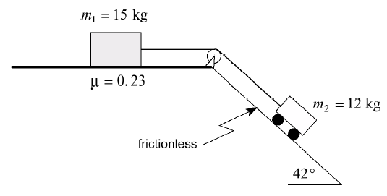
- Two objects are connected by a light string that passes over a frictionless pulley, as shown in the diagram. Mass $m_{1}=15\text{ kg}$rests on a horizontal surface with a coefficient of kinetic friction $μ_{k}=0.23.$Mass $m_{2}=12\text{ kg}$sits on a 42° frictionless incline. When the system is released, the two masses accelerate together. Determine the acceleration of the system.

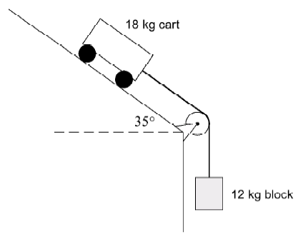
- An 18 kg cart rests on a 35° frictionless incline. It is connected by a light, inextensible string that passes over a frictionless pulley to a 12 kg hanging block, as shown in the diagram. When the system is released, the two masses accelerate together. Determine the magnitude of the acceleration of the cart.

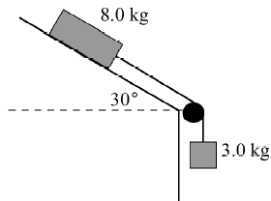
- A 3.0 kg hanging mass is connected by a light string over a frictionless pulley to an 8.0 kg block on a 30° incline, as shown in the diagram. The coefficient of kinetic friction between the 8.0 kg block and the ramp is $μ_{k}=0.26.$ Determine the acceleration of the 8.0 kg block down the ramp.

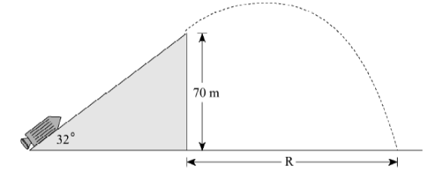
- A rocket starts from rest and accelerates up a frictionless incline that makes a 32° angle with the horizontal. The rocket accelerates at $a=25 {\text{m/s}}^{2}$ until it reaches the end of the incline, where it leaves the surface and becomes a projectile. The rocket’s engines turn off the moment it leaves the ramp. The top of the incline is 70 m above the ground below. Air resistance is negligible. Determine the horizontal distance $R$from the base of the incline to the point where the rocket impacts the ground.

