MARBLE SLIDES
Go to student.desmos.com and type in:

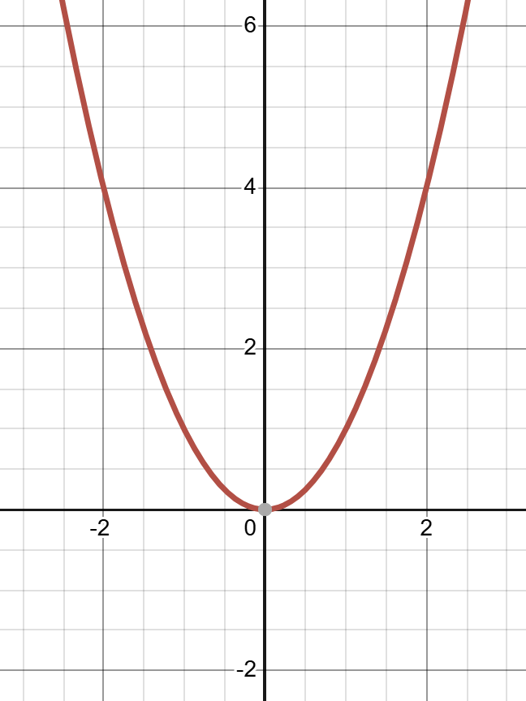
Quadratic Functions

$$y=±a{\left(±b\left(x-h\right)\right)}^{2}+k$$



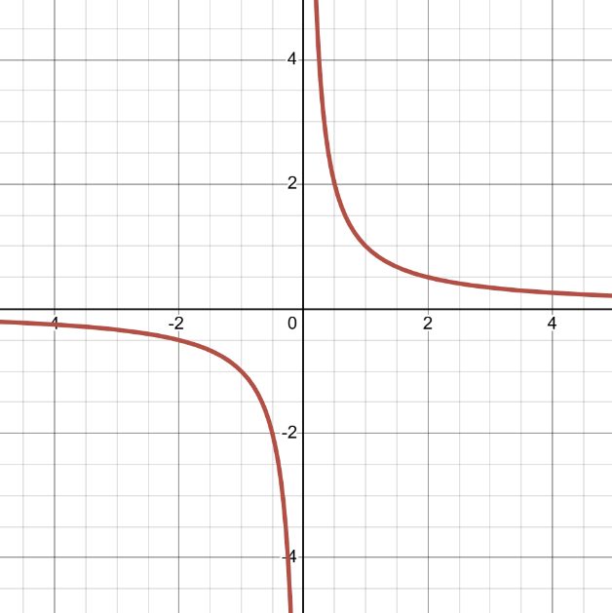
Rational Functions

$$y=±\frac{a}{±b\left(x-h\right)}+k$$



