Springs Review

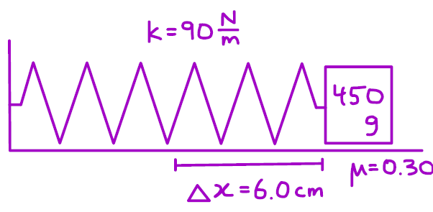
- A horizontal spring with a spring constant of $k=90\text{ N/m}$is attached to a $450\text{ g}$block resting on a rough horizontal surface. The coefficient of kinetic friction between the block and the surface is $μ=0.30$. The spring is stretched $6.0\text{ cm}$from its equilibrium position and then released from rest. What is the acceleration of the block at the instant it is released?

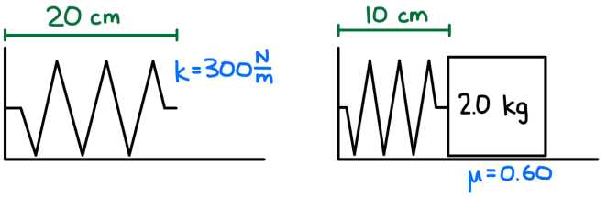
- A $2.0\text{ kg}$block rests on a rough horizontal surface with a coefficient of kinetic friction of $μ=0.60$. The block is pushed against a horizontal spring with a spring constant of $k=300\text{ N/m}$. The spring is compressed $10\text{ cm}$from its equilibrium position and then released from rest. What is the acceleration of the block at the instant it is released?

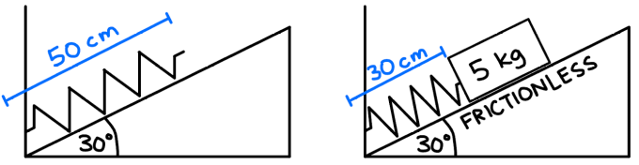
- A frictionless incline is angled at ${30}^{∘}$above the horizontal. A $5.0\text{ kg}$ block is pushed against a spring located along the incline and compresses it $30\text{ cm}$. When the block is released, it travels up the incline taking 0.62 s before momentarily reaching equilibrium at a speed of 2.6 m/s. Determine the spring constant of the spring.

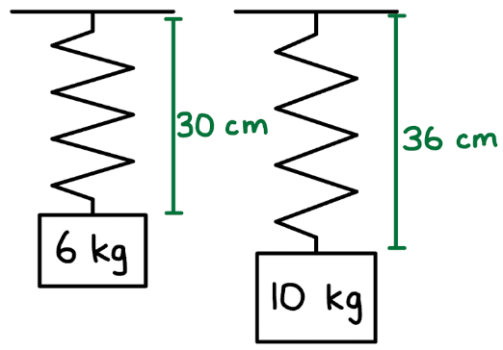
- A vertical spring has an unknown spring constant and an unknown natural (unstretched) length. When a $6\text{ kg}$mass is hung from the spring and allowed to come to rest, the total length of the spring is $30\text{ cm}$. When a $10\text{ kg}$mass is hung from the same spring and allowed to come to rest, the total length of the spring is $36\text{ cm}$.
- Determine the spring constant of the spring.
- Determine the natural (unstretched) length of the spring.

A. Parallel Spring Systems (stretch the same amount)
Parallel rule: Springs arranged side-by-side stretch by the same distance, but share the force.

- A 0.40 kg mass hangs vertically from two springs in parallel (side-by-side). Spring A has $k=320\text{ N/m}$and Spring B has $k=480\text{ N/m}$. Because the springs are in parallel, they both stretch by the same amount when the mass is attached. Determine the extension of each spring in equilibrium.

- A 4.5 kg block on a frictionless horizontal surface is attached to two springs in parallel (side-by-side). Spring 1 has $k=200\text{ N/m}$and Spring 2 has $k=150\text{ N/m}$. The block is pushed 7.0 cm to the right and then released. Because the springs are in parallel, both springs stretch by the same amount when the block is displaced. Determine the restoring force from the springs and the acceleration of the block at the instant of release.

B. Series Spring Systems (same force, stretch different amounts)
Series rule: Springs arranged end-to-end feel the same force, but stretch by different amounts depending on their spring constants.
For springs in series, the effective spring constant $k_{\text{eq}}$satisfies:
$$\frac{1}{k_{\text{eq}}}=\frac{1}{k_{1}}+\frac{1}{k_{2}}$$

- A 1.2 kg mass hangs vertically from two springs in series (end-to-end). Spring 1 has $k=150\text{ N/m}$, natural length 18 cm. Spring 2 has $k=250\text{ N/m}$, natural length 22 cm. Because the springs are in series, they both feel the same force, but stretch by different amounts. Determine the stretch of each spring and the total final length of the combined spring system.

- A 7.0 kg block is attached to two springs arranged in series (end-to-end) on a horizontal surface. Spring 1 has $k=260\text{ N/m}$and Spring 2 has $k=390\text{ N/m}$. The block is pulled 12 cm to the right and released. Because the springs are in series, they both feel the same force, but will stretch by different amounts. The surface has friction with $μ=0.22$. Determine whether the block begins to move when released. If it does move, determine the acceleration at the instant of release.

C. Mass Between Two Springs (neither stretch the same nor share force)
Mass-between rule: Each spring stretches or compresses based on the direction and amount of displacement, not automatically the same. Weight does not matter unless vertical.

- A 0.85 kg mass hangs between two vertical springs: Top spring: $k=420\text{ N/m}$, Bottom spring: $k=330\text{ N/m}$. The mass stretches each spring until the upward and downward spring forces balance. Because the mass is between the springs, they do not stretch the same amount — each adjusts until forces are equal. Determine the extension of each spring in equilibrium.

- A 0.60 kg block on a frictionless horizontal surface sits between two springs attached to opposite walls. The block is pulled 9.0 cm to the left and released. At that moment, the left spring is compressed 9.0 cm and the right spring is stretched 9.0 cm. Because the mass is between the springs, each spring’s force depends only on the displacement toward that spring. Determine the force from each spring and the acceleration of the block at the instant of release.

