Conservation of Energy

- A book of mass m falls freely from rest to the floor from the top of a desk of height h. What is the speed of the book upon striking the floor?

- A water fountain shoots water straight up 5.20 m into the air. What is the speed of the water when it leaves the fountain?

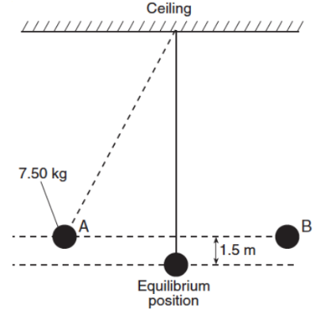
- A pendulum is made from a 7.50-kilogram mass attached to a rope connected to the ceiling of a gymnasium. The mass is pushed to the side until it is at position A, 1.5 m higher than its equilibrium position. After it is released from rest at position A, the pendulum moves freely back and forth between positions A and B, as shown in the diagram below. What is the speed of the mass as it swings freely through its equilibrium position?

- A 1.0 kg rock is dropped from a cliff 90. m high. After falling 20. m, what is the kinetic energy of the rock?

- A child, starting from rest at the top of a playground slide, reaches a speed of 7.0 m/s at the bottom of the slide. What is the vertical height of the slide?

- A 0.50 kg ball is thrown vertically upward with an initial kinetic energy of 25 J. How high will the ball rise?

- A 65 kg pole vaulter wishes to vault to a height of 5.5 m. Calculate the speed the vaulter must attain to have the necessary kinetic energy.

- A 1.00 kg ball is dropped from the top of a building. Just before striking the ground, the ball’s speed is 12.0 m/s. What was the ball’s gravitational potential energy, relative to the ground, at the instant it was dropped?

- A skier is coasting up a 4.0 m high hill. If she is moving at a speed of 6.0 m/s when she is 2.0 m up the hill, will she make it to the top of the hill?

- A 55 kg diver falls freely from a diving platform that is 3.00 m above the surface of the water in a pool. When she is 1.00 m above the water, what are her gravitational potential energy and kinetic energy with respect to the water’s surface?

- A mass m is thrown horizontally at 5.00 m/s off of a 20.0 m high cliff. Find its speed at impact.
  - Solve using kinematics
  - Solve using energy
- A 3.0 kg object is placed on a frictionless track at point A and released from rest. (Assume the gravitational potential energy of the system to be zero at point C.)

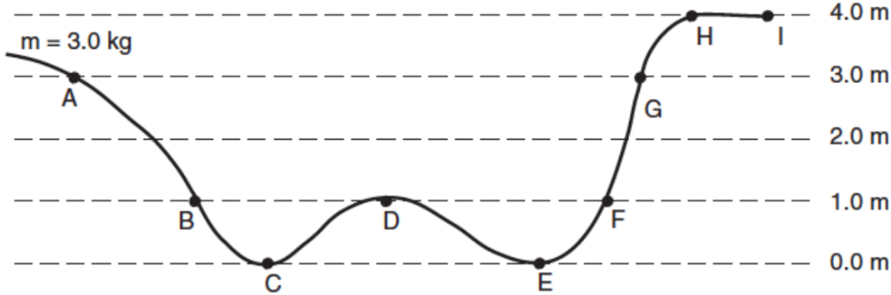

  - Calculate the gravitational potential energy of the object at point A.
  - Calculate the speed of the object at point B.
  - Calculate the speed of the object at point C.
  - Which letter represents the farthest point on the track that the object will reach?

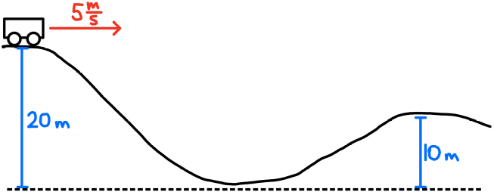
- A cart has a speed of 5 m/s at the top of a 20 m high hill. What is its speed at the top of a 10 m high hill? Assume no friction forces.

- Tarzan has a mass of 85.0 kg and he runs at 6.00 m/s. He grabs onto a vine and swings up until he stops. How high can he swing?

- A 500. kg roller coaster is moving at 1.20 m/s at the top of a 30.0 m high hill. Assuming no friction, what will be the speed of the coaster when it zooms down the hill at is at height of
  - 25.0 m
  - 12.0 m
  - 0.00 m
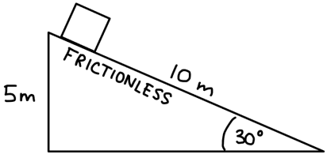
- A block starts from rest and slides down a frictionless ramp. Determine the speed at the bottom of the ramp using…
  - dynamics and kinematics
  - energy

