2- Combination Circuits

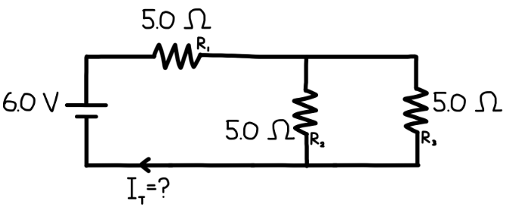
- A 6.0 V DC battery is connected to a circuit consisting of three resistors, as shown in the diagram.
- $R_{1}=5.0 Ω$ is connected in series with a parallel combination of:
  - $R_{2}=5.0 Ω$
  - $R_{3}=5.0 Ω$
(a) Determine the equivalent resistance of the parallel section containing $R_{2}$and $R_{3}$.
(b) Determine the total resistance of the circuit.
(c) Determine the total current supplied by the battery.
(d) Determine the current through $R_{1}$.
(e) Determine the current through $R_{2}$and $R_{3}$.
(f) Determine the voltage drop across each resistor.

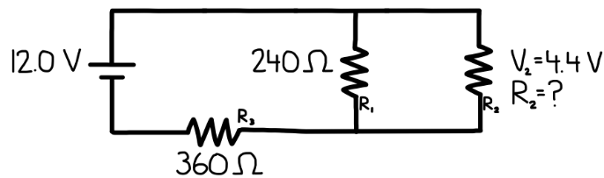
- A 12.0 V DC battery is connected to a circuit consisting of three resistors, as shown in the diagram.
- $R_{3}=360 Ω$is connected in series with a parallel combination of:
  - $R_{1}=240 Ω$
  - $R_{2}$, whose resistance is unknown
    - The voltage drop across $R_{2}$is $V_{2}=4.4\text{ V}$
(a) Determine the voltage across the parallel section of the circuit.
(b) Determine the current through $R_{1}$.
(c) Determine the current through $R_{2}$.
(d) Determine the resistance of $R_{2}$.
(e) Determine the equivalent resistance of the parallel section.
(f) Determine the total resistance of the circuit.
(g) Determine the total current supplied by the battery.

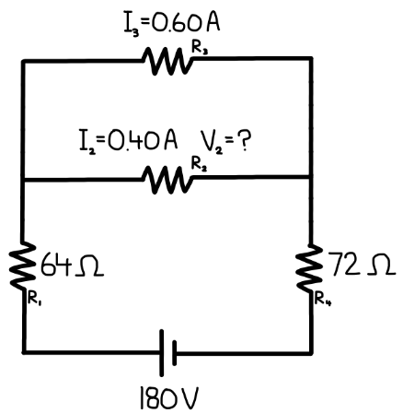
- A 180 V DC power source is connected to a circuit consisting of four resistors, arranged as shown in the diagram.
- $R_{1}=64 Ω$and $R_{4}=72 Ω$are connected in series with the rest of the circuit.
- Between the top and bottom nodes, there are two resistors in parallel:
  - $R_{2}$, carrying a current of $I_{2}=0.40\text{ A}$
  - $R_{3}$, carrying a current of $I_{3}=0.60\text{ A}$
(a) Determine the total current supplied by the power source.
(b) Determine the voltage across the parallel section of the circuit.
(c) Determine the voltage across $R_{2}$.
(d) Determine the resistance of $R_{2}$.
(e) Determine the resistance of $R_{3}$.
(f) Verify that your results are consistent with Ohm’s Law and the rules for series–parallel circuits.

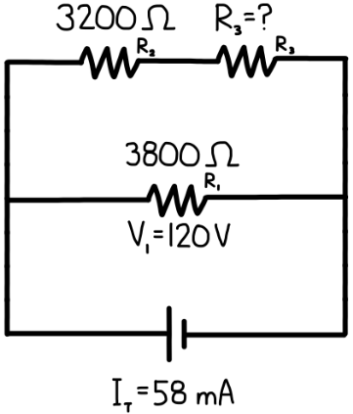
- A DC power source is connected to a circuit consisting of three resistors, arranged as shown in the diagram.
- The total current supplied by the source is $I_{\text{total}}=58\text{ mA}$
- One branch contains a single resistor:
  - $R_{1}=3800 Ω$
  - The voltage across this resistor is $V_{1}=120\text{ V}$
- The other branch contains two resistors in series:
  - $R_{2}=3200 Ω$
  - $R_{3}$, whose resistance is unknown
(a) Determine the voltage of the power source.
(b) Determine the current through $R_{1}$.
(c) Determine the current through the branch containing $R_{2}$and $R_{3}$.
(d) Determine the voltage across the series combination of $R_{2}$and $R_{3}$.
(e) Determine the resistance of $R_{3}$.

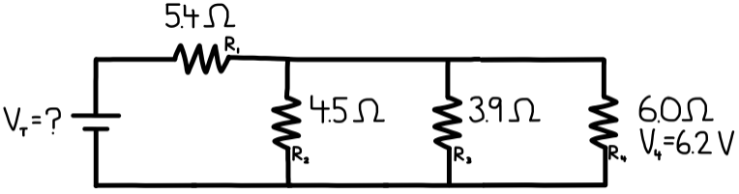
- A circuit consists of a DC power source connected to four resistors, arranged as shown in the diagram.
- $R_{1}=5.4 Ω$is connected in series with a parallel network of three resistors:
  - $R_{2}=45 Ω$
  - $R_{3}=39 Ω$
  - $R_{4}=60 Ω$, The voltage across $R_{4}$is $V_{4}=6.2\text{ V}$
- The voltage of the power source, $V_{T}$, is unknown.
(a) Determine the voltage across the parallel section of the circuit.
(b) Determine the current through $R_{4}$.
(c) Determine the current through $R_{2}$and $R_{3}$.
(d) Determine the total current entering the parallel section.
(e) Determine the voltage drop across $R_{1}$.
(f) Determine the voltage of the power source, $V_{T}$.

Important Instructions
- Do not substitute numerical values for $R$.
- All answers must be expressed symbolically in terms of $R$.
- Final expressions should be fully simplified.

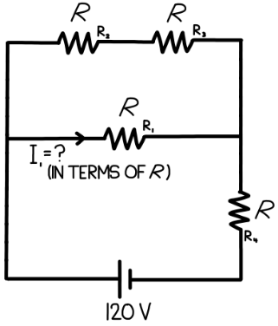
- A 120 V DC power source is connected to a circuit consisting of four identical resistors, each with resistance $R$, arranged as shown in the diagram.
- Two resistors are connected in series along the top branch.
- One resistor is connected alone in the middle branch.
- One resistor is connected in series on the right side of the circuit.
- The current through the middle resistor is labeled $I_{1}$.
(a) Determine the equivalent resistance of the top branch in terms of $R$.
(b) Determine the equivalent resistance of the parallel section in terms of $R$.
(c) Determine the total resistance of the circuit in terms of $R$.
(d) Determine the total current supplied by the battery in terms of $R$.
(e) Determine the current through the middle resistor, $I_{1}$, in terms of $R$.

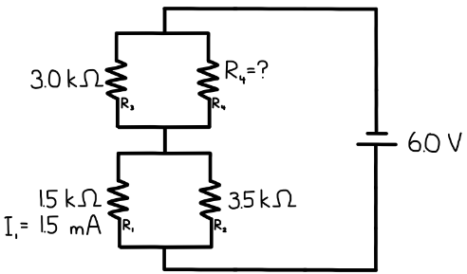
- A 6.0 V DC power source is connected to a circuit consisting of four resistors, arranged as shown in the diagram. The circuit is made of two parallel sections connected in series:
Lower parallel section
- $R_{1}=15\text{ k}Ω$, The current through $R_{1}$is $I_{1}=1.5\text{ mA}$
- $R_{2}=35\text{ k}Ω$
Upper parallel section
- $R_{3}=3.0\text{ k}Ω$
- $R_{4}$, whose resistance is unknown
(a) Determine the voltage across the lower parallel section.
(b) Determine the current through $R_{2}$.
(c) Determine the total current flowing through the circuit.
(d) Determine the voltage across the upper parallel section.
(e) Determine the current through $R_{3}$.
(f) Determine the resistance of $R_{4}$.

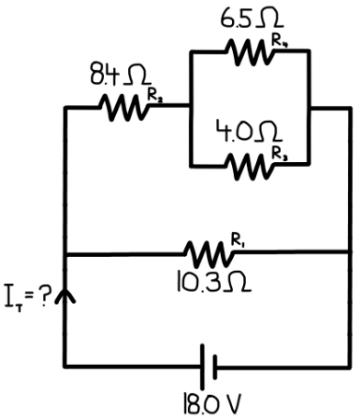
- An 18.0 V DC battery is connected to a circuit consisting of four resistors, arranged as shown in the diagram. The circuit has two branches in parallel:
Upper branch
- A resistor $R_{2}=84 Ω$is connected in series with a parallel combination of:
  - $R_{3}=6.5 Ω$
  - $R_{4}=4.0 Ω$
Lower branch
- A single resistor $R_{1}=10.3 Ω$
The total current supplied by the battery, $I_{T}$, is unknown.
(a) Determine the equivalent resistance of the parallel pair $R_{3}$and $R_{4}$.
(b) Determine the total resistance of the upper branch.
(c) Determine the equivalent resistance of the entire circuit.
(d) Determine the total current supplied by the battery.
(e) Determine the current in each branch.

