Spring Force and Hooke’s Law

- A spring has $k=150\text{ N/m}$. How much force is needed to stretch it $0.06\text{ m}$?

- A force of $18\text{ N}$compresses a spring $3.0\text{ cm}$. What is the spring constant?

- A spring constant is $400\text{ N/m}$. How far will the spring stretch under a $10\text{ N}$ force, in cm?

- A spring stretches from 12.0 cm to 15.8 cm when a $14\text{ N}$ force is applied. What is $k$?

- What force is required to compress a spring (spring constant of 240 N/m) by 5.0 cm?

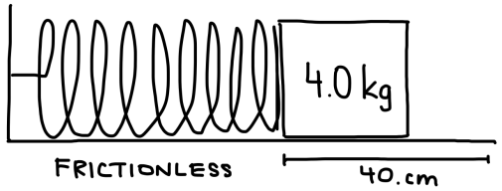
- A 4.0 kg mass is on a horizontal frictionless surface. It is pressed against a spring (spring constant 320 N/m) so that it is 40 cm from its equilibrium position as shown. What is its acceleration immediately after it is released?

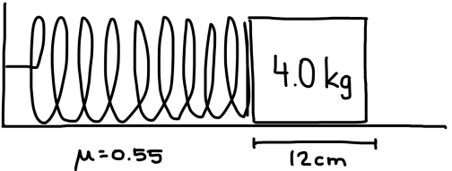
- A $4.0\text{ kg}$ mass on a horizontal surface, $μ=0.55$, pulled by $k=440\text{ N/m}$ spring displaced $12\text{ cm}$. Find acceleration when released.

- A $6.0\text{ kg}$block on a rough surface ($μ=0.28$) is pulled by a $k=380\text{ N/m}$spring stretched $20\text{ cm}$. Will the block move? If yes, what is its acceleration?

- A spring is 20 cm long when a load of 10 N is hanging from it, and 30 cm long when a load of 20 N is hanging from it. Determine its spring constant and equilibrium position.

- A spring’s natural length is unknown. Under 6 N it measures 18.4 cm, and under 14 N it measures 23.6 cm. Determine $k$ and natural length.

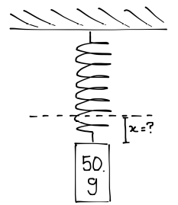
- A $50\text{ g}$ mass hangs from a $k=140\text{ N/m}$spring. How much is the spring stretched?

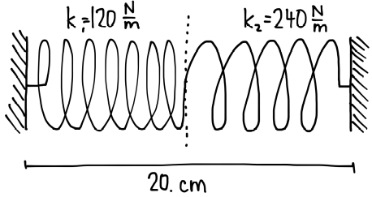
- Two springs in series (16 cm & 12 cm natural lengths; $k_{1}=120, k_{2}=240$) are pressed so total length = 20 cm. Determine compression of each.

