Transforming Radicals

Sketch the transformation of $f\left(x\right)=\sqrt{x}$, then rewrite each function in the form: $g(x)=a(b(x-h))^{2}+k$

- $g(x)=\sqrt{x}+5$

- $g(x)=-\sqrt{x}$

- $g(x)=\sqrt{\frac{1}{2}x}$

- $g(x)=\sqrt{2x-1}$

- $g(x)=-3\sqrt{x}$

- $g(x)=4-\sqrt{5-2x}$

Rewrite each function in the form, $g(x)=a\sqrt{b(x-h)}+k$, describe all transformations of $f\left(x\right)=x^{2}$ in the correct order, then sketch the function.

- $g(x)=5-2\sqrt{x+4}$

- $g(x)=-\sqrt{-4x+8}+1$

- $g(x)=3\sqrt{2-x}-7$

- $g(x)=-\frac{1}{2}\sqrt{6x+12}+9$

- $g(x)=3-\sqrt{2x}$

- $g(x)=\sqrt{-x+6}-1$

- Consider $f\left(x\right)=\sqrt{x}$. Two transformations are applied:
A) Horizontal compression by factor 0.5
B) Horizontal shift 4 units right
Sketch the function if A is performed first and then B.
Sketch the function if B is performed first and then A.
Explain why the results are different.

- Find two completely different transformations of $f\left(x\right)=\sqrt{x}$ that produce the same graph as:
$$g(x)=-2\sqrt{x-3}+5$$

For each function: State the domain and state the range.

- $g(x)=\sqrt{x-4}+2$

- $g(x)=-\sqrt{-x+5}+3$

- $g(x)=4-3\sqrt{2x-6}$

- $g(x)=-2\sqrt{1-3x}-7$

- A radical function has endpoint (–2, 6), opens downward, and is vertically stretched by a factor of 3. Write its equation $y=a\sqrt{b\left(x-h\right)}+k$.

- Write each function in the form $y=a\sqrt{b\left(x-h\right)}+k$ where $f(x)=\sqrt{x}$

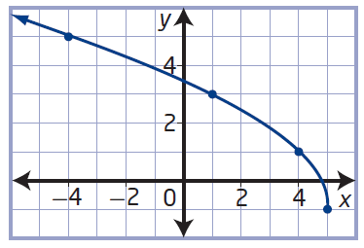
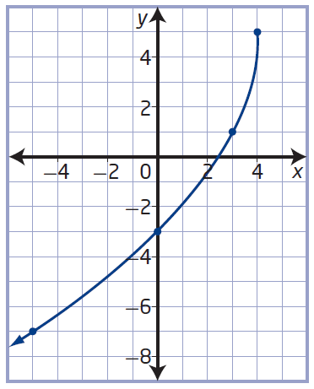
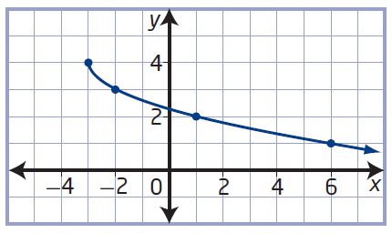

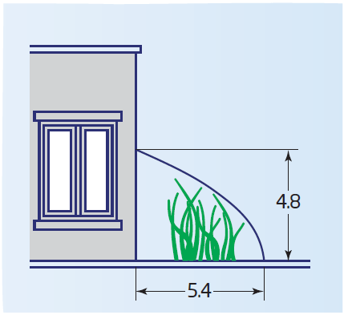
- While meeting with a client, a manufacturer of custom greenhouses sketches a greenhouse in the shape of the graph of a radical function. What equation could the manufacturer use to represent the shape of the greenhouse roof?

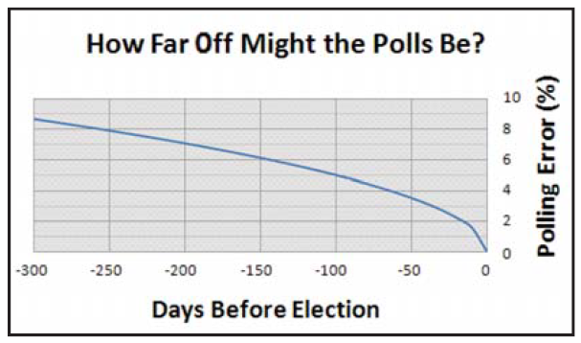
- During election campaigns, campaign managers use surveys and polls to make projections about the election results. One campaign manager uses a radical function to model the possible error in polling predictions as a function of the number of days until the election, as shown in the graph. Determine an equation to represent the function.

