Multi-Body Systems (Angled Surfaces)

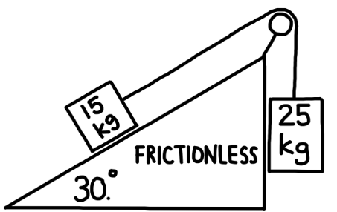
- A 15.0 kg block rests on a frictionless incline that makes an angle of 30.0° with the horizontal. The block is connected by a light, inextensible rope that passes over a frictionless pulley to a 25.0 kg block hanging vertically on the other side.
- Determine the acceleration of the system (magnitude and direction of motion of each mass).
- Determine the tension in the rope.

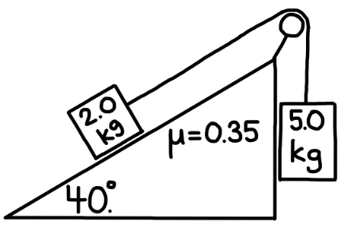
- A 2.0 kg block rests on a 40.0° incline. The coefficient of kinetic friction between the block and the incline is μ = 0.35. The block is connected by a light, inextensible rope that passes over a frictionless pulley to a 5.0 kg block hanging vertically on the other side. Assume the system is released from rest.
- Determine the acceleration of the system. State the direction of motion for each mass.
- Determine the tension in the rope.

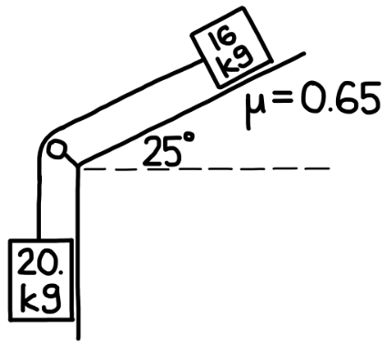
- A 16 kg block sits on a 25° incline. The coefficient of kinetic friction between the block and the surface is μ = 0.65. The block is attached by a light, inextensible rope that passes over a frictionless pulley to a 20 kg block hanging vertically on the other side. The system is released from rest.
  - Determine the acceleration of the system. State the direction of motion of each mass.
  - Determine the tension in the rope.

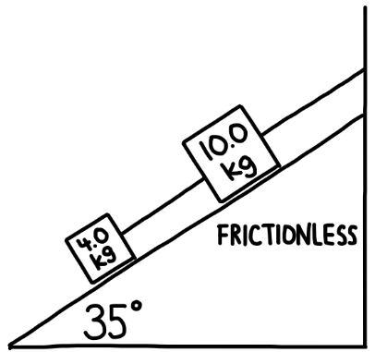
- Two blocks of mass 4.0 kg and 10.0 kg rest on a 35° frictionless incline. They are connected by a light cord along the incline. A second cord attaches the 10.0 kg block to a wall at the top of the incline, preventing any motion. Both cords and the surface are assumed to be frictionless and massless.
  - Determine the tension in the cord between the 4.0 kg and 10.0 kg blocks.
  - Determine the tension in the cord connecting the 10.0 kg block to the wall.

- A 6.0 kg block rests on a 20° incline. The coefficient of kinetic friction between the block and the incline is μ = 0.70. The block is attached by a light, inextensible rope that passes over a frictionless pulley to a hanging mass $m$on the other side. When the system is released, the hanging mass accelerates downward at $2.9 {\text{m/s}}^{2}$.
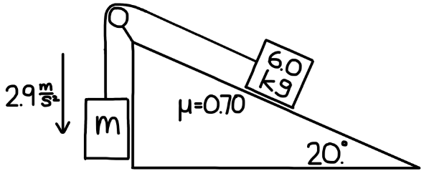
  - Determine the mass $m$.
- Determine the tension in the rope.

