More Forces at Angles

- Determine the acceleration of the object of a 20 kg object being pushed with 200 N downwards at an angle of 40 degrees to the horizontal if the surface has a coefficient of kinetic friction of 0.40.

- While setting up a display, you pull a 25 kg box with a rope that makes a 30° angle above the floor. The tension in the rope is 50 N and the coefficient of kinetic friction is 0.25.
  - Find the acceleration of the box.
  - Is it speeding up or slowing down?

- A 12 kg box slides down a 25° ramp coated in wax (μₖ = 0.20).
  - Determine its acceleration down the ramp.
  - Describe how the friction affects its motion.

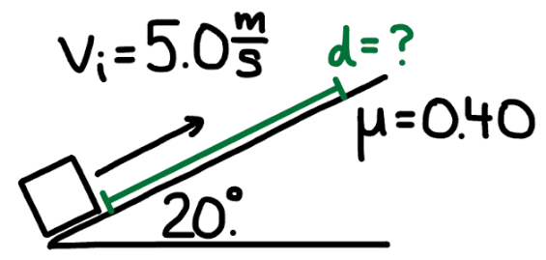
- A block is pushed up a 20° incline with an initial speed of $5.0\text{ m/s}$. The coefficient of kinetic friction between the block and the incline is $μ=0.40$. The block slides up the incline and eventually comes to rest. Determine the distance the block travels up the incline before stopping.

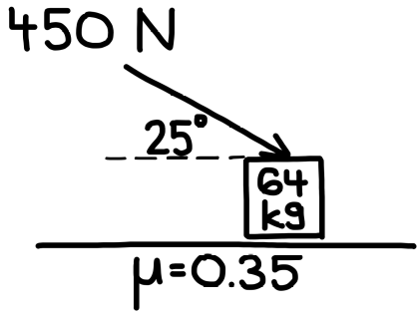
- A 64 kg block rests on a horizontal surface where the coefficient of kinetic friction is $μ=0.35$. A 450 N force is applied to the block at an angle of 25° below the horizontal, as shown. Determine the acceleration of the block.

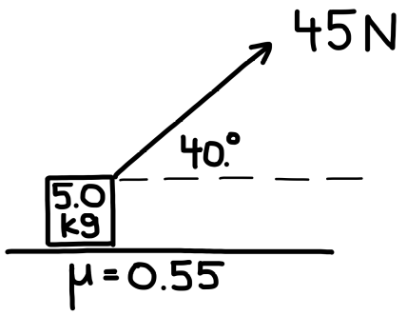
- A 5.0 kg block rests on a horizontal surface where the coefficient of kinetic friction is $μ=0.55$. A 45 N force is applied to the block at an angle of 40° above the horizontal, as shown. Determine the acceleration of the block.

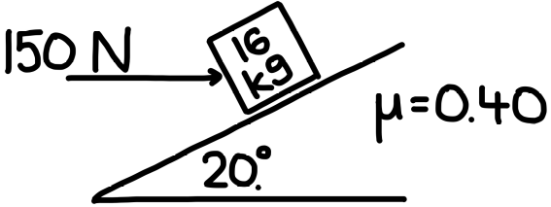
- A 16 kg block rests on a 20° incline where the coefficient of kinetic friction is $μ=0.40$. A 150 N horizontal force is applied to the block, as shown, pushing it toward the incline. Determine the acceleration of the block along the incline. (State whether it accelerates up or down the incline.)

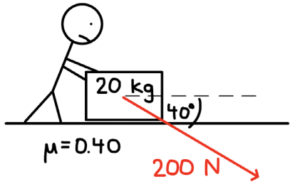
- A 20 kg block rests on a horizontal surface where the coefficient of kinetic friction is $μ=0.40$. A person pushes on the block, applying a 200 N force at an angle of 40° below the horizontal, as shown. Determine the acceleration of the block.

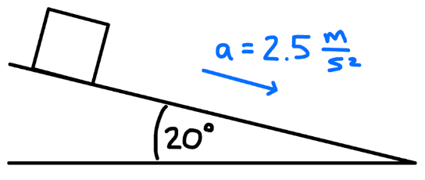
- A block rests on a 20° incline. When released, it accelerates down the incline at $2.5 {\text{m/s}}^{2}$. Determine the coefficient of kinetic friction between the block and the incline.

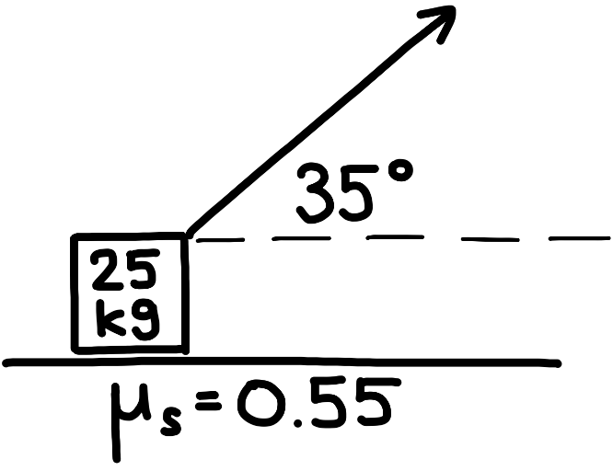
- A 25 kg block rests on a horizontal surface. The coefficient of static friction between the block and the surface is $μ_{s}=0.55$. A force is applied to the block at an angle of 35° above the horizontal, as shown. Determine the minimum force required to start moving the block.

