Forces at Angles

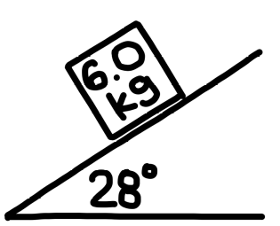
- An 6.0 kg object is on a frictionless ramp as shown. What is the acceleration of the object?

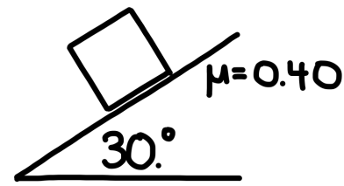
- An object is on a ramp with a shown. If the coefficient of friction is 0.40, what is the acceleration of the object?

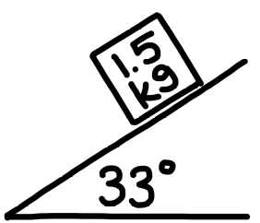
- A 1.5 kg object is on a ramp as shown. If the object accelerates down the ramp at 3.0 m/s², what is the coefficient of friction between the object and the surface of the ramp?

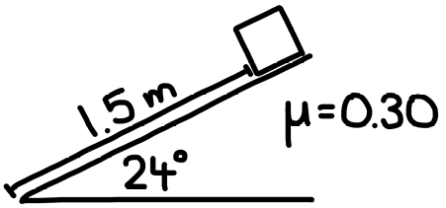
- An object begins sliding down a ramp. If the object was initially at rest 1.5 m from the base of the ramp and the coefficient of friction is 0.30, how long does it take for the object to reach the bottom of the ramp?

